An AI-Enhanced Workflow for Verifiable Social Science
AI can enhance the productivity of scholars, the quality of scholarship, and the rigor of science by offloading laborious tasks and lowering technical and knowledge barriers. However, the probabilistic nature of Large Language Models means that AI produces output that is often 1) plausible but misleading and 2) inconsistent across repeated uses. The plausibility and consistency of AI outputs are not adequately addressed by the existing transparency and reproducibility practices in social science. For social science researchers to trust a scholarly contribution produced by AI, scholars require verification that it is correct and that it was produced by the methods the author intended. We propose a model- and harness-agnostic workflow integrating verification, observability, and traceability into reproducible social science research. Implementing the proposed workflow allows AI contributions to become checkable and their production auditable, ultimately supporting ambitious AI-accelerated research and reusable workflow infrastructure that supports cumulative work.
AI-generated content is entering scientific manuscripts at a staggering pace (Liang et al. 2025; Kusumegi et al. 2025), and standards for using AI in research have lagged. AI can lower the cost of writing, coding, literature search, and other research tasks, allowing scholars to undertake work that would otherwise require more time, technical expertise, or cross-disciplinary collaborators (Doshi and Hauser 2024; Lee and Chung 2024; Boiko et al. 2023). These capabilities lower the cost of exploring risky ideas and help scholars work across fields and languages (Zheng et al. 2026). But the power of AI to accelerate research has numerous negative consequences beyond its ethical and environmental concerns (Resnik and Hosseini 2025; Luccioni et al. 2024). The rising volume of manuscripts is straining the peer review process (Gartenberg et al. 2026) and AI’s polished output can mask underlying flaws (Dell’Acqua et al. 2026), increasing the rate of low-quality submissions (Kusumegi et al. 2025; Suchak et al. 2025). Scholars want clear guidance on acceptable use (Schulz et al. 2026; Oxford University Press 2026; Wiley 2025), but journal policies rarely go beyond disclosure (He and Bu 2026; Ans et al. 2026). The gap is a lack of systematic procedures for establishing what AI contributed, whether those contributions meet appropriate standards, and documentation of how the contributions were produced.
AI presents two challenges to rigorous science that current transparency and reproducibility practices do not address: the plausibility problem and inconsistency across identical uses. The plausibility problem occurs when AI produces plausible, yet incorrect outputs or surreptitiously generates the output using a process the scholar did not intend. Plausibility failures appear in hallucinated citations (Walters and Wilder 2023), misattributed claims (Linardon et al. 2026), and analyses that reach a defensible answer while skipping required steps (Kapoor et al. 2026). Inconsistency occurs when generative AI models emit inconsistent output across runs with identical inputs. Inconsistency occurs because models sample their output from probabilities and GPU arithmetic shifts with hardware and server load (Yuan et al. 2025).

Our approach and contribution
Our core contribution is a model- and harness-agnostic workflow that integrates verification, observability, and traceability into reproducible research. The workflow treats AI contributions as objects whose production, compliance with specified requirements, and incorporation into research products should be inspectable and documented. We use procedural graphs (Lu et al. 2026) stored in a queryable knowledge base to route AI contributions through verification procedures (JCGM 2012), which is supported by auditable records of AI sessions and tool use. This workflow aims to support scholarly accountability through documented evidence rather than disclosure alone (He and Bu 2026; Ans et al. 2026).
The workflow builds on a plain-text reproducible research pipeline, which assembles manuscripts from text, references, and analysis code through a build script (Healy 2020). A build shows how a research product, such as a manuscript, website, research compendium, or presentation, was assembled, but not whether AI followed the intended procedure or whether a source supports a claim. Similarly, transcripts and agent logs record AI activity but do not establish that its contributions meet specified requirements. The workflow links these functions by implementing explicit human verification of AI contributions, recording AI session transcripts and tool use, and carrying accepted contributions into a reproducible pipeline. Verification, observability, and auditability enable more trustworthy AI use by making contributions checkable, their production visible, and their origins documented.
Verification is the “provision of objective evidence that a given item fulfils specified requirements” (JCGM 2012, 2.44 and Note 2) and is implemented in a verification layer. Procedural graphs document steps for implementing a verification procedure while a code script is triggered to build the verification report. Process verification procedures check whether AI performed its assigned task (for example, reading a paper before summarizing it); output verification procedures compare the factuality and accuracy of AI contributions (for example, checking to make sure a reference is not hallucinated). Passing a check establishes compliance with requirements as judged by the scholar.
Observability concerns real-time monitoring of the process behind an AI output in an observability layer, which is hidden from anyone who sees only the output (Åström and Murray 2008). In real time, the scholar may observe which files the harness reads, which tools it calls, and which knowledge base entries it retrieves, so a harness asked to apply a verification procedure can be seen retrieving it in addition to the LLM reasoning behind these choices. Observability is less formal than verification and comes earlier, allowing quick correction.
Audibility is a documented chain from each element of a research product to the inputs, sources, scripts, and sessions that produced it (JCGM 2012, 2.41) referred to as an audit layer in this workflow. Because repeating an AI interaction may not reproduce the same output, maintaining session records and logs is essential for auditing and downstream verification (Hosseini, Resnik, and Holmes 2023). The audit layer records, stores, and tags every AI session transcript and tool call, so that any AI contribution can be reviewed either in real-time as part of the observability layer or more formally as part of the verification layer.
The proposed workflow extends reproducible research infrastructure beyond assembling reproducible manuscripts. It provides a way to make the procedures governing AI-assisted research explicit, executable, and open to systematic scrutiny. Its reusable procedural specifications could support the development and critique of research standards across projects, while its model- and harness-agnostic design aims to accommodate diverse researcher preferences and software ecosystems. The resulting infrastructure would give researchers a practical foundation for more systematic AI-assisted inquiry and enable journals, research teams, and professional organizations to consider evidence-based accountability requirements.

System overview
The workflow operationalizes verification, observability, and traceability by processing AI contributions through a common sequence of identification, verification, review, and incorporation into a reproducible research product. It organizes AI contributions into four streams (Table 1 and Figure 1): prose, references, data and analysis code, and build files. These four streams broadly represent the types of AI outputs that show a direct impact on a research product and require different verification standards. The workflow identifies contributions to a research product and produces a verification report for a scholar’s review and approval. Creating a record indicating exactly where and how a research product received AI contributions.
Table 1. Streams and verification procedures
Stream | Tools | Verification Procedure
Prose | Text editor | Change review
References | Citation manager | Source support
Data and analysis code | R, Python, Quarto | Code
Build | Pandoc, Make | Build integrity
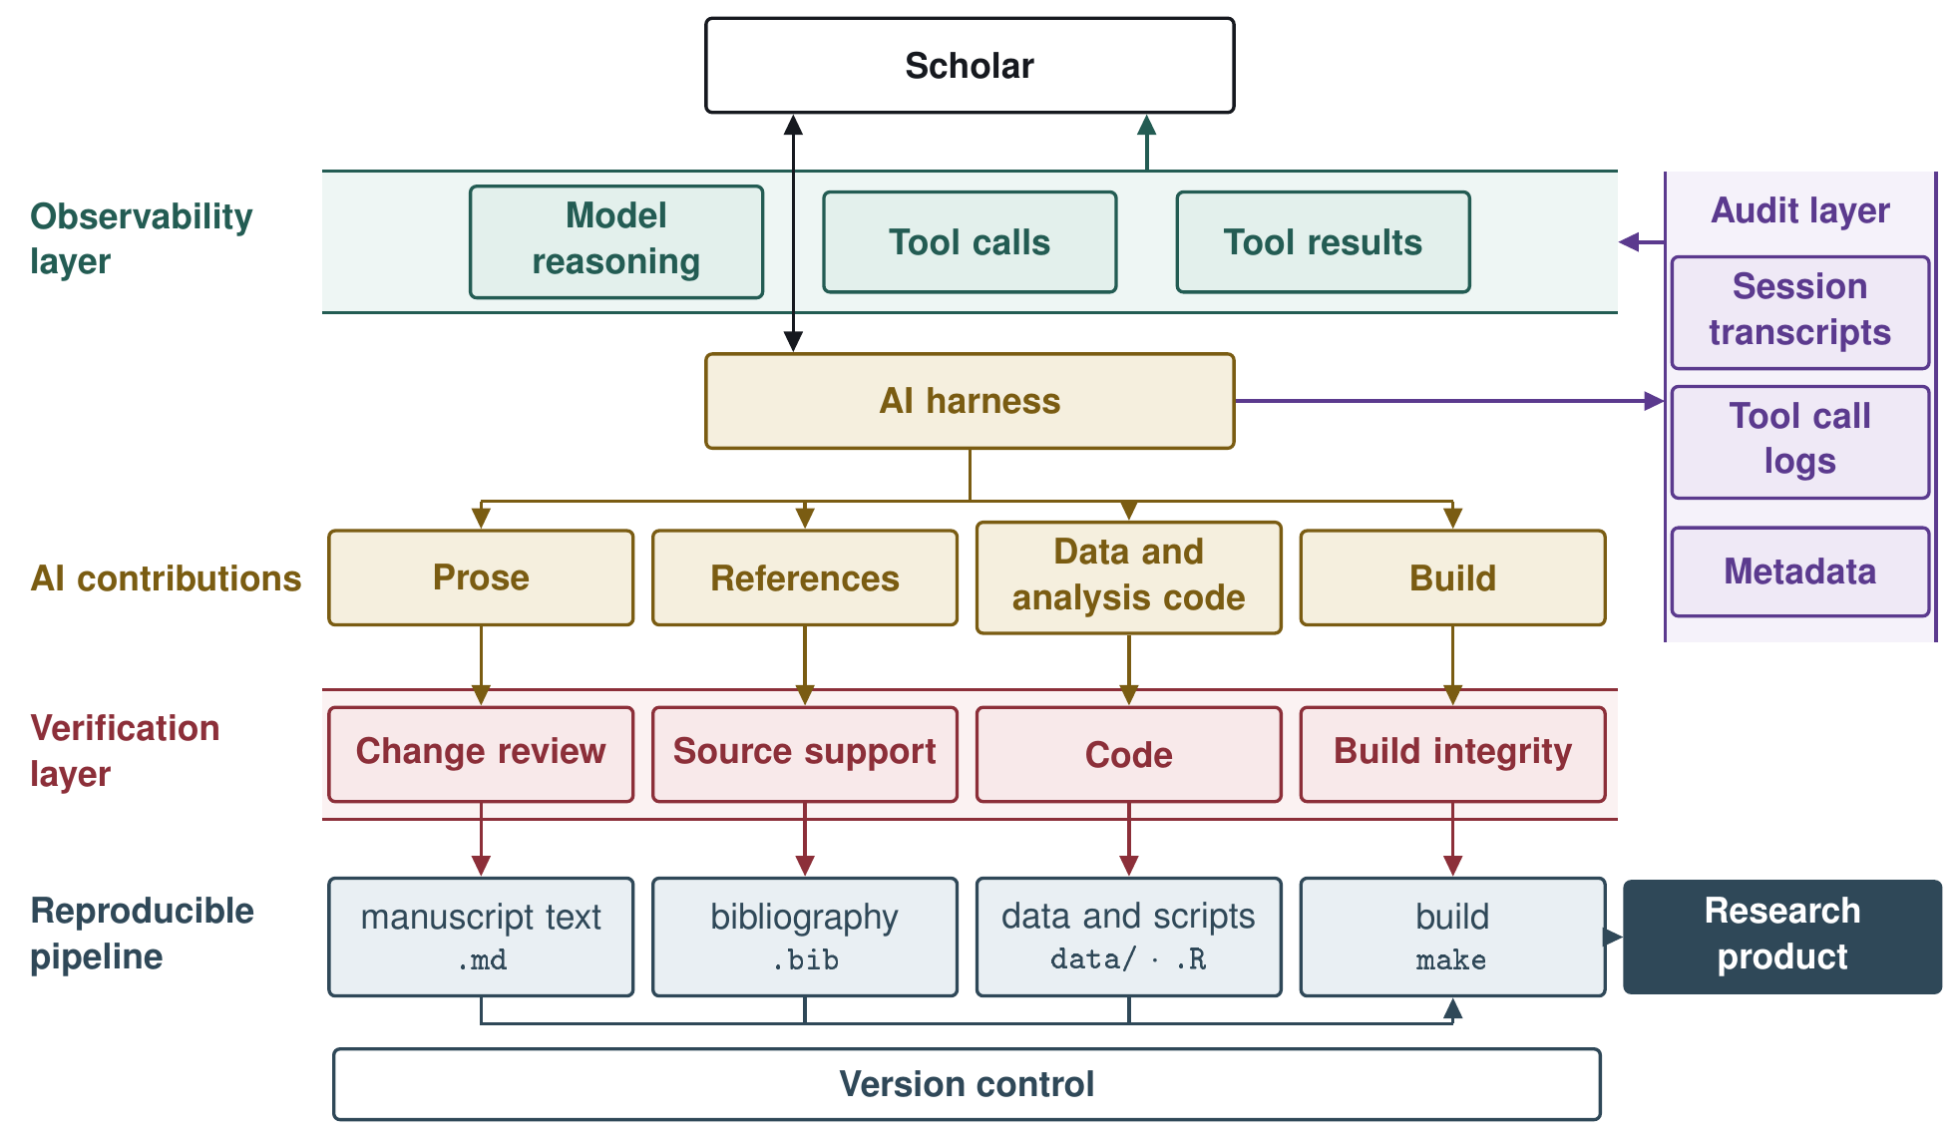
Figure 1. System Workflow Diagram
The architecture has four components that enable cross project work (Figure 2): AI harness, databases, reproducible pipeline, and external software. The AI harness is the software that connects to an AI model and connects it to tools and files (Zhang et al. 2026). It is the scholar’s point of contact with AI and AI’s point of contact with the rest of the workflow, and events in the harness, such as an AI edit or the end of a turn, start the verification procedures. The workflow’s databases hold the scholar’s working knowledge base, procedural graphs, session transcripts and action logs and specially designed stores for scholarly manuscripts and research data. The reproducible pipeline assembles research products from text, references, data, and code. External software includes the researcher’s editor, statistical software, citation manager, version control, and build tools such as Pandoc, Make, or Quarto, which is connected to the workflow through wrappers and Model Context Protocol servers. This architecture is designed to separate the research procedures and evidence requirements from any particular AI model or harness. Its practical agnosticism depends on the availability of interfaces that expose the events and information required by the workflow; we will evaluate this portability across multiple harnesses, models, and software integrations.
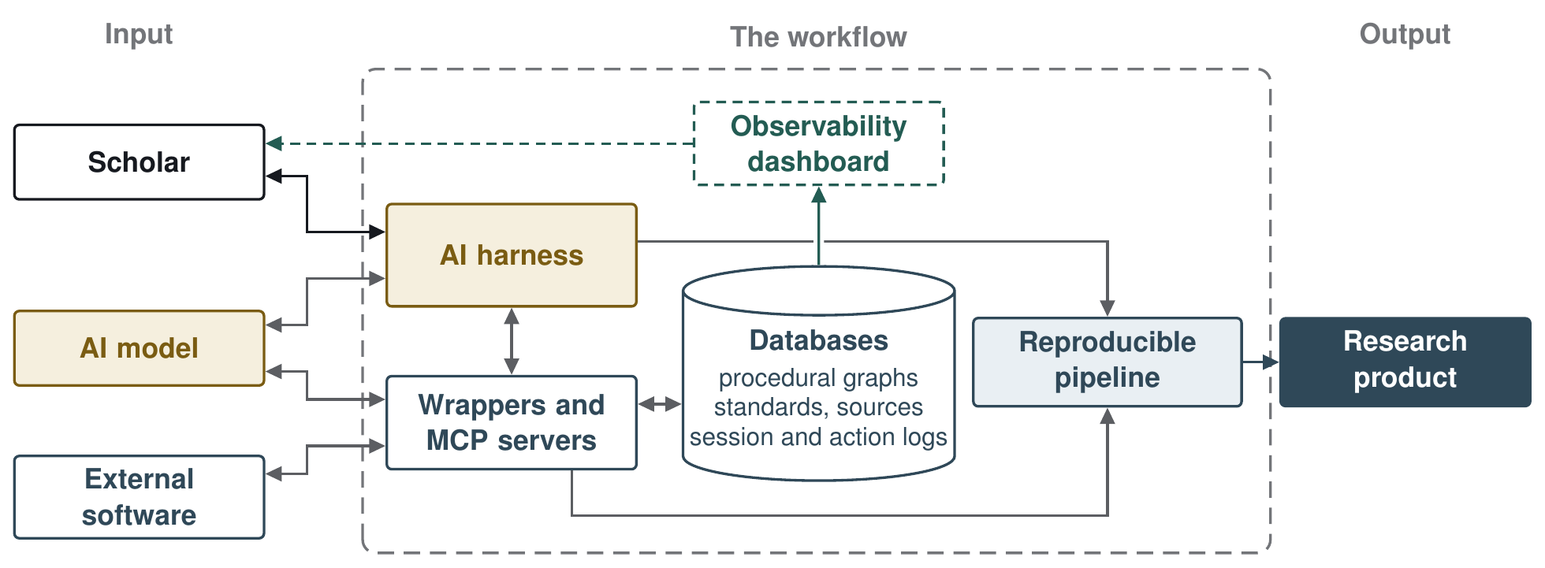
Figure 2. System Component Diagram
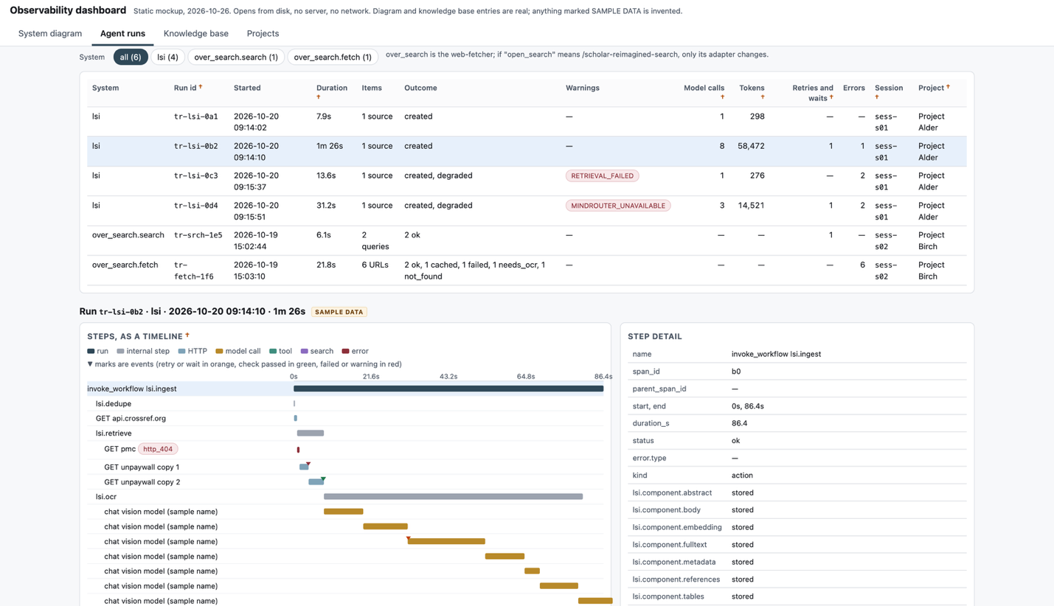
Figure 3. Observability Dashboard Prototype
The workflow also supports reusable, project-specific features and AI-assisted project organization. Pipeline setup can help researchers establish a reproducible project structure and connect their existing software environment. A project organizer can assist with maintaining files, builds, and session records as work evolves, with changes intended to remain observable and reversible. These features apply the core workflow to a practical barrier to adoption: researchers often lack the time or technical expertise to establish and maintain reproducible infrastructure (Stodden 2010) and work in disjointed and loosely organized ways, which leaves code and project files messy and often unable to run (Rule, Tabard, and Hollan 2018; Eubank 2016; Trisovic et al. 2022). The procedural graph system also provides a potential mechanism for reusing institution- and researcher-specific operational procedures. Further, the procedural graph system enables scholars to implement reusable procedures for the operational tasks around research that are unique to a scholar’s institution and preferences, such as connecting to a university high-performance computing cluster or adding a project to version control.

Current Status and Development Plan
The proposal builds on a working prototype. We have built and tested the reproducible pipeline and a runtime for the verification procedures, specified the databases and the observability layer, and planned the two features, pipeline setup and project organizer above. The reproducible pipeline is the most mature component. It makes no model or network calls; blocks build with unfilled computed-result placeholders; numbers and checksums each build; refuses to replace an altered prior build; and traces a reported number to its manifest entry and every sentence or table citing it.
The verification layer is partly built. A runtime walks procedural graphs for all four streams, and each stream has a clean and a seeded test manuscript, with every seeded fault caught under both recorded and live judgment across 36 tests. Shared schemas and reports, harness triggers, observability, and adapters for R and Quarto are designed but not yet built.
In Stage 2 (January to May 2027), we will complete the verification layer and test it. First, we will finalize the procedural graph system, so that verification procedures, wrappers, MCP servers, and operational tasks can all be written as procedural graphs. Second, we will finish building and testing the verification layer. Third, we will build the observability layer and the associated wrappers and MCP tools required to integrate AI observability into tools outside of the workflow, a live view of what the harness reads, calls, and retrieves, with the same events written to the logs. Fourth, we will test the workflow across multiple open-source harnesses, models, external software integrations and scenarios. Finally, we will develop an interactive web portal to help scholars learn, implement, and critique the workflow.

Key risks
Two key risks could limit the development, timely execution, and impact of the proposed workflow. First, this system is being designed, tested and evaluated to be model and harness agnostic, but the usefulness of said system can still be limited by institutional IT policies, AI model provider’s terms of service contracts, and the evolving legal landscape. Second, the verification process may become verification theater in practice. Until standards are developed and adopted by the scientific community, verification will be practiced intermittently and reported seldomly.

Implications
If the workflow is successfully built and disseminated, social scientists would gain both conceptual guidance and practical implementation support for AI-assisted research. In addition, researchers would have a foundation for developing their personal AI-assisted workflow enabling them to reuse procedures and audit records and standardize internal verification and observability of AI use in scientific teams. Finally, journals, conferences, and professional organizations could move from disclosure statements to reporting requirements that ask for evidence, such as a verification report and the session record behind each AI contribution.

Technical appendix and research artifact
The technical appendix describes each layer as designed, gives the status of every part, and lists commands that run the prototype offline in a few minutes without a model key. The research artifact is a public Git repository, tagged for this submission, at [URL]. It holds the reproducible pipeline, the procedural graph system with its four verification procedures and tests, clean and seeded test files for each stream so reviewers can watch the procedures catch planted faults, a sample project whose manuscript and slides are built from one numbers file and checked by the data procedure, and the records of our live model runs.

References
Ans M, Maggio LA, Algodi H, Costello JA, Driessen E, Oswald K, Lingard L (2026) The presence and nature of AI-use disclosure statements in medical education journals: A bibliometric study. Perspect. Medical Ed. 15(1):212–225. https://doi.org/10.5334/pme.2431
Åström KJ, Murray RM (2008) Feedback Systems: An Introduction for Scientists and Engineers (Princeton University Press, Princeton, NJ). https://doi.org/10.1515/9781400828739
Boiko DA, MacKnight R, Kline B, Gomes G (2023) Autonomous chemical research with large language models. Nature 624(7992):570–578. https://doi.org/10.1038/s41586-023-06792-0
Dell’Acqua F, McFowland E III, Mollick E, Lifshitz H, Kellogg KC, Rajendran S, Krayer L, Candelon F, Lakhani KR (2026) Navigating the jagged technological frontier: Field experimental evidence of the effects of artificial intelligence on knowledge worker productivity and quality. Organ. Sci. 37(2):403–423. https://doi.org/10.1287/orsc.2025.21838
Doshi AR, Hauser OP (2024) Generative AI enhances individual creativity but reduces the collective diversity of novel content. Sci. Adv. 10(28):eadn5290. https://doi.org/10.1126/sciadv.adn5290
Eubank N (2016) Lessons from a decade of replications at the Quarterly Journal of Political Science. PS Political Sci. Politics 49(2):273–276. https://doi.org/10.1017/S1049096516000196
Gartenberg C, Hasan S, Murray A, Pierce L (2026) More versus better: Artificial intelligence, incentives, and the emerging crisis in peer review. Organ. Sci. 37(3):795–812. https://doi.org/10.1287/orsc.2026.ed.v37.n3
He Y, Bu Y (2026) Academic journals’ AI policies fail to curb the surge in AI-assisted academic writing. Proc. Natl. Acad. Sci. USA 123(9):e2526734123. https://doi.org/10.1073/pnas.2526734123
Healy K (2020) The Plain Person’s Guide to Plain-Text Social Science. Version 2020-10-24. Accessed October 22, 2026, https://kieranhealy.org/files/papers/plain-person-text.pdf.
Hosseini M, Resnik DB, Holmes K (2023) The ethics of disclosing the use of artificial intelligence tools in writing scholarly manuscripts. Res. Ethics 19(4):449–465. https://doi.org/10.1177/17470161231180449
JCGM (Joint Committee for Guides in Metrology) (2012) International Vocabulary of Metrology: Basic and General Concepts and Associated Terms (VIM), 3rd ed. JCGM 200:2012 (Bureau International des Poids et Mesures, Sèvres, France). https://doi.org/10.59161/jcgm200-2012
Kapoor S, Stroebl B, Kirgis P, Nadgir N, Siegel ZS, Wei B, Xue T, et al. (2026) Holistic agent leaderboard: The missing infrastructure for AI agent evaluation. Proc. Internat. Conf. Learn. Representations (ICLR 2026), https://proceedings.iclr.cc/paper_files/paper/2026/hash/a0928f924a344aaebbb7f6cd8d56e34c-Abstract-Conference.html. Preprint: https://doi.org/10.48550/arXiv.2510.11977
Kusumegi K, Yang X, Ginsparg P, de Vaan M, Stuart T, Yin Y (2025) Scientific production in the era of large language models. Science 390(6779):1240–1243. https://doi.org/10.1126/science.adw3000
Lee BC, Chung J (2024) An empirical investigation of the impact of ChatGPT on creativity. Nature Human Behav. 8(10):1906–1914. https://doi.org/10.1038/s41562-024-01953-1
Liang W, Zhang Y, Wu Z, Lepp H, Ji W, Zhao X, Cao H, et al. (2025) Quantifying large language model usage in scientific papers. Nature Human Behav. 9(12):2599–2609. https://doi.org/10.1038/s41562-025-02273-8
Linardon J, Messer M, Anderson C, Soliman OM, Liu C, Firth J, Torous J (2026) Fluency without fidelity: Errors in citation-attributed claims in large language model-generated literature reviews in mental health. J. Tech. Behav. Sci., ePub ahead of print April 20, https://doi.org/10.1007/s41347-026-00630-6.
Lu Y, Chen Y, Wu S, Arık SÖ (2026) Procedural graphs: Self-evolving execution structures for LLM agents. Preprint, submitted September 8, https://doi.org/10.48550/arXiv.2609.09153.
Luccioni S, Jernite Y, Strubell E (2024) Power hungry processing: Watts driving the cost of AI deployment? Proc. 2024 ACM Conf. Fairness Accountability Transparency (FAccT ’24) (Association for Computing Machinery, New York), 85–99. https://doi.org/10.1145/3630106.3658542
Oxford University Press (2026) Disclosing AI Use in Academic Research: A Global Study by Oxford University Press. Report, September, Oxford University Press. https://fdslive.oup.com/www.oup.com/Group_comms/pdf/Disclosing_AI_use_in_academic_research.pdf
Resnik DB, Hosseini M (2025) The ethics of using artificial intelligence in scientific research: New guidance needed for a new tool. AI Ethics 5(2):1499–1521. https://doi.org/10.1007/s43681-024-00493-8
Rule A, Tabard A, Hollan JD (2018) Exploration and explanation in computational notebooks. Proc. 2018 CHI Conf. Human Factors Comput. Systems (Association for Computing Machinery, New York), Paper 32, 1–12. https://doi.org/10.1145/3173574.3173606
Schulz MS, Tavera Fenollosa L, Dussauge Laguna MI, Fontanelli O, Quintana Nedelcu D, Alba Udave J, Andersen JP (2026) The uses of generative artificial intelligence in social research north and south: Comparing empirical evidence from surveys in Denmark and Mexico. Methodological Innovations 19(3):173–191. https://doi.org/10.1177/20597991261454555
Stodden V (2010) Reproducibility of computational results: Opening code and data. Presentation, IASSIST 2010: Social Data and Social Networking, June 2, Ithaca, NY. https://doi.org/10.5281/zenodo.3781771
Suchak T, Aliu AE, Harrison C, Zwiggelaar R, Geifman N, Spick M (2025) Explosion of formulaic research articles, including inappropriate study designs and false discoveries, based on the NHANES US national health database. PLOS Biol. 23(5):e3003152. https://doi.org/10.1371/journal.pbio.3003152
Trisovic A, Lau MK, Pasquier T, Crosas M (2022) A large-scale study on research code quality and execution. Sci. Data 9(1):60. https://doi.org/10.1038/s41597-022-01143-6
Walters WH, Wilder EI (2023) Fabrication and errors in the bibliographic citations generated by ChatGPT. Sci. Rep. 13(1):14045. https://doi.org/10.1038/s41598-023-41032-5
Wiley (2025) ExplanAItions: An AI Study by Wiley. Report, February, John Wiley & Sons. https://assets.wiley.com/image/upload/v1781548107/wiley-explanaItions-ai-study-february-2025vers3.pdf
Yuan J, Li H, Ding X, Xie W, Li Y-J, Zhao W, Wan K, Shi J, Hu X, Liu Z (2025) Understanding and mitigating numerical sources of nondeterminism in LLM inference. Adv. Neural Inform. Processing Systems 38 (NeurIPS 2025). https://doi.org/10.52202/085713-5653
Zhang Y, Wang J, Ge Y, Xu W, Hamm J, Reddy CK (2026) Stop comparing LLM agents without disclosing the harness. Preprint, submitted May 7, https://doi.org/10.48550/arXiv.2605.23950.
Zheng X, Hong X, Liu J, Ni C (2026) Scientific exploration, collaboration and labor division in the large language model era. Preprint, submitted July 23, https://doi.org/10.48550/arXiv.2607.20923.

