Endless Summer
Transcultural Geographies of City Pop Art
Martin Roberts
2025-01-30
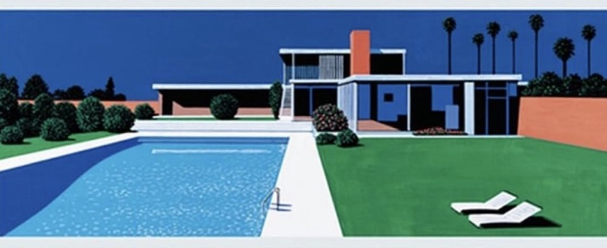
Paper proposal for Research Workshop, And Suddenly There Was City Pop: The Global Dimensions of the Retrograde Formation of a Japanese Popular Music Genre
University of Amsterdam, 19-21 March 2025

This paper continues the exploration of transcultural imaginaries reverberating back and forth between Japan and the U.S., begun in my book on Cornelius’s album Fantasma. Drawing on Shuhei Hosokawa’s analysis of musical pastiche in what he calls the “soy sauce music” of Haruomi Hosono, I am interested in exploring City Pop not as a musical but as an audiovisual construct, circulating not only in album artwork but also coffee-table books, posters, clothing, and social media platforms. Just as “City Pop” was retroactively constituted as a nostalgic embodiment of 1970s-1980s Japan, so too was it characterized by a Japanese fantasy of California, as well as of U.S. Pacific territories more generally (Hawaii, Guam).
The paper explores this fantasy cultural geography through the work of the Japanese designer and pop artist Hiroshi Nagai. Inspired by the artist’s visits to the U.S. and Guam in the mid-1970s, Nagai’s album art, paintings, and books such as Time Goes By… and Tropical Modern have become synonymous with City Pop, with their iconography of cloudless blue skies, palm trees, ocean highways, open-top cars, and hotel swimming pools. Perhaps the most striking aspect of Nagai’s imaginary landscapes, the paper will suggest, is the conspicuous absence of any human subjects, recalling the dystopian modernism of the British novelist J.G. Ballard. Unlike the empty swimming pools of Ballard’s post-apocalyptic worlds, however, Nagai’s are invitingly full and decidedly utopian, fantasy projections of the California good life.
Nagai’s city-pop landscapes, the paper argues, are also futuristic, and as such they also help to position the musical genre within the larger cultural shift from modernist to postmodernist aesthetics. In his book Ghosts of My Life, Mark Fisher argues that postmodernist culture has become so absorbed with stylistically mimicking its past that it has lost the capacity of 1970s popular music to imagine the future. Both musically and visually, the paper concludes, City Pop can be seen in similar terms, as nostalgic for a modernist future that never arrived and that we are still waiting for today.

References
Shuhei Hosokawa, “Soy Sauce Music: Haruomi Hosono and Japanese Self-Orientalism,” in Philip Hayward, ed., Widening the Horizon: Exoticism in Post-War Popular Music (Sydney: John Libbey / Perfect Beat Publications, 1999): 114-44.
Mark Fisher, “‘The Slow Cancelation of the Future,’” in Ghosts of My Life: Writings on Depression, Hauntology and Lost Futures (Winchester, UK / Washington USA, 2014): 13-35.
Simon Reynolds, Futuromania: Electronic Dreams, Desiring Machines, and Tomorrow’s Music Today (New York: Hachette, 2024).
Martin Roberts, Cornelius’s ‘Fantasma’. 33 1/3 (New York: Bloomsbury, 2019).

