//（1） 练习计算两个数之和源程序的编辑编译及运行。

#include <stdio.h>

void main()

{

int a,b,sum;

a = 123;

b = 567;

printf("sum is %d\n",sum = a + b);

}

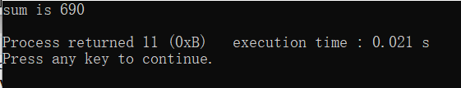

/\*（2）练习找两个数最大数源程序的编辑编译及运行。\*/

#include <stdio.h>

int max(int x, int y);

void main()

{

int a,b,c;

printf("input a & b: ");

scanf("%d%d",&a,&b);

c = max(a,b);

printf("max = %d\n",c);

}

int max(int x, int y)

{

int z;

if(x<=y)

z = y;

else

z = x;

return(z);

}

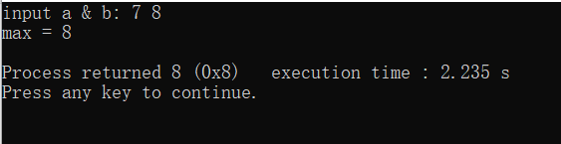

/\*（3）猜数字游戏 \*/

#include <stdio.h>

#include <stdlib.h>

#include <time.h>

void main()

{

int number,ask,times = 1;

long t;

srand((unsigned)time(NULL));

number = rand()%100;

printf("请输入您猜的数字(1~100):");

scanf("%d",&ask);

t = time(NULL);

while (ask!=number)

{

if(ask>number)

printf("\n您猜的数字大了，请重新输入：");

if(ask<number)

printf("\n您猜的数字小了，请重新输入：");

scanf("%d",&ask);

times++;

}

t = time(NULL) -t ;

printf("\n恭喜您！回答正确。您猜对了%d次，用时%d秒。\n",times,t);

}

