Marco Rodriguez Gomez
4/10/2026
Module 5.2 Assignment : Movies: Setup

GitHub : https://github.com/mrodriguezLearning/csd-310

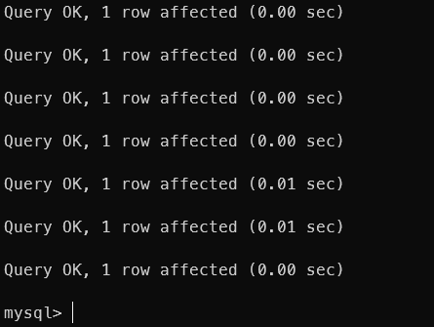
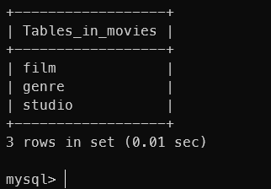
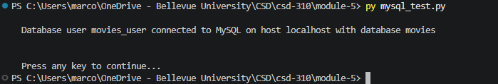
GitHub : https://github.com/mrodriguezLearning/csd-310

