Marco Rodriguez Gomez
04/10/2026
Module 4.2 Assignment: MySQL Install

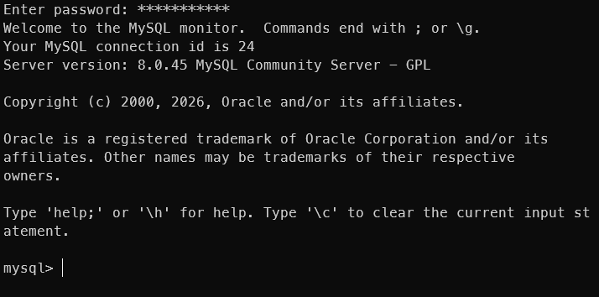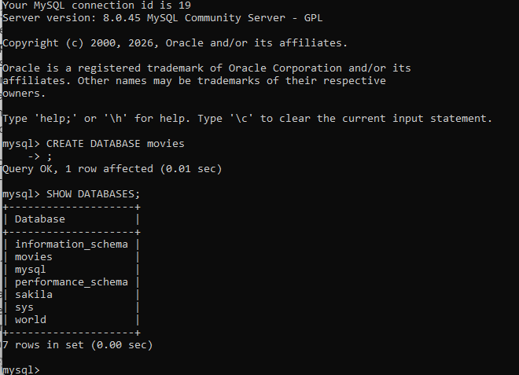
LENGTH Function
This query measures the length of the film titles. This is useful if you were designing a website UI and needed to ensure the titles fit within a specific card size or to identify unusually long titles.
Using my default database ‘sakila’ and alias ‘title_length’.
SQL Statement: SELECT title, LENGTH(title) AS title_length FROM sakila.film;
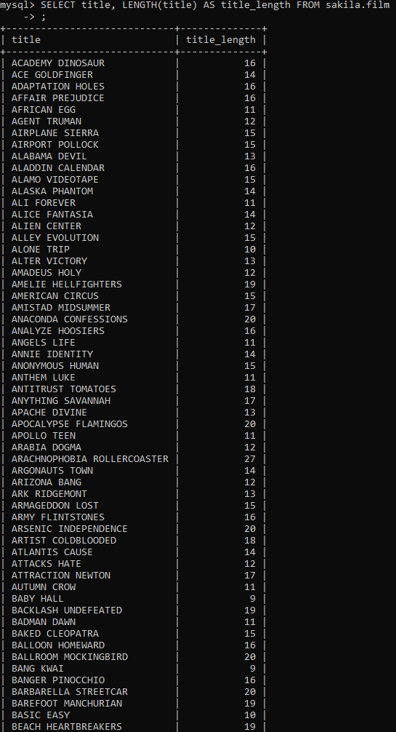
COUNT Function
This query counts the total number of customers in the database. In a professional setting, this aggregate function is essential for reporting on user growth or active client lists.
Using my default database ‘sakila’ and alias ‘total_customer_count’.
SQL Statement: SELECT COUNT(customer_id) AS total_customer_count FROM sakila.customer;
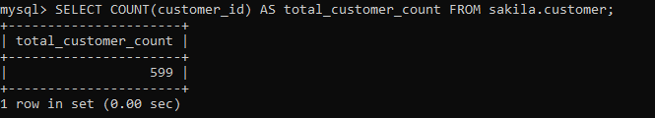
TIMESTAMP (NOW) Function
This query retrieves the rental details and uses a timestamp function to show exactly when you generated this specific report. This provides a clear audit trail for data exports.
Using my default database ‘sakila’, alias ‘report_processed_at’ and LIMIT 25.
SQL Statement: SELECT rental_id, inventory_id, NOW() AS report_processed_at FROM sakila.rental LIMIT 25;
