Marco Rodriguez Gomez
03/27/2026
Module 2.2 Assignment

Flowchart
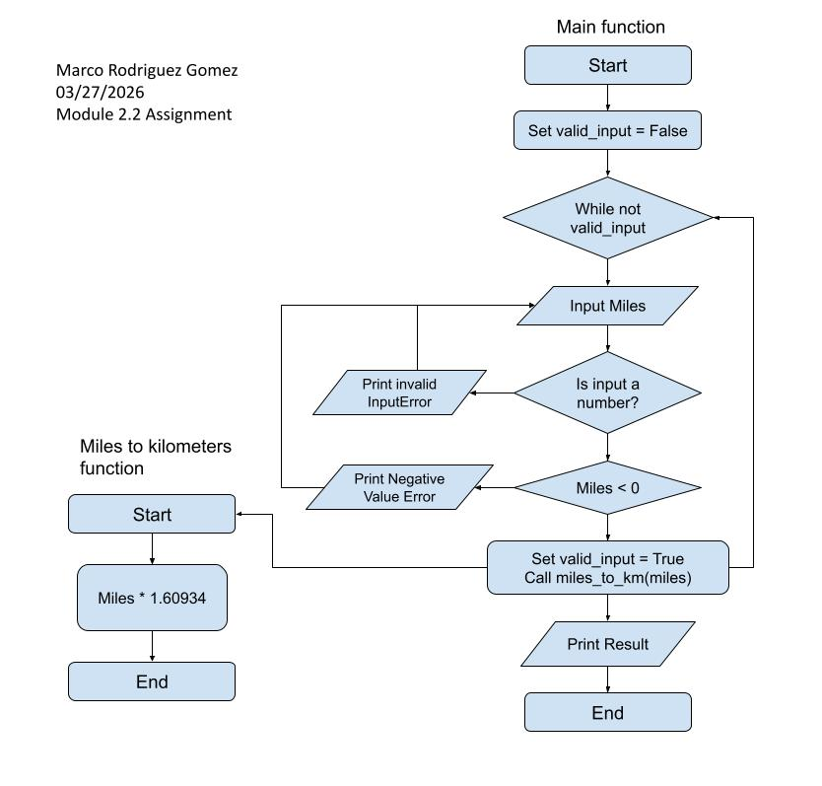
Add a breakpoint
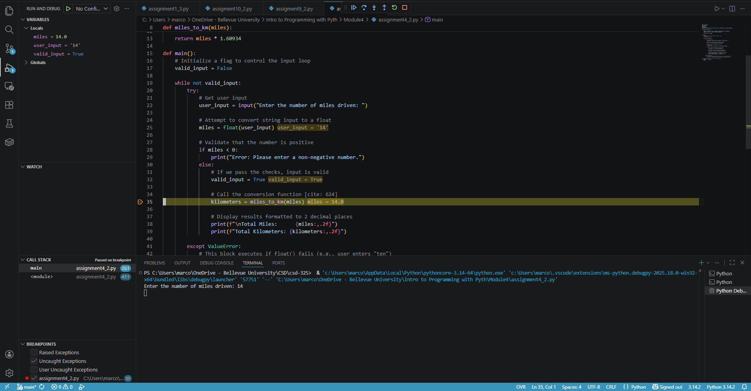
Stepping into the fuction
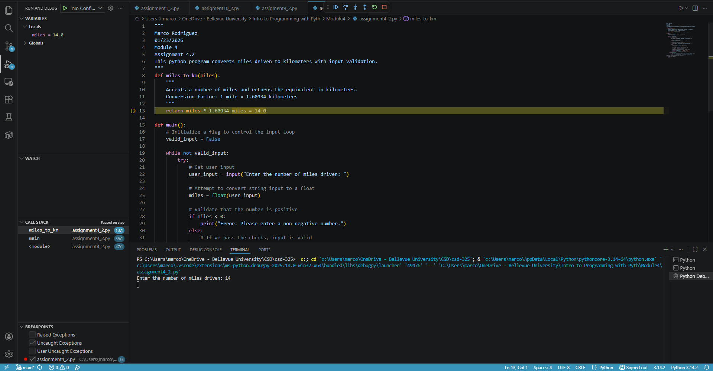

Parenthesis was not closed
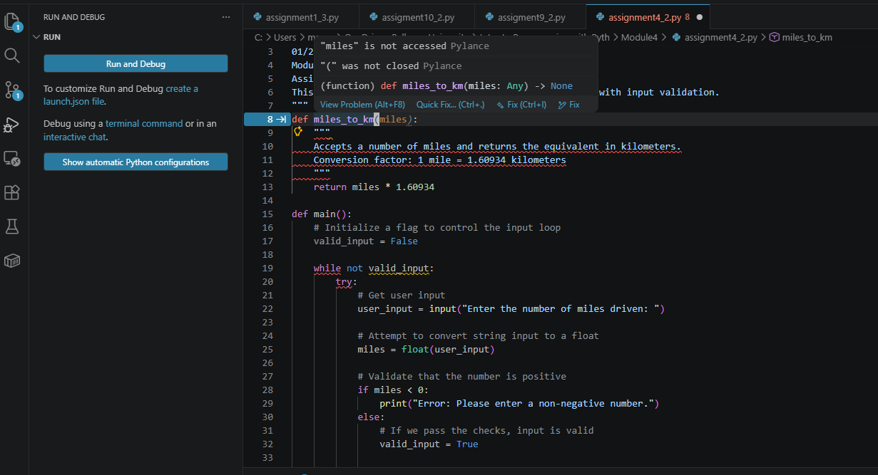
Is dividing not multiplying miles * 1.6.934
