Marco Rodriguez Gomez
4/10/2026
Assignment: High/Low Temperatures

Original
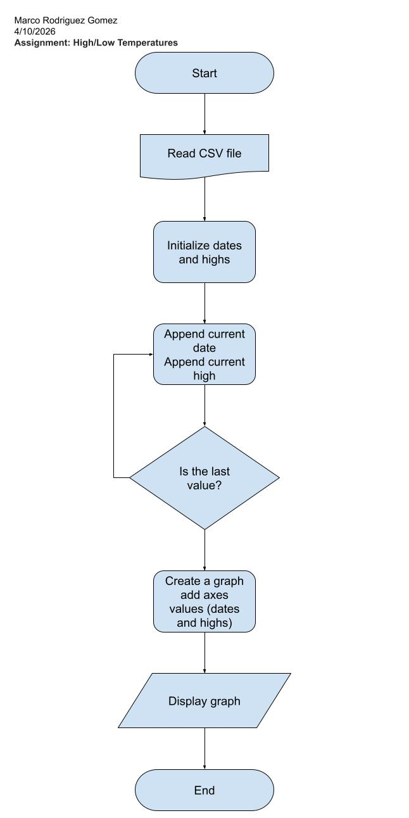

With changes
