Marco Rodriguez Gomez
04/03/2026
Module 3.2 Assignment

Original
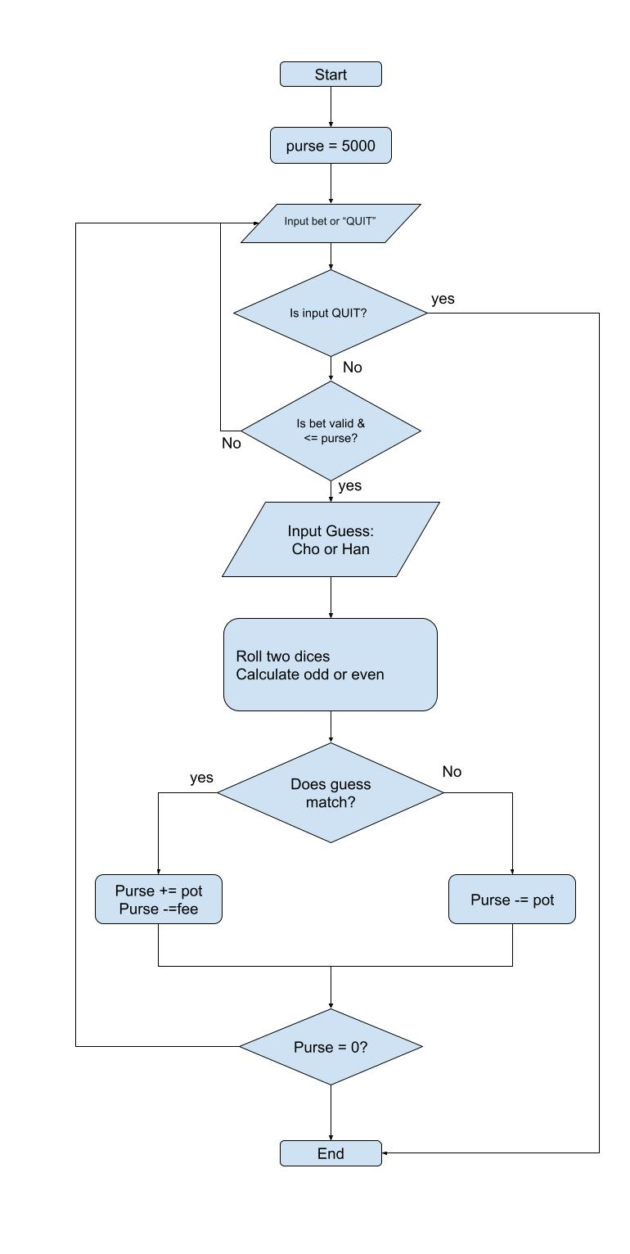

Assignment modifications
