Marco Rodriguez Gomez
Assignment: bioSite: Ideas, Sketches, and Inspiration
6/26/2026
Subject: Madison Berry
Project Role: Founder & Licensed Clinical Social Worker
Course Assignment: Module 4 Project Deliverable

1. Front-End Style Guide (Pattern Library)
This style guide uses principles of Atomic Design, establishing consistent, foundational elements that map to a calming, professional private practice environment.
Color Palette
- Base Page Background: #fcf9f6 (White)
- Main Card and Header Container Fill: # E7D5C6 (Beige)
- Typography and Text Element Fill: # 403F3B (Dark Gray)
- Primary Accent and Action Button Callout: # C26B42 (Burnt Orange)
Typography & Hierarchy
- Primary Landing Title (h1): Elms Sans set to a larger scale size with regular or medium weight to mimic the clean layout from the example image.
- Section Headings (h2, h3): Elms Sans set to a medium weight with wide letter spacing.
- Body and Biography Paragraph Text: Elms Sans set to a light weight with a clean line height of 1.6 to maintain a calm and spacious text flow.

2. Subject Interview
Interviewee: Madison Berry
- What inspired you to pursue a career in mental health and open a private practice?
  - Response: I have always wanted to help people. A career in mental health seemed like a great way to offer support one on one. I chose to open a private practice so I could manage my own schedule and spend more time with my family.
- How would you describe your therapeutic approach to someone new to therapy?
  - Response: It is relational, collaborative, and grounded in empathy. I focus on helping clients identify internal strengths while building practical tools.
- What is one of the most rewarding aspects of your daily work?
  - Response: Witnessing the moment a client reconnects with their own resilience and begins applying boundaries successfully in their life.
- What are your primary professional goals for your practice over the next few years?
  - Response: To grow and scale the practice to help more people, especially caregivers and those living with dementia.
- Outside of your practice, what hobbies help you maintain your own personal balance?
  - Response: Spending time outdoors, painting, baking, and connecting with my family.
- Looking beyond just therapy, how do your personal values influence the decisions you make regarding your digital presence and aesthetic?
  - Response: I choose warm tones, grounded imagery, and transparent messaging so that the initial digital touchpoint feels as welcoming as an office visit.
- What is a major personal or professional achievement that has brought you a lot of peace and satisfaction recently?
  - Response: I have successfully filled my caseload! It’s been a long time coming.
- What role do curiosity and lifelong learning play in your life, even when you aren't focused purely on clinical techniques?
  - Response: It is essential. Being a lifelong learner doesn’t just help me stay up to date with the latest research-informed best practices, it also allows me to exercise my brain and expand my worldview.
- Outside of work, when you are simply a person browsing the web, what do you like to see in terms of design?
  - Response: I like the design to tell a story, but simply and understated.
- What central message do you want visitors to take away from your website?
  - Response: For a website that’s focused on my bio and hobbies, I hope people can see that I am a compassionate and creative person.
3. Formalized Biography Document
Madison Berry is a dedicated Licensed Clinical Social Worker (LCSW) who owns and operates an independent private therapy practice in Texas. Driven by a lifelong desire to help others, Madison focuses on providing deep, one-on-one support grounded in an empathetic, relational, and collaborative framework. Her therapeutic approach centers on helping individuals uncover their internal strengths and build practical, real-world tools. By transitioning into private practice, she intentionally created a professional structure that allows her to manage her own schedule, ensuring she can dedicate meaningful time to connecting with her family.
In her clinical work, Madison finds immense reward in witnessing the exact moments her clients reconnect with their own resilience and begin successfully applying boundaries in their lives. Looking to the future, her primary goals center on growing and scaling her practice to reach more individuals in need. She is particularly passionate about expanding her services to offer specialized, compassionate support to caregivers and those living with dementia.
To maintain her own personal balance away from her caseload, Madison intentionally steps back from her clinical role to embrace a variety of creative and grounding hobbies. She stays energized by spending time outdoors, painting, baking, and focusing on family life. This creative side naturally influences her philosophy on web presentation, where she values designs that tell a story in a simple, understated way. Ultimately, Madison views curiosity and lifelong learning as essential values. Keeping up with research-informed best practices allows her to exercise her brain and continuously expand her worldview, ensuring she shows up for others as a genuinely compassionate and creative professional.
4. Images
Landing Page Images: Goals & Personal Accomplishments
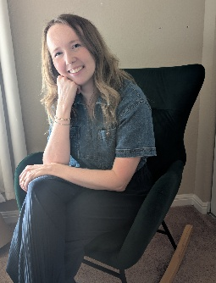
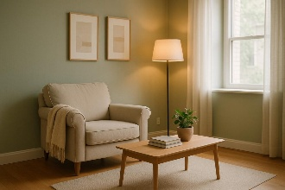


About Page Image: Main Portrait
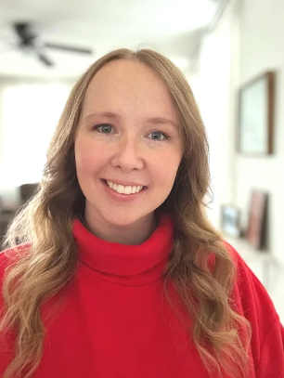
Hobbies Page Images: Personal Grounding & Balance

- Wireframes and Layout Prototypes
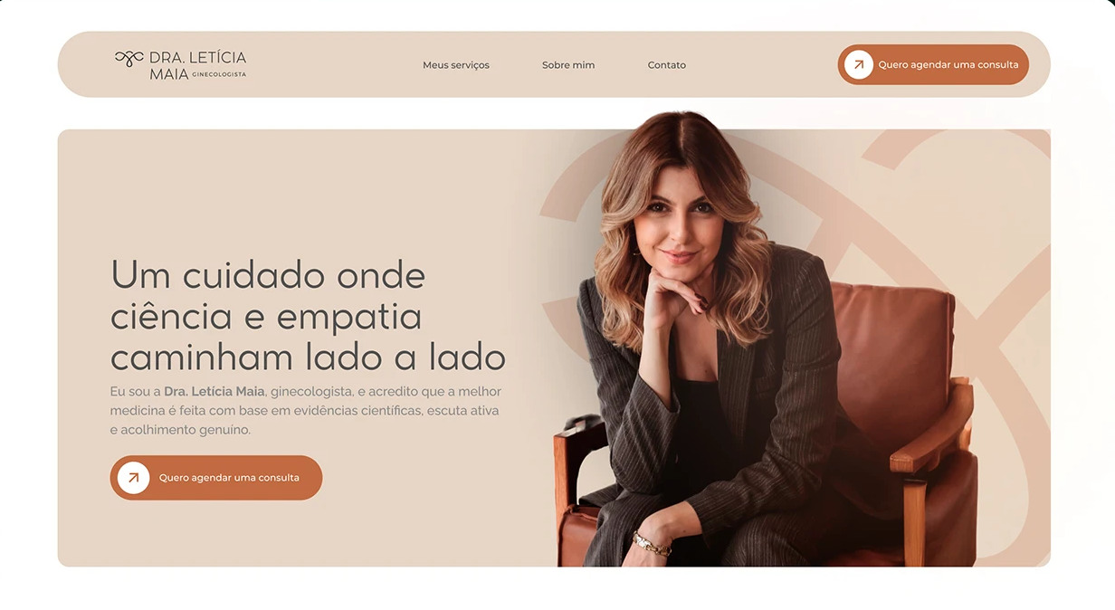
https://www.behance.net/gallery/244447107/Dra-Leticia-Maia-Landing-Page-Web-Site-Design
I found this inspiration on behance.net, and I instantly knew it was the perfect look for Madison's site. Since she is a therapist, I wanted a design that feels incredibly calm, open, and welcoming the second you look at it. This specific layout uses a lot of breathing room and avoids harsh, square boxes, which helps lower visual stress for anyone looking for support.
I'm adapting a few specific design choices directly from this Behance layout:
- The Floating Navigation Pill: A fully rounded header bar that hovers cleanly at the top of the screen to keep things looking modern and uncluttered.
- Rounded Container Cards: Huge, softly rounded background blocks to group the content into clean, friendly sections.
- Cut-Out Portrait Integration: Placing Madison's main portrait on the right side of the card so it seamlessly blends into the layout background, creating a warm and approachable first impression.

My Layout Sketches & Layout Structure
Section 1: Landing Page
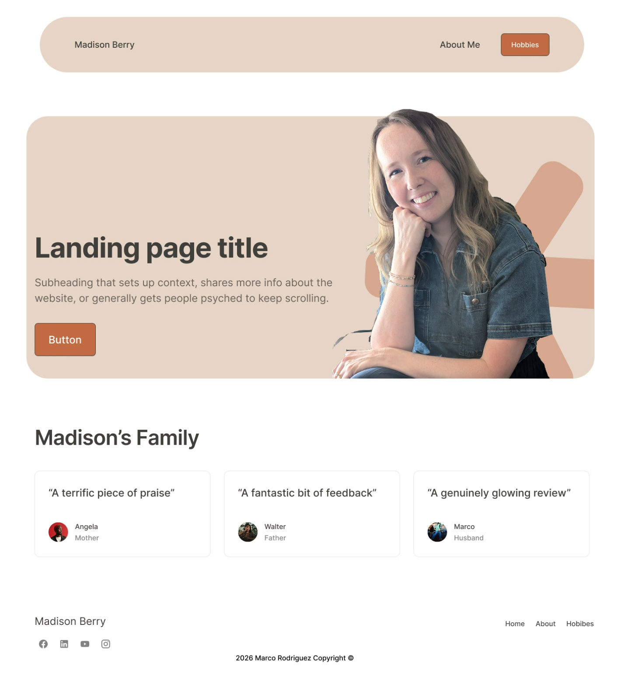

Section 2: About Page
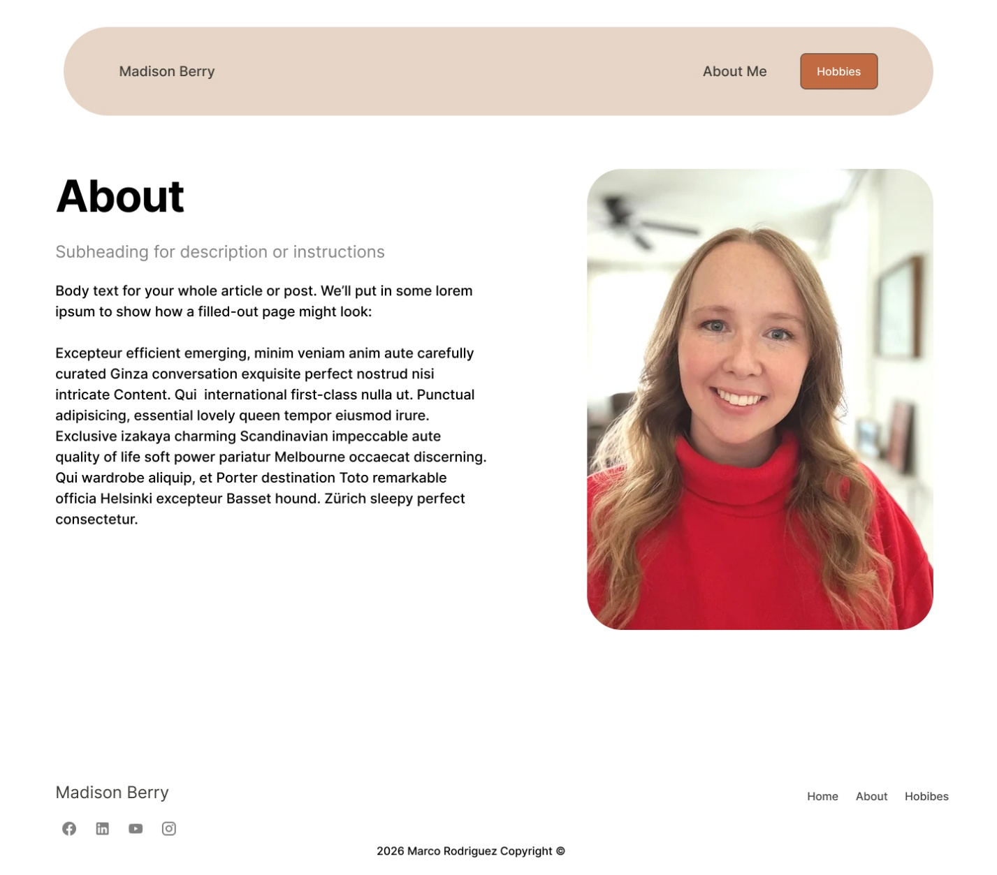

Section 3: Hobbies Page
