CyberPatriot: Unplugged

Julienne Cox & Melissa Roesch

**Abstract**

While computer science and many of its concepts, like cyber security, are becoming more mainstream within middle schools and high schools, there are still many children out there who are not getting access to these topics due to issues like not being able to afford a computer at home or being too intimidated by technology to jump into it. By taking concepts off the computer and putting them onto paper, more children have the ability to learn the skills needed to not only understand cyber security concepts, but also to help prepare them for competitions within the cyber security field. Our approach to this issue was to create booklets that require no technology to complete. By “unplugging” the concepts, students have a new way to learn cybersecurity concepts. We started with the basics of what cyber security is and some important terms students would need to know to grasp the basic concepts. From there students are given he ability to learn basics about Windows and Linux systems, which are the most commonly used operating systems in CyberPatriot competitions. These booklets have both terms and exercises that allow the students to be exposed to some of the things they would see on a computer screen, like a command terminal or task manager. With the help of these booklets, more kids are able to be exposed to and experience cyber security, which we hope will give them the courage to compete in CyberPatriot competitions and further delve into computer science as they grow.

Code.org, *2013: States with at least one policy*.

**Key Words – CyberPatriots, Unplugged, Linux, Windows, Cybersecurity**

**I. INTRODUCTION**

Cyber security is currently on the rise in the marketplace. According to Cybersecuirty Ventures, by 2121 there will be 3.5 million cybersecurity job openings [1]. This rise is due to an increase in cyber crime, which is predicted to cost the world 6 trillion by 2021 [1]. The rise in the demand for cybersecurity employees is due that rising cost of cybercrime. A lot of companies are taking cybersecurity more seriously and in constant need for more protection for their company and data.

The good news is that computer science is becoming a more common course taught to students in middle schools and high schools. In 2017, 33 states had passed policies, like allocating funding for a computer science program and allowing computer science classes to count as a core graduation requirement, that would help promote computer science among kids [2].

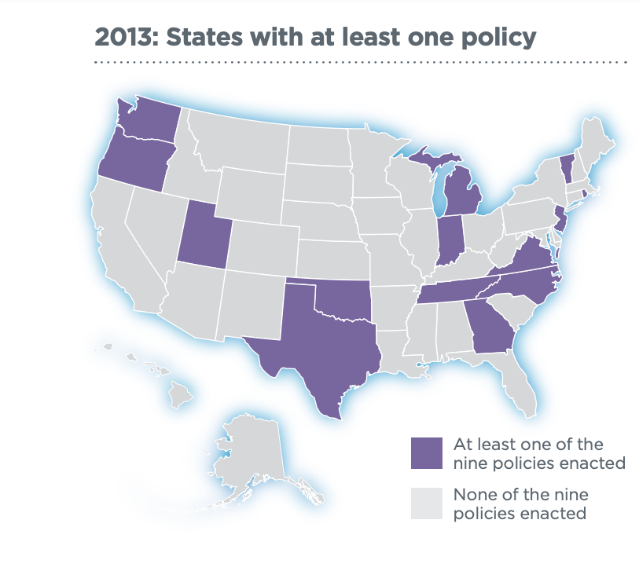



Code.org, *2018: States with at least one policy*.

Students are being given the opportunity to gain essential skills of cyber security by participating in competitions like CyberPatriot’s National Youth Cyber Defense Competition and Capture the Flag (CTF) competitions.

**II. CYBERPATRIOT**

CyberPatriot the National Youth Cyber Education Program was created by the Air Force Association to encourage students in grades K-12 to seek out careers in cyber security or other STEM disciplines [3]. What started in 2009 as an 8 team, one-round competition, they now have more than 5000 teams competing in a number of complex and difficult challenges [3]. CyberPatriot has many types of programs, including The National Youth Cyber Defense Competition, cyber camps, and even classes offered to senior citizens to help them better navigate technology. In recent years they have expanded even further with their Cyber Education Literature Series in 2017. They published a book called “Sarah the Cyber Hero”, which is targeted to pre-k readers.

**III. THE ISSUE**

There are many issues that are preventing students from tackling the subject of cybersecurity and computer science. For some, access to the computer and Internet is not available at home due to their family’s financial situation or geographical location. According to the U.S. Census Bureau, 80% of children had access to a computer at home [4]. For those 20% of children who have no access, navigating computers can be a daunting task.

However, even with computers there are many children who see computing as boring or too complicated. These stereotypes prevent students from taking steps into the field of computing. Not only does this prevent them from learning about careers that they might actually be interested in, but it also causes them to reject opportunities at a young age that could help them in future careers involving computing [5].

Another factor to consider when it comes to teaching computer science to school aged kids is the teachers responsible to conveying this information. Many teachers in middle schools and high schools have little to no experience when it comes to computer science. Many times, student engagement is not something that comes naturally, but it something that needs to be fostered and encouraged by teachers [6].

**IV. GOING UNPLUGGED**

While technology and access to computers is ultimately the best way to learn cyber security, how do we expose those stated in part III to these concepts? The answer lies in traditional pencil and paper. “Unplugging” the concepts and activities from the computer has the ability to expose many more children who would not have access to it otherwise. We chose to format the guides in the form of booklets with activities and important terms. By creating mock-ups of command terminals and other windows on the OS, kids can get an idea of what the computer screen would actually look like. While you cannot get super deep into topics and how to navigate far into the software, activity booklets give enough information to get students started.

The main booklet includes important terms for understanding cyber security, like CIA, virtual machines, and firewalls. Along with the basic information, several activities are set up along the way to encourage understanding and remembering the terms. Students are asked to match terms to definitions and sort vocabulary words into sections based on if they relate to computers only or to networks. From there, the student continues on to more focused booklets, with one on the Windows operating system and one on the Linux operating system. Within these booklets, students are exposed to concepts that are unique to the individual operating systems.

The Windows booklet focuses on topics like how to monitor the CPU’s usage from the task monitor, terminal commands that can help check for malware running on the system, and how to set permissions for users. Each section has activities that go along with it to further help the student understand the concepts.

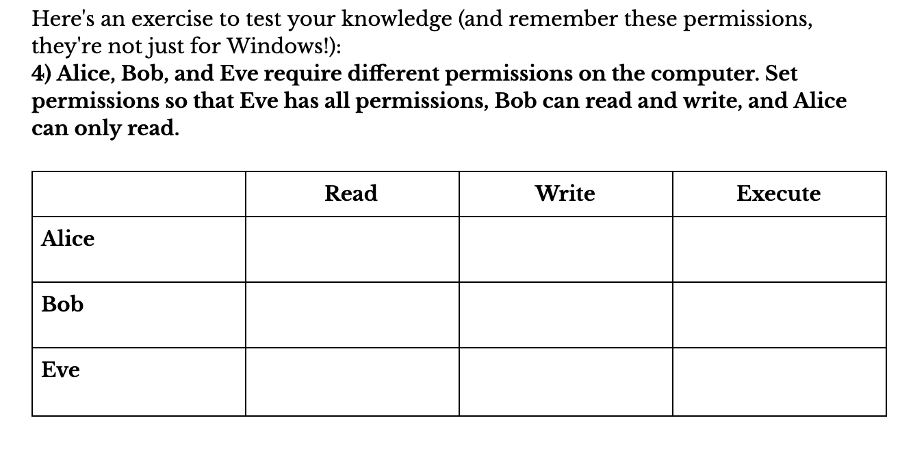

The Linux booklet focuses on the main important terms that go along with the Linux OS and focuses heavily on the command line, which is a major part of working with Linux. It also teaches students about the built-in Ubuntu firewall and how to configure it. Setting permissions is also taught in this section since it looks slightly different than it does in the Windows section.

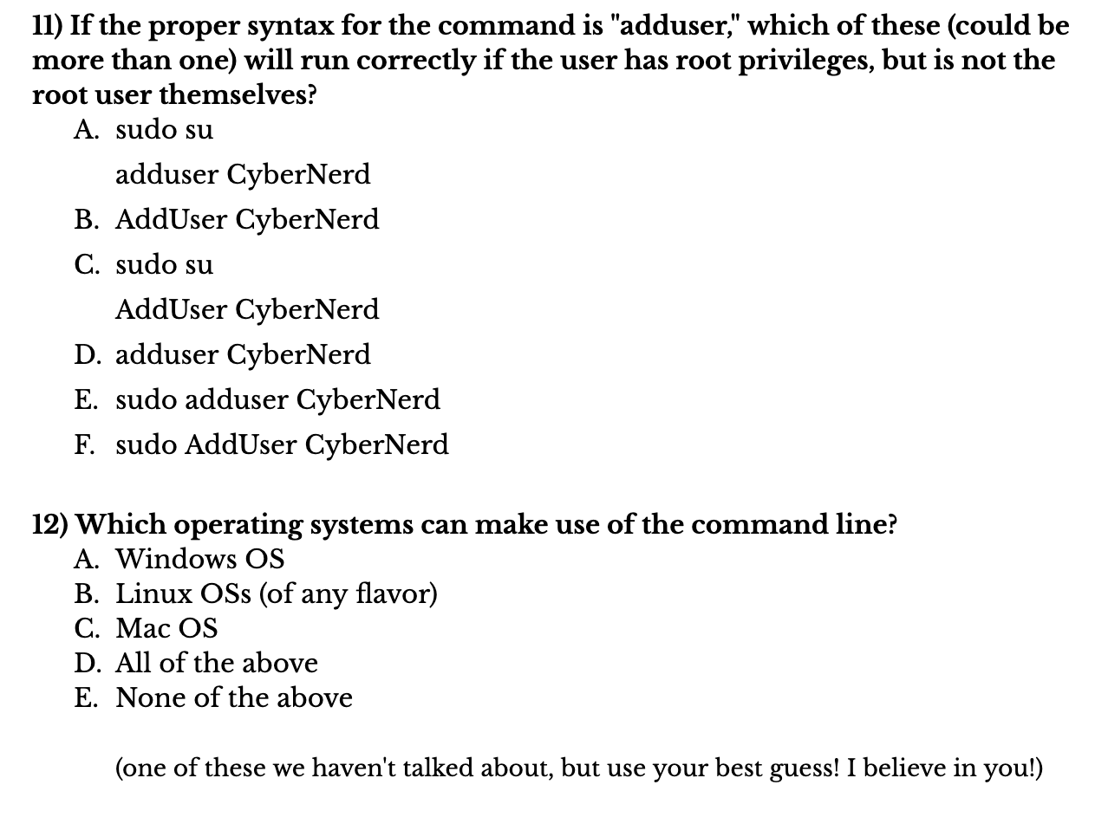

**V. SETBACKS**

The biggest challenge was how to convert information from something on the computer to something you can do on paper. So many concepts require the use of a computer to understand fully. The concepts and activates needed to be interesting yet also accurate enough that if someone were to transition from the unplugged booklets to an actual computer, they would feel confident in their skills.

Another challenge was how to present concepts in a way that were clear and easy to understand by everyone since some of the people accessing these packets may have little to no experience with computer science or computers in general. Since these booklets are geared towards middle school children, we needed to make sure we were speaking at their level and keeping them engaged by creating content that was not too dry. We accomplished this by making sure we included activities to break up the monotony of terms and by peer evaluation on each other’s work.

**VI. CONCLUSION**

As the number of cyber security attacks continues to increase in our world, so does our demand for people to take the growing amount of jobs in the field. Both individuals and companies are becoming more aware of the need for security in a world of ever growing technology and connected devices. As we look towards the future of cybersecurty, we must also look towards the future generations. It is never too early to start making children aware of Internet security. By encouraging and exposing them to computer science at an early age, we can foster their interest in the subject for years to come.

Our goal was to create a booklet to help prepare students for high-level cyber security classes. We “unplugged” by putting it onto paper, which not only helps students who do not have access to a computer on a daily basis, but also gives students a new way to look at cybersecurity by making them perform activities without the help of a computer.

**REFERENCES**

[1] “Cybersecurity Jobs Report 2018-2021,” *Cybercrime Magazine*, 07-Jan-2019. [Online]. Available: https://cybersecurityventures.com/jobs/. [Accessed: 19-Apr-2019].

[2] “2018 State of Computer Science Education Policy and Implementation.”

[3] *What is CyberPatriot?*[Online]. Available: https://www.uscyberpatriot.org/Pages/About/What-is-CyberPatriot.aspx. [Accessed: 19-Apr-2019].

[4] US Census Bureau, “Computer and Internet Use,” *Census.gov*, 18-May-2017. [Online]. Available: https://www.census.gov/topics/population/computer-internet.html. [Accessed: 19-Apr-2019].

[5] T. Bell, J. Alexander, I. Freeman, and M. Grimley, “Computer Science Unplugged: school students doing real computing without computers.” .

[6] R. J. Marzano, D. J. Pickering, and T. Heflebower, *The highly engaged classroom*. Bloomington, IN: Marzano Research Laboratory, 2011.