**Problem 1.1**

It is given that both principal points of two image planes coincide with coordinate (0,0), thus the projected point x in the two image planes are *xT* = [0 0 1] and *xT* = [0 0 1]

According to the property of fundamental matrix when the points are at the origin we have,

On simplifying the above matrices, all the terms that have the image point coordinates get cancelled at the origin and therefore, we get the following relation.

**Problem 1.2**

For pure translation along the x-axis, transformation matrices are as follows:

The essential matrix is given by,

tx and essential matrix can be written as follows,

Let xT1 = [a1 a2 1] and xT2 = [b1 b2 1], we have

Thus, the epipolar line in the first camera is t1y1 − b2t1 = 0, and the epipolar line in the second camera is −t1y2 + a2t1 = 0. Both of them do not contain x components, so they are both parallel to the x-axis

**Problem 1.3**

Let P be 3D world coordinates of the point in the image, p1 be 2D coordinates on the image plane at time frame i and p2 be 2D coordinates on the image plane at time frame i+1 World coordinate and image plane can be related by:

*P* = *t*1 + *R*1*p*1

*p*1 = *R*1*−*1(*P − t*1)

Similarly,

*p*2 = *R*2*−*1(*P − t*2)

Combining the above equations:

*p*2 = *R*2*−*1(*t*1 + *R*1*p*1 *− t*2)

*p*2 = *R*2*−*1*R*1*p*1 + *R*2*−*1(*t*1 *− t*2)

Comparing the above equation with *p*2 = *Rrelp*1 + *trel*

*Rrel* = *R*2*−*1*R*1

*trel* = *R*2*−*1(*t*1 *− t*2)

Also. from the equations for essential matrix and fundamental matrix:

*E* = [*trel*]*xRrel*

*F* = *K−T* [*trel*]*xRrelK−*1

**Problem 1.4**

Let *C* and *Cj* be the camera in the real and virtual world respectively, its intrinsic matrix be *K*. Let *P* and *x* be the 3D point in real world and the point in image plane and *Pj* and *xj* be its reflection in the in the mirror and this point in the image plane. Given the mirror is flat, the transformation between these two points is a pure translation.

*Pj* = *P* + *t*

*λ*1 *x* = *K P*

*λ*2 *xj* = *K Pj*

With the help of the above equations, relationship between the two points is as follows:

*λ*2*K−*1 *xj* = *λ*1*K−*1 *x* + *t*

We can simplify the equation and eliminate some terms by taking cross product with *t* on both sides, followed by dot product with *xj* to get the following:

*xjT K−T t×K−*1 *x* = 0

We can see that, *t×* is a skew-symmetric matrix here and we know the relation that *xjT F x* = 0. Comparing this with above form, we get the following expression for *F* :

*F* = *K−T t×K−*1

Since, *t×* is skew symmetric, it can be shown that *F* here will also retain the property of skew-symmetric for a given intrinsic matrix *K*.

*FT* = *− F*

Therefore, we can conclude that the two images of the object are related by a skew-symmetric fundamental matrix.

**Problem 2.1**

q2_1_eightpoint.py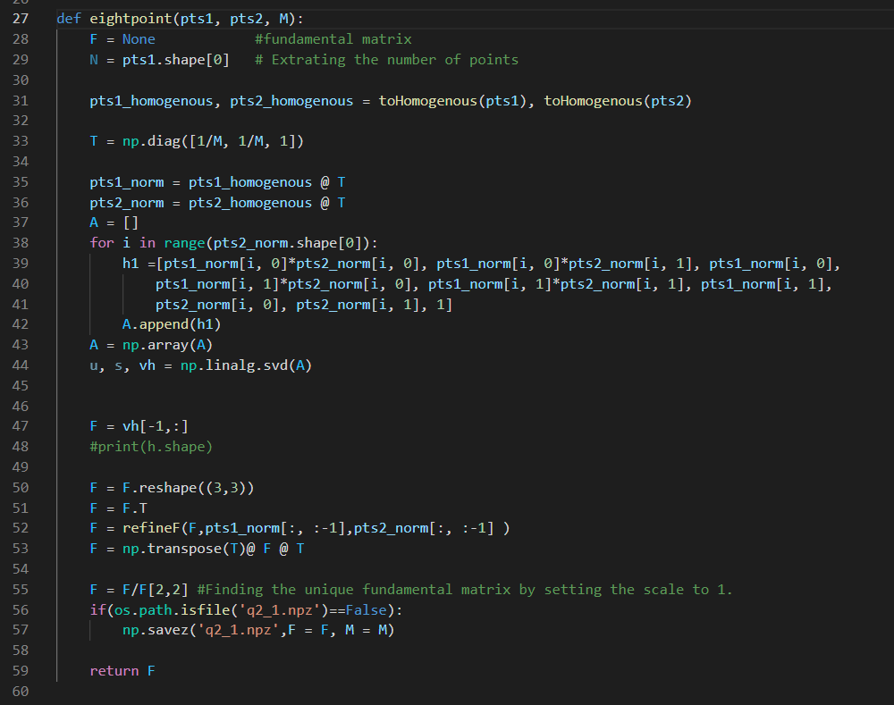

The recovered matrix F from eight-point algorithm is

[[-2.18962367e-07 2.95584511e-05 -2.51851099e-01]

[ 1.28367203e-05 -6.63934217e-07 2.63094865e-03]

[ 2.42194841e-01 -6.81933857e-03 1.00000000e+00]]

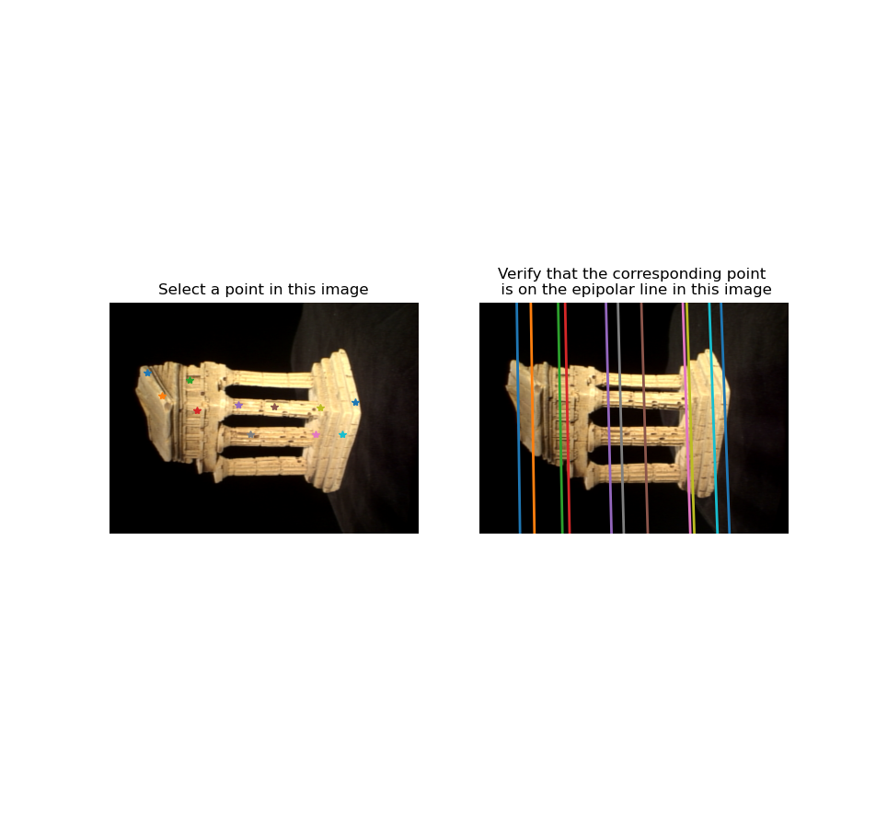

**Problem 2.2**

q2_2_sevenpoint.py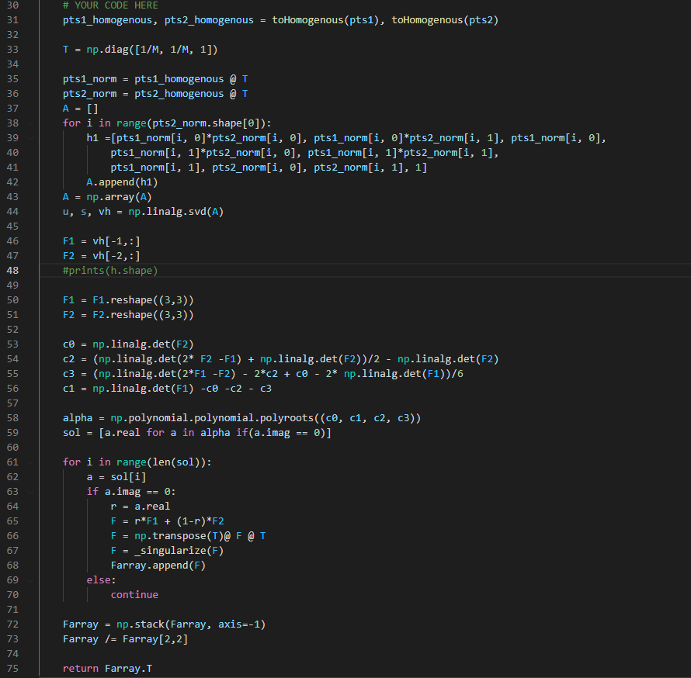

The recovered matrix F from seven-point algorithm is

[[ 2.17048089e-06 -1.37879287e-05 -1.95306038e-01]

[ 4.72931040e-05 1.56277138e-07 -6.67499589e-03]

[ 1.86889771e-01 2.55438738e-03 1.00000000e+00]]

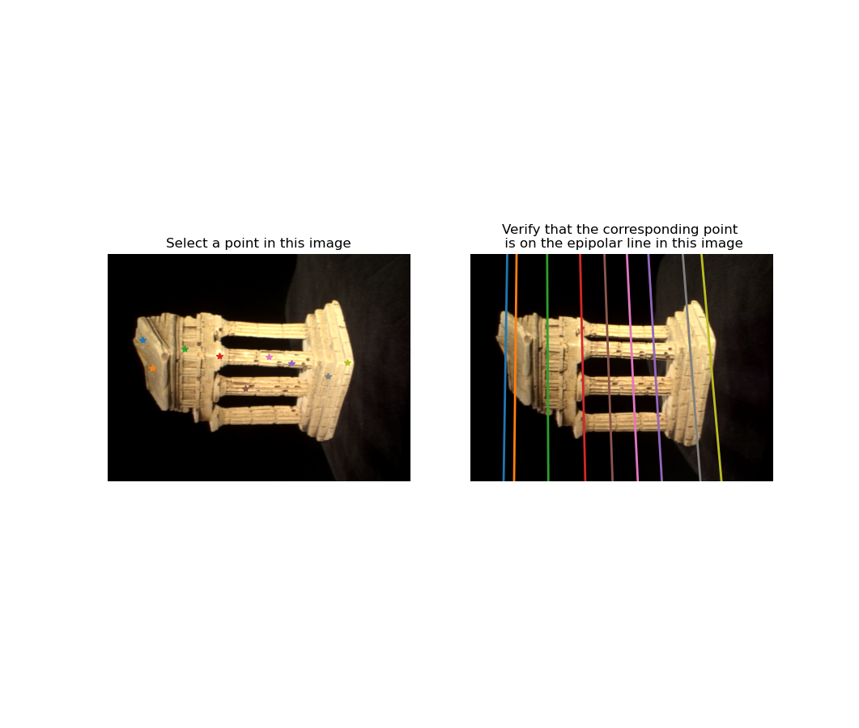

**Problem 3.1**

q3_1_essential_matrix.py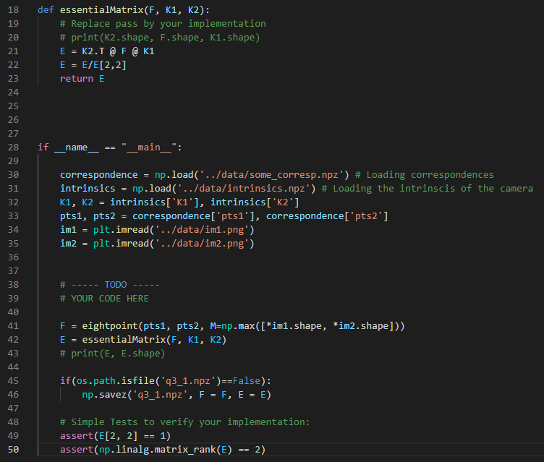

**Problem 3.2**

Let *C*1*i* be the *ith* row of *C*1 and *C*2*i* be the *ith* row of *C*2. If *Wi* is a 4X1 vector of the 3D coordinates in the homogeneous form, we have

and,

*C*11*Wi* = *xi*1 *C*12*Wi* = *yi*1 *C*13*Wi* = *1*

*C*21*Wi* = *xi*2 *C*22*Wi* = *yi*2 *C*23*Wi* = *1*

On rearranging the terms, we get,

(*xi*1*C*13 *− C*11) *Wi* = 0

(*yi*1*C*13 *− C*12) *Wi* = 0

(*xi*2*C*23 *− C*21) *Wi* = 0

(*yi*2*C*23 *− C*22) *Wi* = 0

Thus, A can be written as,

Ai =

**Problem 3.3**

q3_2_triangulate.py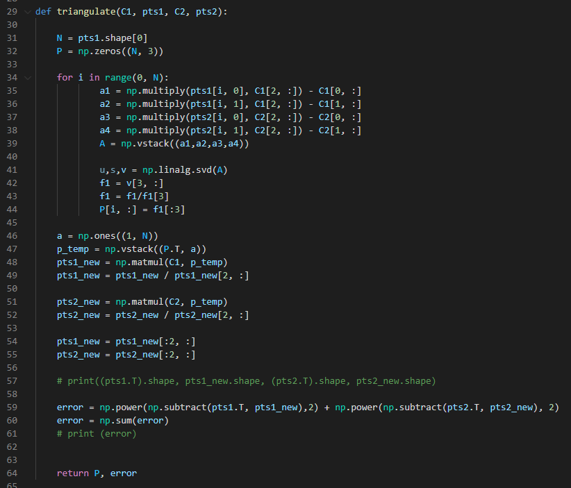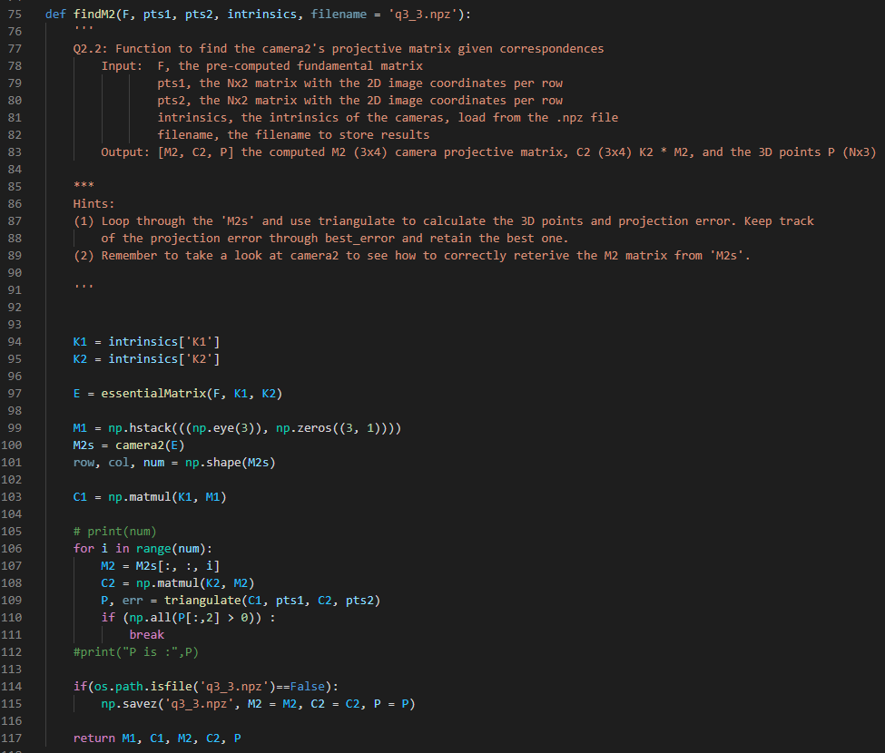

**Problem 4.1**

q4_1_epipolar_correspondence.py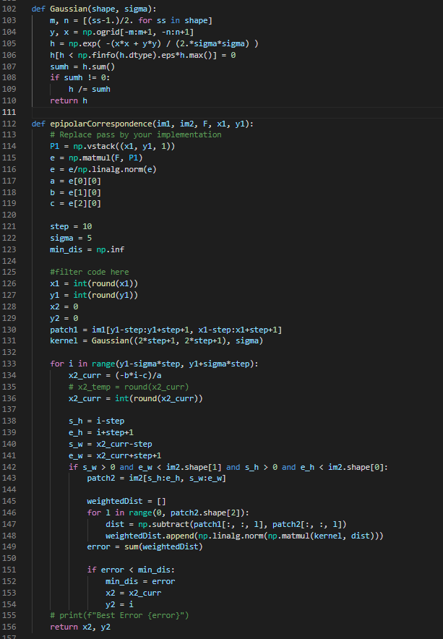

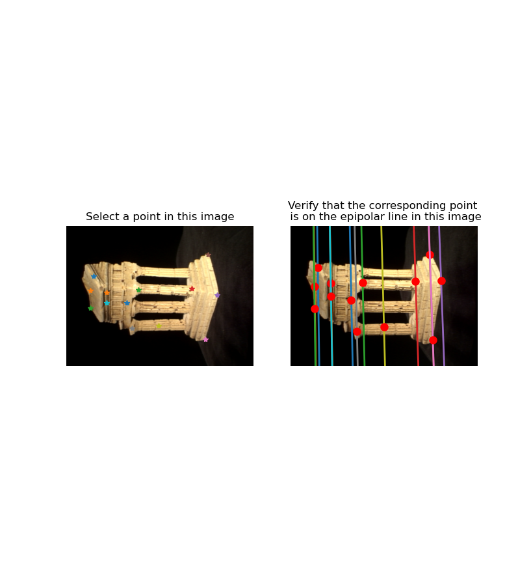  
*Epipolar Correspondences*

**Problem 4.2**

q4_2_visualize.py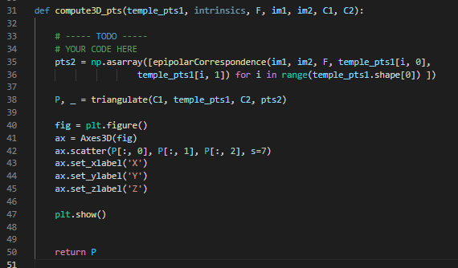

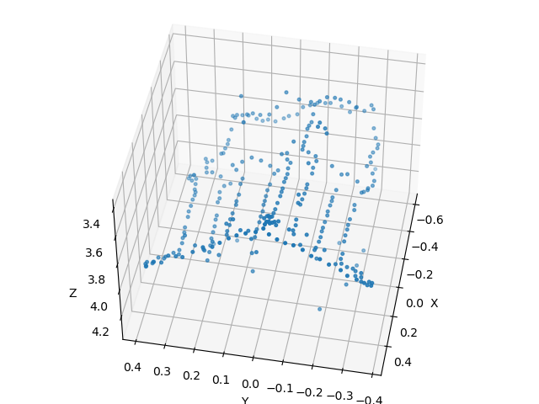 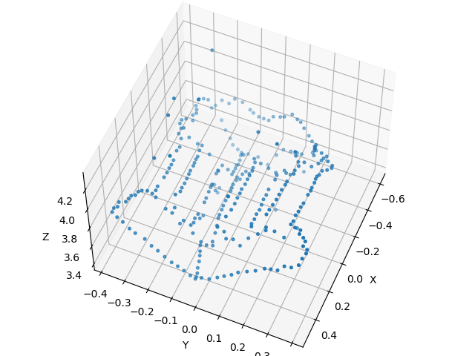

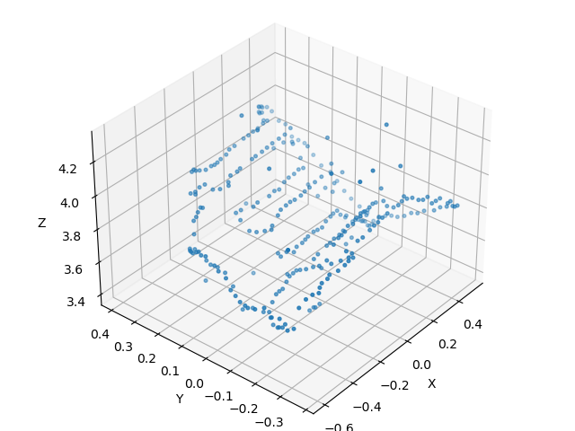 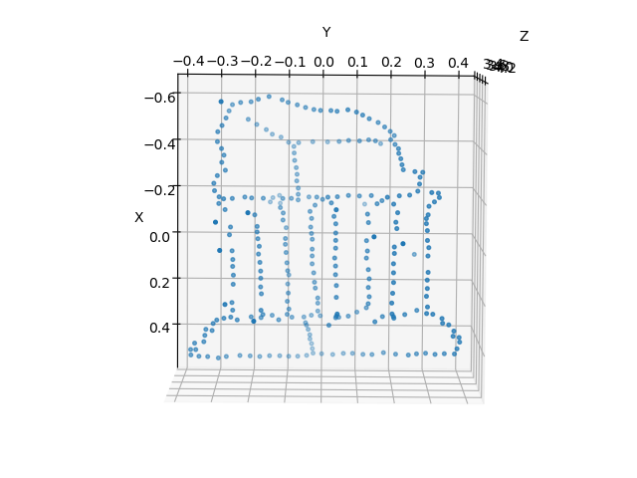

**Problem 5.1**

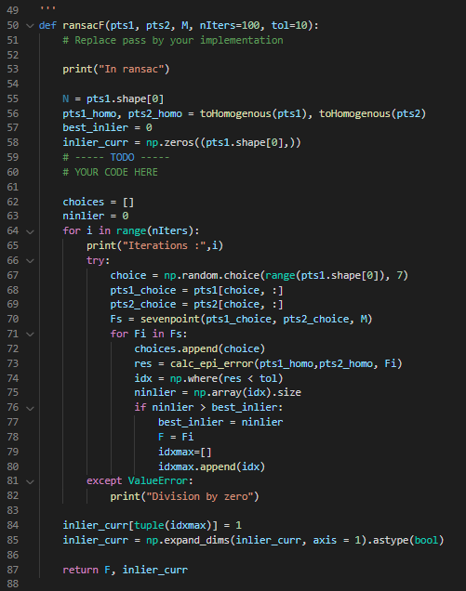

If *errori* is smaller than a tolerance (i.e., 0.82), we consider this pair of points as an inlier. Effect of number of iterations and tolerance on fundamental matrix.

1. As the number of iterations is increased the fundamental matrix becomes more accurate in determining the points as it is a non-deterministic algorithm that produces result only with a certain probability, the probability increases with iterations. But after a point of threshold iteration the results provided by fundamental matrix stops changing value.
2. With the increase in the tolerance value more inliers and thus data points get included due to which estimation of fundamental matrix becomes more accurate. But higher tolerance will allow all the points to be included as inliers and defeat the purpose of RANSAC.

**Problem 5.2**

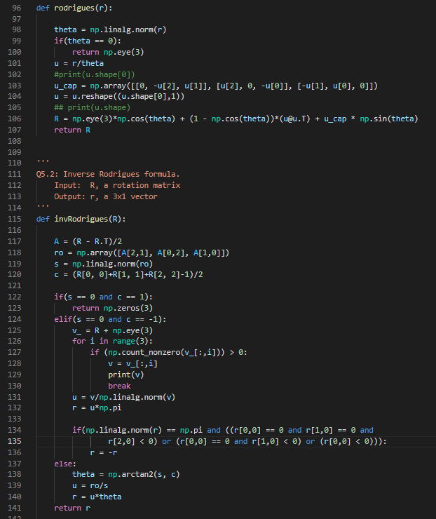

**Problem 5.3**

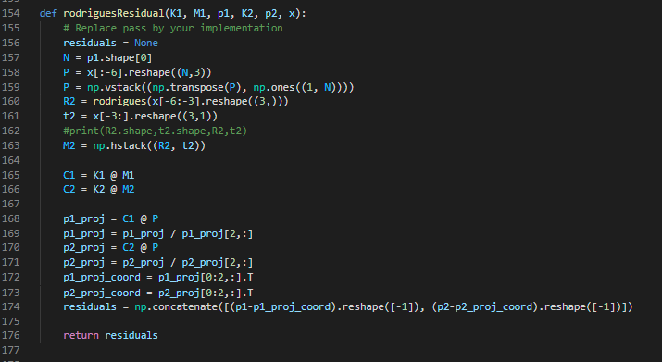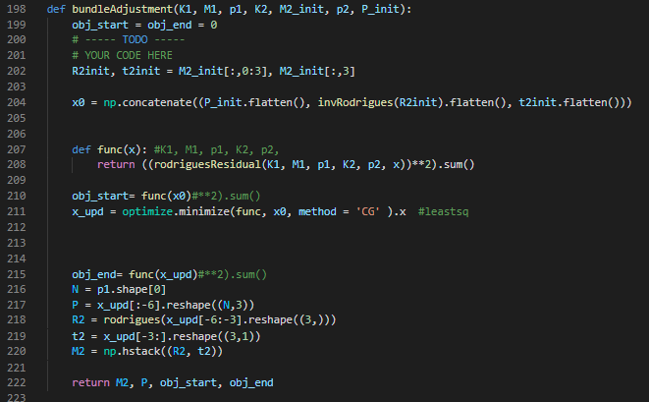

In this case, I optimized the F matrix again and ran the subsequent functions,

Re-projection Error for Inlier Points (Before Optimization) : 4941.746751245216

Re-projection Error for Inlier Points (After Optimization) : 13.103318510909448

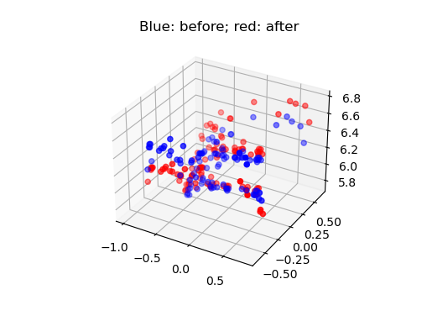

**Problem 6**

q6_ec_multiview_reconstruction.py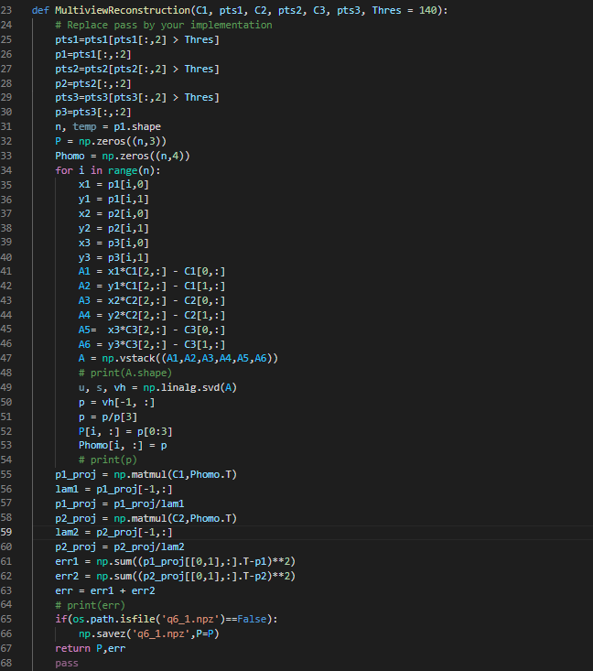

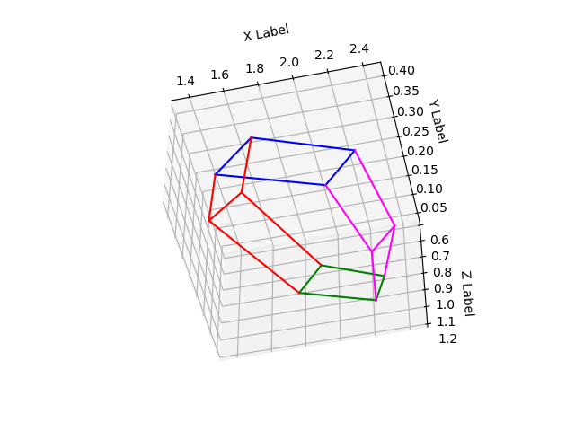 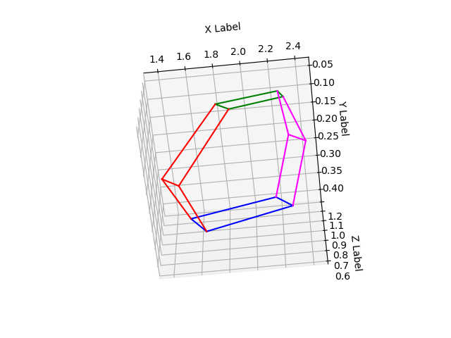

In order to compute the 3D location, triangulate function was extended to three views by changing the A matrix as follows:

Ai =

This modified A matrix is used to solve SVD and get the 3D location of points. From the given 2D points only the ones with confidence value greater than threshold is used for finding the 3D locations. After multiple iterations with the threshold, value of 140 gave the best results.