Sacado de JJ en Ericsson:

3.- Bases de Datos. (Allí usan MySQL con paquete XSQL).  
   - como harías un trigger o un procedimiento PL/SQL.

- Conceptos: Primary Key, Foreign Key, Índices, Problemas asociados al definir muchos índices, ….  
   - como detectas que una consulta va lenta y q hacer para optimizarla.

Most Popular Database Interview Questions And Answers

Given below is a list of most popular Database interview questions and answers for your reference.

**Q #1) What do you understand by ‘Database’?**

**Ans:** Database is an organized collection of related data where the data is stored and organized to serve some specific purpose.

For ***Example***, A librarian maintains a database of all the information related to the books that are available in the library.

**Q #2) Define DBMS.**

**Ans:**DBMS stands for Database Management system. It is a collection of application programs which allow the user to organize, restore and retrieve information about data efficiently and as effectively as possible.

Some of the popular DBMS's are MySql, Oracle, Sybase, etc.

**Q #3) Define RDBMS.**

**Ans:**Relational Database Management System(RDBMS) is based on a relational model of data that is stored in databases in separate tables and they are related to the use of a common column. Data can be accessed easily from the relational database using Structured Query Language (SQL).

**Q #4) Enlist the advantages of DBMS.**

**Ans: The Advantages of DBMS includes:**

* Data is stored in a structured way and hence redundancy is controlled.
* Validates the data entered and provide restrictions on unauthorized access to the database.
* Provides backup and recovery of the data when required.
* Provides multiple user interfaces.

**Q #5) What do you understand by Data Redundancy?**

**Ans:**Duplication of data in the database is known as Data redundancy. As a result of Data Redundancy, duplicated data is present at various locations, hence it leads to wastage of the storage space and the integrity of the database is destroyed.

**Q #6) What are the various types of relationships in Database? Define them.**

**Ans: There are 3 types of relationships in Database:**

* **One-to-one:** One table has the relationship with another table having the similar kind of column. Each primary key relates to only one or no record in the related table.
* **One-to-many:** One table has a relationship with another table that has primary and foreign key relation. The primary key table contains only one record that relates to none, one or many records in the related table.
* **Many-to-many:** Each record in both the tables can relate to many numbers of record in another table.

**Q #7) Explain Normalization and De-Normalization.**

**Ans*:*Normalization** is the process of removing the redundant data from the database by splitting the table in a well-defined manner in order to maintain data integrity. This process saves much of the storage space.

**De-normalization** is the process of adding up redundant data on the table in order to speed up the complex queries and thus achieve better performance.

**Q #8) What are the different types of Normalization?**

**Ans: Different Types of Normalization are:**

* **First Normal Form (1NF):** A relation is said to be in 1NF only when all the entities of the table contain unique or atomic values.
* **Second Normal Form (2NF):**A relation is said to be in 2NF only if it is in 1NF and all the non-key attribute of the table is fully dependent on the primary key.
* ***Third Normal Form (3NF):***A relation is said to be in 3NF only if it is in 2NF and every non-key attribute of the table is not transitively dependent on the primary key.

**Q #9) What is BCNF?**

**Ans:**BCNF is Boyce Code Normal form. It is the higher version of 3Nf which does not have any multiple overlapping candidate keys.

**Q #10) What is SQL?**

**Ans:**Structured Query language, SQL is an ANSI(American National Standard Institute) standard programming language which is designed specifically for storing and managing the data in the relational database management system (RDBMS) using all kinds of data operations.

**Q #11) How many SQL statements are used? Define them.**

**Ans:**SQL statements are basically divided into three categories, DDL, DML, and DCL.

**They can be defined as:**

**Data Definition Language (DDL)**commands are used to define the structure that holds the data. These commands are auto-committed i.e. changes done by the DDL commands on the database are saved permanently.

**Data Manipulation Language (DML)** commands are used to manipulate the data of the database. These commands are not auto-committed and can be rolled back.

**Data Control Language (DCL)**commands are used to control the visibility of the data in the database like revoke access permission for using data in the database.

**Q #12) Enlist some commands of DDL, DML, and DCL.**

**Ans: Data Definition Language (DDL) commands:**

* CREATE to create a new table or database.
* ALTER for alteration.
* Truncate to delete data from the table.
* DROP to drop a table.
* RENAME to rename a table.

**Data Manipulation Language (DML) commands:**

* INSERT to insert a new row.
* UPDATE to update an existing row.
* DELETE to delete a row.
* MERGE for merging two rows or two tables.

**Data Control Language (DCL) commands:**

* COMMIT to permanently save.
* ROLLBACK to undo the change.
* SAVEPOINT to save temporarily.

**Q #13) Define DML Compiler.**

**Ans:**DML compiler translates DML statements in a query language into a low-level instruction and the generated instruction can be understood by Query Evaluation Engine.

**Q #14) What is DDL interpreter?**

**Ans:**DDL Interpreter interprets the DDL statements and records the generated statements in the table containing metadata.

**Q #15) Enlist the advantages of SQL.**

**Ans: Advantages of SQL are:**

* Simple SQL queries can be used to retrieve a large amount of data from the database very quickly and efficiently.
* SQL is easy to learn and almost every DBMS supports SQL.
* It is easier to manage the database using SQL as no large amount of coding is required.

**Q #16) Explain the terms ‘Record’, ‘Field’ and ‘Table’ in terms of database.**

**Ans: Record:** Record is a collection of values or fields of a specific entity. Eg. An employee, Salary account, etc.

**Field:** A field refers to an area within a record which is reserved for a specific piece of data. Eg. Employee ID.

**Table:** Table is the collection of records of specific types. E.g. Employee table is a collection of record related to all the employees.

**Q #17) What do you understand by Data Independence? What are its two types?**

**Ans:**Data Independence refers to the ability to modify the schema definition in one level in such a way that it does not affect the schema definition in the next higher level.

**The 2 types of Data Independence are:**

* **Physical Data Independence**: It modifies the schema at the physical level without affecting the schema at the conceptual level.
* **Logical Data Independence:**It modifies the schema at the conceptual level without affecting or causing changes in the schema at the view level.

**Q #18) Define the relationship between ‘View’ and ‘Data Independence’.**

**Ans:**View is a virtual table which does not have its data on its own rather the data is defined from one or more underlying base tables.

Views account for logical data independence as the growth and restructuring of base tables is not reflected in views.

**Q #19) What are the advantages and disadvantages of views in the database?**

**Ans: Advantages of Views:**

* As there is no physical location where the data in views is stored, it generates output without wasting resources.
* Data access is restricted as it does not allow commands like insertion, updation, and deletion.

**Disadvantages of Views:**

* View becomes irrelevant if we drop a table related to that view.
* More memory is occupied when the view is created for large tables.

**Q #20) What do you understand by Functional dependency?**

**Ans:**A relation is said to be in Functional dependency when one attribute uniquely defines another attribute.

**For Example,** R is a Relation, X and Y are two attributes. T1 and T2 are two tuples. Then,

T1[X]=T2[X] and T1[Y]=T2[Y] means the value of component X uniquely define the value of component Y.

Also, X->Y means Y is functionally dependent on X.

**Q #21) When is functional dependency said to be the fully functional dependency?**

**Ans:**To fulfill the criteria of fully functional dependency, the relation must meet the requirement of functional dependency.

A functional dependency ‘A’ and ‘B’ is said to be fully functional dependent when removal of any attribute say ‘X’ from ‘A’ means the dependency does not hold anymore.

**Q #22) What do you understand by E-R model?**

**Ans:**E-R model is an Entity-Relationship model which defines the conceptual view of the database.

E-R model basically shows the real world entities and their association/relations. Entities here represent the set of attributes in the database.

**Q #23) Define Entity, Entity type, and Entity set.**

**Ans: Entity** can be anything, be it a place, class or object which has an independent existence in the real world.

**Entity type** represents a set of entities which have similar attributes.

**Entity set** in the database represents a collection of entities having a particular entity type.

**Q #24) Define Weak Entity set.**

**Ans:**Weak entity set is the one whose primary key comprises of its partial key as well as the primary key of its parent entity.

This is the case because the entity set may not have sufficient attributes to form a primary key.

**Q #25) Explain the terms ‘Attribute’ and ‘Relations’**

**Ans: Attribute** describes the properties or characteristics of an entity. For ***Example***, Employee ID, Employee Name, Age, etc., can be attributes of the entity Employee.

**Relation** is a two-dimensional table containing a number of rows and columns where every row represents a record of the relation. Here, rows are also known as ‘Tuples’ and columns are known as ‘Attributes’.

**Q #26) What are VDL and SDL?**

**Ans: VDL**is View Definition language which represents user views and their mapping to the conceptual schema.

**SDL**is Storage Definition Language which specifies the mapping between two schemas.

**Q #27) Define Cursor and its types.**

**Ans:**Cursor is a temporary work area which stores the data as well as the result set occurred after manipulation of data retrieved. A cursor can hold only one row at a time.

**The 2 types of Cursor are:**

**Implicit cursors** are declared automatically when DML statements like INSERT, UPDATE, DELETE is executed.

**Explicit cursors** have to be declared when SELECT statements which are returning more than one row are executed.

**Q #28) What is Database transaction?**

**Ans:**Sequence of operation performed which changes the consistent state of the database to another is known as the database transaction. After the completion of the transaction, either the successful completion is reflected in the system or the transaction fails and no change is reflected.

**Q #29) Define Database Lock and its types.**

**Ans:**Database lock basically signifies the transaction about the current status of the data item i.e. whether that data is being used by other transactions or not at the present point of time.

There are two types of Database lock which are **Shared Lock and Exclusive Lock.**

**Q #30) What is Data Warehousing?**

**Ans:**The storage as well as access to data, that is being derived from the transactions and other sources, from a central location in order to perform the analysis is called Data Warehousing.

**Q #31) What do you understand by Join?**

**Ans:**Join is the process of explaining the relationship between different tables by combining columns from one or more table having common values in each. When a table joins with itself, it is known as Self Join.

**Q #32) What do you understand by Index hunting?**

**Ans:**Index hunting is the process of boosting the collection of indexes which help in improving the query performance as well as the speed of the database.

**Q #33) How to improve query performance using Index hunting?**

**Ans: Index hunting help in improving query performance by:**

* Using query optimizer to coordinate queries with the workload.
* Observing the performance and effect of index and query distribution.

**Q #34) Differentiate between ‘Cluster’ and ‘Non-cluster’ index.**

**Ans:**Clustered Index alters the table and reorders the way in which the records are stored in the table. Data retrieval is made faster by using the clustered index.

A Non-clustered index does alter the records that are stored in the table but creates a completely different object within the table.

**Q #35) What are the disadvantages of a Query?**

**Ans: Disadvantages of a Query are:**

* Indexes are not present.
* Stored procedures are excessively compiled.
* Difficulty in interfacing.

**Q #36) What do you understand by Fragmentation?**

**Ans:**Fragmentation is a feature which controls the logical data units, also known as fragments that are stored at different sites of a distributed database system.

**Q #37) Define Join types.**

**Ans:**Given below are the types of Join, which are explained with respect to the tables as an ***Example***:

**employee table:**

[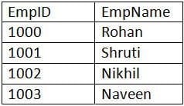](https://cdn.softwaretestinghelp.com/wp-content/qa/uploads/2017/04/employee-table.jpg)

**employee_info table:**

[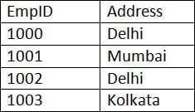](https://cdn.softwaretestinghelp.com/wp-content/qa/uploads/2017/04/employee_info-table.jpg)

**1) Inner JOIN:** Inner JOIN is also known as a simple JOIN. This SQL query returns result from both the tables having a common value in rows.

**SQL Query:**

SELECT * from employee, employee_info WHERE employee.EmpID = employee_info.EmpID ;

**Result:**

[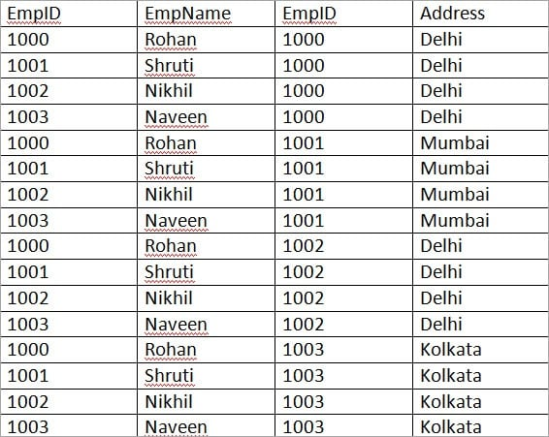](https://cdn.softwaretestinghelp.com/wp-content/qa/uploads/2018/02/Inner-Join-Example.jpg)

**2) Natural JOIN:** This is a type of Inner JOIN which returns results from both the tables having same data values in the columns of both the tables to be joined.

**SQL Query:**

SELECT * from employee NATURAL JOIN employee_info;

**Result:**

[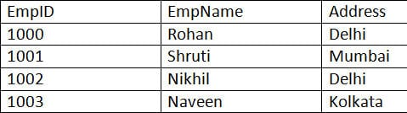](https://cdn.softwaretestinghelp.com/wp-content/qa/uploads/2017/04/Natural-JOIN.jpg)

**3) Cross JOIN:** Cross JOIN return results as all the records where each row from the first table is combined with each row of the second table.

**SQL Query:**

SELECT * from employee CROSS JOIN employee_info;

**Result:**

Let us do some modification in the above tables to understand Right JOIN, Left JOIN, and Full JOIN.

**employee table:**

[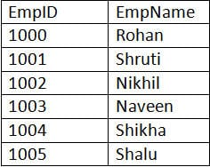](https://cdn.softwaretestinghelp.com/wp-content/qa/uploads/2017/04/employee-table-new.jpg)

**employee_info table:**

[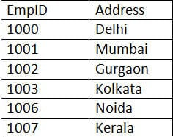](https://cdn.softwaretestinghelp.com/wp-content/qa/uploads/2017/04/employee_info-table-new.jpg)

**1) Right JOIN:** Right JOIN is also known as Right Outer JOIN. This returns all the rows as a result from the right table even if the JOIN condition does not match any records in the left table.

**SQL Query:**

SELECT * from employee RIGHT OUTER JOIN employee_info on (employee.EmpID = employee_info.EmpID);

**Result:**

[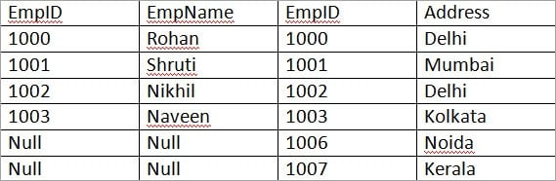](https://cdn.softwaretestinghelp.com/wp-content/qa/uploads/2018/02/Right-Join-Example.jpg)

**2) Left JOIN:** Left JOIN is also known as Left Outer JOIN. This returns all the rows as a result of the left table even if JOIN condition does not match any records in the right table. This is exactly the opposite of Right JOIN.

**SQL Query:**

SELECT * from employee LEFT OUTER JOIN employee_info on (employee.EmpID = employee_info.EmpID);

**Result:**

[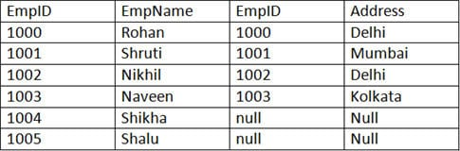](https://cdn.softwaretestinghelp.com/wp-content/qa/uploads/2017/04/Left-JOIN.jpg)

**3) Outer/Full JOIN:** Full JOIN return results in combining the result of both the Left JOIN and Right JOIN.

**SQL Query:**

SELECT * from employee FULL OUTER JOIN employee_info on (employee.EmpID = employee_info.EmpID);

**Result:**

[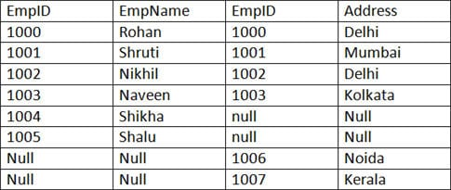](https://cdn.softwaretestinghelp.com/wp-content/qa/uploads/2017/04/Outer-Full-JOIN.jpg)

**Q #38) What do you understand by ‘Atomicity’ and ‘Aggregation’?**

**Ans: Atomicity** is the condition where either all the actions of the transaction are performed or none. This means, when there is an incomplete transaction, database management system itself will undo the effects done by the incomplete transaction.

**Aggregation** is the concept of expressing the relationship with the collection of entities and their relationships.

**Q #39) Define Phantom deadlock.**

**Ans:**Phantom deadlock detection is the condition where the deadlock does not actually exist but due to a delay in propagating local information, deadlock detection algorithms identify the deadlocks.

**Q #40) Define checkpoint.**

**Ans:**Checkpoint declares a point before which all the logs are stored permanently in the storage disk and is the inconsistent state. In the case of crashes, the amount of work and time is saved as the system can restart from the checkpoint.

**Q #41) What is Database partitioning?**

**Ans:**Database partitioning is the process of partitioning tables, indexes into smaller pieces in order to manage and access the data at a finer level.

This process of partitioning reduces the cost of storing a large amount of data as well as enhances the performance and manageability.

**Q #42) Explain the importance of Database partitioning.**

**Ans: The importance of Database partitioning are:**

* Improves query performance and manageability.
* Simplifies common administration tasks.
* Acts as a key tool for building systems with extremely high availability requirements.
* Allows accessing a large part of a single partition.

**Q #43) Explain Data Dictionary.**

**Ans:**Data dictionary is a set of information describing the content and structure of the tables and database objects. The job of the information stored in the data dictionary is to control, manipulate and access the relationship between database elements.

**Q #44) Explain Primary Key and Composite Key.**

**Ans: Primary key** is that column of the table whose every row data is uniquely identified. Every row in the table must have a primary key and no two rows can have the same primary key. Primary key value can never be null nor can be modified or updated.

**Composite Key**is a form of the candidate key where a set of columns will uniquely identify every row in the table.

**Q #45) What do you understand by Unique key?**

**Ans:**A Unique key is same as the primary key whose every row data is uniquely identified with a difference of null value i.e. Unique key allows one value as NULL value.

**Q #46) What do you understand by Database Triggers?**

**Ans:**A set of commands that automatically get executed when an event like Before Insert, After Insert, On Update, On Delete of row occurs in a table is called as Database trigger.

**Q #47) Define Stored procedures.**

**Ans:**A Stored procedure is a collection of pre-compiled SQL Queries, which when executed denotes a program taking input, process and gives the output.

**Q #48) What do you understand by B-Trees?**

**Ans:**B-Tree represents the data structure in the form of a tree for external memory that reads and writes large blocks of data. It is commonly used in databases and file systems where all the insertions, deletions, sorting, etc., are done in logarithmic time.

**Q #49) Name the different data models that are available for database systems.**

**Ans: Different data models are:**

* Relational model
* Network model
* Hierarchical model

**Q #50) Differentiate between ‘DELETE’, ‘TRUNCATE’ and ‘DROP’ commands.**

**Ans:**After the execution of **‘DELETE’** operation, COMMIT and ROLLBACK statements can be performed to retrieve the lost data.

After the execution of**‘TRUNCATE’** operation, COMMIT, and ROLLBACK statements cannot be performed to retrieve the lost data.

**‘DROP’** command is used to drop the table or key like the primary key/foreign key.

**Q #51) Based on the given table, solve the following queries.**

**Employee table**

[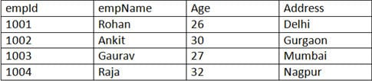](https://cdn.softwaretestinghelp.com/wp-content/qa/uploads/2017/04/Employee-table-1.jpg)

**1)** Write the SELECT command to display the details of the employee with empid as 1004.

**Ans:**

SELECT empId, empName, Age, Address from Employee WHERE empId = 1004;

**Result:**

[SELECT command](https://cdn.softwaretestinghelp.com/wp-content/qa/uploads/2017/04/SELECT-command.jpg)

**2)** Write the SELECT command to display all the records of table Employee.

**Ans:**

SELECT * from Employee;

**Result:**

[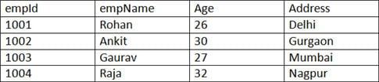](https://cdn.softwaretestinghelp.com/wp-content/qa/uploads/2017/04/display-all-records.jpg)

**3)** Write the SELECT command to display all the records of the employee whose name starts with the character ‘R’.

**Ans:**

SELECT * from Employee WHERE empName LIKE ‘R%’;

**Result:**

[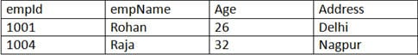](https://cdn.softwaretestinghelp.com/wp-content/qa/uploads/2017/04/name-starts-with-character-R.jpg)

**4)** Write a SELECT command to display id, age and name of the employees with their age in both ascending and descending order.

**Ans:**

SELECT empId, empName, Age from Employee  ORDER BY Age;

**Result:**

[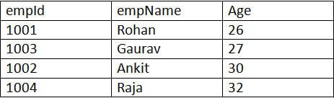](https://cdn.softwaretestinghelp.com/wp-content/qa/uploads/2017/04/employees-with-their-age-in-ascending.jpg)

SELECT empId, empName, Age from Employee  ORDER BY Age Desc;

**Result:**

[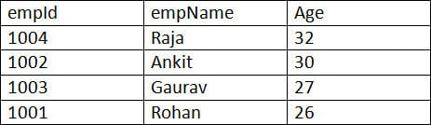](https://cdn.softwaretestinghelp.com/wp-content/qa/uploads/2017/04/employees-with-their-age-in-descending.jpg)

**5)** Write the SELECT command to calculate the total amount of salary on each employee from the below Emp table.

**Emp table:**

[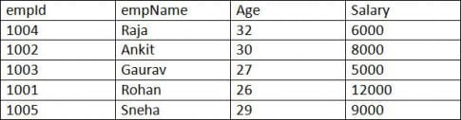](https://cdn.softwaretestinghelp.com/wp-content/qa/uploads/2017/04/Emp-table-1.jpg)

**Ans:**

SELECT empName, SUM(Salary) from Emp GROUP BY empName;

**Result:**

[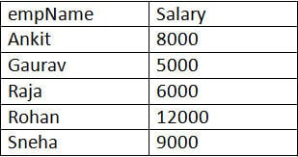](https://cdn.softwaretestinghelp.com/wp-content/qa/uploads/2017/04/Result.jpg)

Conclusion

These are the set of Database interview questions and answers which are mostly asked in the interview.

Mostly the basics of every subject are questioned in the interviews. It is a well-known fact to everyone that, if your basics are clear, you can reach top heights.

***However, there may be some more tricky questions. Just be confident and face each question with clarity in your subject knowledge.***

**1. What are the two authentication modes in SQL Server?**

There are two authentication modes –

* Windows Mode
* Mixed Mode

Modes can be changed by selecting the tools menu of SQL Server configuration properties and choose security page.

**2. What Is SQL Profiler?**

SQL Profiler is a tool which allows system administrator to monitor events in the SQL server. This is mainly used to capture and save data about each event of a file or a table for analysis.

**3. What is recursive stored procedure?**

SQL Server supports recursive stored procedure which calls by itself. Recursive stored procedure can be defined as a method of problem solving wherein the solution is arrived repetitively. It can nest up to 32 levels.

CREATE PROCEDURE [dbo].[Fact]

(

@Number Integer,

@RetVal Integer OUTPUT

)

AS

DECLARE @In Integer

DECLARE @Out Integer

IF @Number != 1

BEGIN

SELECT @In = @Number – 1

EXEC Fact @In, @Out OUTPUT - Same stored procedure has been called again(Recursively)

SELECT @RetVal = @Number * @Out

END

ELSE

BEGIN

SELECT @RetVal = 1

END

RETURN

GO

**4. What are the differences between local and global temporary tables?**

* Local temporary tables are visible when there is a connection, and are deleted when the connection is closed.

CREATE TABLE #<tablename>

* Global temporary tables are visible to all users, and are deleted when the connection that created it is closed.

CREATE TABLE ##<tablename>

**5. What is CHECK constraint?**

A CHECK constraint can be applied to a column in a table to limit the values that can be placed in a column. Check constraint is to enforce integrity.

**6. Can SQL servers linked to other servers?**

SQL server can be connected to any database which has OLE-DB provider to give a link. Example: Oracle has OLE-DB provider which has link to connect with the SQL server group.

**7. What is sub query and its properties?**

A sub-query is a query which can be nested inside a main query like Select, Update, Insert or Delete statements. This can be used when expression is allowed. Properties of sub query can be defined as

* A sub query should not have order by clause
* A sub query should be placed in the right hand side of the comparison operator of the main query
* A sub query should be enclosed in parenthesis because it needs to be executed first before the main query
* More than one sub query can be included

**8. What are the types of sub query?**

There are three types of sub query –

* Single row sub query which returns only one row
* Multiple row sub query which returns multiple rows
* Multiple column sub query which returns multiple columns to the main query. With that sub query result, Main query will be executed.

**9. What is SQL server agent?**

The SQL Server agent plays a vital role in day to day tasks of SQL server administrator(DBA). Server agent's purpose is to implement the tasks easily with the scheduler engine which allows our jobs to run at scheduled date and time.

**10. What are scheduled tasks in SQL Server?**

Scheduled tasks or jobs are used to automate processes that can be run on a scheduled time at a regular interval. This scheduling of tasks helps to reduce human intervention during night time and feed can be done at a particular time. User can also order the tasks in which it has to be generated.

**11. What is COALESCE in SQL Server?**

COALESCE is used to return first non-null expression within the arguments. This function is used to return a non-null from more than one column in the arguments.

Example –

Select COALESCE(empno, empname, salary) from employee;

**12. How exceptions can be handled in SQL Server Programming?**

Exceptions are handled using TRY----CATCH constructs and it is handles by writing scripts inside the TRY block and error handling in the CATCH block.

**13. What is the purpose of FLOOR function?**

FLOOR function is used to round up a non-integer value to the previous least integer. Example is given

FLOOR(6.7)

Returns 6.

**14. Can we check locks in database? If so, how can we do this lock check?**

Yes, we can check locks in the database. It can be achieved by using in-built stored procedure called sp_lock.

**15. What is the use of SIGN function?**

SIGN function is used to determine whether the number specified is Positive, Negative and Zero. This will return +1,-1 or 0.

Example –

SIGN(-35) returns -1

**16. What is a Trigger?**

Triggers are used to execute a batch of SQL code when insert or update or delete commands are executed against a table. Triggers are automatically triggered or executed when the data is modified. It can be executed automatically on insert, delete and update operations.

**17. What are the types of Triggers?**

There are four types of triggers and they are:

* Insert
* Delete
* Update
* Instead of

**18. What is an IDENTITY column in insert statements?**

IDENTITY column is used in table columns to make that column as Auto incremental number or a surrogate key.

**19. What is Bulkcopy in SQL?**

Bulkcopy is a tool used to copy large amount of data from Tables. This tool is used to load large amount of data in SQL Server.

**20. What will be query used to get the list of triggers in a database?**

Query to get the list of triggers in database-

Select * from sys.objects where type='tr'

**21. What is the difference between UNION and UNION ALL?**

* UNION: To select related information from two tables UNION command is used. It is similar to JOIN command.
* UNION All: The UNION ALL command is equal to the UNION command, except that UNION ALL selects all values. It will not remove duplicate rows, instead it will retrieve all rows from all tables.

**22. How Global temporary tables are represented and its scope?**

Global temporary tables are represented with ## before the table name. Scope will be the outside the session whereas local temporary tables are inside the session. Session ID can be found using @@SPID.

**23. What are the differences between Stored Procedure and the dynamic SQL?**

Stored Procedure is a set of statements which is stored in a compiled form. Dynamic SQL is a set of statements that dynamically constructed at runtime and it will not be stored in a Database and it simply execute during run time.

**24.** **What is Collation?**

Collation is defined to specify the sort order in a table. There are three types of sort order –

1. Case sensitive
2. Case Insensitive
3. Binary

**25. How can we get count of the number of records in a table?**

Following are the queries can be used to get the count of records in a table -

Select * from <tablename> Select count(*) from <tablename> Select rows from sysindexes where id=OBJECT_ID(tablename) and indid<2

**26. What is the command used to get the version of SQL Server?**

Select SERVERPROPERTY('productversion')

is used to get the version of SQL Server.

**27. What is UPDATE_STATISTICS command?**

UPDATE_STATISTICS command is used to update the indexes on the tables when there is a large amount of deletions or modifications or bulk copy occurred in indexes.

**28. What is the use of SET NOCOUNT ON/OFF statement?**

By default, NOCOUNT is set to OFF and it returns number of records got affected whenever the command is getting executed. If the user doesn't want to display the number of records affected, it can be explicitly set to ON- (SET NOCOUNT ON).

**29. Which SQL server table is used to hold the stored procedure scripts?**

Sys.SQL_Modules is a SQL Server table used to store the script of stored procedure. Name of the stored procedure is saved in the table called Sys.Procedures.

**30. What are Magic Tables in SQL Server?**

During DML operations like Insert, Delete, and Update SQL Server create magic tables to hold the values during the DML operations. These magic tables are used inside the triggers for data transaction.

**31. What is the difference between SUBSTR and CHARINDEX in the SQL Server?**

The SUBSTR function is used to return specific portion of string in a given string. But, INSTR function gives character position in a given specified string.

SUBSTR("Smiley",3)

Gives result as Smi

CHARINDEX("Smiley",'i',1)

Gives 3 as result as I appears in 3rd position of the string

**32. What is the use of =,==,=== operators?**

= is used to assign one value or variable to another variable. == is used for comparing two strings or numbers. === is used to compare only string with the string and number with numbers.

**33. What is ISNULL() operator?**

ISNULL function is used to check whether value given is NULL or not NULL in sql server. This function also provides to replace a value with the NULL.

**34. What is the use of FOR Clause?**

FOR clause is mainly used for XML and browser options. This clause is mainly used to display the query results in XML format or in browser.

**35. What will be the maximum number of index per table?**

For SQL Server 2008 100 Index can be used as maximum number per table. 1 Clustered Index and 999 Non-clustered indexes per table can be used in SQL Server.

1000 Index can be used as maximum number per table. 1 Clustered Index and 999 Non-clustered indexes per table can be used in SQL Server.

1 Clustered Index and 999 Non-clustered indexes per table can be used in SQL Server.

**36. What is the difference between COMMIT and ROLLBACK?**

Every statement between BEGIN and COMMIT becomes persistent to database when the COMMIT is executed. Every statement between BEGIN and ROOLBACK are reverted to the state when the ROLLBACK was executed.

**37. What is the difference between varchar and nvarchar types?**

Varchar and nvarchar are same but the only difference is that nvarhcar can be used to store Unicode characters for multiple languages and it also takes more space when compared with varchar.

**38. What is the use of @@SPID?**

A @@SPID returns the session ID of the current user process.

**39. What is the command used to Recompile the stored procedure at run time?**

Stored Procedure can be executed with the help of keyword called RECOMPILE.

Example

Exe <SPName> WITH RECOMPILE

Or we can include WITHRECOMPILE in the stored procedure itself.

**40. How to delete duplicate rows in SQL Server?**

Duplicate rows can be deleted using CTE and ROW NUMER feature of SQL Server.

**41. Where are SQL Server user names and passwords stored in SQL Server?**

User Names and Passwords are stored in sys.server_principals and sys.sql_logins. But passwords are not stored in normal text.

**42. What is the difference between GETDATE and SYSDATETIME?**

Both are same but GETDATE can give time till milliseconds and SYSDATETIME can give precision till nanoseconds. SYSDATE TIME is more accurate than GETDATE.

**43. How data can be copied from one table to another table?**

INSERT INTO SELECT

This command is used to insert data into a table which is already created.

SELECT INTO

This command is used to create a new table and its structure and data can be copied from existing table.

**44. What is TABLESAMPLE?**

TABLESAMPLE is used to extract sample of rows randomly that are all necessary for the application. The sample rows taken are based on the percentage of rows.

**45. Which command is used for user defined error messages?**

RAISEERROR is the command used to generate and initiates error processing for a given session. Those user defined messages are stored in sys.messages table.

**46. What do mean by XML Datatype?**

XML data type is used to store XML documents in the SQL Server database. Columns and variables are created and store XML instances in the database.

**47. What is CDC?**

CDC is abbreviated as Change Data Capture which is used to capture the data that has been changed recently. This feature is present in SQL Server 2008.

**48. What is SQL injection?**

SQL injection is an attack by malicious users in which malicious code can be inserted into strings that can be passed to an instance of SQL server for parsing and execution. All statements have to checked for vulnerabilities as it executes all syntactically valid queries that it receives.

Even parameters can be manipulated by the skilled and experienced attackers.

**49. What are the methods used to protect against SQL injection attack?**

Following are the methods used to protect against SQL injection attack:

* Use Parameters for Stored Procedures
* Filtering input parameters
* Use Parameter collection with Dynamic SQL
* In like clause, user escape characters

**50. What is Filtered Index?**

Filtered Index is used to filter some portion of rows in a table to improve query performance, index maintenance and reduces index storage costs. When the index is created with WHERE clause, then it is called Filtered Index

Sacado otan bruselas:

CREATE DATABASE WEBAPI_DB

GO

USE WEBAPI_DB

GO

CREATE TABLE Employees

(

ID int primary key identity,

FirstName nvarchar(50),

LastName nvarchar(50),

Gender nvarchar(50),

Salary int

)

GO

INSERT INTO Employees VALUES ('Pranaya', 'Rout', 'Male', 60000)

INSERT INTO Employees VALUES ('Anurag', 'Mohanty', 'Male', 45000)

INSERT INTO Employees VALUES ('Preety', 'Tiwari', 'Female', 45000)

INSERT INTO Employees VALUES ('Sambit', 'Mohanty', 'Male', 70000)

INSERT INTO Employees VALUES ('Shushanta', 'Jena', 'Male', 45000)

INSERT INTO Employees VALUES ('Priyanka', 'Dewangan', 'Female', 30000)

INSERT INTO Employees VALUES ('Sandeep', 'Kiran', 'Male', 45000)

INSERT INTO Employees VALUES('Shudhansshu', 'Nayak', 'Male', 30000)

INSERT INTO Employees VALUES ('Hina', 'Sharma', 'Female', 35000)

INSERT INTO Employees VALUES ('Preetiranjan', 'Sahoo', 'Male', 80000)

GO

SELECT authors.author_name, SUM(books.sold_copies) AS sold_sum

FROM authors

JOIN books

ON books.book_name = authors.book_name

GROUP BY authors.author_name

ORDER BY sold_sum DESC

LIMIT 3;

//-----------------------

user_id event_date_time

7494212 1535308430

7494212 1535308433

1475185 1535308444

6946725 1535308475

6946725 1535308476

6946725 1535308477

… …

…and it has over one billion rows.

Note: If the event_date_time column’s format doesn’t look familiar, google “epoch timestamp”!

Write an SQL query to find out how many users inserted more than 1000 but less than 2000 images in their presentations!

SELECT count(user_id) AS numberOfUsers

FROM event_log

WHERE user_id =

(

SELECT user_id

FROM event_log

GROUP BY user_id

HAVING count()>1000

AND count()<2000

)

SELECT COUNT(*)

FROM

(SELECT user_id, COUNT(event_date_time) AS image_per_user

FROM event_log

GROUP BY user_id)

AS image_per_user

WHERE image_per_user < 2000

AND image_per_user > 1000;

//-----------------------

You have two SQL tables! The first one is called employees and it contains the employee names, the unique employee ids and the department names of a company. Sample:

department_name employee_id employee_name

Sales 123 John Doe

Sales 211 Jane Smith

HR 556 Billy Bob

Sales 711 Robert Hayek

Marketing 235 Edward Jorgson

Marketing 236 Christine Packard

… … …

The second one is named salaries. It holds the same employee names and the same employee ids – and the salaries for each employee. Sample:

salary employee_id employee_name

500 123 John Doe

600 211 Jane Smith

1000 556 Billy Bob

400 711 Robert Hayek

1200 235 Edward Jorgson

200 236 Christine Packard

… … …

The company has 546 employees, so both tables have 546 rows.

Print every department where the average salary per employee is lower than $500!

(Note: I created this test question based on a real SQL interview question that I heard from a friend, who applied at one of the biggest social media companies (name starts with ‘F.’ :))

SELECT employees.department_name

FROM employees

JOIN (SELECT employees.department_name, (SUM(salaries.salary) / count(employees.employee_id)) AS avg

FROM employees

JOIN salaries

ON employees.employee_id = salaries.employee_id

GROUP BY employees.department_name) AS Avg_table

ON employees.department_name = Avg_table.department_name

WHERE Avg_table.avg , 500

SELECT department_name, AVG(salaries.salary) AS avg_salaries

FROM employees

JOIN salaries

ON employees.employee_id = salaries.employee_id

GROUP BY department_name

HAVING AVG(salaries.salary) < 500;

1) Write the SELECT command to display the details of the employee with empid as 1004.

SELECT *

FROM employee

WHERE empid = 1004

3) Write the SELECT command to display all the records of the employee whose name starts with the character ‘R’.

SELECT *

FROM employee

WHERE empName LIKE 'R%'

5) Write the SELECT command to calculate the total amount of salary on each employee from the below Emp table.

SELECT empName, Sum(Salary) AS totalSalary

FROM employee

GROUP BY empid