Procurement Watch — User Guide
Version 1.2 · Last updated April 2026
Procurement Watch is an internal intelligence platform for tracking procurement and tender opportunities across multiple international sources. It scrapes, verifies, and enriches opportunities using AI, then surfaces them in a unified dashboard for analyst review.

Table of Contents
- 1. Getting Started
- 2. First-Time Login
- 3. Dashboard Overview
- - Project Table
- - Toolbar & Search
- - Advanced Boolean Search
- - Saved Searches
- 4. Project Inspector
- - Project Details
- - Decision Workflow
- - Deadline Override
- - Voting
- - User Assignment
- - Deep Dive Research
- 5. Discussion & Comments
- - Writing Comments
- - File Attachments
- - Mentions & Notifications
- 6. Syncing Data
- - Manual Sync
- - Scheduled Sync
- - Live Sync Output
- - Sync History & Logs
- 7. Notifications
- 8. Configuration
- - Keywords
- - Regions & Geography
- 9. User Administration
- - Creating Users
- - Editing Users
- - Resetting Passwords
- - Deactivating & Deleting Users
- 10. Data Export
- 11. Supported Procurement Sources
- 12. User Roles & Permissions
- 13. Release Notes Management
- 14. Troubleshooting
- 15. Architecture Overview

pip install -r requirements.txt

1. Getting Started
For the installation guide, please refer to INSTALL.md.

2. First-Time Login
- 1. Start the backend with ADMIN_EMAIL and ADMIN_PASSWORD set in .env.
- 2. The backend automatically creates a bootstrap admin user if none exists.
- 3. Open the app and sign in with the configured admin credentials.
- 4. You will be forced to choose a new password before you can proceed. This is a one-time security step.
[!NOTE] There is no public registration flow. All users must be created by an admin through the User Management page.

3. Dashboard Overview

Project Table
The main table displays all stored projects with the following columns:
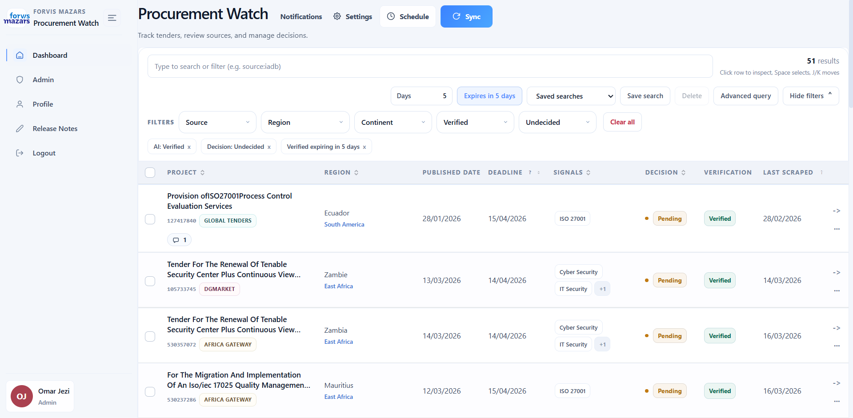
<div><center><i> figure 1: Proc Watch Dashboard </div></i></center>
The following table explains each column meaning
Column | Description
Project | Title of the tender/opportunity
Region | Region and Country of the tender/opportunity
Publish Date | Date the submission was published (different from date scraped)
Deadline | Submission deadline
Signals | Keywords used in search filter to find that project
Decision | Can only be set by manager (Go/No Go)
Verified | After being scraped, tenders need to pass AI verifications to make sure it falls within our scope of services.
Last Scraped | When was this scraped

- - Click any row to open the project inspector drawer on the right.
- - Sort by clicking column headers.
- - Paginate through results at the bottom of the table.

Toolbar & Search
The toolbar at the top of the table provides:
- - Text search — Filter projects by typing keywords in the search box. Matches against project name, description, sponsor, source, and other text fields.
- - Filter dropdowns — Quick filters for source, decision status, AI verification, continent, and region.
- - Bulk actions — Select multiple projects via checkboxes and apply bulk operations (e.g. bulk delete).
- - Excel export — Download current project data as .xlsx.

Advanced Boolean Search
For power users, the search supports an advanced boolean query mode using structured field-value syntax:
source:"World Bank" AND decision:Go
continent:Africa OR region:"West Africa"
NOT verified:No AND source:IADB
keyword:Cybersecurity AND (source:GIZ OR source:IADB)
Available query fields:
Field | Description | Example
source | Procurement source | source:"World Bank"
decision | Go / No Go status | decision:Go
region | Geographic region | region:"West Africa"
continent | Continent | continent:Africa
verified / ai | AI verification status | verified:Yes
country | Country name | country:Senegal
keyword | Matched keyword | keyword:Cybersecurity
signals | AI signal tags | signals:VAPT
id | Project ID | id:P-12345
published_date | Published date | published_date:2026-01
deadline | Deadline date | deadline:2026-06
last_scraped | Last scraped date | last_scraped:2026-03

Operators: AND, OR, NOT, and parentheses () for grouping.

Saved Searches
You can save frequently used search queries:
- 1. Set up your desired search and filter combination.
- 2. Click the Save Search button in the toolbar.
- 3. Give it a name and save.
- 4. Access saved searches from the dropdown to quickly re-apply them.
Each user can store up to 30 saved searches.

4. Project Inspector
Clicking a project row opens the inspector drawer on the right side of the screen. This is the primary workspace for reviewing individual tender details.
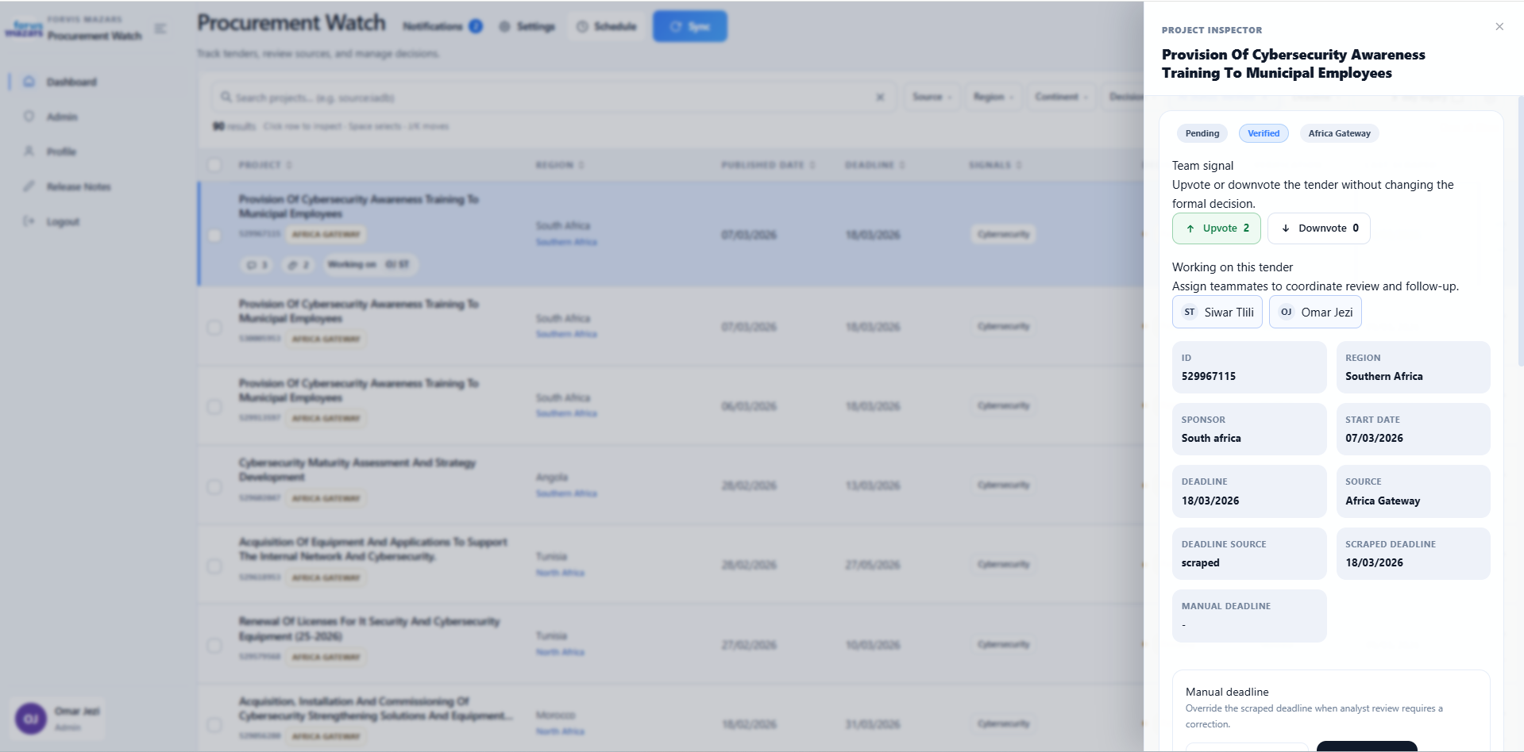

Project Details
The inspector shows:
- - Project name and link to the original source page
- - Document links (if any were found during enrichment)

Decision Workflow
Users can vote on projects:
- - Upvote (👍) — Signal that the project looks promising
- - Downvote (👎) — Signal that the project may not be relevant
- - Click the same vote again to remove your vote
Managers can mark each project with a decision
- - Go
- - No Go
Only users with the manager role can set decisions.

Deadline Override
Users can set a manual deadline that overrides the scraped deadline because some scrapers fails or are unable to retrieve the deadline. The original scraped deadline is preserved for traceability.
- 1. In the inspector, locate the deadline section.
- 2. Click the edit icon to set a manual deadline.
- 3. Clear the manual deadline to revert to the original scraped value.
#

User Assignment
Assign one or more team members to a project for review:
- 1. In the inspector, click the assignment section.
- 2. Select users from the dropdown.
- 3. Assigned users receive a notification about their new assignment.

Deep Dive Research
For verified projects, you can trigger Deep Dive — an AI-powered research process that:
- 1. Searches the source for additional documents and links.
- 2. Summarizes the project context.
- 3. Posts the findings as a bot comment in the project's discussion thread.
To trigger: click the Deep Dive button in the inspector. The process runs in the background and you'll be notified when it completes.

5. Discussion & Comments
Each project has a built-in discussion thread for team collaboration, accessible from the project inspector.

Writing Comments
- 1. Open a project in the inspector.
- 2. Scroll to the discussion section at the bottom.
- 3. Type your message (up to 4,000 characters) and press Send.

File Attachments
You can attach files to comments:
- - Images (PNG, JPG, WebP, GIF, etc.) — Display inline in the thread. Large images are automatically compressed.
- - PDFs — Open in an in-app PDF viewer when clicked.
- - Other files — Download when clicked.
Maximum file size: 20 MB per file.

Mentions & Notifications
Tag team members in comments using @mentions:
- 1. While writing a comment, type @ followed by the user's name.
- 2. Select the user from the autocomplete dropdown.
- 3. When you send the comment, mentioned users receive a notification.
Mentioning a user also automatically subscribes them to the project's discussion thread, so they'll receive notifications for future comments on that project.

6. Syncing Data
Syncing is the process of fetching new tender opportunities from procurement sources.

Manual Sync
- 1. Click the Sync button in the navigation bar.
- 2. In the sync panel, select which sources to scrape (or select all).
- 3. Configure options:
- - Skip AI verification — Bypass the cybersecurity relevance check
- - Skip AI enrichment — Bypass document analysis and enrichment
- - Include expired — Include tenders with past deadlines
- 4. Click Start Sync.
- 5. Watch the live console output as scrapers run.

Scheduled Sync
Automate syncing on a recurring schedule:
- 1. Click the Schedule button in the navigation bar.
- 2. Toggle the schedule on.
- 3. Configure:
- - Frequency — Daily or weekly
- - Day of week (for weekly syncs)
- - Time — Hour and minute
- - Timezone — Your local timezone offset
- - Sources — Which scrapers to include
- - Options — Skip AI, include expired, etc.
- 4. Click Save.
The system uses APScheduler to trigger syncs at the configured time. The next scheduled run time is displayed in the schedule panel.

Live Sync Output
During a sync (manual or scheduled), you can view real-time console output:
- - The sync panel shows a live-updating log of scraper progress.
- - Each scraper reports its status (starting..., OK, failed).
- - A final summary shows total scraped, new projects, and AI verification stats.
- - Per-scraper detailed logs are also available after completion.

Sync History & Logs
The schedule panel displays sync run history, showing:
Field | Description
Status | Success / failure
Started at | Timestamp when the sync began
Finished at | Timestamp when the sync completed
Duration | Total run time
New projects | Number of new tenders found
Sources | Which scrapers were run
Per-scraper logs | Expandable detailed output per source

7. Notifications
Procurement Watch has a real-time notification system. You receive notifications when:
Event | Description
Mention | Someone tags you in a comment with @mention
Comment | Someone comments on a project you're assigned to or subscribed to
Assignment | Someone assigns you to a project
New projects | A sync finds new projects (browser notification)

Notification features:
- - Bell icon in the navigation bar shows unread count.
- - Click the bell to view the notification dropdown.
- - Notifications are grouped by project, so multiple comments on the same project show as one item.
- - Mark as read — Click a notification to mark it as read.
- - Mark all as read — Clear all unread notifications.
- - Click a notification to jump directly to the relevant project in the inspector.
- - Sound alert — A notification sound plays when new projects are found during sync (only when the browser tab is active).

8. Configuration

Keywords
Keywords define what the scrapers search for. They are cybersecurity-related terms used to filter procurement notices.
To manage keywords:
- 1. Navigate to the Configuration panel (gear icon).
- 2. View, add, or remove keywords.
- 3. Click Save to persist changes.
Default keywords include: Cybersecurity, Penetration Testing, ISO 27001, VAPT, ISMS, PCI DSS, SWIFT CSP, and more.
[!TIP] Keywords support both English and French terms. Add industry-specific terms that match the tenders you're looking for.

Regions & Geography
The app includes normalized geography data for filtering:
- - Continents — Top-level geographic grouping
- - Regions — Sub-continental groups (e.g. West Africa, Southeast Asia)
- - Countries — Individual countries mapped to regions
Region data is used by:
- - Dashboard filter dropdowns
- - Project metadata normalization
- - Advanced boolean search queries
To manage regions:
- 1. Go to the Configuration panel.
- 2. Edit the region-country mappings.
- 3. Save changes.
Default regions: West Africa, East Africa, Southern Africa, Central Africa, North Africa, Central Asia, South Asia, Southeast Asia, Latin America, Caribbean, Eastern Europe.

9. User Administration
Admin role required for all user management actions.

Creating Users
- 1. Navigate to the User Management page (user icon in the sidebar).
- 2. Click Add User.
- 3. Fill in:
- - Name
- - Email
- - Role — admin, manager, or user
- - Password (optional) — If not provided, a secure password is auto-generated
- 4. Click Create.
- 5. Share the temporary password with the new user. They will be forced to change it on first login.

Editing Users
- 1. On the User Management page, click Edit on any user row.
- 2. Update the user's name, email, role, or active status.
- 3. Click Save.
You cannot remove your own admin role.

Resetting Passwords
- 1. Click Reset Password on a user row.
- 2. Optionally provide a specific new password, or let the system generate one.
- 3. The user will be forced to change the password on next login.

Deactivating & Deleting Users
- - Deactivate — Toggle the user's active status off. They can no longer log in but their data is preserved.
- - Delete — Permanently remove the user account.
You cannot delete your own account.

10. Data Export
Export project data as Excel spreadsheets:
- - Export All — Download all projects as projects.xlsx from the toolbar.
- - Export Filtered — Apply filters/search first, then export only the visible results.
- - Export Selected — Select specific projects with checkboxes, then export the selection.
The Excel file includes all project fields: source, name, ID, sponsor, country, deadline, decision, AI verification status, matched keywords, and more.
[!NOTE] An Excel file is also automatically regenerated after each sync and after project mutations (delete, decision change, etc.).

11. Supported Procurement Sources
Source | Key | Description
IADB | iadb | Inter-American Development Bank
World Bank | worldbank | World Bank procurement opportunities
Global Tenders | globaltenders | Global Tenders aggregator
GIZ | giz | German development agency
DevelopmentAid | devaid | DevelopmentAid tenders portal
DGMarket | dgmarket | DGMarket procurement notices
Africa Gateway | africagateway | African Development Bank opportunities
IsDB | isdb | Islamic Development Bank
BADEA | badea | Arab Bank for Economic Development in Africa
BCIE | bcie | Central American Bank for Economic Integration
EABR | eabr | Eurasian Development Bank
OAS | oas | Organization of American States
African Union | africanunion | African Union procurement

Each scraper searches these sources using your configured keywords and returns normalized project records.

12. User Roles & Permissions
Action | Admin | Manager | User
View dashboard & projects | ✅ | ✅ | ✅
Search & filter | ✅ | ✅ | ✅
Vote on projects | ✅ | ✅ | ✅
Comment & attach files | ✅ | ✅ | ✅
Export data to Excel | ✅ | ✅ | ✅
Set project decisions | ❌ | ✅ | ❌
Override deadlines | ✅ | ✅ | ❌
Assign users to projects | ✅ | ✅ | ✅
Trigger manual sync | ✅ | ✅ | ✅
Manage schedule | ✅ | ✅ | ✅
Configure keywords/regions | ✅ | ✅ | ✅
Manage users (CRUD) | ✅ | ❌ | ❌
Reset user passwords | ✅ | ❌ | ❌
Manage release notes | ✅ | ❌ | ❌
Delete projects | ✅ | ✅ | ✅

13. Release Notes Management
Admin role required.
Admins can manage in-app release notes that inform users about platform updates:
- 1. Navigate to Release Notes in the admin section.
- 2. Add, edit, or remove release note entries.
- 3. Each release note has:
- - Version number (e.g. 1.2)
- - Title — Brief headline
- - Summary — Short description
- - Items — Bullet list of changes
When a new version is deployed, users see the release notes modal on their next visit. They can also access full release notes history from the app menu.

14. Troubleshooting

Common Issues
Problem | Solution
"No admin exists" on login page | Set ADMIN_EMAIL and ADMIN_PASSWORD in backend/.env and restart backend
Cannot log in | Check that the user account is active and credentials are correct
Sync fails for a source | Check the scraper logs for errors; the source website may be down
AI verification skipped | Ensure DEEPSEEK_API_KEY or OPENAI_API_KEY is set in .env
No projects found after sync | Check your keywords configuration; projects may not match any keywords
Excel export fails | Ensure openpyxl is installed and disk space is available
Frontend can't connect to backend | Verify backend is running on port 8000; check CORS settings
DGMarket scraper fails | Update DGMARKET_SESSION_ID in .env with a fresh session ID

Checking Backend Health
curl http://localhost:8000/api/health
# Expected: {"ok": true}

Running Tests
cd backend
pytest

Viewing Logs
- - Backend logs — Check the terminal running uvicorn or Docker container logs.
- - Sync logs — Available in the Schedule panel under run history.
- - Per-scraper logs — Expandable detail in each sync history entry.

15. Architecture Overview
┌─────────────────────────────────────────────────────────────────┐
│ Frontend (React + Vite) │
│ Login │ Dashboard │ Inspector │ Sync │ Schedule │ Admin │
└────────────────────────────┬────────────────────────────────────┘
│ REST API + SSE
┌────────────────────────────┴────────────────────────────────────┐
│ Backend (FastAPI + Python) │
│ Auth │ Projects │ Comments │ Notifications │ Scheduler │ Sync │
├─────────────┬──────────────────┬────────────────────────────────┤
│ MongoDB │ File Uploads │ Sync Subprocess (main.py) │
│ (data) │ (backend/ │ ┌─ Scrapers (13 sources) │
│ │ uploads/) │ ├─ AI Filter (relevance) │
│ │ │ ├─ AI Enrichment (docs) │
│ │ │ └─ Deduplication + Persistence│
└─────────────┴──────────────────┴────────────────────────────────┘
Key data flows:
- 1. User → Frontend → API → MongoDB — Standard CRUD operations
- 2. Sync → Subprocess → Scrapers → AI → MongoDB — Background data pipeline
- 3. Backend → SSE → Frontend — Real-time sync logs and notifications
Technology stack:
Layer | Technology
Frontend | React 19, Vite 7, React Aria, Untitled UI, CSS
Backend | Python 3.12, FastAPI, Pydantic, APScheduler
Database | MongoDB (via PyMongo)
AI | DeepSeek / OpenAI APIs
Scraping | Requests, BeautifulSoup, Selenium, mitmproxy
Auth | JWT (PyJWT), bcrypt
Deploy | Docker Compose, Nginx

For developer documentation, see [ARCH.md](ARCH.md). For installation details, see [INSTALL.md](INSTALL.md).

