Procurement Watch User Guide
This guide gives a practical overview of the application, the main workflows, and the screens users interact with every day.

1. Purpose
Procurement Watch helps teams find cybersecurity-related tenders, review them with AI support, collaborate on decisions, and manage monitoring from one workspace.

2. Access and Roles
- - Users sign in with their account and may be asked to change their password on first access.
- - User can review tenders, comment, vote, assign users, save searches, run sync, and use Deep Dive Search.
- - Manager can do everything a user can do and can also set Go / No Go.
- - Admin manages users, release notes, settings, and platform configuration.

3. Dashboard Overview
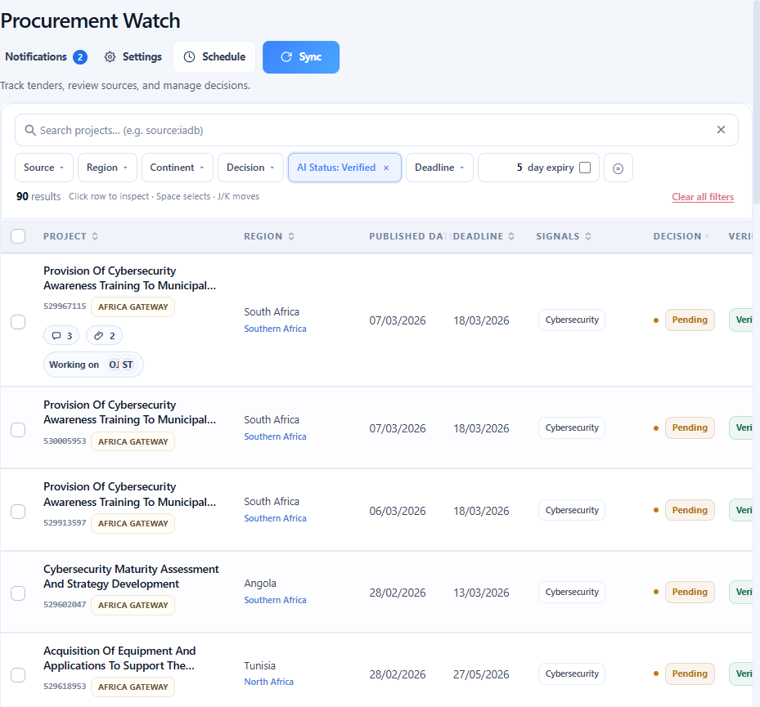
The dashboard is the main review workspace.
- - Search tenders with the global search box.
- - Apply quick filters for source, region, continent, decision, AI status, and deadline.
- - Use the expiring filter with a custom number of days.
- - Save a search and reuse it later from Saved searches.
- - Open a tender directly from the row or inspect it in the drawer.
- - See row signals for comments, attachments, and assigned users.

4. Search, Filters, and Saved Searches

- - Hide filters collapses the full search area to save space.
- - Advanced query supports boolean logic such as AND, OR, NOT, and parentheses.
- - Saved searches store the current search, filters, and advanced query state.
- - The quick expiry control helps focus on AI-verified tenders closing soon.

5. Tender Drawer and Review Workflow
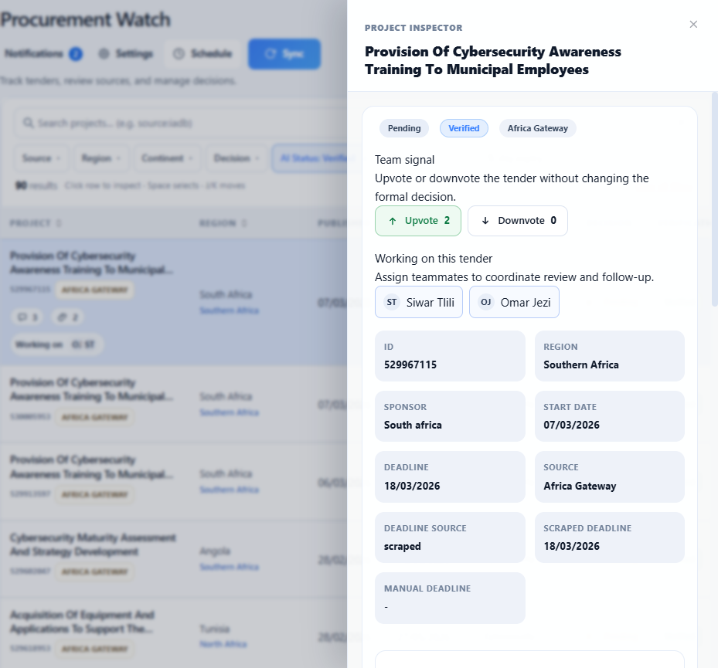
The drawer is the main tender review panel.
- - Review title, source, region, dates, and matched signals.
- - Open the source page or supporting links.
- - Update the deadline when your role allows it.
- - Set Go / No Go if you are a manager.
- - Use Upvote and Downvote to give team signal.
- - Assign teammates to show who is working on the tender.
- - Run Deep Dive Search to ask the AI to research the tender source and post a summary in comments.

6. Comments, Mentions, and Attachments

- - Add comments directly inside the tender drawer.
- - Tag users with @ to mention them.
- - Images appear inline in the discussion thread.
- - PDF files open inside the app instead of forcing a download.
- - Bot comments and user comments appear in the same discussion history.
- - Tagged users receive notifications and remain subscribed to future discussion on that tender.

7. Notifications
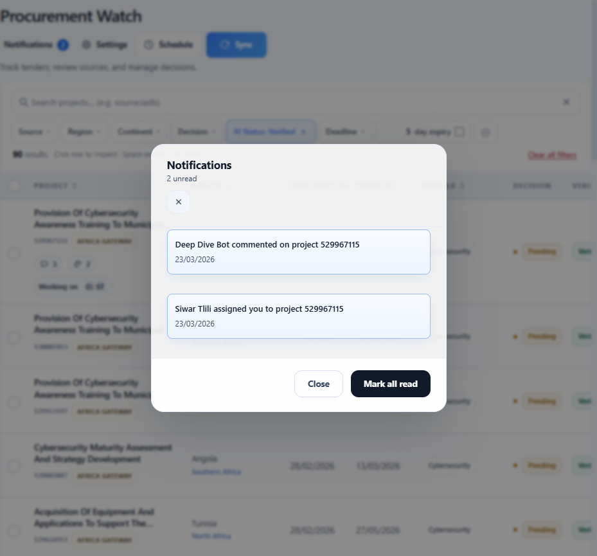
- - Notifications are grouped by tender and action.
- - Unread and read items are visually distinct.
- - Opening the panel marks notifications as viewed.
- - Clicking a notification marks it as read and opens the related tender drawer.
- - Notifications cover mentions, assignments, and new comments on followed tenders.

8. Manual Sync
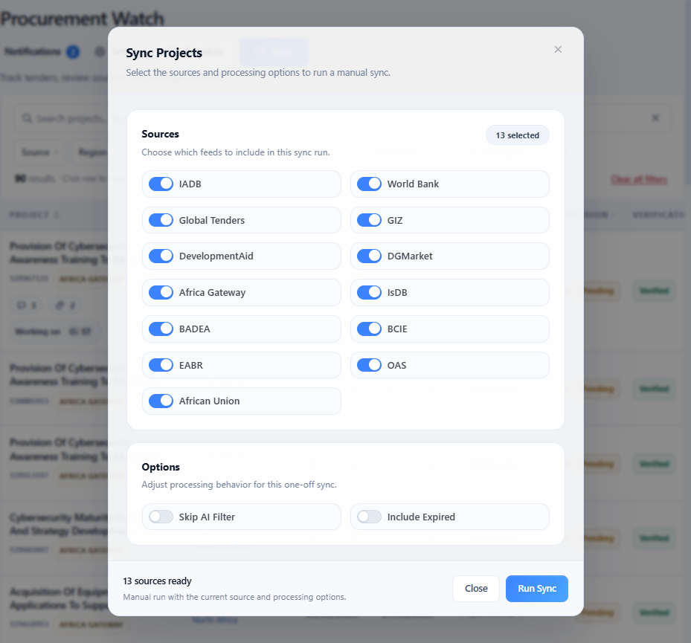
Manual sync lets users launch an on-demand collection run.
- - Select one or more sources.
- - Choose processing options such as skipping AI or including expired notices.
- - Follow live status in the log panel while the sync is running.
- - New tenders found during sync enter the normal AI review pipeline.

9. Scheduled Sync
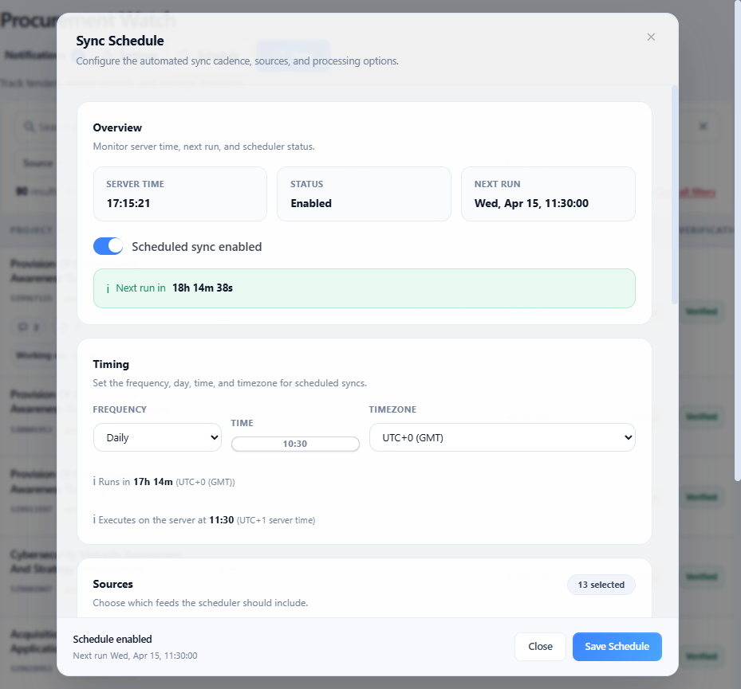
Scheduled sync automates collection.
- - Enable or disable the scheduler.
- - Choose daily or weekly execution.
- - Set local time and timezone.
- - The application translates that time to server execution time.
- - Select the sources to include in the schedule.
- - Review run history, durations, new project counts, and scraper output.

10. Settings
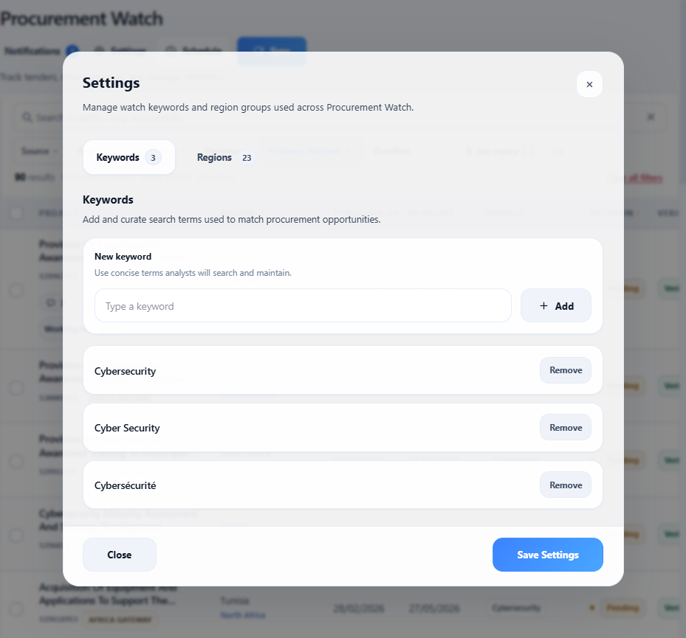
Settings control the watch list used by the platform.
- - Manage tracked keywords.
- - Maintain region groups and geography mappings.
- - Save changes so sync and filtering stay aligned with analyst needs.

11. Admin: User Management
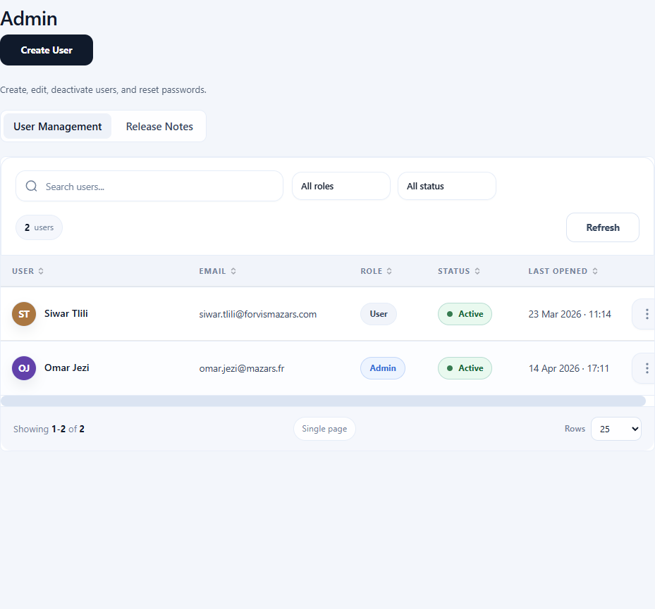
Admins can manage platform access from the Admin page.
- - Create users.
- - Set role: user, manager, or admin.
- - Activate or deactivate accounts.
- - Reset passwords.
- - Review last app activity.

12. Admin: Release Notes
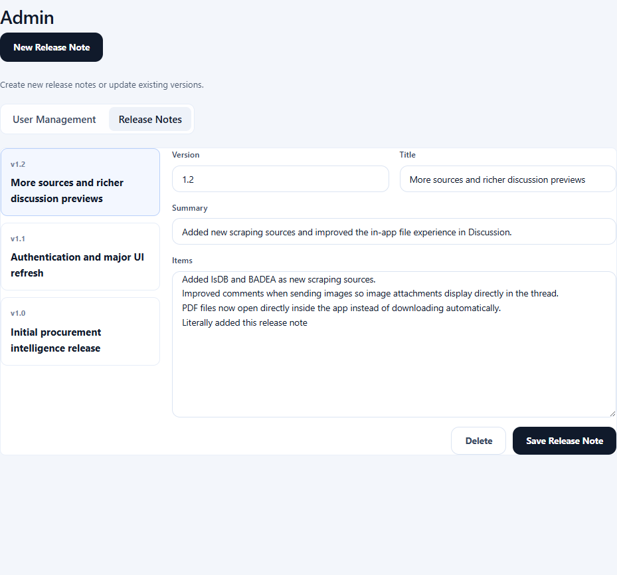
Admins can maintain in-app release notes.
- - Create a new release note.
- - Edit version, title, summary, and bullet points.
- - Delete outdated notes.
- - Publish updates so users see what changed after a release.

13. Profile
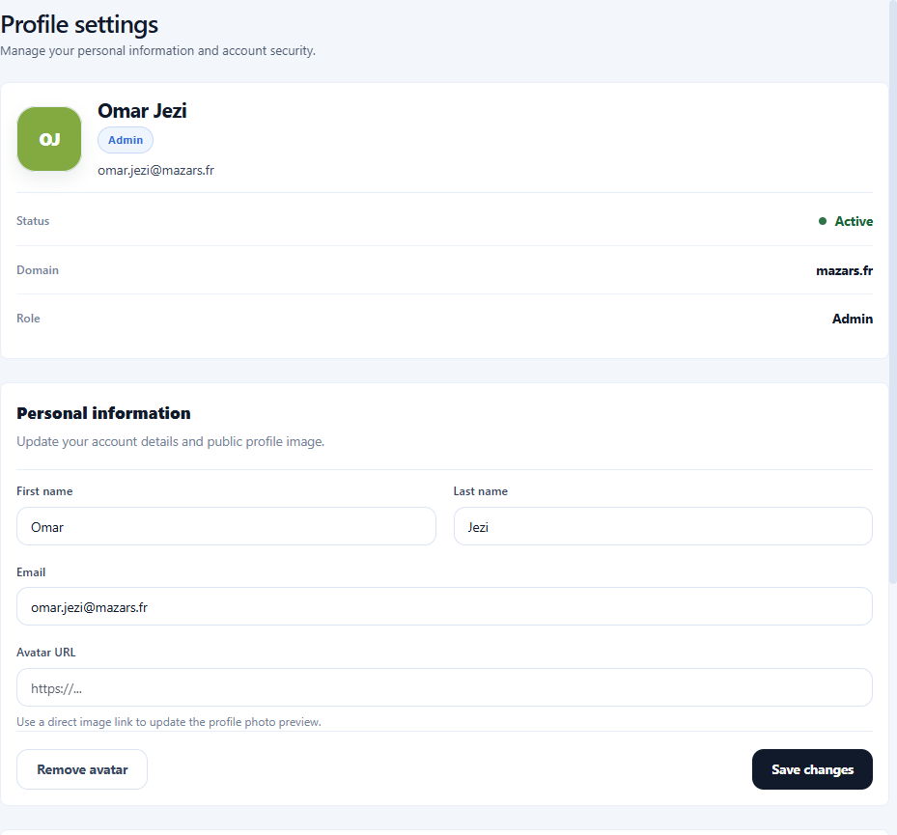
Each user can manage their own account details.
- - Update display name and email.
- - Add or change avatar URL.
- - Change password.
- - Review account information in one place.

14. Release Notes
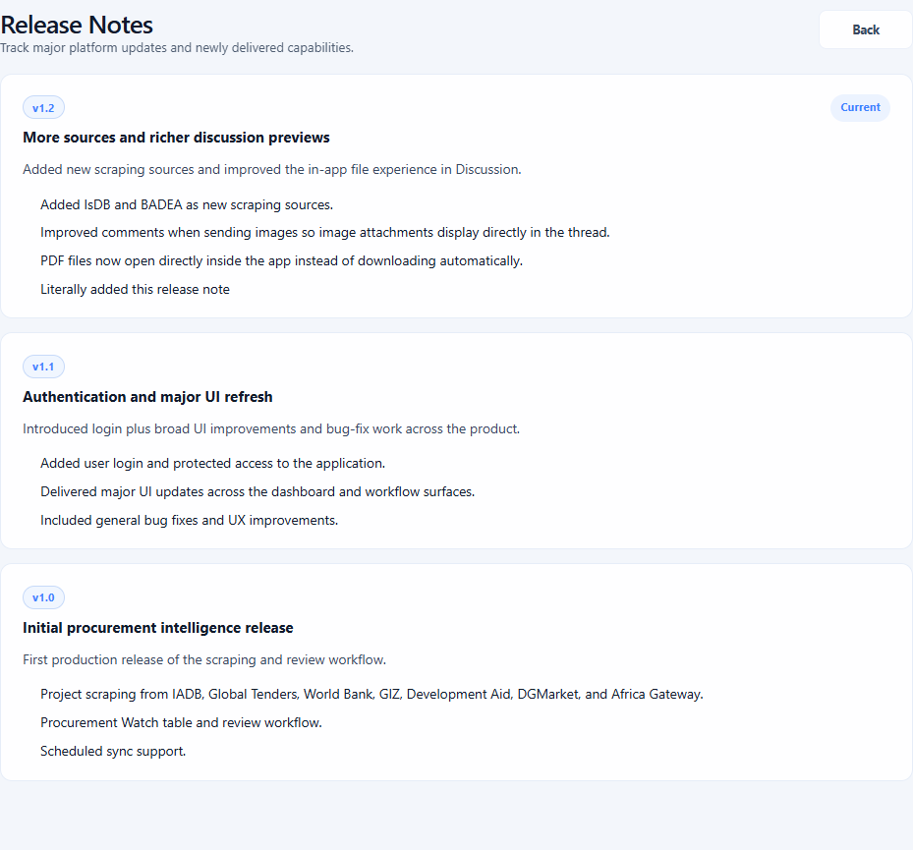
- - Users can open release notes at any time from the sidebar.
- - The app also shows the latest release note automatically after an upgrade.
- - Full version history stays available from the release notes page.

15. Supported Sources
The platform currently supports these sources:
- - IADB
- - World Bank
- - Global Tenders
- - GIZ
- - DevelopmentAid
- - DGMarket
- - Africa Gateway
- - IsDB
- - BADEA
- - BCIE
- - EABR
- - OAS
- - African Union

16. Typical Daily Workflow
- 1. Open the dashboard and load a saved search or apply quick filters.
- 2. Review AI-verified tenders and focus on expiring opportunities.
- 3. Open a tender in the drawer.
- 4. Assign teammates, vote, comment, and mention users where needed.
- 5. Use Deep Dive Search when more context is required.
- 6. Set the final decision if your role allows it.
- 7. Monitor notifications for mentions, assignments, and new comments.

17. Key AI Usage in Procurement Watch
AI is used in three main places:
- - AI verification filters incoming tenders and keeps relevant cybersecurity opportunities.
- - AI enrichment improves tender context and extracted metadata during sync.
- - Deep Dive Search researches a selected tender, identifies the likely source, and posts a short structured summary in the discussion thread.

