NB: At first upgrade the project, then provide me the system file. Then you can add two options with take long time (if You need) which is given below.

Upgrade(Unique Features to Add)
For a strong defense, the project should focus on five features. These are realistic to implement and strong enough to explain academically.
1. Verified Listing Trust Score
2. Smart Match Score
3. Tenant-Fit Recommendation
4. Admin Verification and Complaint Handling
5. Rent Fairness or Duplicate Listing Detection as the advanced feature
6. Users Will 3 Types. (Normal User: Can visit And Rent Or Buy The Property, Land Lord/Hottel Manager/ Property Owner) NB: While an user register an account, system will provide some options: Flat Owner/ Property owner/ Hotel Manager/ User.
Recommended scope: keep Rent and Property as the main modules. Hotel booking can stay as a future extension unless you have enough time to fully implement it. Adding too many modules can make the project broad but shallow.

Detailed Feature Design with Examples

1 Verified Listing Trust Score
This should be the strongest unique feature. The score can be calculated using simple database fields and admin approval, so it is feasible even without advanced AI.
Verification item | Score
Phone number verified | 15
Address checked by admin | 20
Real property photos uploaded | 15
Rent amount confirmed | 15
Availability date confirmed | 10
Owner/landlord document checked privately | 15
No previous complaint | 10
Total | 100

Example output shown to users: Trust Score 85/100 - Verified by Admin.
Why it is feasible: it can be implemented using boolean fields such as phone_verified, address_verified, photos_verified, rent_confirmed, availability_confirmed, document_checked, and complaint_count. The backend can calculate the total score automatically.

2 Smart Match Score
This feature makes the project look like a smart decision-support system. The system ranks listings rather than only showing all results.
User input | Example value
City | Dhaka
Budget | 18,000 BDT
Tenant type | Bachelor
Priority | Best price
Preferred area | Mirpur
Bedrooms | 1-2

Property | Rent | Tenant type | Area | Match score
Flat A | 17,000 BDT | Bachelor allowed | Mirpur 10 | 94%
Flat B | 18,500 BDT | Bachelor allowed | Kazipara | 88%
Flat C | 15,000 BDT | Family only | Mirpur 2 | 61%

Example formula: Match Score = Budget Fit + Location Fit + Tenant Fit + Verification Score + Feature Match.
Feasibility: high. This can be implemented with a rule-based scoring algorithm. A rule-based score is easier to defend than a black-box machine learning model because you can explain every part of the recommendation.

3 Tenant-Fit Recommendation
This is important because rental suitability in Bangladesh depends heavily on tenant identity and living arrangement. A normal property website may show a flat, but users still need to know whether it accepts bachelors, female tenants, students, job holders, sublets, or families.
Tenant-fit category | Example use
Family | Family-only flat
Bachelor male | Bachelor-friendly flat or shared apartment
Bachelor female | Female-friendly or student-safe flat
Student | Near university, college, or coaching area
Job holder | Near office zone or transport route
Sublet | Single room or shared flat

Example listing label: Suitable for female students, small family, and job holders. Not allowed: bachelor male group.
Feasibility: high. This requires adding tenant_type_allowed and tenant_type_not_allowed fields to the listing database.

4 Rent Fairness Estimator
This feature is more advanced and can make the project more research-oriented. It compares a listing with similar listings in the same area, property type, bedroom count, and size range.
Comparison item | Value
Area | Mirpur
Property type | Apartment
Bedrooms | 2
Average similar rent | 22,000 BDT
Current listing rent | 28,000 BDT
System output | High rent - about 27% above similar listings

Feasibility: medium. It needs enough listing data. For a thesis prototype, you can use 100-300 sample listings and clearly state that the estimator is a prototype, not an official national rent index.

5 Fake or Duplicate Listing Detection
This is a strong technical feature because it adds safety and moderation. Start with rule-based detection before attempting advanced AI image similarity.
Detection rule | Example warning
Same phone number used in many listings | One number posted 20 houses in different cities.
Same address with different rents | Same flat listed at 15,000 and 25,000 BDT.
Very low rent for expensive area | Gulshan 3-bedroom flat listed at 8,000 BDT.
Very similar title and description | Two listings appear to describe the same unit.
Repeated image | Same bedroom photo used for different locations.

Then Add Two Others Feature:

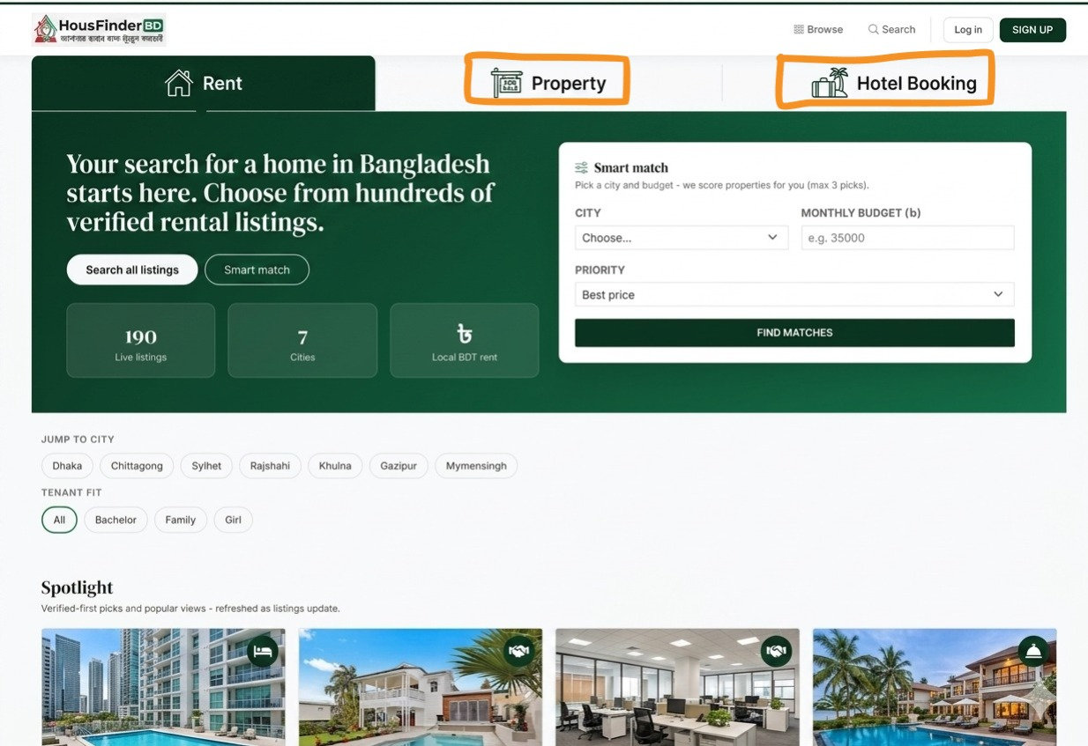
- Property (Buy And Sell)
- Hotel (Rent/ Booking)

01.Property (Buy And Sell):
- Normal user can be Buy a property.
- Property Lord Can be listing.
- Admin Can control All thigs

2. Hotel (Rent/ Booking)
- Normal user can be Book The hotel.
- Hottel manager Can be listing.
- Admin Can control All thigs

