*Oliver Wang, Yuqing Guo, Juntong He*

*101105522 101106497 101107404*

***Group 13***

***COMP3004 Team Project***

*MCT Use Case Model*

*OO Design Model*

*Traceability Matrix and Tests*

**UC-1**

**MCT Device Startup Use Case**

Actor: Device User(Primary), skin sensor

Scope: The MCT device system

Stakeholders and Interests:

MCT device user – use the device for the treatment of functional disorders

skin sensor - transport the request and send the signal to control system to complete user’s requests.

Minimal Guarantee: The MCT device control system response to users’ operation.

Success Guarantee: Users request and the sensors send the request to command the device. The MCT device control system response to users’ operation.

Precondition: The device has battery to start up.

Main Success Scenario:

1. User presses the ON/OFF button, the sensor sends request to microprocessor, the device is turn on and the main menu is shown on the display screen.

2. User presses “up” button, the menu page is scroll up, and user press “down” button, the menu page is scroll down.

3. User select the therapies and frequency, the system will receive the requests set the device for corresponding functions and frequency.

4. The electrode is not on the skin, the output signal waveform remains initial status.

5. User presses “return” button, the menu page will return to previous page.

Extension:

1a. If the device is run out of battery, the screen will show no battery and the main menu will send signal to microprocessor and the device will be turned off.

1b. The device is out of battery, the signal will trigger clear history, the history will be clear after the device being turned off.

Post-condition:

User opens the device and selects the therapies and frequency

**UC-2**

**MCT Device Begin Therapies Use Case**

Actor: Device User(Primary), skin sensor

Scope: The operating system that controls the MCT device.

Stakeholders and Interests: Device User

Level: User goal

Precondition: MCT device is turned on and waiting for requests from users.

Minimal guarantee: MCT has enough battery and can respond to users’ requests.

Success guarantee: The device user wants the therapies and sends the requests to use the device.

Main Success scenario:

1. The user presses the OK button to select a type of therapy from the menu. The button sends a request to the microprocessor (or the operating system) to start the selected therapy.
2. The skin sensor then detects whether the device is placed on tissue or skin. If the device is not placed on tissue or skin, the sensor will not start the timer and wait for skin to be placed.
3. The user puts the MCT device on skin. The skin sensor immediately sends a signal to notify the microprocessor that skin or tissue are detected.
4. The operating system starts functioning and commands the light emitter to start the treatment at the selected power level when the device is placed on the skin.
5. The operating system commands the timer to count down and the display screen to display the time left for the rest of the therapy.
6. The user presses the left or right button to adjust power level (between 1 to 100) of the therapy. The button sends signals to the microprocessor so that the operating system can command the light emitter to adjust electrical impulse output level.
7. When the time is up, the timer sends signals to the microprocessor and the operating system stops the treatment.
8. The selected therapy finishes. The display screen returns back to the menu.

Extensions:

1. The battery runs out and the device shuts down. The therapy stops automatically. (may happen anytime during the scenario). And the it will send signal to trigger the clear history, and the history treatment will be cleared.
2. When the device is not placed on the skin during the therapy, the skin sensor will notify the operating system and also the timer. The operating system of the MCT device will pause the timer. The therapy is then paused as well. The therapy and the timer continue when the device is placed back on the skin. (may happen anytime during the therapy)
3. The user wants to stop the therapy and presses the ‘return’ button. The button sends the signal to notify the operating system which then commands to stop the therapy. The main menu is shown when the user presses the ‘return’ button.

7a. The user selects to record the therapy and checks the record box on the UI.

a1) The record checkbox sends a request to the microprocessor to notify user’s decision

a2) The microprocessor stores the current therapy to the treatment history.

a3) When the time is up, the timer sends signals to the microprocessor and the operating system stops the treatment. The display screen returns back to the main menu.

a4) Then the user can select the ‘record history’ option in the menu to view the treatment histories.

Post-condition: The device user selects the therapies and sends the requests to use the device.

**UC-3**

**MCT Device Begin based on Frequency Use Case**

Actor: Device User(Primary), skin sensor

Scope: The operating system that controls the MCT device.

Stakeholders and Interests: Device User

Level: User goal

Precondition: MCT device is turned on and waiting for requests from users.

Minimal guarantee: MCT has enough battery and can respond to users’ requests.

Success guarantee: The device user wants the treatment in a specific frequency of the device and sends the requests to use the device.

Main Success scenario：

1. The user presses the OK button to select a level of frequency from the menu. The button sends a request to the microprocessor(or the operating system) to start the selected therapy.
2. The skin sensor then detects whether the device is placed on tissue or skin. If the device is not placed on tissue or skin, the sensor will not start the timer and wait for skin to be placed.
3. The user puts the MCT device on skin. The skin sensor immediately sends a signal to notify the microprocessor that skin or tissue are detected.
4. The operating system starts functioning and commands the light emitter to start the treatment at the selected power level when the device is placed on the skin.
5. The operating system commands the timer to count up and the display screen to display the time that the device have worked on a specific frequency.
6. The user presses the left or right button to adjust power level (between 1 to 100) of the therapy. The button sends signals to the microprocessor so that the operating system can command the light emitter to adjust electrical impulse output level.
7. When the user press return button, the timer sends signals to the microprocessor and the operating system stops the treatment.
8. The selected frequency treatment finishes. The display screen returns back to the menu.

Extensions:

1. The battery runs out and the device shuts down. The therapy stops automatically. (may happen anytime during the scenario) And the it will send signal to trigger the clear history, and the history treatment will be cleared
2. When the device is not placed on the skin during the therapy, the skin sensor will notify the operating system and also the timer. The operating system of the MCT device will pause the timer. The therapy is then paused as well. The therapy and the timer continue when the device is placed back on the skin. (may happen anytime during the therapy)

7a. The user selects to record the therapy and checks the record box on the UI.

a1) The record checkbox sends a request to the microprocessor to notify user’s decision

a2) The microprocessor stores the current treatment in the specific frequency to the treatment history.

a3) When user want to stop the treatment, they press ‘return’ , the timer sends signals to the microprocessor and the operating system stops the treatment. The display screen returns back to the main menu.

a4) Then the user can select the ‘record history’ option in the menu to view the treatment histories.

Post-condition: The device user selects the frequency and sends the requests to use the device.

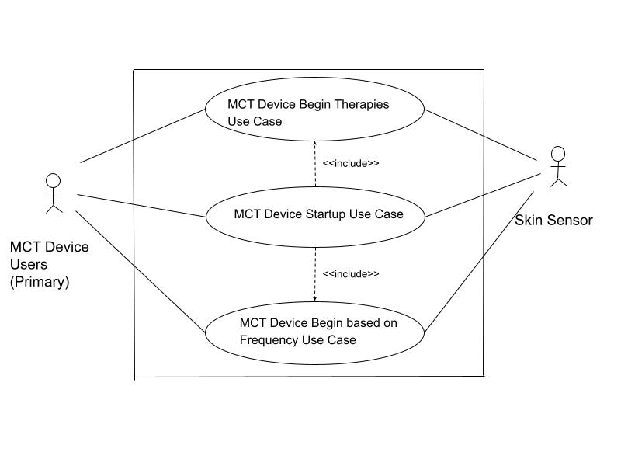

**Use Case Diagram:**

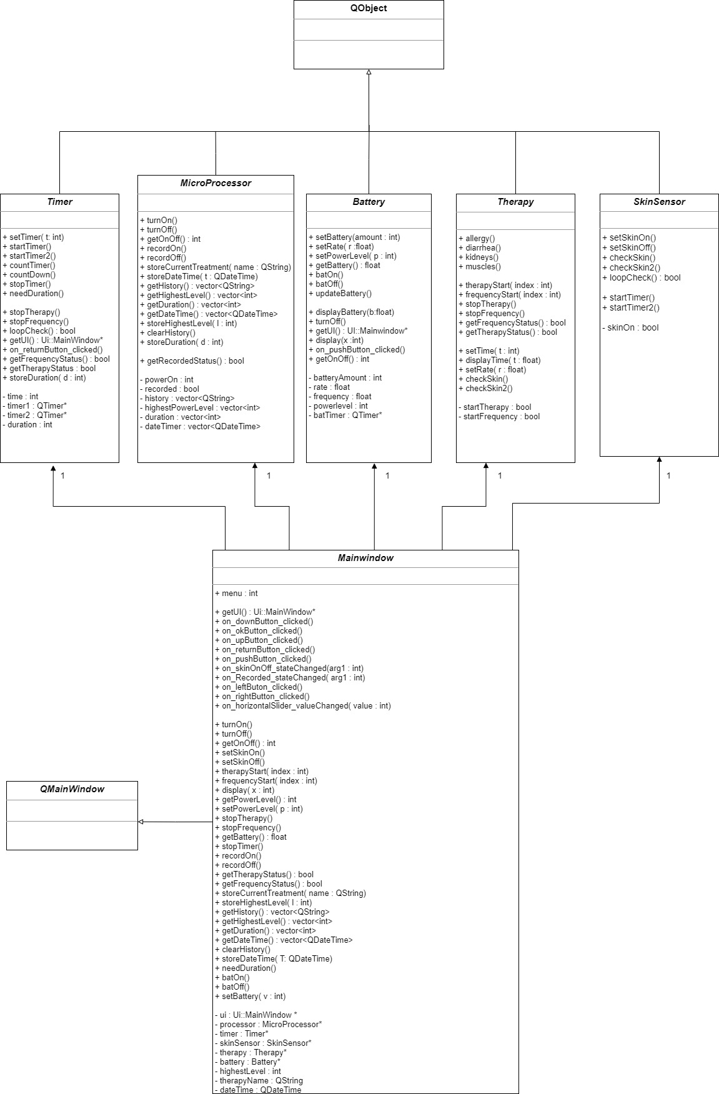**UML Class Diagram:**

**Sequence Diagrams:**

(refers to UC-1)

**SD-1 (Please check the pdf file ‘sequenceDiagram1’ for a clearer version)**

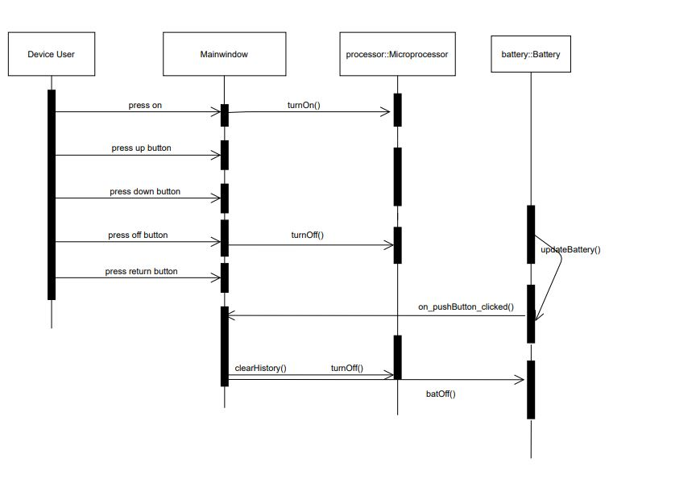

(Refers to UC-2)

**SD-2 (Please check the pdf file ‘sequenceDiagram2’ for a clearer version)**

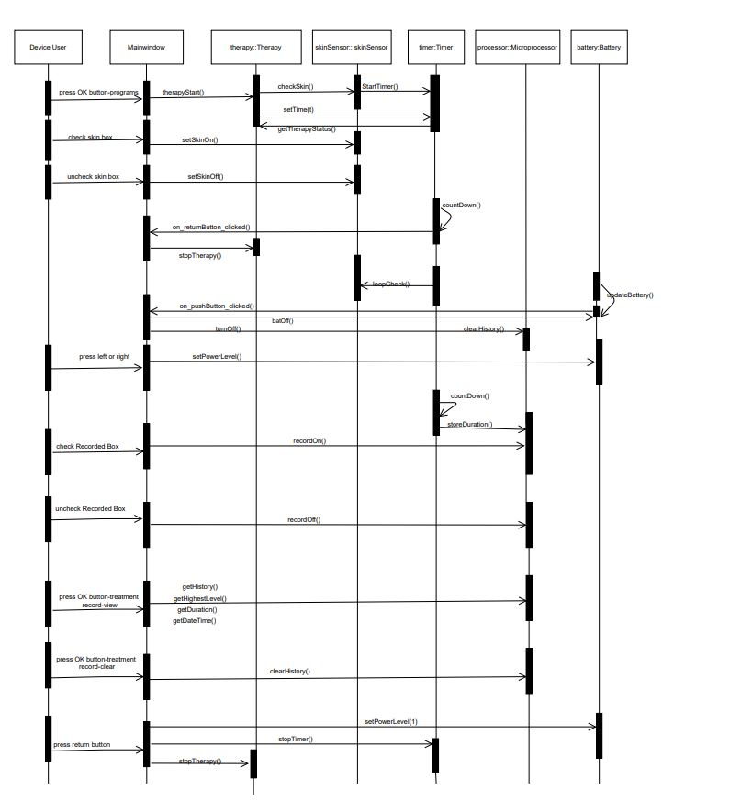

(refers to UC-3)

**SD-3 (Please check the pdf file ‘sequenceDiagram3’ for a clearer version)**

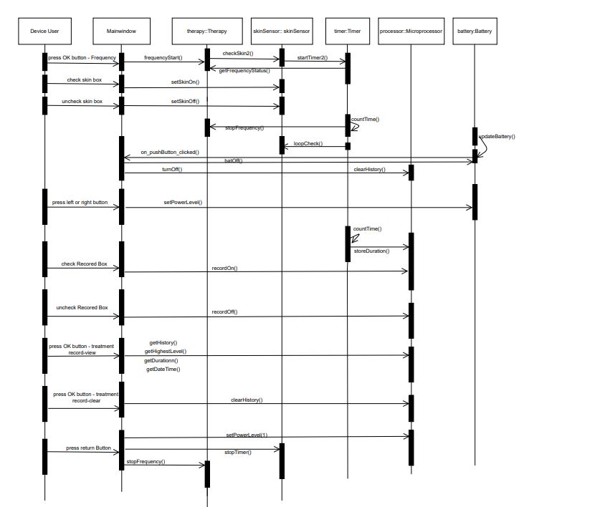

**State Diagram: (Please check the pdf file ‘state diagram’ for a clearer version)**

(refers to all 3 use cases )

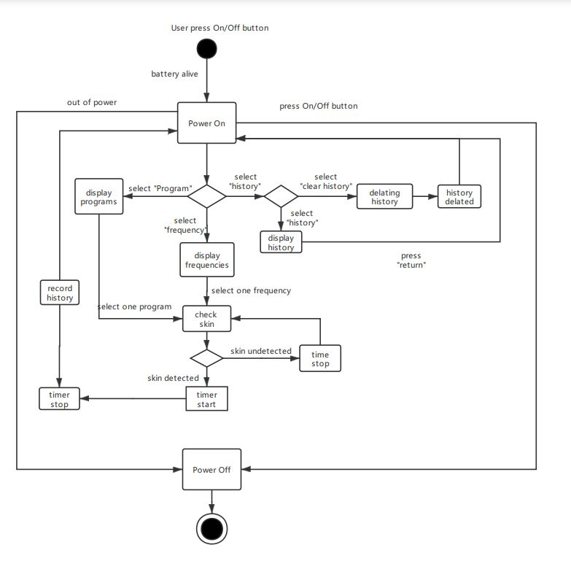

**Traceability Matrix and Tests:**

|  |  |  |  |
| --- | --- | --- | --- |
| **Traceability number#** | **Use case #** | **Requirement scenario** | **Sequence diagram#** |
| 1 | UC-1 | Users can press different buttons to browse each menu. | SD-1 |
| 2 | UC-2 | Users can choose a therapy program to start the treatment, while being able to control the power output level and use the record function. | SD-2 |
| 3 | UC-3 | Users can choose a preferred frequency to start treatments, while being able to control the power output level and use the record function. | SD-3 |

|  |  |  |  |  |
| --- | --- | --- | --- | --- |
| **Testcase # (TC)** | **Requirement Description** | **Test Case** | **Test Steps** | **Expected Result** |
| 1 | A properly working interface including buttons and display. | Test menu and button | 1) click powerOn button  2) check two checkboxes  3) click ok button to select programs or history record | The display screen properly displays the menu and the button works fine |
| 2 | Battery amount decreases as timer passes and it decreases faster with higher power levels.  The device should be automatically turned off when battery runs out. | Battery test | 1) click powerOn button  2) select a therapy and start  3) observe the battery amount  4) click right button to increase power level and observe the battery amount  5) set the battery amount with the horizontal slider  6) observe the behavior of the device when battery runs out | The battery amount starts to decrease when the device is On. The battery amount drops faster when we select a higher power level. The device is turned off automatically when running out of battery. |
| 3 | The display screen shows the timer during the therapy. The timer only advances during skin on, pauses when skin off. | Therapy timer test | 1) click powerOn button  2) select a therapy and start  3) check the ‘skinOn/Off’ checkbox  4) uncheck the ‘skinOn/Off’ check box | The timer should either count down or count up only when the ‘skinOn/Off’ is checked. Otherwise, the timer is paused. |
| 4 | Users can select power level only during the process of the treatment. Users can select between range 1 – 100. | Power level test | 1) click powerOn button to open the device  2) select a therapy and start  3) press left or right button to adjust power level | The power level can not be adjusted in the menu page. The minimum power level is 1 and the maximum is 100. |
| 5 | Users can choose to record the current treatment and view the treatment history by selecting the history option in the menu. Record histories can be also deleted by users. | Record history test | 1) click powerOn button to open the device  2) select a therapy and start  3) adjust power levels and check the ‘recordOn’ checkbox  4) repeat the steps few times.  5) press return button to return to the menu page  6) select Record History option and then select ‘View’  7) select the ‘Clear’ option | When user chooses to record a therapy, the device should be able to record the start time, therapy name, highest power level and the duration. Users can check the record history from the menu page. Also, users are able to clear the history with the ‘Clear’ option. |

Requirement and Tests Traceability Matrix

|  |  |  |  |
| --- | --- | --- | --- |
| **Traceability number #** | **Requirement Scenario** | **Involved Test Case #** | **Test Status and Result** |
| 1 | Users can press different buttons to browse each menu. | TC-1  TC-4  TC-5 | TC-1: Pass  TC-4: Pass  TC-5: Pass |
| 2 | Users can choose a therapy program to start the treatment, while being able to control the power output level and use the record function. | TC-1  TC-2  TC-3  TC-4  TC-5 | TC-1: Pass  TC-2: Pass  TC-3: Pass  TC-4: Pass  TC-5: Pass |
| 3 | Users can choose a preferred frequency to start treatments, while being able to control the power output level and use the record function. | TC-1  TC-2  TC-3  TC-4  TC-5 | TC-1: Pass  TC-2: Pass  TC-3: Pass  TC-4: Pass  TC-5: Pass |