Student ID:  
6345123

Name:  
Mark Romig

**Task 1: Relational Schema**tour (tourName, description)  
primary key (tourName)

client (clientID, surname, givenName, Gender)  
primary key (clientID)

event (eventYear, eventMonth, eventDay, eventFee)  
primary key (tourName, eventYear, eventMonth, eventDay)  
foreign key (tourName) references tour

booking (dateBooked, payment)  
primary key (clientID, tourName, eventYear, eventMonth, eventDay)  
foreign key (client ID) references client  
foreign key (tourName, eventYear, eventMonth, eventDay) references event

**Task 2: DDL**

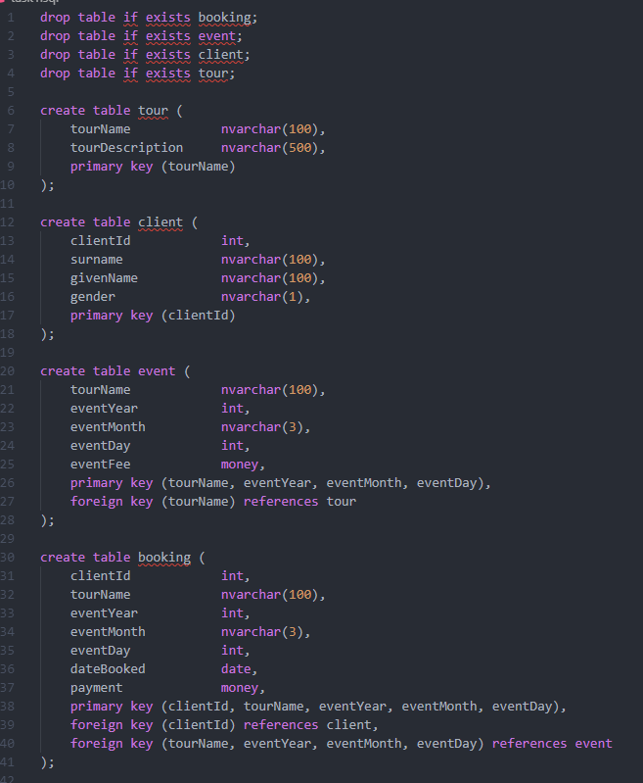

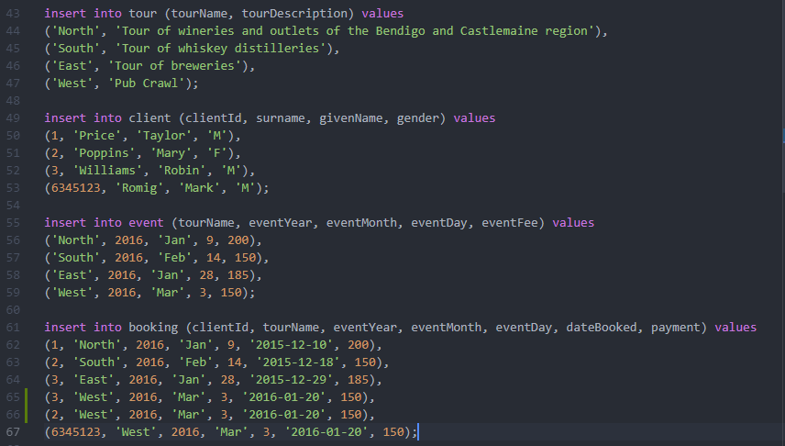

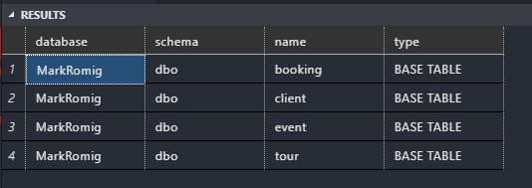

**Task 3: Sample test data  
  
Select * from Client result set**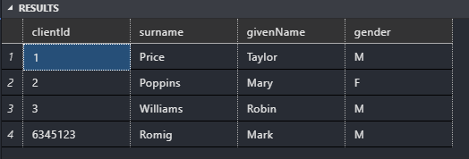

**Task 4: Queries**

**Query 1: Query & Result Set**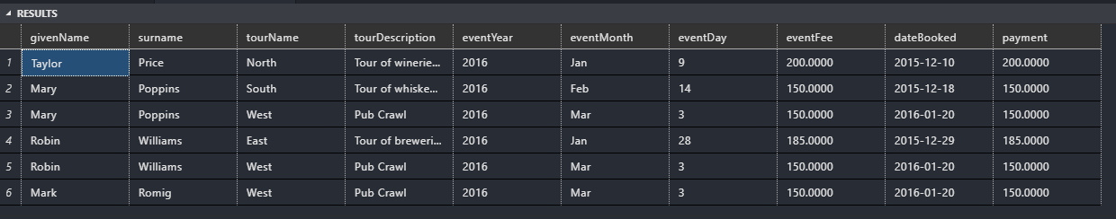

**Query 2: Query & Result Set**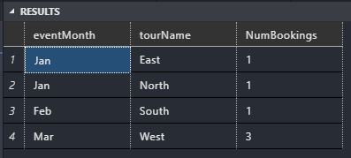

**Query 3: Query & Result Set**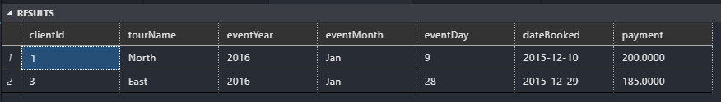

**Task 6: Create View**