posner

maki kiko minako

02/04/2020

We did Posner’s classic gaze cuing experiment on psytoolkit.org. We recorded the results for us 3 participants, entered them into a csv file and tried to visualise them.

library(tidyverse)

## ── Attaching packages ───────────────────────────────────────── tidyverse 1.3.0 ──

## ✓ ggplot2 3.3.0 ✓ purrr 0.3.3  
## ✓ tibble 3.0.0 ✓ dplyr 0.8.4  
## ✓ tidyr 1.0.2 ✓ stringr 1.4.0  
## ✓ readr 1.3.1 ✓ forcats 0.5.0

## ── Conflicts ──────────────────────────────────────────── tidyverse_conflicts() ──  
## x dplyr::filter() masks stats::filter()  
## x dplyr::lag() masks stats::lag()

read.csv("/Users/makir/OneDrive - University of Glasgow/R/posner.csv")

## id type rt  
## 1 mummy valid 436  
## 2 mummy invalid 460  
## 3 kiko valid 463  
## 4 kiko invalid 458  
## 5 mina valid 414  
## 6 mina invalid 505

posner_data <- read.csv("/Users/makir/OneDrive - University of Glasgow/R/posner.csv")

ggplot(posner_data, aes(x=type, fill= id)) + geom_bar(position = "dodge", alpha =.6)

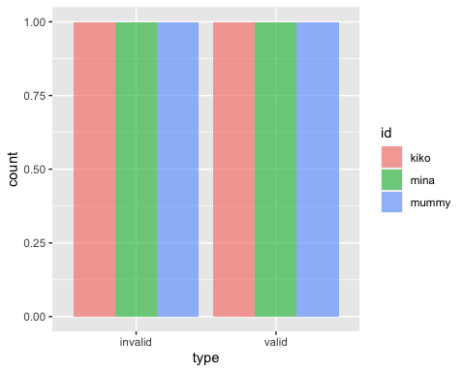

ggplot(posner_data, aes(x=type, y= rt, color = id))+geom_point()+ scale_x_discrete(name="cue type (valid or invalid)") + scale_y_continuous(name="Reaction Time(msec)") + geom_smooth(method = lm)

## `geom_smooth()` using formula 'y ~ x'

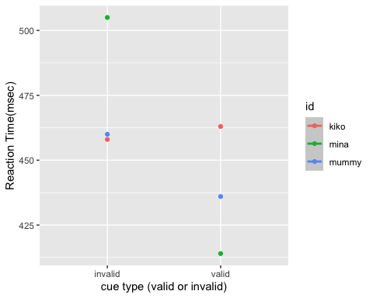

ggplot(posner_data, aes(x = type, y=rt, color=id)) + geom_boxplot() + geom_point() +geom_jitter(height = 0, width = .1) + scale_x_discrete(name="cue type (valid or invalid)") + scale_y_continuous(name="Reaction Time(msec)") + scale_fill_discrete(guide = FALSE)

