**Task 1 components:**

**i**

* Planning and system requirements (include normal pcs and other devices like mobile, tablets. Include things like processors, RAM, HDD and other storage, GPU, Display size…
* External research of similar applications, websites, services, can include Paas and Saas etc. Include screenshots and good references. Detailed general overview of the application, talk about how it links to the proposal. Include similarities and things it is lacking….
* Find other examples to compare together – 3-4 ideally (to give a clear idea of what you might come up with and I’ve done good extensive research. Remember to include applications both on mobile, and PC.
* Talk about usability (Nielsen’s 10 (list the heuristics) (Could include Schneiderman’s 8 rules) Also Consistency, Accessibility, visual hierarchy (contrast, scale, Z/F Pattern), GESTALT – Proximity, common pattern, continuity, similarity, closure, common region, symmetry.
* List each point out and talk about how it is used/not used in the applications researched.
* Include Statistics – User statistics.
* Empathy Map/Mood board (Ask questions like what is the ideal customer? / Current behaviour patterns of user? / Needs and goals of the user? / Issues and pain-points users currently face within the given

context?

**ii**

* **Description of proposed solution:**

List out requirements and expand how you are going to implement them into your proposed solution.

Include What approach type – computational, logical, agile, waterfall etc.

List out KPI’s.

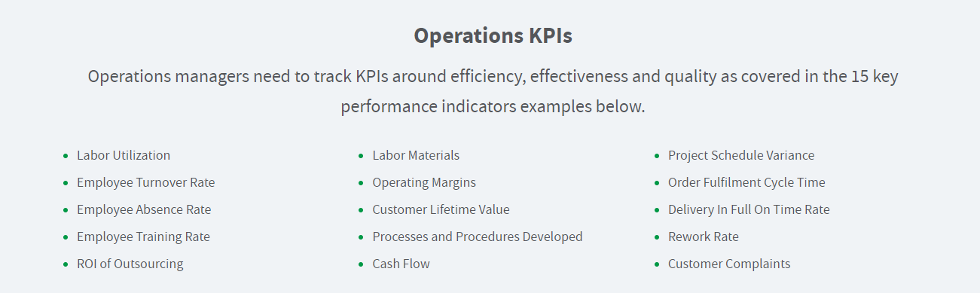

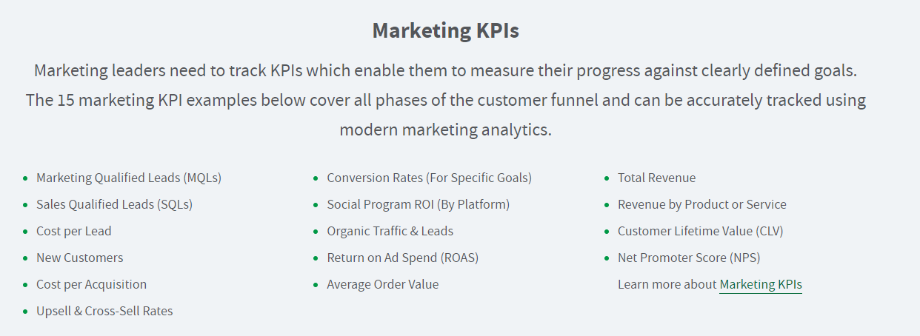

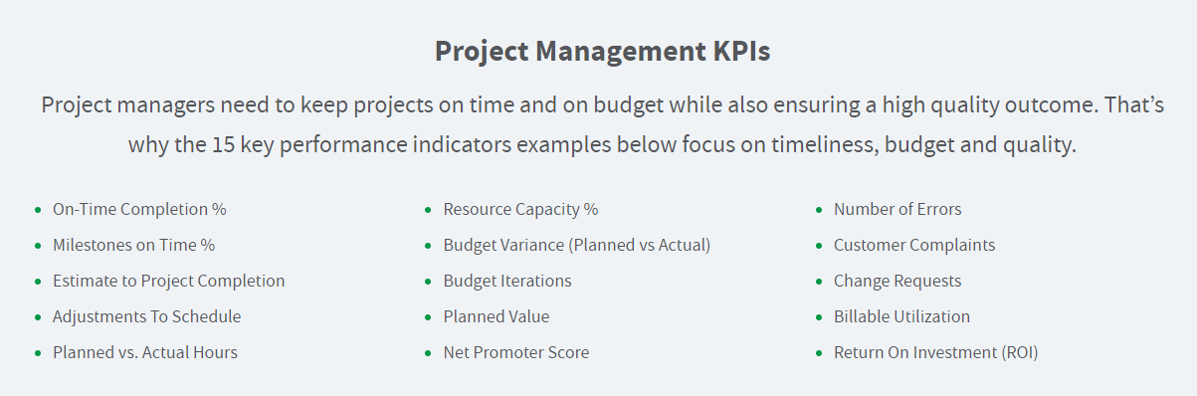

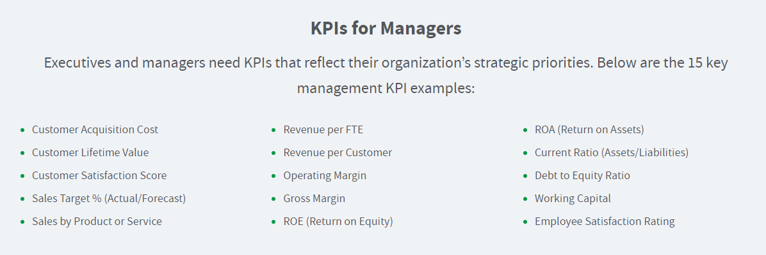

List out the main aspects/websites of the system.

DFD Diagrams, Context Diagrams basic login and relevant processes and systems.

Functional and non-functional requirements.

Accessibility considerations.

Hierarchy diagrams – login all the way to certain pages depending on certain things e.g. - register/login/all pages etc.

This includes things like tree branching down from creating an account – range check, validation, security, storing the details, password checking, etc.

wv