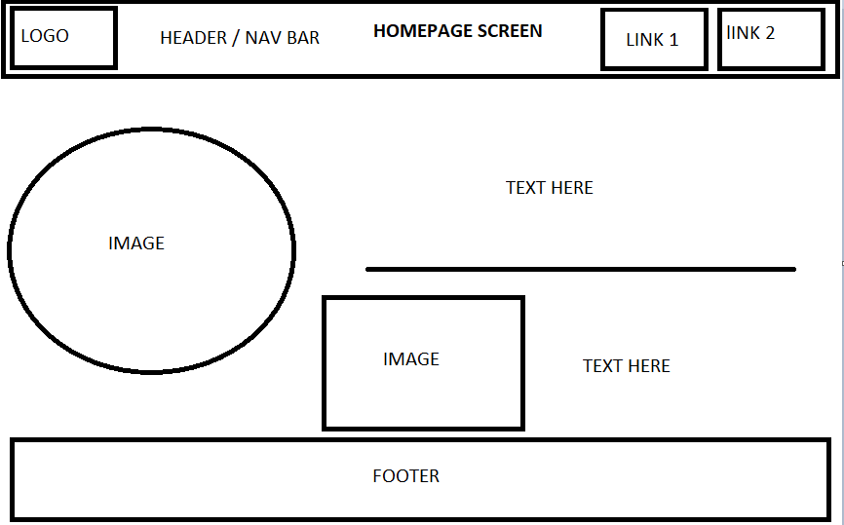

Login page

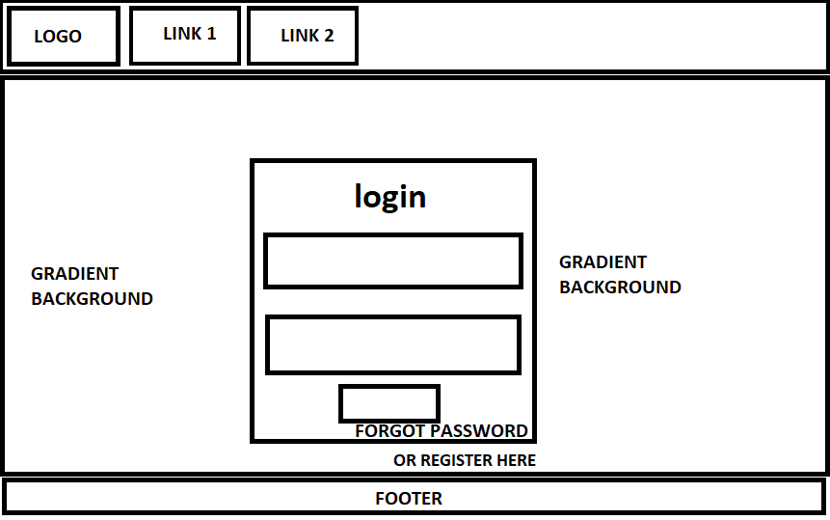

REGISTER FORM

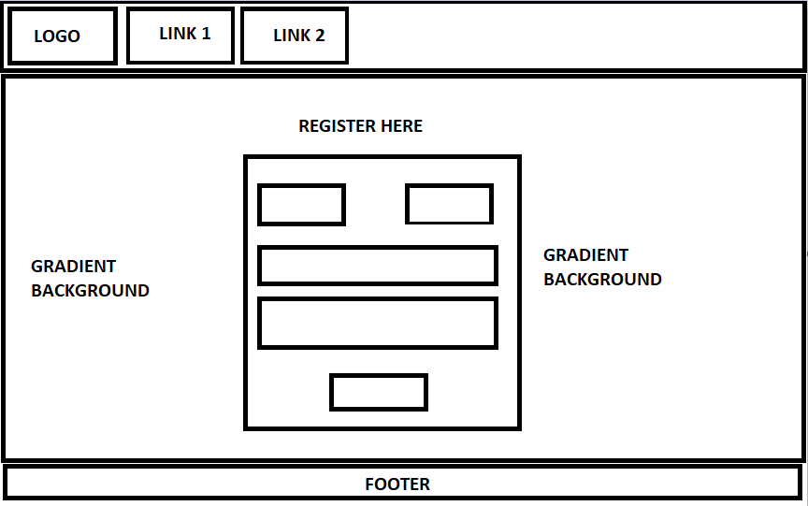

* Enables teachers to monitor learner progress.
* Increases learners' engagement and interaction.
* Provides informative feedback for both learner and tutor on learners progress.
* Tutors can set goals and progress points based off of assessment results.
* Less time wasted working out what point the learner is at with the module or unit.

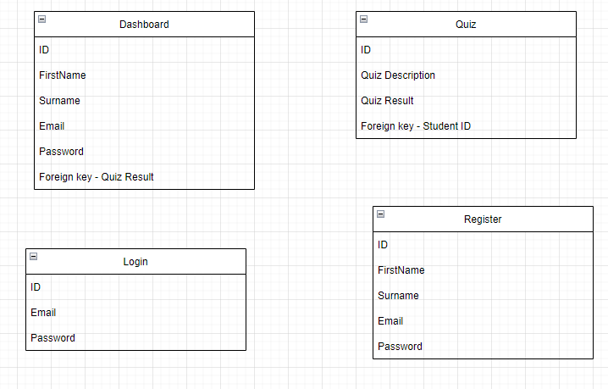

SITE MAP

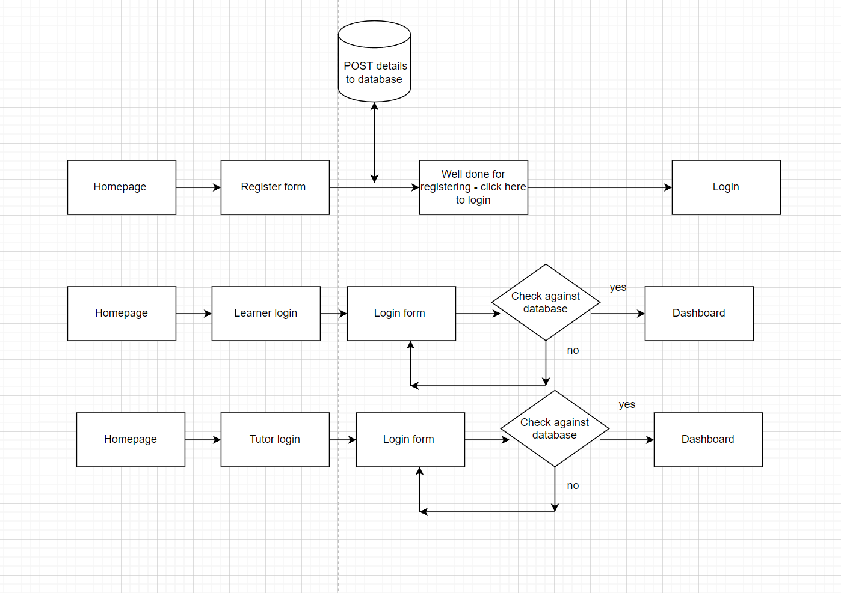

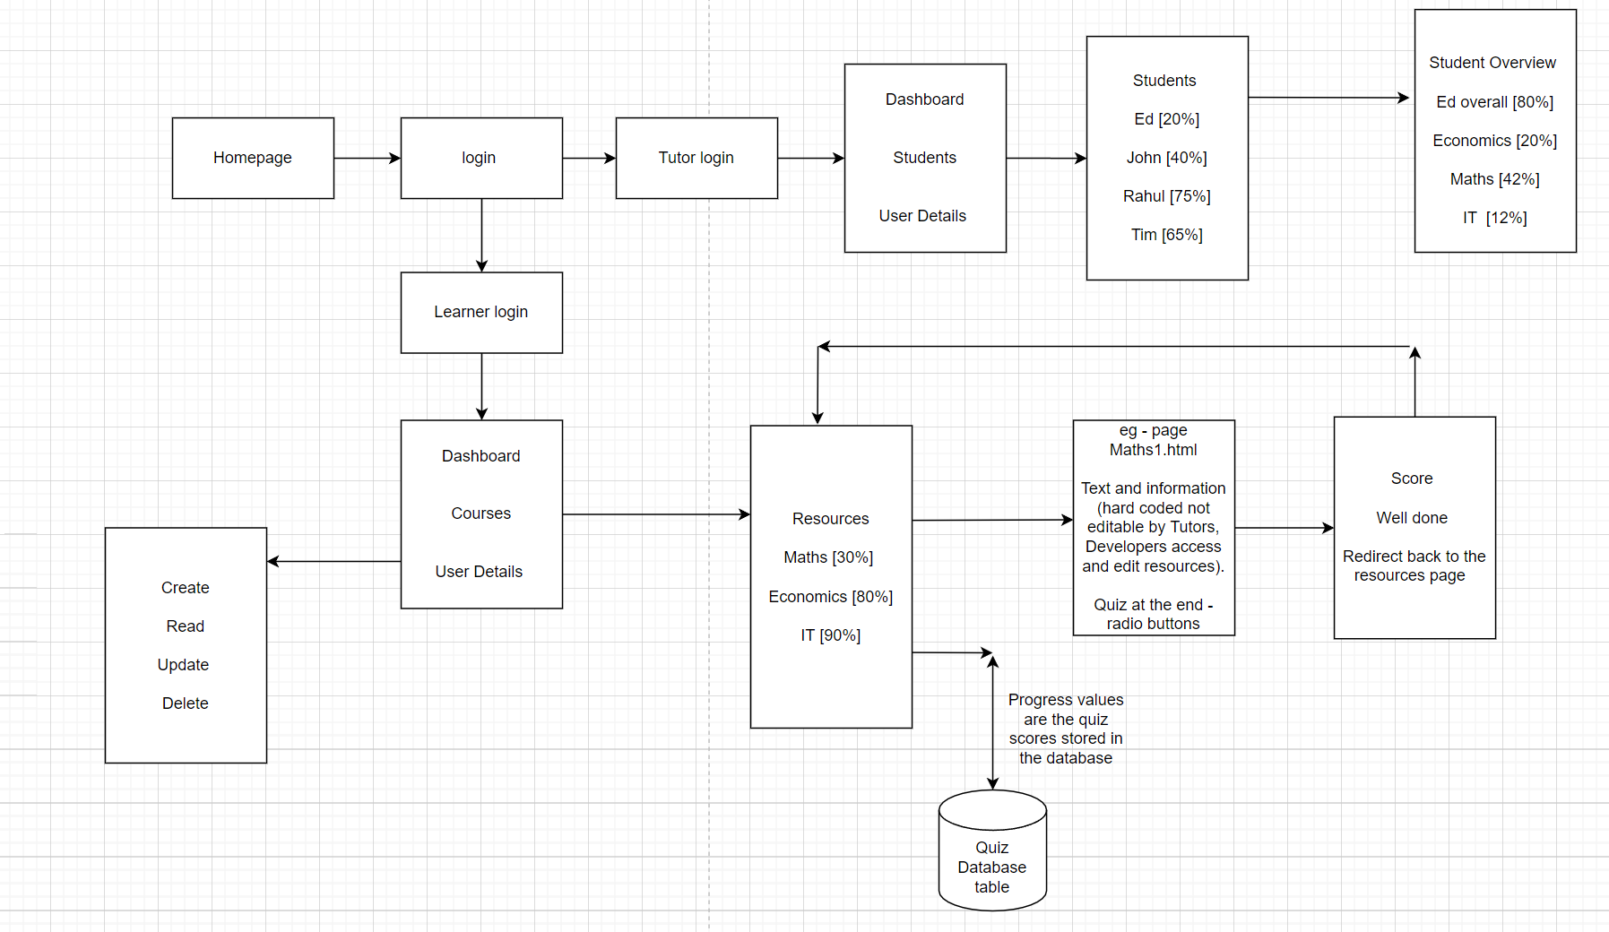

**KPIS**

* Must be compatible with smartphones, tablets, laptops and desktops. All accessible internet devices.
* Must allow users to take assessments and have their progress/score recorded.
* Must have functionality where both learner and tutor can see the learners progress.
* Maintain a suitable speed for each user
* Maintain a good general capacity (storage, processing power, etc.) - don’t overload.]

**Data**

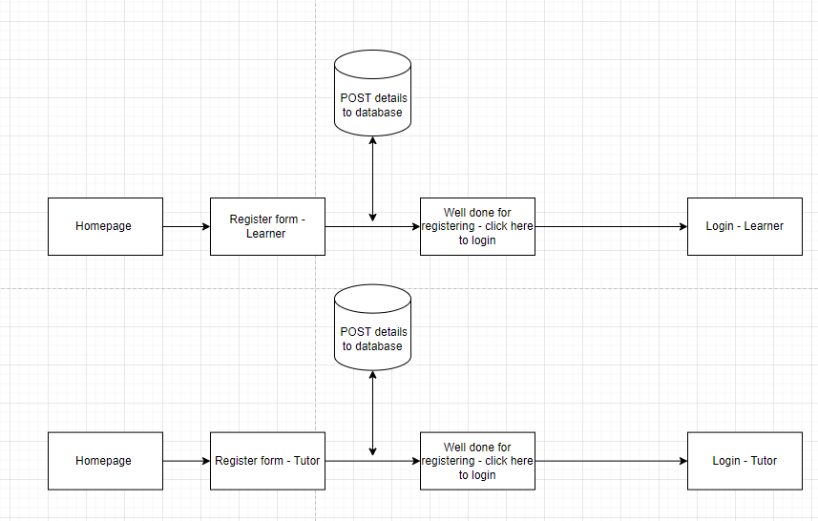

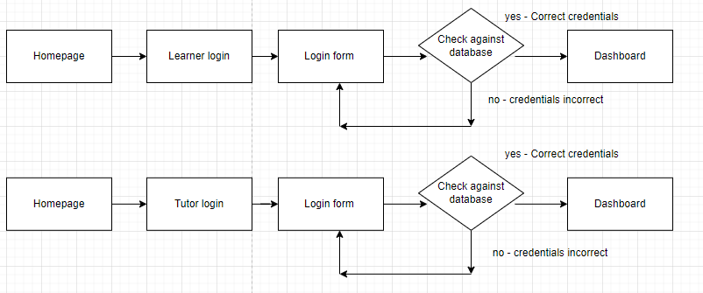

This shows that I will have a learner and tutor register and login system. This will produce 4 tables in the database, and only learners can login via the learner form and vice versa for the tutors.

The login system tests against the register database and once logged in a session will start and the login table learner/tutor will be filled in until that session runs out and then data will be removed from the table.

**Front end requirements and needs.**

There is a need for:

* An attractive and well laid out interface throughout the website.
* Link to back end

**Backend requirements and needs**

Data storage

Ability to read and write data

Security

Link to front end

<https://online.visual-paradigm.com/app/diagrams/#diagram:proj=0&type=DataFlowDiagram&width=11&height=8.5&unit=inch> FOR DFD Diagrams

