**Diwali**

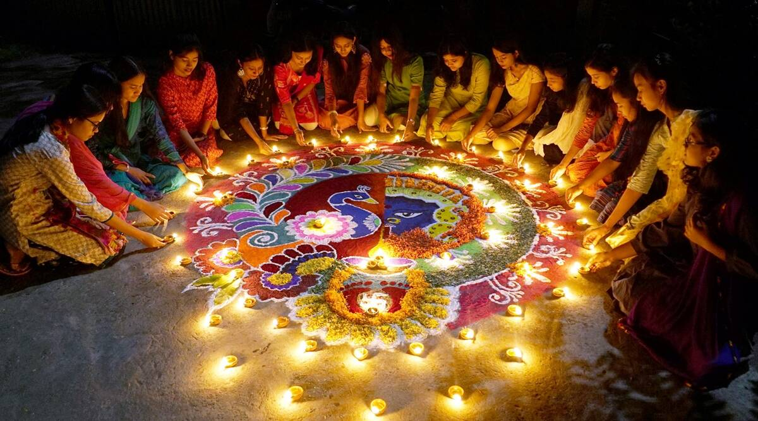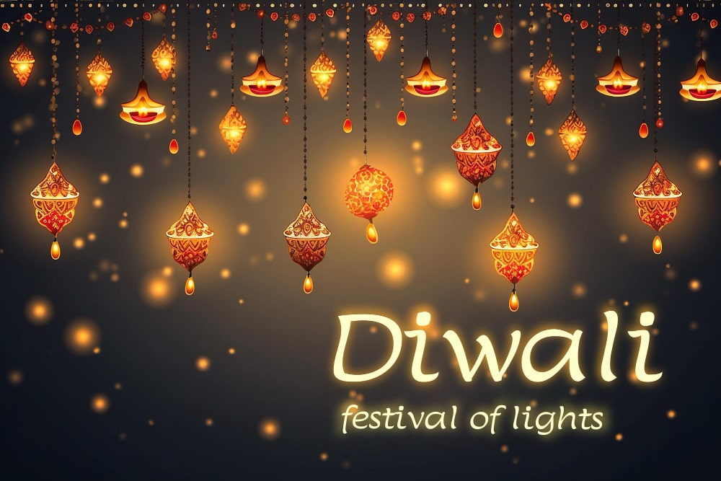About 80% of the Indian population regard themselves as Hindu.Most scholars believe Hinduism started somewhere between 2300 B.C. and 1500 B.C. in the Indus Valley, near modern-day Pakistan. But many Hindus argue that their faith is timeless and has always existed.Hindus observe numerous sacred days, holidays and festivals.Some of the most well-known include:-Diwali: the festival of lights-Navaratri: a celebration of fertility and harvest-Holi: a spring festival-Krishna Janmashtami: a tribute to Krishna’s birthday-Raksha Bandhan: a celebration of the bond between brother and sister-Maha Shivaratri: the great festival of Shiva

Diwali, or Dipawali, is India's biggest and most important holiday of the year. The festival gets its name from the row (avali) of clay lamps (deepa) that Indians light outside their homes to symbolize the inner light that protects from spiritual darkness. This festival is as important to Hindus as the Christmas holiday is to Christians.Over the centuries, Diwali has become a national festival that's also enjoyed by non-Hindu communities. For instance, in Jainism, Diwali marks the nirvana, or spiritual awakening, of Lord Mahavira on October 15, 527 B.C.; in Sikhism, it honors the day that Guru Hargobind Ji, the Sixth Sikh Guru, was freed from imprisonment. Buddhists in India celebrate Diwali as well.