**Heilala**

**When: July 3/4 for one to three weeks**

The largest celebration in Tonga is a multi-week event that takes place every year on July 3 or 4. The **Heilala Festival** is an annual celebration of the King's birthday that includes a variety of shows and activities. The celebration begins with the King's Birthday and continues throughout the week with talent shows, brass band performances, singing competitions, and other activities. The Miss Heilala beauty pageant is one of the highlights, with participants from all over the world coming together to promote Tonga's tradition and distinct culture via talent, beauty, and wisdom.

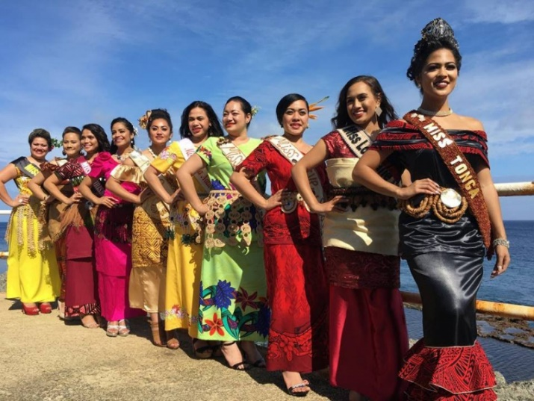

The Festival is called after the Heilala, Tonga's national flower, which is the highest in the Tongan flower hierarchy. Heilala plants are difficult to propagate and must be carefully managed in order to thrive.

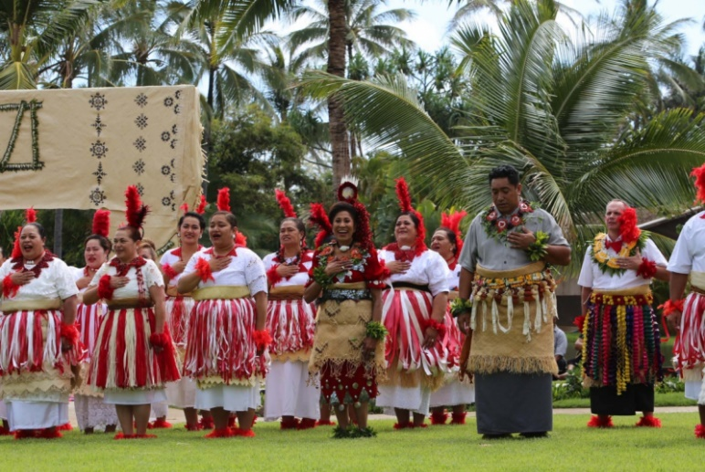

The Tonga Visitors Bureau (Ministry of Tourism) initially held the **Heilala Festival** in 1980 to commemorate His Late Majesty's King Taufa'ahau Tupou IV's birthday. It has since become one of the important and most famous festivals in Tonga.