SPEECH RECOGNITION SYSTEM USING

CONDITIONAL RANDOM FIELDS

A PROJECT REPORT

Submitted by

ROSHNI MURALI
in partial fulfillment for the award of the degree of

BACHELOR OF TECHNOLOGY
in

INFORMATION TECHNOLOGY

SRI SIVASUBRAMANIYA NADAR COLLEGE OF ENGINEERING,

KALAVAKKAM

APRIL 2014

ANNA UNIVERSITY: CHENNAI 600 025

BONAFIDE CERTIFICATE

Certified that this project report “SPEECH RECOGNITION SYSTEM USING CONDITIONAL RANDOM FIELDS” is the bonafide work of “ROSHNI MURALI (31510205090)” who carried out the project work under my supervision.

SIGNATURE SIGNATURE
Mrs. P.Vasuki Dr. T. NAGARAJAN
SSN PROFESSOR HEAD OF THE DEPARTMENT
Department of Information Department of Information
Technology Technology
SSN College of Engineering SSN College of Engineering
Chennai – 600 025. Chennai – 600 025.

ACKNOWLEDGEMENTS
I would like to extend my heartfelt gratitude to my Chairman Padma Bhushan Dr.Shiv Nadar and SSNCE management for giving us all resources needed for this project.
I would like to express my sincere thanks to my beloved and respected Principal Dr.S.Salivahanan for providing the necessary infrastructure and computing facilities to build my project in the college premises.
I would also like to express my deep sense of gratitude to Dr. T.Nagarajan, Professor and Head of Department, Information Technology who had supported me by providing me all the facilities deemed by the project during its course.
I convey my sincere thanks to my guide Mrs. P.Vasuki, for guiding me throughout this project and providing me with valuable ideas and suggestions.
I would also like to thank my friends who provided their knowledge and expertise whenever I encountered technical barriers during the implementation of this project.
Last, but not the least, I thank my family for bearing with me and being my pillars of support during tough times.

TABLE OF CONTENTS

CHAPTER NO. TITLE PAGE NO.
ACKNOWLEDGEMENTS 3

ABSTRACT 7

1 INTRODUCTION
1.1 Speech Production 8
1.2 Speech Recognition System 9

2 MOTIVATION 12

3 LITERATURE SURVEY

3.1 Existing Systems 13
3.1.1 Continuous Speech Recognition Systems
3.1.2 Discrete Speech Recognition Systems

3.2 Speech Recognition Algorithms 13
3.2.1 Hidden Markov Modeling
3.2.2 Dynamic Time Warping
3.2.3 Neural Networks
3. 2.4 Conditional Random Fields

4 SYSTEM ARCHITECTURE
4.1. Data Collection 19
4.2. Feature Extraction 20
4.2.1 Frame Blocking
4.2.2 Windowing
4.2.3 FFT
4.2.4 Mel Frequency Warping
4.2.5 Cepstrum
4.3 Training 23
4.4 Testing 23

5 IMPLEMENTATION DETAILS
5.1 Hardware Requirements 25
5.2 Software Requirements 25
5.3 Modules 25
5.3.1 Feature Representation
5.3.2 Decoding and Inference
5.3.3 Assigning Node Potentials
5.3.4 Initialising weights
5.3.5 Splitting weights
5.3.6 Error Computation
5.3.7 Training CRF

6 CONCLUSION 31
7 REFERENCES 31

ABSTRACT

Acoustic modeling based on hidden Markov models (HMMs) is employed by state-of-the-art stochastic speech recognition systems. Although HMMs are a natural choice to warp the time axis and model the temporal phenomena in the speech signal, their conditional independence properties limit their ability to model spectral phenomena well. In this project, a new acoustic modeling paradigm based on conditional random fields (CRF) is investigated and developed. This paradigm addresses some limitations of HMMs while maintaining many of the aspects which have made them successful. I present an efficient and new framework for estimating these models that ensures scalability and generality.

1. INTRODUCTION:

1.1 SPEECH PRODUCTION:

Humans communicate with one another through speaking. Human voice is as unique as fingerprint. It helps define his/her personality, mood, and health.
To be able to understand how the production of speech is performed one need to know how the human vocal mechanism is constructed . The most important parts of the human vocal mechanism are the vocal tract together with nasal cavity, which begins at the velum. The velum is a trapdoor-like mechanism that is used to formulate nasal sounds when needed. When the velum is lowered, the nasal cavity is coupled together with the vocal tract to formulate the desired speech signal. The cross sectional area of the vocal tract is limited by the tongue, lips, jaw and velum and varies from 0-20 cm2.
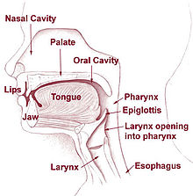

1.2 SPEECH RECOGNITION SYSTEM
This report discusses Speech Recognition Systems and how it takes input
and processes it for recognition of the correct word. Audio signals are either discrete in nature or continuous in nature. These signals are characterized in terms of signal model since without the source presence these provide much detail about the signal source.

Speech recognition converts speech signals to sequence of word. Speech
recognition can be classified into many models. But the most popular models are hidden Markov model and Conditional Random Fields.

Speech recognition is talking to a computer, having it recognize what one is saying, and trying to reproduce it in real time. This process fundamentally functions as a pipeline that converts PCM (Pulse Code Modulation) digital audio from a sound card into recognized speech.
The elements of the pipeline are:
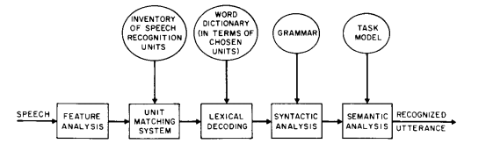

➢ Transform the PCM digital audio into a better acoustic representation – The input to the system is in the form of a stream of amplitudes. But audio in this form is not useful for the system. Hence, Fast-Fourier transformations are used to produce graphs of frequency components describing the sound heard for 1/100th of a second. The sounds are then identified by matching them to their closest entry in the database of graphs, producing a number called the “feature number” that describes the sound.

➢ Unit matching system
It provides likelihoods of a match of all sequences of speech recognition units to the input speech. These units may be phones, diphones, syllables, derivative units such as fenones and acoustic units or even whole word units. Each such unit is characterized by some model whose parameters are estimated through a training set of speech data.
➢ Lexical Decoding
It limits the unit matching system to follow only those path sequences whose speech units are present in a word dictionary.
➢ Apply a "grammar" so that the speech recognizer knows what phonemes to expect. This further places constraints on the search sequence of unit matching system.
➢ Figure out which phonemes are spoken
This is a quite difficult task as different words sound differently when spoken by different persons. Also, background noises from microphone make the recognizer hear a different sound. Thus, a probability analysis is done during recognition based on which a hypothesis is formed. The recognition system works by hypothesizing a number of different "states" at once. Each state contains a phoneme with a history of previous phonemes. The hypothesized state with the highest score is used as the final recognition result.

2. MOTIVATION

The accuracy of the most popular well known model, the hidden markov model depends on left to right traversal and analysis of previous n-1 states to predict the current state.
Conditional Random Fields has been experimented and studied upon to enhance this accuracy. They can traverse both back and forth resulting in an undirected graph. Probability of the next state depends on the previous n-1 states, the (n+1)^{th} state as well as the current state. It works upon the assumption that all available states influence the occurrence of the next state. This increases the accuracy of speech recognition and is an efficient and alternate model.

3. LITERATURE SURVEY

3.1 EXISTING SYSTEMS

3.1.1 Continuous Speech Recognition Systems:
This speech recognition system eliminates the need to insert a pause between every word. This recognition system let's one speak to the computer at a conversational pace. One speaks at the same pace as most conversations and the spoken words are transcribed immediately onto the computer screen.

3.1.2 Discrete Speech Recognition Systems:
This speech recognition system requires one to insert a slight pause between every word. This system is particularly useful for people having difficulties in forming complete phrases in one utterance.

3.2. SPEECH RECOGNITION ALGORITHMS

INTRODUCTION
Speech recognition is the translation of spoken words into text. It is also known as "automatic speech recognition" (ASR), "computer speech recognition" or just "speech to text" (STT).
Some recognition systems use "speaker independent speech recognition" while others use "training" where an individual speaker reads sections of text into the recognition system. These systems analyze the person's specific voice and use it to fine tune the recognition of that person's speech, resulting in more accurate transcription. Systems that do not use training are called "speaker independent" systems whereas systems that use training are called "speaker dependent" systems.

3.2.1 HIDDEN MARKOV MODELING TECHNIQUE:
Modern general-purpose speech recognition systems are based on Hidden Markov Models (HMM). A speech signal can be viewed as a piecewise stationary signal or a short-time stationary signal.
HMM is a statistical model in which the system being modeled is assumed to be a Markov process with unobserved states. They are left to right models, i.e. current state depends upon previous n-1 states. Each state is transient. The rightmost state is the absorbing state.
Consider an example to understand the modeling technique. A person is trying to deduce the weather of a particular day based on the seaweed, whether it is soggy or dry. If the seaweed is soggy then the weather is predicted to be rainy. The state of the weather can also depend on the previous day’s weather. This is called as the Markov assumption. In the system the weather is not observable i.e. the underlying state is hidden. The observable sequence would be the seaweed and the hidden state would be the weather.

3.2.2 DYNAMIC TIME WARPING ALGORITHM
Dynamic time warping is an approach that was historically used for speech recognition but has now largely been displaced by the more successful HMM-based approach.
It is an algorithm for measuring similarity between two sequences that may vary in time or speed. For example, similarities in walking patterns would be detected, if in one video the person was walking slowly and if in another he or she were walking more quickly, or even if there were accelerations and decelerations during the course of an observation. DTW has been applied to video, audio, graphics and any data that can be turned into a linear representation.
A well-known application has been automatic speech recognition, to cope with different speaking speeds. In general, it is a method that allows a computer to find an optimal match between two given sequences (e.g., time series) with certain restrictions. That is, the sequences are "warped" non-linearly to match each other.

3.2.3 NEURAL NETWORKS
Neural networks is an acoustic modeling approach in ASR. It is used in many aspects of speech recognition such as phoneme classification, isolated word recognition, and speaker adaptation.
In contrast to HMMs, neural networks make no assumptions about feature statistical properties. While estimating the probabilities of a speech feature segment, neural networks use discriminative training. Few assumptions on the statistics of input features are made with neural networks. Even though they have been successful in classifying short-time units such as isolated words, they are not very successful for continuous recognition tasks, mainly because of their lack of ability to model temporal dependencies. Thus, one alternative approach is to use neural networks for pre-processing e.g. feature transformation, dimensionality reduction, for the HMM based recognition.

3.2.4. CONDITIONAL RANDOM FIELDS
represents a sequence of input observations and represents the respective labels for the input observations.
are structured to form a chain, with an edge between each and .This layout admits efficient algorithms for:
- model training, learning the conditional distributions between the and feature functions from some corpus of training data.
- inference, determining the probability of a given label sequence given .
- decoding, determining the most likely label sequence given .

The conditional dependency of each on is defined through a fixed set of feature functions of the form , which can informally be thought of as measurements on the input sequence that partially determine the likelihood of each possible value for . The model assigns each feature a numerical weight and combines them to determine the probability of a certain value for .

Linear-chain CRFs have many of the same applications as HMMs, but relax certain assumptions about the input and output sequence distributions. An HMM can be understood as a CRF with very specific feature functions that use constant probabilities to model state transitions and emissions. Conversely, a CRF can be understood as a generalization of an HMM that makes the constant transition probabilities into arbitrary functions that vary across the positions in the sequence of hidden states, depending on the input sequence.
In contrast to HMMs, CRFs can contain any number of feature functions.
The feature functions can inspect the entire input sequence at any point during inference and the range of the feature functions need not have a probabilistic interpretation.

4. SYSTEM ARCHITECTURE
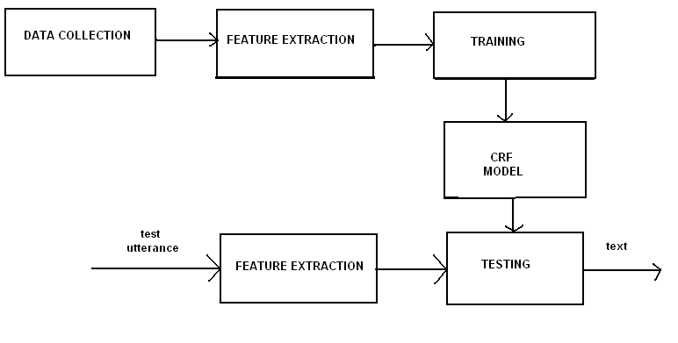

4.1 Data collection:
Speech data are collected from 20 speakers for training the system and building the respective CRF model. Each speaker is made to utter a selected phrase 10 times for a precise duration of 2 seconds.
Data is recorded in an environment where noise level is very low. If noise is present, the wave file will be corrupted and DC off set will be high. Also recording should be done in the same system with the same microphone. Speech data recording is done with a command brec (buffered sound recording/playing). brec copies data from the audio device to the named sound file.

4.2 Feature Extraction
Obtaining the acoustic characteristics of the speech signal is referred to as Feature Extraction. It comprise of the following steps:
1. Frame Blocking
2. Windowing
3. FFT (Fast Fourier Transform)
4. Mel-Frequency Wrapping
5. Cepstrum (Mel Frequency Cepstral Coefficients)
This stage is often referred as speech processing front end. The main goal of Feature Extraction is to simplify recognition by summarizing the vast amount of speech data without losing the acoustic properties that defines the speech. The schematic diagram of the steps is depicted in the below figure
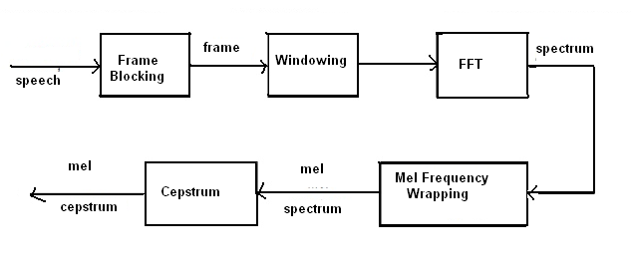

4.2.1 Frame Blocking
Investigations show that speech signal characteristics stays stationary in a sufficiently short period of time interval (It is called quasi-stationary). For this reason, speech signals are processed in short time intervals. It is divided into frames with sizes generally between 30 and100 milliseconds. Each frame overlaps its previous frame by a predefined size. The goal of the overlapping scheme is to smooth the transition from frame to frame.

4.2.2 Windowing
The second step is to window all frames. This is done in order to eliminate discontinuities at the edges of the frames. If the windowing function is defined as w(n), 0 < n < N-1 where N is the number of samples in each frame, the resulting signal will be; y(n) = x(n)w(n). In this project, hamming windows are used.

4.2.3 Fast Fourier Transform
The next step is to take Fast Fourier Transform of each frame. It changes the domain from time to frequency.

4.2.4 Mel Frequency Warping
The human ear perceives the frequencies non-linearly. Researches show that the scaling is linear up to 1 kHz and logarithmic above that. The Mel-Scale (Melody Scale) filter bank characterizes the human ear’s perceiveness of frequency. It is used as a band pass filtering for this stage of identification. The signals for each frame is passed through Mel-Scale band pass filter to mimic the human .As mentioned above, psychophysical studies have shown that human perception of the frequency contents of sounds for speech signals does not follow a linear scale. Thus for each tone with an actual frequency, f , measured in Hz, a subjective pitch is measured on a scale called the mel scale. The mel-frequency scale is a linear frequency spacing below 1000 Hz and a logarithmic spacing above 1000 Hz. As a reference point, the pitch of a 1 kHz tone, 40 dB above the perceptual hearing threshold, is defined as 1000 mels. Therefore we can use the following approximate formula to compute the mels for a given frequency
f in Hz:
mel(f)=2595*(log (1 + f/700))
One approach to simulating the subjective spectrum is to use a filter bank, one filter for each desired mel-frequency component. That filter bank has a triangular bandpass frequency response, and the spacing as well as the bandwidth is determined by a constant mel-frequency interval. The number of mel cepstral coefficients, K, is typically chosen as 20. Note that this filter bank is applied in the frequency domain; therefore it simply amounts to taking those triangle-shape windows on the spectrum. A useful and efficient way of implementing this is to consider these triangular filters in the Mel scale where they would in effect be equally spaced filters

4.2.5 Cepstrum
Cepstrum name was derived from the spectrum by reversing the first four letters of spectrum. We can say cepstrum is the Fourier Transformer of the log with unwrapped phase of the Fourier Transformer.
Mathematically we can say
Cepstrum of signal = FT(log(FT(the signal))+2IIm)
Where,
FT – Fourier Transform
m – the integer required to properly unwrap the angle or imaginary part of the complex log function.
II - 3.14
For defining the real values real cepstrum uses the logarithm function while for defining the complex values, the complex cepstrum uses the complex logarithm function. The real cepstrum uses the information of the magnitude of the spectrum, whereas complex cepstrum holds information about both magnitude and phase of the initial spectrum which allows the construction of the signal. We can calculate the cepstrum by many ways.

4.3 TRAINING

This involves splitting of weights and assigning each feature a numerical weight and then combining them to determine the probability of a certain value for . Learning the parameters is usually done by maximum likelihood learning for p(Yi|Xi). All nodes are observed during training. The Quasi-Newton algorithm has been used here.

4.4 TESTING
During testing, the test utterance will be compared with the trained CRF model and the likelihood value is calculated. If the test utterance is correct, a higher likelihood value will be produced else a lower likelihood value will be produced. Since the input mel frequency coefficients are in floating point form, some discrepancies may occur in the reshape() function, which may result in error. This is because the reshape() function takes only integers as arguments.
So, an effective way of testing would be to insert pauses between segments of code and using the round() function where floating point values are used.

5. IMPLEMENTATION DETAILS

5.1 Hardware Requirements
Processor : Any Processor above 512 MHz.
Ram : 256 MB.
Hard Disk : 80 GB.
Compact Disk : 650 MB.
Input Device : Standard Keyboard, microphone and mouse.
Output Device : PC Monitor.

5.2 Software Requirements
Operating System : Windows XP, Windows 7.
Software : Matlab R2010a
Compiler : Mingw( for compilation of mex files), gnumex

5.3 MODULES
Feature Representation
Decoding and inference
Assigning Node Potentials
Initialising weights
Splitting weights
Error computation
Training CRF

5.3.1 Feature Representation
The functions use a data matrix X and a label vector y. Each element i in y gives the label at position i, among the values 0-k (for some k). The label 0 is special, it indicates the position between 'sentences'. Each element (i,j) in the data matrix X gives the value of feature j at position i, among the values 0-f (for some f that can be different for each feature). A feature value of 0 is special, it indicates that the feature is ignored at this position (this is used in natural language applications to represent words that don't occur very often). The features at positions with label values of 0 are ignored.

5.3.2 Decoding and Inference
Decoding involves computing the most likely configuration. Inference involves computing the partition function and marginal probabilities.

5.3.3 Assigning Node Potentials
In CRFs, the potentials depend on the features. So to make a set of potentials, we need to choose a set of features. The function CRF_makePotentials takes a training instance number and returns the corresponding potentials.

5.3.4 Initialising weights
The model uses four sets of parameters:
w_{i,j,k}: The potential of state j given that feature i takes the value k.
v_{start,j}: The potential of state j to start a sentence.
v_{end,j}: The potential of state j to end a sentence.
v_{i,j}: The potential for the transition from state i to j.

5.3.5 Splitting Weights

This involves assigning weights to each phenome or word. Each feature is given a numerical weight and then combined to determine the probability of a certain value for .

5.3.6 Error Computation
This involves computation of training and testing error based on likelihood value.

5.3.7 Training CRF
It considers minimizing the negative log-likelihood in order to maximize the likelihood. The negative log-likelihood (and its) gradient are computed. With log-linear CRFs, the negative log-likelihood is still differentiable and jointly convex in the node and edge parameters, so we can again computes its optimal value using minFunc. The negative log-likelihood for CRFs takes features as arguments.

OUTPUT

MFCC output
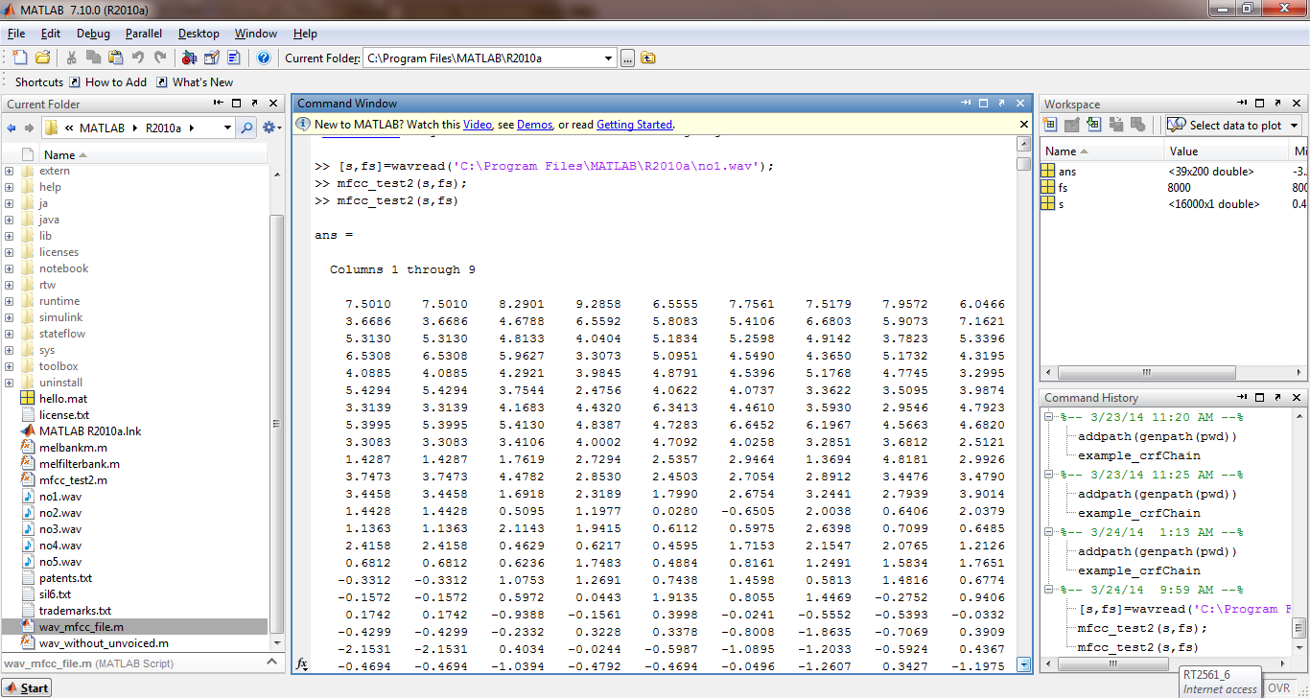

crfChain output
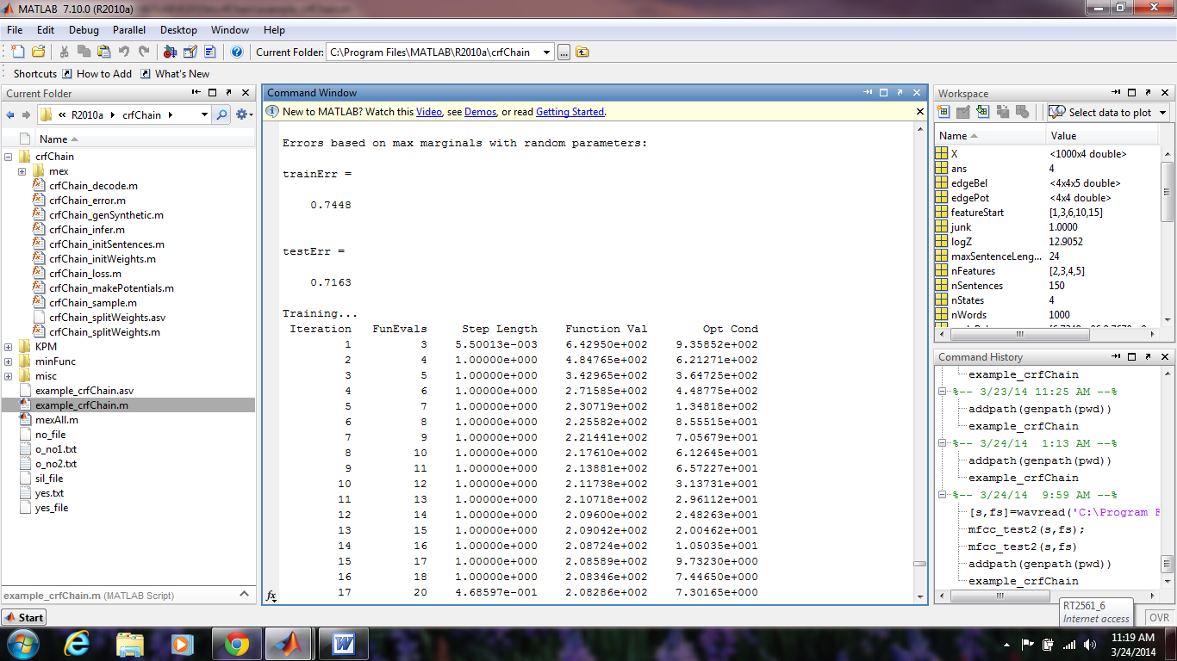

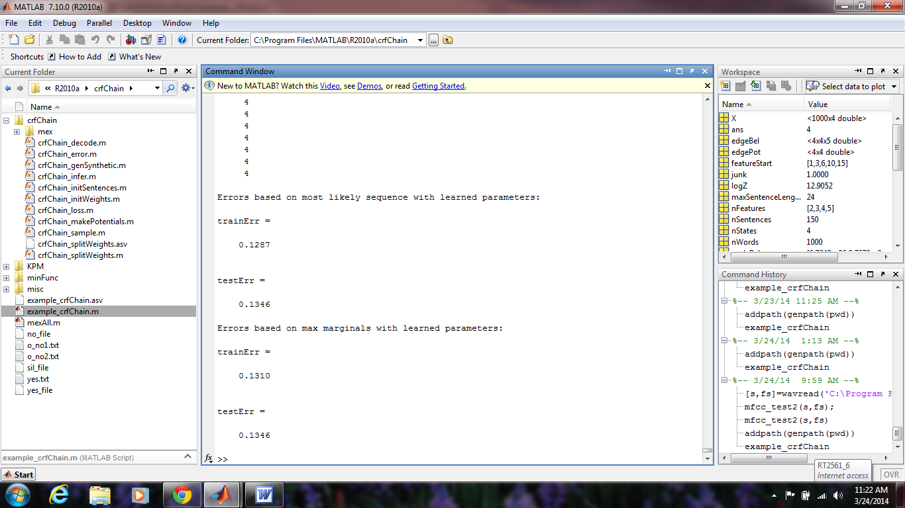

6. CONCLUSION
Thus a new concept called Conditional Random Fields was experimented,
analysed and studied. The accuracy of speech recognition was improved by
taking future states into consideration.

7. REFERENCES
1. crfChain by Mark Schmidt, Kevin Swersky (2008).
2. Lafferty, J., McCallum, A., Pereira, F. (2001)."Conditional random fields: Probabilistic models for segmenting and labeling sequence data". Proc. 18th International Conf. on Machine Learning. Morgan Kaufmann. pp. 282–289.
3. Conditional Random Fields: An Introduction. ∗. Hanna M. Wallach. , 2004.
4. “Conditional Random Fields for information Extraction” by Sunita
Sarawagi, Indian Institute of Technology, Bombay

