Data Mining 10.12.2017 – Piotr Mrowczynski – Assignment 5

The goal of this assignment is to understand distributed graph partitioning using gossip-based peer-to-peer techniques, such as, JaBeJa described in [F. Rahimian, et al., JA-BE-JA: A Distributed Algorithm for Balanced Graph Partitioning, SASO2013]

Project structure

k-way-graph-partitioning
├── src/main/java/se/kth/jabeja
│ │
│ └── Jabeja.java : JaBeJa algorithm implementation
│
├── compile.sh : Building project
│
├── run.sh : Running project
│
├── plot.sh : Plotting results
│
└── FreqItemsAssoc.odt

3elt.graph

1000 rounds, 0.003 delta, 2.0 temp, 2.0 alpha

Linear anealing with local candidates – ~4000edge cut
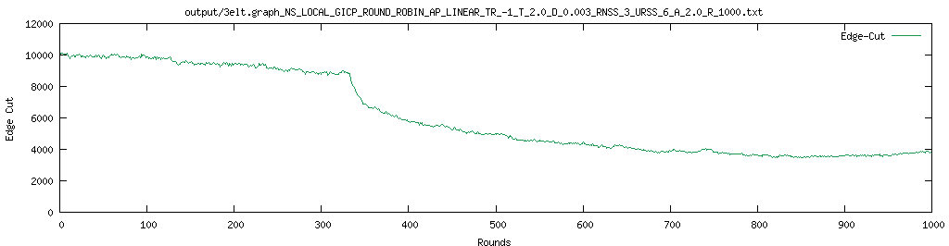
Linear anealing with random candidates – ~6200edge cut
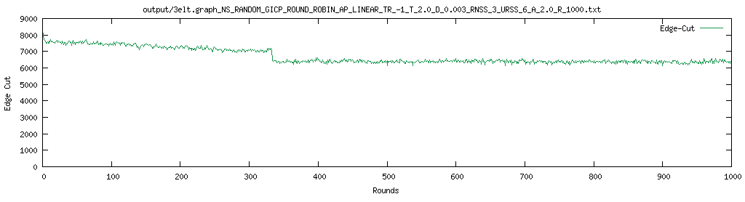

Linear anealing with hybrid candidates – ~3800edge cut
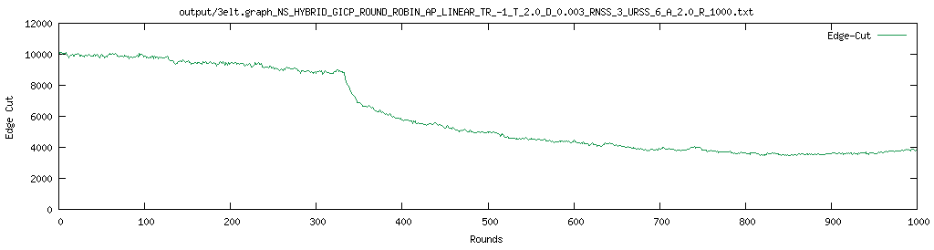
Linear anealing conclusions

For this graph using linear anealing, local and hybrid gave good results, while random gave bad results

Acceptance Probability with local candidates – ~3200edge cut

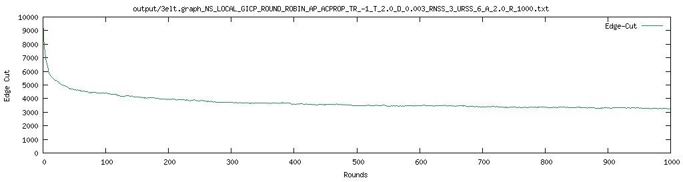
Acceptance Probability with random candidates – ~1200edge cut

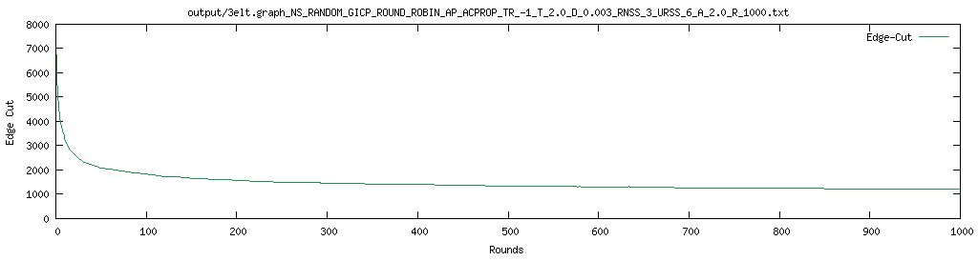
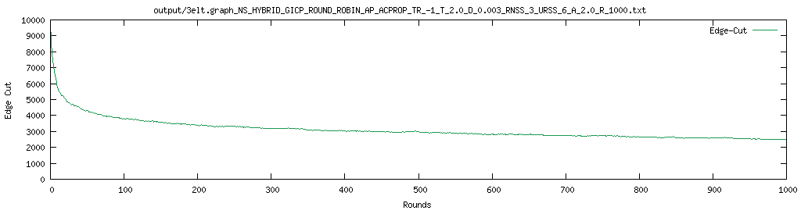
Acceptance Probability with hybrid candidates – ~2500edge cut

Facebook

1000 rounds, 0.003 delta, 2.0 temp, 2.0 alpha

Linear anealing with local candidates – ~565000 edge cut

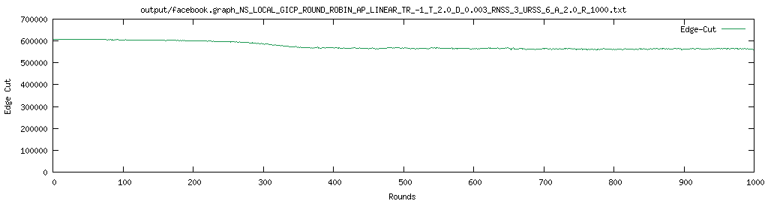
Linear anealing with random candidates – ~580000 edge cut

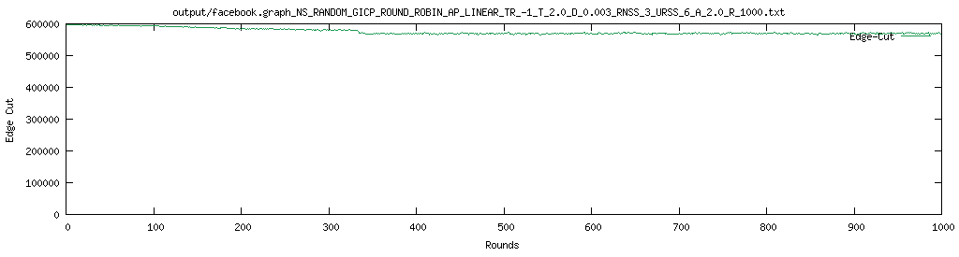
Acceptance Probability with local candidates – ~220000 edge cut

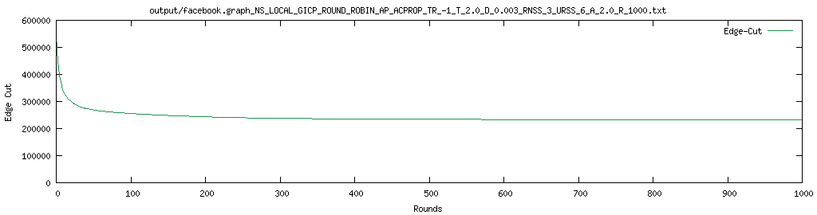
Acceptance Probability with random candidates – ~130000 edge cut

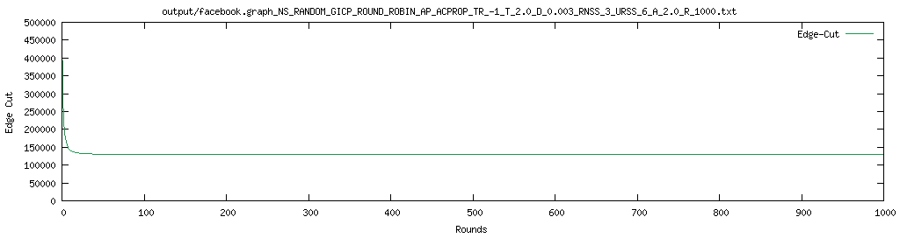

Acceptance probability anealing conclusions – both graphs

Using acceptance probability in both graphs convergence is achieved much faster, and with better edge-cuts. It is due to avoiding a problem of stuck in the local optima solution to do the fact with certain (decreasing) probability we allow bad-cuts to be able to get into global optima.

3elt.graph – parameters testing

2500 rounds, random, acceptance probability, reset 2500 – ~1000 edge cuts
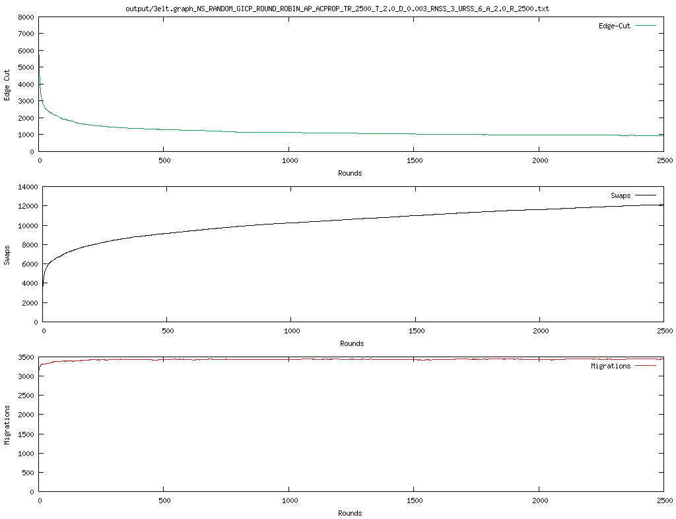

2500 rounds, random, acceptance probability, reset 1250 – ~980 edge cuts

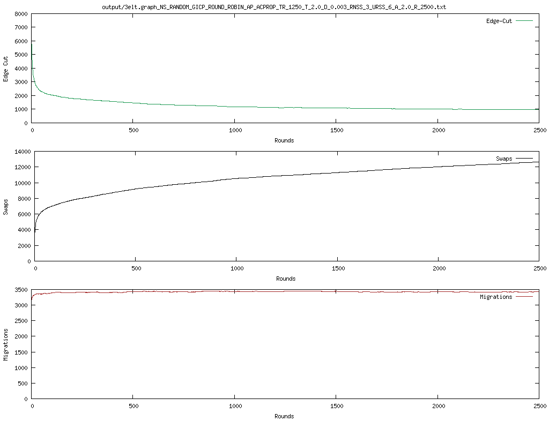
2500 rounds, random, acceptance probability, reset 500 – ~930 edge cuts
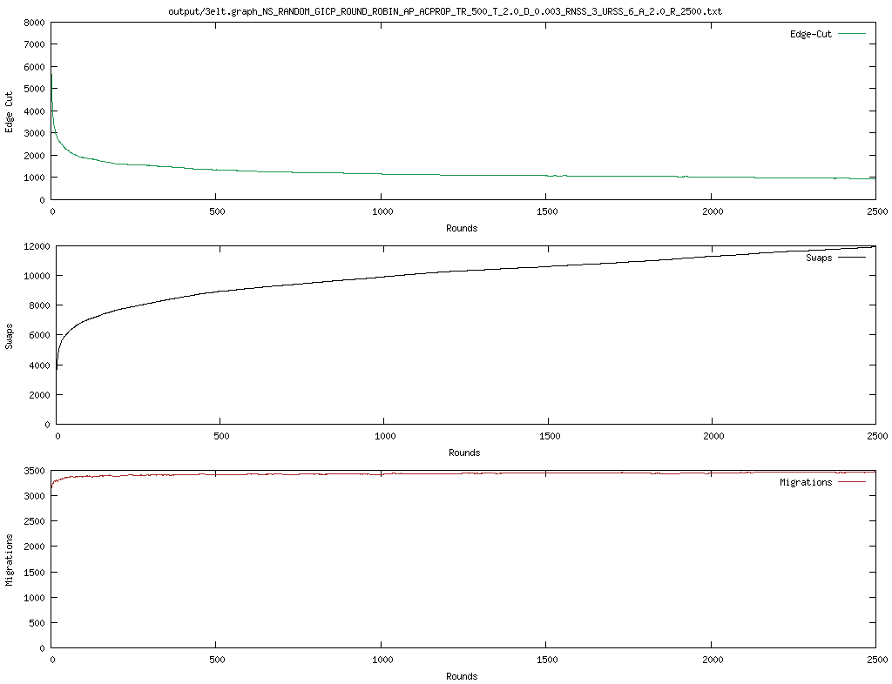

3elt.graph – parameters performance

random – acceptance probability – slow and fast converge, low number of swaps
hybrid – linear – fast and slow converge, high number of swaps

