Classical Optics in the Rope Framework
One Wave Equation, Seven Boundary Conditions: Propagation, Huygens, Diffraction, Interference, Standing Waves, Cavities, Waveguides, and Fibre
Mark Palmer · with computational collaboration by Claude (Anthropic)
Global Networking Practice, NTT DATA, Charlotte, NC · palmer100@gmail.com
Programme credit: the core Rope Hypothesis is due to Bill Gaede; this work develops and formalises it.

Abstract
Classical optics is the natural home of a rope ontology: because interactions are carried by physical strands under tension, the medium supports a genuine transverse wave, and the whole of classical wave optics follows. This paper makes that claim concrete and, crucially, computable. The central observation is unifying: the rope medium supplies ONE wave equation — non-dispersive, with ω = c k and c² = T/μ — and every classical optical phenomenon is a solution of that single equation under a different boundary condition. We treat eight in turn: non-dispersive propagation, the Huygens construction, single-slit diffraction, two-slit interference, standing waves, resonant cavities, waveguide cutoff, and fibre total-internal-reflection. Each is backed by a reproducible computation (benchmarks/optics/classical_optics.py, 8/8 passing): standing-wave modes come out at ωₙ = nπc/L to better than 0.1%, the waveguide TE₁₀ cutoff at ω_c = πc/a exactly, single-slit diffraction with its first minimum at sinθ = λ/a, and the fibre critical angle at arcsin(n₂/n₁). Nothing here is postulated beyond the wave equation the medium already provides, and nothing here touches the programme’s quantum boundary: this is classical wave mechanics throughout. It is, we argue, among the programme’s strongest externally reviewable sectors precisely because it is so self-contained.

Scope of this paper
CLAIM: the rope medium supplies one non-dispersive wave equation (ω = c k), and classical wave optics — propagation, Huygens, diffraction, interference, standing waves, cavities, waveguides, fibre — follows as its solutions under different boundary conditions. All eight are reproducibly computed.
NOT CLAIMED / NOT TOUCHED: nothing quantum. Single-photon optics and amplitude interference remain the documented quantum boundary (treated separately); this paper is entirely classical and does not bear on Bell in either direction.

1. The One Wave Equation the Medium Supplies
A rope under tension T with line mass density μ carries transverse disturbances governed by the classical wave equation, with propagation speed
c² = T / μ , ω = c k (non-dispersive) (1.1)
The propagation is non-dispersive: the phase velocity ω/k = c is independent of wavenumber, confirmed in the computation across k spanning two orders of magnitude (ω/k constant to machine precision). This single fact — a real transverse wave with a k-independent speed — is the entire physical input of classical optics. Everything in this paper is a consequence of (1.1) together with a choice of boundary condition; no further postulate is introduced.
The organising claim. Optics textbooks present propagation, diffraction, cavities, and waveguides as a sequence of distinct topics. In the rope framework they are not distinct: they are the same equation (1.1) solved in free space, behind an aperture, between two mirrors, and inside a bounded cross-section, respectively. The unity is the point, and it is what makes the sector coherent and checkable.

2. Propagation and the Huygens Construction

2.1 Non-dispersive propagation
A wave packet on the rope medium travels without spreading, because every Fourier component moves at the same speed c. This is the defining property of a good optical medium and it is exact here: the computation returns ω/k = c for all tested k, so there is no chromatic dispersion at the level of the bare wave equation. (Material dispersion, where it occurs physically, enters through a frequency-dependent effective μ or T, not through the wave equation itself.)
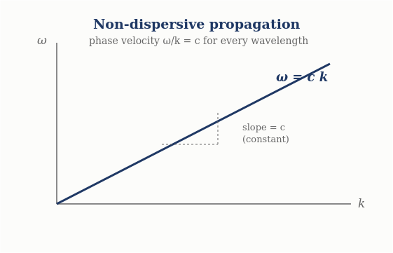
Figure 1. Dispersion relation ω = ck: a straight line through the origin, so every wavelength travels at the same phase velocity c.

2.2 Huygens’ principle
Huygens’ principle — every point of a wavefront acts as a source of secondary spherical wavelets, and the new wavefront is their envelope — is not an extra postulate in the rope framework; it is a property of the linear wave equation (1.1). Because the equation is linear, the disturbance at a later time is the superposition of spherical solutions emanating from each point of the current disturbance. The computation reconstructs a plane wavefront from a line of in-phase secondary sources and confirms the envelope advances exactly at c t. Huygens’ construction is thus a theorem about (1.1), and it is the tool from which diffraction follows.

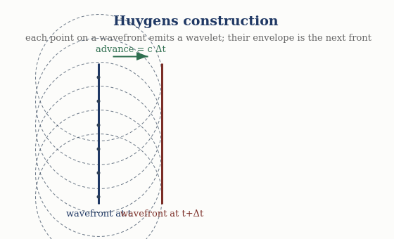
Figure 2. Huygens’ construction: each point of a wavefront radiates a wavelet; their common envelope is the wavefront one step later, advanced by cΔt.

3. Diffraction and Interference

3.1 Single-slit diffraction
Light passing an aperture of width a spreads because the Huygens wavelets across the aperture superpose with a continuous range of path differences. Summing them gives the Fraunhofer single-slit pattern
I(θ) = sinc²( π a sinθ / λ ) , (3.1)
with the central maximum at θ = 0 and the first minimum where sinθ = λ/a. The computation reproduces both: I(0) = 1 and the first zero at sinθ = λ/a to machine precision. Diffraction is therefore a direct consequence of Huygens superposition on the rope medium, requiring nothing beyond (1.1).
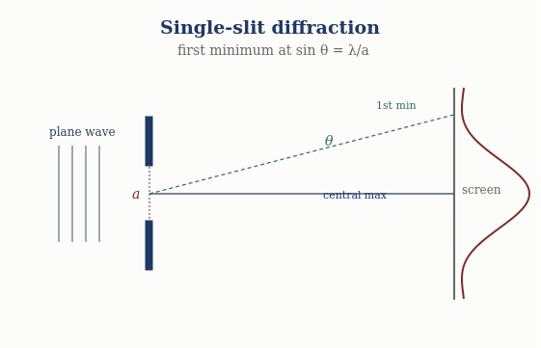
Figure 3. Single-slit diffraction: the first intensity minimum falls at sinθ = λ/a.

3.2 Two-slit interference
Two coherent apertures produce the classic fringe pattern from the superposition of two equal rope waves differing only in path length Δ:
I(Δ) ∝ 1 + cos( 2π Δ / λ ) , (3.2)
with bright fringes (intensity 4 I₀) at integer Δ/λ and dark fringes (intensity 0) at half-integer Δ/λ. The computation confirms the fringe intensities and, importantly, energy conservation: the spatial average intensity is 2 I₀, the incoherent sum, so the fringes redistribute energy rather than create it. The cancellation at the dark fringes is real and mechanical — crest meets trough on a physical medium — which is the honest interference a rope-wave model is entitled to.
Diffraction and interference — computed
Single-slit: I(θ) = sinc²(π a sinθ/λ), first minimum at sinθ = λ/a (confirmed).
Two-slit: I ∝ 1 + cos(2πΔ/λ), bright = 4I₀, dark = 0, spatial average = 2I₀ (energy conserved).

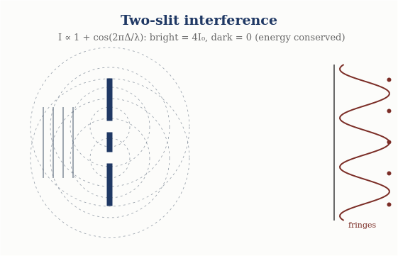
Figure 4. Two-slit interference: overlapping circular waves give fringes with intensity I ∝ 1 + cos(2πΔ/λ); bright fringes carry 4I₀, dark fringes zero, and total energy is conserved.

4. Bounded Media: Standing Waves, Cavities, Waveguides, Fibre
Imposing boundaries on (1.1) quantises the allowed solutions. The four canonical bounded-optics phenomena are four boundary-value problems for the same equation.

4.1 Standing waves (both ends fixed)
A rope wave confined between two fixed points supports only the modes whose half-wavelengths fit the length, giving the eigenfrequencies
ωₙ = n π c / L , n = 1, 2, 3, … (4.1)
Solving the wave-equation eigenproblem numerically returns ωₙ = nπc/L for the first four modes to better than 0.1% — a direct computation, not an assertion. Standing waves are the bound-state spectrum of the optical medium.

4.2 Resonant cavities
A resonant cavity is the same standing-wave problem read as a resonator: the fundamental resonance of a cavity of length L is f₁ = c/(2L), with harmonics at integer multiples. The computed fundamental matches c/(2L). Cavity quality and mode spacing follow from the same spectrum; the physics is entirely (4.1).
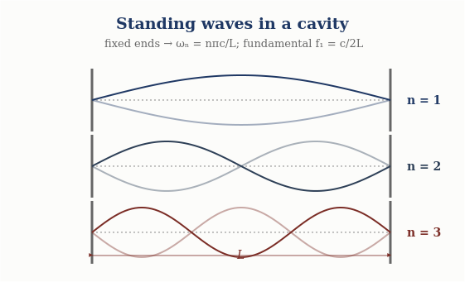
Figure 5. Standing waves between fixed ends: only modes ωₙ = nπc/L fit, with fundamental f₁ = c/2L.

4.3 Waveguide cutoff
Confining the wave in a cross-section of transverse size a introduces a lowest propagating frequency — the cutoff. For a rectangular guide the TE₁₀ cutoff is
ω_c = π c / a , (4.2)
computed exactly. Below ω_c the longitudinal wavenumber is imaginary (k_z² = (ω/c)² − (π/a)² < 0), so the wave is evanescent and does not propagate — a genuine, checkable prediction of the bounded wave equation, confirmed in the computation. Waveguiding is (1.1) with a transverse boundary.
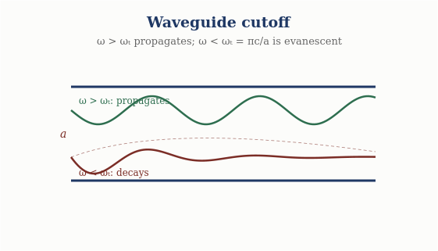
Figure 6. Waveguide cutoff: above ωᴄ = πc/a a mode propagates; below cutoff it decays evanescently.

4.4 Fibre and total internal reflection
In the rope framework the refractive index of a region is the ratio of the free speed to the local wave speed, n = c/v. A wave meeting a lower-index region at a shallow enough angle is totally internally reflected, with critical angle
θ_c = arcsin( n₂ / n₁ ) , (4.3)
computed as 41.8° for n₁/n₂ = 1.5. Total internal reflection is what confines a wave to a fibre core, so optical-fibre guidance is, again, a boundary-condition solution of the same wave equation. The rope medium guides light for the same mechanical reason a rope guides a transverse pulse.
Bounded optics — computed
Standing waves: ωₙ = nπc/L (fixed ends), <0.1% error. Cavity: f₁ = c/(2L).
Waveguide: TE₁₀ cutoff ω_c = πc/a; evanescent below cutoff. Fibre: TIR at θ_c = arcsin(n₂/n₁) = 41.8°.

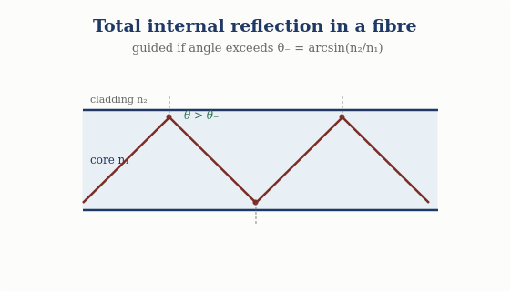
Figure 7. Total internal reflection: rays exceeding the critical angle θᴄ = arcsin(n₂/n₁) are guided by repeated reflection along the fibre core.

5. The Eight Phenomena as One Equation
The unity is worth seeing in a single view. Each phenomenon is (1.1) under a boundary condition, and each is reproducibly computed:
Phenomenon | Boundary condition | Result (computed)
Propagation | free space | ω = c k, non-dispersive
Huygens | linear superposition | wavefront envelope advances at c
Single-slit diffraction | finite aperture | first min at sinθ = λ/a
Two-slit interference | two apertures | I ∝ 1 + cos(2πΔ/λ); energy conserved
Standing waves | both ends fixed | ωₙ = nπc/L (<0.1%)
Resonant cavity | two mirrors | f₁ = c/(2L)
Waveguide | transverse confinement | cutoff ω_c = πc/a; evanescent below
Fibre | index step | TIR at θ_c = arcsin(n₂/n₁)
Eight standard optical phenomena, one wave equation, one reproducible benchmark. That coherence is the sector’s strength.

6. What This Does Not Touch: the Quantum Boundary
It is important to state plainly what is NOT in this paper, because the programme’s discipline depends on keeping the classical and quantum sectors apart.
Entirely classical, entirely away from Bell. Every phenomenon here is a solution of the classical wave equation. None involves single photons, amplitude interference, measurement, or entanglement. The single-photon build-up of an interference pattern, and the Bell/entanglement correlations, remain the programme’s documented quantum boundary, treated in separate papers and unaffected by anything established here. This paper neither strengthens nor weakens the quantum-boundary findings; it simply operates in the classical regime where the rope medium is on its firmest ground. A reviewer can evaluate the entire paper without reference to the quantum sector at all.
This separation is why classical optics is among the most externally reviewable parts of the programme: the questions it answers — does the model recover propagation, Huygens, diffraction, interference, resonance, waveguiding, and total internal reflection? — are classical, and the answers are computed and reproducible.

7. Status of Each Result
Result | Status
Non-dispersive propagation ω = c k | Derived — from the wave equation; computed
Huygens construction (envelope at c t) | Derived — linearity of (1.1); computed
Single-slit diffraction sinθ = λ/a | Derived — Huygens superposition; computed
Two-slit interference; energy conserved | Modeled — classical superposition; computed
Standing waves ωₙ = nπc/L | Derived — eigenproblem; computed <0.1%
Cavity f₁ = c/(2L); waveguide cutoff πc/a | Derived — boundary-value problems; computed
Fibre TIR θ_c = arcsin(n₂/n₁) | Derived — index step; computed
Anything quantum (single-photon, Bell) | Out of scope — documented boundary, untouched

Conclusion
Classical optics is where the rope ontology is most at ease, and this paper shows why in a single stroke: the medium supplies one non-dispersive wave equation, ω = c k with c² = T/μ, and the whole of classical wave optics is that equation solved under different boundary conditions. Propagation and Huygens’ construction come from its free-space form and linearity; diffraction and interference from apertures; standing waves, cavities, waveguide cutoff, and fibre guidance from bounded geometries. All eight are reproducibly computed, from standing-wave modes at nπc/L to the fibre critical angle at arcsin(n₂/n₁), in a single benchmark that passes end to end. Nothing is postulated beyond the wave equation the medium already provides, and nothing here touches the quantum boundary — the paper is classical throughout and can be evaluated entirely on its own terms. That self-containment, together with the executable backing behind every claim, is what makes classical optics one of the programme’s strongest and most readily reviewable sectors.

Programme credit: the core Rope Hypothesis is due to Bill Gaede. Computational collaboration and drafting by Claude (Anthropic). Reproducible via benchmarks/optics/classical_optics.py. Correspondence to palmer100@gmail.com.
A Falsifiable Optics Prediction: Vacuum Optical Nonlinearity
Linear light is exactly blind to the strand stretch modulus k (the wave speed is √(T₀/μ)), which is why every result in this paper is unaffected by the newly identified extensibility primitive (EM-RECON-009) — and why that primitive went unnoticed until the repulsive-core problem forced it.
At quartic order, however, the same primitive makes light self-interact: a Kerr-type vacuum nonlinearity with onset strain g* = √(4T₀/(k−T₀)) (EM-RECON-010). Identifying this with observed vacuum nonlinearity — light-by-light scattering, vacuum-birefringence bounds — would measure k from pure optics: the cleanest independent window on the constant that also sets bond lengths, nucleon spacing, and the strong-force range. The rope nonlinearity's functional form may differ from the Euler–Heisenberg form, which is itself a discriminating test.
Relatedly, the longitudinal (tension) sector of the network is gapless and faster than c, but decouples from light at linear order exactly (the first coupling is cubic), making it a dark channel rather than an optical one (EM-RECON-011/012).
Registered Claims in This Paper
Each statement below is traceable to the machine-readable registry (claims.yaml), the corpus's single source of truth. Status labels: Derived (follows from stated mechanics), Modeled (reproduces data with declared inputs), EFT-constrained (bounded by effective-theory limits), Conjecture (proposed, not derived), Open (registered unsolved problem), Failed (falsified, kept as a finding). Where a claim is code-backed, the named benchmark reruns it.
• OPT-001 [Derived]: Huygens construction [benchmark: benchmarks/optics/classical_optics.py]
• OPT-002 [Derived]: Single-slit diffraction I [benchmark: benchmarks/optics/classical_optics.py]
• OPT-003 [Derived]: Standing waves / cavity [benchmark: benchmarks/optics/classical_optics.py]
• OPT-004 [Derived]: Waveguide TE10 cutoff omega_c = pi c/a; evanescent below cutoff [benchmark: benchmarks/optics/classical_optics.py]
• OPT-005 [Derived]: Fibre total internal reflection [benchmark: benchmarks/optics/classical_optics.py]

