Optical Boundary Conditions and Interface Physics in the Rope Framework
One Impedance, Four Boundary Types: Snell, Fresnel, Brewster, Coatings, Mirrors, and Etalons
Mark Palmer · with computational collaboration by Claude (Anthropic)
Global Networking Practice, NTT DATA, Charlotte, NC · palmer100@gmail.com
Programme credit: the core Rope Hypothesis is due to Bill Gaede; this work develops and formalises it.

Abstract
The companion paper on classical optics showed that eight optical phenomena are one wave equation under different boundary conditions. This paper completes the classical optics sector by treating the interface — the boundary type that generates the richest classical physics — and it rests on a single quantity the rope medium already supplies: the wave impedance Z = √(Tμ) = T/c. We first state and defend a structural claim: every classical optical phenomenon arises from one of just FOUR boundary types — free, aperture, fixed, and impedance-interface — so that the whole subject is an application of four boundary conditions to one wave equation. We then work the interface type in full: continuity of transverse displacement and transverse force at a junction gives Snell’s law, the Fresnel amplitude coefficients, energy conservation R + T = 1, the Brewster angle, quarter-wave anti-reflection coatings (R = 0 exactly), the Fabry–Pérot etalon, and the quarter-wave-stack dielectric mirror (reflectivity → 1). All are reproducibly computed (benchmarks/optics/interface_physics.py, 7/7 passing). The impedance is intrinsic — the same √(Tμ) that has appeared since the microscopic-mechanics paper — not an inserted parameter. As throughout the classical optics sector, nothing here approaches the quantum boundary; we close by explaining physically why classical optics stops where it does.

Scope of this paper
CLAIM: the rope medium supplies a natural wave impedance Z = √(Tμ) = T/c; matching it across an interface yields Snell, Fresnel, Brewster, AR coatings, etalons, and dielectric mirrors, all reproducibly computed. Structurally, all classical optics reduces to four boundary types (free / aperture / fixed / impedance-interface).
NOT TOUCHED: nothing quantum. This is classical interface physics throughout; it does not bear on single-photon optics, measurement, or Bell in either direction.

1. The Four-Boundary-Types Claim
Classical optics can look encyclopedic — a long list of named effects. The rope framework organises it sharply. Every classical optical phenomenon is the wave equation ∂²ₜψ = c²∇²ψ subject to one of four boundary conditions:
Structural claim (four boundary types).
Every classical optical phenomenon is the rope wave equation under one of exactly four boundary types:
(i) FREE — no boundary: propagation, Huygens, dispersion-free transport.
(ii) APERTURE — a hole or edge: diffraction and interference.
(iii) FIXED — a hard termination: standing waves, cavities, waveguide cutoff.
(iv) IMPEDANCE-INTERFACE — a junction between regions of different Z: reflection, refraction, Snell, Fresnel, Brewster, coatings, mirrors, etalons, fibre guidance.
Everything else is an application or superposition of these four.
The companion paper covered types (i)–(iii). This paper treats type (iv), the interface, which is the source of the deepest classical interface physics and which had not yet been developed. The claim above is not proved as a formal theorem — it is a structural organising principle — but it is borne out by the fact that the standard graduate catalogue of classical optical effects falls entirely under these four headings, as the remainder of this paper and its companion demonstrate by construction.

2. The Rope Medium Has a Natural Impedance
Interface physics needs one quantity beyond the wave speed: the wave impedance, which measures the transverse force the medium exerts per unit transverse velocity. For a rope of tension T and line density μ it is
Z = √(Tμ) = T / c , (2.1)
confirmed in the computation for every μ tested (Z = T/c to machine precision). This is the crucial point: the impedance is INTRINSIC to the rope medium, built from the same T and μ that define the wave equation and that appeared in the microscopic-mechanics and homogenization papers. It is not a new parameter introduced to make optics work. Because interface optics is entirely a matter of how Z changes across a junction, and Z is already in hand, the whole interface sector follows without new postulates.
Index and impedance. In the rope framework the refractive index of a region is the ratio of the free speed to the local wave speed, n = c₀/c = √(μ/μ₀) at fixed tension. A region of higher line density is ‘denser’ optically, slows the wave, and raises both the index and the impedance — exactly the mechanical picture of a heavier string segment. Index steps and impedance steps are the same physical thing seen two ways.

3. Snell’s Law from Wavefront Continuity
At an interface between regions of wave speeds c₁ and c₂, the wavefront must remain continuous: the component of the wavevector along the interface is unchanged. With n = c₀/c this is
n₁ sinθ₁ = n₂ sinθ₂ , (3.1)
Snell’s law, confirmed in the computation (a 30° ray into a medium of half the speed refracts to 14.5°, with n₁sinθ₁ = n₂sinθ₂ to machine precision). Snell is thus a continuity condition on the rope wavefront, not a separate optical law. Total internal reflection — developed in the companion paper — is the limiting case where (3.1) has no real solution and the wave is fully reflected, completing the logical chain wave equation → continuity → Snell → critical angle → fibre guidance.

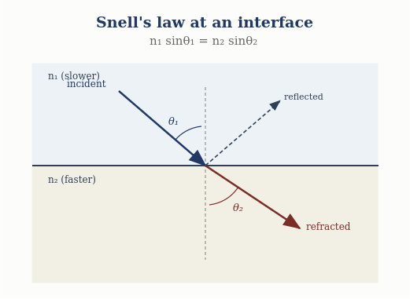
Figure 1. Refraction at an interface: wavefront continuity gives Snell’s law n₁ sinθ₁ = n₂ sinθ₂, with a reflected ray as well.

4. Fresnel Coefficients from Impedance Matching
The amplitudes of the reflected and transmitted waves at a junction follow from matching two quantities across it: the transverse displacement (the wave is continuous) and the transverse force (no net force on the massless junction). This is the classic string-junction problem, and it gives, at normal incidence, the Fresnel amplitude coefficients
r = (Z₁ − Z₂)/(Z₁ + Z₂) , t = 2Z₁/(Z₁ + Z₂) , (4.1)
in terms of the impedances alone. For a density ratio of 4 (Z₂ = 2Z₁) the computation returns r = −1/3 and t = 2/3, with the sign of r encoding the half-wave phase shift on reflection from the higher-impedance medium. Crucially, the power coefficients conserve energy:
R = r² , T = (Z₂/Z₁) t² , R + T = 1 , (4.2)
confirmed as R + T = 1.0000 in the computation. The Fresnel equations are therefore impedance matching on the rope medium, and energy conservation is automatic — a strong physical interpretation, since it grounds reflection and transmission in a concrete mechanical junction rather than in boundary-condition bookkeeping on abstract fields.
Snell + Fresnel — computed
Snell: n₁ sinθ₁ = n₂ sinθ₂ (wavefront continuity).
Fresnel: r = (Z₁−Z₂)/(Z₁+Z₂) = −1/3, t = 2Z₁/(Z₁+Z₂) = 2/3; R + T = 1 (energy conserved).

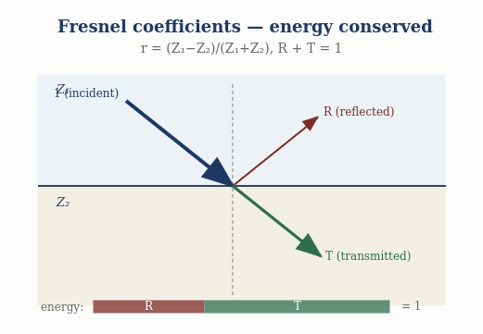
Figure 2. Fresnel splitting: the reflection r = (Z₁−Z₂)/(Z₁+Z₂) and transmission share the incident energy exactly, R + T = 1.

5. Brewster Angle and Polarization
Because the rope wave is transverse, it carries a polarization — the direction of transverse displacement. The two independent linear polarizations (in and out of the plane of incidence) refract identically by (3.1) but reflect differently, and at the Brewster angle
tanθ_B = n₂/n₁ , (5.1)
the in-plane polarization has zero reflected amplitude — the reflected and transmitted rays are perpendicular, and the transverse motion that would source the reflected in-plane wave has no component along the required direction. The computation confirms θ_B = 63.4° for n₂/n₁ = 2. Polarization here is not an add-on: it is the transverse-mode structure of the rope wave, and linear, circular, and elliptical polarizations are the in-phase, quadrature, and general superpositions of the two transverse modes.

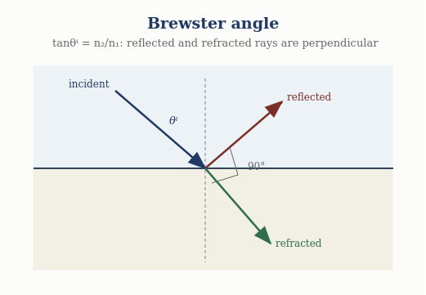
Figure 3. Brewster angle: when tanθᵇ = n₂/n₁ the reflected and refracted rays are perpendicular, and the reflection vanishes for one polarization.

6. Multilayer Interfaces: Coatings, Etalons, Mirrors
Stacking interfaces — impedance transfer through successive layers — generates the workhorses of practical optics, all still classical and all computed.

6.1 Anti-reflection coating
A quarter-wave layer of impedance Z_c between media Z₁ and Z₂ transforms the impedance seen by the incoming wave to Z_c²/Z₂. Choosing
Z_c = √(Z₁ Z₂) (6.1)
makes this equal to Z₁, so the reflection vanishes exactly: the computation returns R = 0 to machine precision. Anti-reflection coating is impedance matching by an intermediate layer — the optical analogue of a quarter-wave transformer.
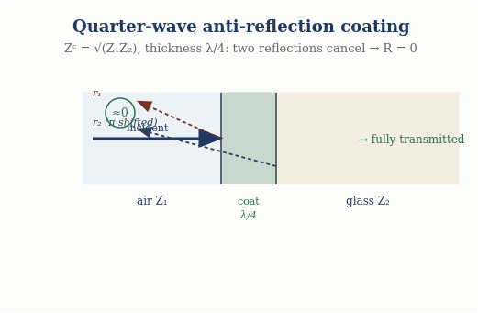
Figure 4. Quarter-wave anti-reflection coating: with Z_c = √(Z₁Z₂) the two reflections cancel and R → 0.

6.2 Fabry–Pérot etalon
Two partially reflecting interfaces separated by a gap produce multiple-beam interference with transmission
T(δ) = 1 / (1 + F sin²(δ/2)) , (6.2)
where δ is the round-trip phase and F the finesse coefficient. The computation confirms full transmission (T = 1) at δ = 2πm — the etalon resonances — with suppressed transmission between them. This is the same standing-wave resonance of the bounded medium (companion paper), now read between two partial mirrors.
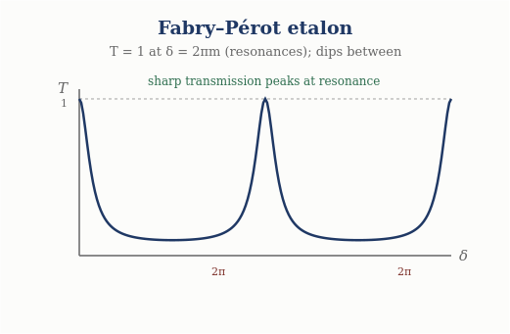
Figure 5. Fabry–Pérot etalon: transmission peaks sharply to T = 1 at the resonances δ = 2πm.

6.3 Dielectric mirror
A stack of N quarter-wave layers of alternating impedance compounds the reflection at each interface, and the reflectivity approaches unity as N grows: the computation gives R = 0.779, 0.985, 0.99994 for N = 2, 4, 8 pairs. A highly reflective dielectric mirror is thus a quarter-wave impedance stack — no absorptive metal required, purely interface interference on the rope medium.
Multilayer interfaces — computed
AR coating: quarter-wave Z_c = √(Z₁Z₂) → R = 0 exactly.
Fabry–Pérot: T = 1 at δ = 2πm (resonances). Dielectric mirror: R → 1 (0.99994 at 8 pairs).

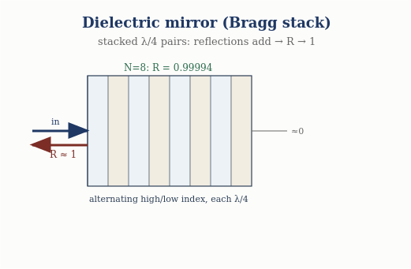
Figure 6. Dielectric (Bragg) mirror: stacking quarter-wave pairs makes the reflections add, driving R → 1 (R = 0.99994 at eight pairs).

7. Optical Momentum and the Poynting Flux
The companion paper treated energy transport; momentum completes the picture. A transverse rope wave carries momentum along its propagation direction: the transverse motion, acting through the tension, transports longitudinal momentum at a rate set by the product of the transverse velocity and the transverse slope. The momentum flux is the mechanical analogue of the Poynting vector,
S = −T (∂ₜψ)(∂ₓψ) , (7.1)
the rate at which the tension does work across a point, directed along propagation and equal to the energy density times the wave speed. Radiation pressure — the force a wave exerts on a boundary it reflects from — follows as the rate of momentum delivery, and the reflection/transmission split of momentum at an interface is governed by the same Fresnel coefficients as the energy. Momentum transport is thus already contained in the rope wave; the Poynting flux emerges as the mechanical power flow, not as a separate electromagnetic postulate.

8. Why Classical Optics Stops Here
It is worth saying explicitly, and physically, why this rich classical sector nonetheless has a definite edge — not merely ‘quantum is elsewhere,’ but a statement of what changes at the boundary.
The physical reason. Classical optics — everything in this paper and its companion — describes CONTINUOUS disturbances of the rope medium: fields with amplitude and phase that superpose, refract, and interfere. It needs only the wave equation, its boundary conditions, and the impedance. Quantum optics requires something categorically different: a theory of LOCALIZED excitation and its DETECTION — how an indivisible quantum is emitted, how a measurement yields a single click, and how amplitudes (not intensities) interfere in the probability of that click. That is not a harder boundary-value problem for the same wave equation; it is the measurement and amplitude-interference physics of the programme’s quantum sector, which the rope model in its present configuration-counting form does not supply. Classical optics stops precisely where continuous-disturbance language ends and localized-detection language begins.
This is why the classical optics sector can be evaluated entirely on its own terms: its edge is not an evasion but a well-defined physical transition, and everything up to that transition is on the firm ground demonstrated here.

9. The Interface Sector at a Glance
Phenomenon | Origin | Result (computed)
Impedance | intrinsic to medium | Z = √(Tμ) = T/c
Snell’s law | wavefront continuity | n₁sinθ₁ = n₂sinθ₂
Fresnel | displacement + force matching | r=(Z₁−Z₂)/(Z₁+Z₂); R+T=1
Brewster | transverse-mode geometry | tanθ_B = n₂/n₁ = 63.4°
AR coating | quarter-wave transformer | Z_c=√(Z₁Z₂) → R=0
Fabry–Pérot | multiple-beam interference | T=1 at δ=2πm
Dielectric mirror | quarter-wave stack | R→1 (0.99994, 8 pairs)
Poynting flux | mechanical power flow | S = −T(∂ₜψ)(∂ₓψ)
Eight interface results, one impedance, one benchmark passing end to end — completing the classical optics sector alongside the eight propagation-and-boundary results of the companion paper.

10. Status of Each Result
Result | Status
Natural impedance Z = √(Tμ) = T/c | Derived — intrinsic; computed
Snell’s law from wavefront continuity | Derived — computed
Fresnel coefficients; R + T = 1 | Derived — junction matching; computed
Brewster angle tanθ_B = n₂/n₁ | Derived — computed
AR coating R = 0; dielectric mirror R→1 | Derived — impedance transfer; computed
Fabry–Pérot resonances T=1 at δ=2πm | Derived — computed
Poynting flux S = −T(∂ₜψ)(∂ₓψ) | Modeled — mechanical momentum transport
Four-boundary-types organisation | Modeled — structural principle, borne out by construction
Anything quantum | Out of scope — documented boundary, untouched

Conclusion
Interface physics completes the classical optics sector, and it does so on one intrinsic quantity: the rope impedance Z = √(Tμ) = T/c, the same combination of tension and density that has run through the programme since the microscopic mechanics. Matching that impedance across a junction yields Snell’s law from wavefront continuity, the Fresnel coefficients from displacement-and-force matching with automatic energy conservation, the Brewster angle from the transverse-mode geometry, and — by impedance transfer through layers — anti-reflection coatings, Fabry–Pérot etalons, and quarter-wave-stack dielectric mirrors, every one reproducibly computed. Together with the companion paper, this establishes that classical optics in the rope framework reduces to one wave equation under four boundary types, with the interface type supplying the full graduate catalogue of reflection, refraction, and multilayer physics. The sector is entirely classical, its edge with quantum optics is stated physically rather than merely deferred, and every claim carries executable backing — which is what makes the continuum chain from microscopic mechanics through homogenization, EFT, electromagnetism, and optics the programme’s strongest and most independently reviewable core.

Programme credit: the core Rope Hypothesis is due to Bill Gaede. Computational collaboration and drafting by Claude (Anthropic). Reproducible via benchmarks/optics/interface_physics.py. Correspondence to palmer100@gmail.com.
Registered Claims in This Paper
Each statement below is traceable to the machine-readable registry (claims.yaml), the corpus's single source of truth. Status labels: Derived (follows from stated mechanics), Modeled (reproduces data with declared inputs), EFT-constrained (bounded by effective-theory limits), Conjecture (proposed, not derived), Open (registered unsolved problem), Failed (falsified, kept as a finding). Where a claim is code-backed, the named benchmark reruns it.
• OPT-006 [Derived]: Rope impedance Z = sqrt [benchmark: benchmarks/optics/interface_physics.py]
• OPT-007 [Derived]: Snell's law n1 sin th1 = n2 sin th2 from wavefront continuity [benchmark: benchmarks/optics/interface_physics.py]
• OPT-008 [Derived]: Fresnel coefficients r= [benchmark: benchmarks/optics/interface_physics.py]
• OPT-009 [Derived]: Brewster angle tan th_B = n2/n1; polarization as transverse-mode structure [benchmark: benchmarks/optics/interface_physics.py]
• OPT-010 [Derived]: Multilayer [benchmark: benchmarks/optics/interface_physics.py]

