The Rope Picture of the Universe
Mark Palmer · July 2026 · corpus v2.2.1
A Plain-Language Guide to Light, Electricity, Magnetism, Gravity, Chemistry, the Nucleus, and Black Holes
Building on Bill Gaede’s Rope Hypothesis. Crediting the origin is not an endorsement of every position Gaede holds.

One Object, Six Tricks
Imagine someone hands you a single object — one rope — and says: explain absolutely everything with this.
A rope can do a surprising number of things. It can carry a ripple. It can twist. It can be tied into a knot. It can be pulled tight under tension. It can hum with a standing vibration. It can be stretched. Six different tricks — and the question this guide explores is a daring one: could six completely different pieces of physics — light, electricity, magnetism, gravity, chemistry, and black holes — turn out to be nothing more than six different things the SAME rope can do?
That is the whole game. As you read, notice something: no new ingredient ever gets added. It is the same rope on every page — now rippling, now twisting, now vibrating, now pulled taut. By the last chapter the hope is that you feel a small jolt of surprise that the explanation never had to change.
Here is the picture in one breath. Imagine the universe filled with an unimaginable number of ropes — not metaphors, real two-strand ropes like a twisted double cord — stretching between every pair of atoms in existence. You are tied to your chair, to the Sun, to the nearest star, to every scrap of matter in the cosmos. The ropes are under tension, like a guitar string pulled tight. They can twist and wiggle. And crucially they pass THROUGH each other and through matter without tangling — like beams of light crossing, not like ropes piled on a table.
THE SIX, IN SIX WORDS | Light = RIPPLE. Charge = HANDEDNESS (the mirror-orientation of the two strands, like a left vs right glove). Current = TURNING that helix like a screw, so it drives the load at the far end. Magnetism = the network’s CIRCULATING RESPONSE to those rotating ropes. Gravity = TENSION. Chemistry = STANDING WAVE. Black hole = EXHAUSTED TENSION. Six words. One rope. Keep them in mind — they are the whole book in miniature, and every chapter is just one of these words unpacked.
Why Try to Picture It This Way?
A fair question before we start: physics already works: why bother learning another picture of it? The answer is that physics has always moved forward by finding a simpler picture hiding underneath complicated mathematics.
Newton showed that the falling apple and the orbiting Moon were the same thing. Maxwell showed that electricity and magnetism were two faces of one thing. Einstein showed that gravity and the geometry of space were deeply the same thing. Each leap took phenomena that looked unrelated and revealed one idea underneath. This guide follows that same spirit and asks a single question: could six apparently different phenomena be six behaviours of one underlying object, a rope?
That framing matters, because it means the rope picture is not trying to OVERTURN modern physics — it reproduces the same tested equations, as we will keep noting. It is trying to offer a physical THING to hold in your mind where physics usually hands you only mathematics.
THE ITCH IT SCRATCHES. Modern physics gets the right ANSWERS but often gives strange non-answers for what is physically HAPPENING. A “wave packet” that spreads out and then “collapses.” A “virtual particle” that by definition can never be seen. “Dark matter” that is really just a name for something not yet found. The rope picture tries to replace those placeholder words with an actual object you could, in principle, picture — the way you can picture a wave on the ocean, even if you can’t picture a “wave packet.”

Light — A Ripple Racing Down the Rope
Think of the rope not as a static cord but as something that can carry a traveling ripple — the way a wave races down a jump rope when you snap your wrist, or a ripple crosses a pond after you drop a stone. That traveling ripple, moving sideways to the rope’s own length, is light.
What mainstream physics says | What the rope picture proposes
Light is an oscillation of the electromagnetic field — a self-sustaining ripple of the abstract E and B fields at each point of spacetime, governed by Maxwell’s equations. Ask “what is waving?” and modern physics answers: the field itself, a mathematical object; there is no mechanical medium (the old “aether” was abandoned over a century ago). | Light is a literal ripple travelling along a real physical rope, the way a wave races down a jump rope. There IS something waving — the rope network — and it plays the role a medium plays for sound or water waves.
The math: the SAME wave equation, reproduced. The rope adds a mechanical ORIGIN for the speed of light: c = √(T/μ), the speed set by the network’s tension T and mass-per-length μ — the same value physics measures, now with a physical reason behind it rather than a postulate.
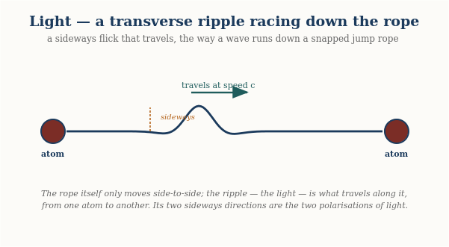
Light is a transverse ripple: the rope moves only side-to-side, while the ripple itself races along it from one atom to another at speed c. The two sideways directions are the two polarisations of light. (The travelling wave becomes a standing wave when confined — that trapped version is what forms the electron shells in the chemistry chapter.)
THE ANALOGY. Picture two people holding a long jump rope, and one of them gives it a single, sharp flick. A hump of rope travels down the length of the cord at a fixed speed — determined by how tightly the rope is pulled and how heavy it is per foot — and arrives at the other end carrying exactly the energy of that flick. That traveling hump, in the rope picture, IS a photon: a single, localized kink racing along a real physical rope.
A single flick sends one hump racing down the rope at speed c — that travelling hump is a photon. The rope only moves sideways; the pattern is what travels.
If you have ever seen a crowd do “the wave” around a stadium, you already have the deepest part of this picture. Nobody in the crowd runs around the stadium — each person just stands up and sits back down. Yet a wave races all the way around the stands. The PATTERN travels; the people barely move. Light is exactly that: the ripple races along at full speed while the rope itself barely stirs. Hold on to this image — a pattern moving through a medium that itself stays nearly still — because electric current, a few chapters on, turns out to be the very same trick.
This picture explains several things that are usually left as unexplained mathematical facts:
- Why light always travels at exactly the same speed (c). The ripple’s speed is set by the rope’s tension and weight, both fixed properties of the background rope network — the way the speed of a sound wave is set by the medium it travels through, not by how loud the sound is.
- Why light has a color (frequency). A gentle flick sends a long, lazy ripple; a sharp flick sends a tight, rapid one. The tightness of the ripple is its frequency — red light is a lazier ripple, blue light a tighter one.
- Why light has polarization. The rope is a two-strand structure, like a twisted double cord, and the ripple can travel while favoring one strand’s plane of motion over the other — that preferred direction of wiggle is what polarizing sunglasses filter.
- Why the vacuum of empty space isn’t really empty. There’s no such thing as a ripple with nothing to ripple THROUGH. In this picture, the rope network is the thing light travels through — it plays the role that the medium plays for a sound wave or a water wave.
HONEST LIMIT: nearly all of everyday optics now falls straight out of this one picture. The full classical behaviour of light follows from the single rope wave equation — how it bends and spreads through a slit, how two beams interfere, how lenses focus, how mirrors and anti-reflection coatings work, how light stays trapped inside a fibre-optic cable. All of it is the same travelling ripple meeting different boundaries, with no new ingredient. What the rope does NOT resolve on its own is the deeper QUANTUM puzzle — why a single photon seems to “know” about both slits at once. That one piece is handled in the papers by borrowing an existing (and still debated) interpretation of quantum mechanics. So the rope gives all of classical light a physical home and reproduces it in full; it is only the deepest mystery of quantum measurement that it does not, by itself, resolve.

Electricity — Strand Handedness and Its Streaming
Here is the one detail about the rope we have saved until now, because electricity is where it matters most: each rope is really two strands. Electric charge is not a substance added to the rope, and not a number of knots tied in it. It is the HANDEDNESS of the two strands — the geometric orientation with which they are arranged, like a left hand versus a right hand.
What mainstream physics says | What the rope picture proposes
Charge is the conserved “Noether charge” of a gauge symmetry — an abstract bookkeeping quantity that is conserved because the equations have a certain symmetry, and quantized for subtle reasons tied to the mathematics. It is not made “of” anything; it is a property particles simply carry. | Charge is the HANDEDNESS of a rope’s two strands — a concrete geometric orientation, like a left glove versus a right glove. Electron and positron are mirror images of one structure; there is no separate charge-substance, only strand geometry.
The math: the SAME conservation and quantization, reproduced. What is a symmetry-and-topology statement in the textbooks becomes, in the rope picture, a geometric fact about handedness (you cannot make half a handedness, or a lone unmatched one) — the same rules with a physical origin. And the static force between charges is now derived as well: Coulomb's form and both signs from twist-field superposition, with nothing put in by hand.
WHAT CHARGE IS | Think of a left glove and a right glove. Same material, same stitching — nothing has been ADDED to make one “left.” They differ only in orientation: each is the mirror image of the other. Gaede’s picture of charge is exactly this. An electron and a positron are the same two-strand structure with OPPOSITE handedness — mirror images, not different amounts of some charge-fluid. “Charge” is simply which handedness the strands present to the surrounding network. There is no separate charge; there are only strand configurations, and their handedness is what we name positive or negative.
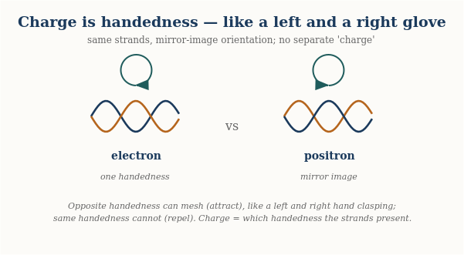
Charge is the handedness of the two strands — electron and positron are the same structure in mirror-image orientations, like a left and right glove. Each knot fills the ropes around it with twist of its own handedness, and that stored twist is what decides how two knots push and pull on one another.
This picture now makes the familiar rules a computed result rather than an analogy. Each knot fills the ropes around it with stored twist matching its handedness. Put two LIKE-handed knots near each other and their twist fields add in the region between them: the closer they sit, the more twist energy the ropes between them must hold, so they are pushed apart. Put OPPOSITE-handed knots together and their twists cancel between them: less stored energy when close, so they are pulled together. Worked out carefully this gives exactly Coulomb's law — strength falling as one over distance squared — with both signs coming out of the geometry rather than being put in by hand. There is a satisfying subtlety here: a naive “field between charges” argument famously gives the WRONG sign (that kind of field makes like charges attract — it is why gravity attracts). The sign comes out right precisely because a winding is a knot in the ropes' topology — a fact about how the strands are tied, imposed on the network, not a source that could be switched off. The older intuition that opposite ends “mesh like a nut and bolt” remains a fine image of what handedness IS; but the pushing and pulling itself happens through the twist the knots store in the ropes between them, reaching across distance the way everything in this picture does: along the strands.
Charge comes in whole units because an end is either one handedness or the other — there is no halfway between a left and a right glove. And charge is conserved because you cannot manufacture a single unmatched handedness out of nothing, any more than a factory can make one lone left glove: handedness comes in matched pairs, so charges are created as electron-and-positron together, keeping the total strand geometry balanced.

Current — and the light-switch puzzle every kid notices
What mainstream physics says | What the rope picture proposes
A current is the flow of charge — conventionally the drift of countless charge carriers through the metal. The everyday puzzle (why the lamp lights instantly when the drifting electrons crawl along at less than a millimetre per second) is resolved by saying the ENERGY travels as an electromagnetic field disturbance near the wire, at nearly light-speed — a separate, abstract field carrying the signal while the carriers barely move. | A current is the two-strand helix being turned like a screw. Rotate it at the battery and, because a helix IS a screw (corkscrew, Archimedes screw), the turning drives the load at the far end — one motion, one object. The instant-on puzzle dissolves: turning a shaft transmits promptly, like a speedometer cable, with no separate field invoked.
The math: the SAME conserved current and continuity, reproduced. The screw is verified to pump exactly one unit of charge per turn and to deliver power as torque × turning-rate, mirroring power = voltage × current — the same electrical laws, realized as a literal mechanical screw rather than an abstract carrier-drift-plus-field.
Flip a switch and the lamp lights instantly, even though the wire is long. If current were the rope material sliding down the wire, that would be impossible — nothing crawls that fast. Here is the physical resolution, and it is more concrete than it first sounds: a current is the two-strand helix being turned at one end, like a flexible drive shaft or a speedometer cable. The battery grips the rope and rotates it; that turning runs down the rope and turns the load at the far end, delivering work there — the way turning the handle of a hand-crank drill spins the bit at the other end.
WHAT CURRENT IS — THE HELIX IS A SCREW | This is the key physical fact. Turn a plain rod and it merely spins; nothing is carried along it. But the rope is a two-strand HELIX, and turning a helix is turning a SCREW — like a corkscrew driving into a cork, or an Archimedes screw lifting water. Rotating the helix does not just spin it; the winding converts that rotation into drive ALONG the rope. So there is no need for a separate “wave” bolted onto the rotation: the rotation and the transport are the SAME motion, tied together by the helix’s shape. The battery turns the screw; the screw pumps down the wire; the load at the far end is turned and work is done.
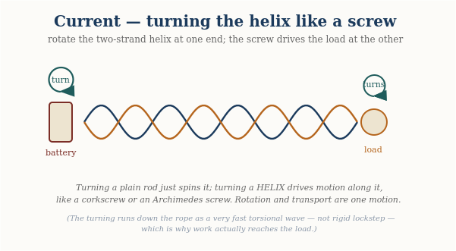
A current is the two-strand helix turned like a screw: rotate it at the battery and, because a helix is a screw (corkscrew, Archimedes screw), the turning drives the load at the far end. Rotation and transport are one motion; the material stays put.
One honest refinement keeps this picture accurate. A perfectly rigid shaft, spinning in exact lockstep from end to end, would deliver twist but pump nothing THROUGH — a screw only does work as it advances against the nut. So the rope is not perfectly rigid: as you turn one end, the turning runs down the rope as a very fast torsional wave, each section taking up the rotation a hair after the one before it. That is why the rope does not simply wind up in place, and why work actually reaches the load. So “the helix is turned like a screw” and “the turning travels down the rope” are not two mechanisms — the second is just the honest way the first propagates in anything that is not infinitely stiff. What does NOT happen is the rope material itself sliding down the wire; only the turning travels.
There is a subtle point that turns out to be one of the most powerful in the whole picture. If the rope simply kept rotating one way, would it not “wind up” tighter and tighter without limit? No — because the turning is not stored up, it passes THROUGH: as much rotation leaves each section into the next as arrives into it from the one before. For that to hold steadily, the turning must enter at one end and leave at the other, which is only possible if the wire is part of a closed loop with a source and a return. (And notice the payoff from the charge chapter: because a right-handed and a left-handed screw drive opposite ways when turned, the HANDEDNESS of the strands — the charge — is exactly what sets which direction the current pumps. Positive and negative charges are opposite-handed screws, and so they drive current in opposite directions.)
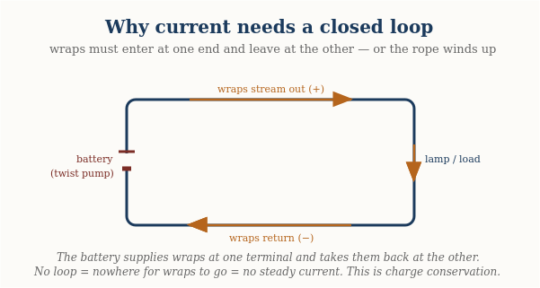
A current needs a closed loop: the streaming orientation enters at one terminal and returns at the other. No loop means nowhere for it to go — and no steady current.
ONE INSIGHT, THREE FAMILIAR RULES | “The rope cannot wind up without limit,” “orientation-in equals orientation-out,” and “current only flows in a closed circuit” are not three separate facts — they are one statement seen three ways. In the physicist’s shorthand it is the continuity equation, and it is the mechanical face of charge conservation. The rope picture does not predict anything new here; it REPRODUCES a known law, but it lets you SEE why the law must hold.

What makes a current strong or weak, and why wires warm up
Three things set how much current flows. First, how hard you push — the voltage, which in the rope picture is the TENSION the strand configuration sources: a stronger orientation mismatch pulls the strands taut and raises the tension. (Voltage is the tension; charge is the handedness — related, but not the same thing.) Second, how many strands push at once — the thickness of the wire. Third, how cleanly each strand carries the wave — the material. In some materials the rotation glides through; in others it snags.
That snagging is resistance, and it is where wires get warm. When the streaming pattern catches on the atomic lattice, some of the ordered rotation is knocked into random jiggling of the ropes — and random rope jiggling, as the heat chapter explains, simply IS temperature. So a resistive wire warms up because ordered streaming is being scattered into disordered motion.
HONEST LIMIT | The rope picture reproduces all the standard rules of simple circuits — how current, voltage, and resistance relate, why loops are needed, why resistive wires heat. What it does NOT do here is derive the deep quantum reasons some materials conduct and others insulate; that rests on the electron’s quantum behaviour, which this picture does not claim to replace. The mechanism is a faithful mechanical retelling of classical circuit behaviour, not a new theory of materials.
Voltage — the stretch that has not moved yet
Current is charge in motion. Voltage is the readiness to move — and in the rope picture it is wonderfully concrete. Between two points, voltage is a DIFFERENCE in the stored tension of the strand configuration: how much harder the ropes are pulled and twisted at one place than at the other. A battery is a chemical tension pump. Its chemistry continuously maintains a standing mismatch between its two terminals, the way a wound spring maintains a standing readiness to turn. Nothing needs to be flowing for the voltage to be there; the mismatch simply waits. Connect a loop and the mismatch finally has somewhere to relax — the screw begins to turn, and that turning is the current. Volts measure how hard the mismatch pulls on each unit of charge that makes the trip: the work the ropes do on every winding carried from one terminal to the other.
Everyday life checks this picture nicely. Touch a nine-volt battery to your tongue and you feel a small sting: a small tension mismatch, relaxing gently through the salt water of you. Shuffle across a carpet in winter and your body strips windings from the fibers, building up a mismatch of several thousand volts between you and the doorknob — which sounds alarming until you remember that voltage is only the strength of the pull, not the amount that moves. The snap at your fingertip is a large stretch relaxing through a tiny trickle of charge in a fraction of a second: big volts, little current, all startle and no harm. Power companies run the logic the other way: they deliberately transmit at very high voltage so that the same power can ride on a small current — and a small current means less snagging on the lattice, which, as the previous section explained, means less of the energy lost as heat along a hundred miles of wire.
One honest refinement keeps the picture straight. Voltage is always a difference between two places, never a property of one place alone. Only mismatches pull. That is why a bird perches on a high-tension line unbothered: both feet share one and the same tension state, so between them there is no mismatch, no pull, no current — and no cooked bird. Danger begins only when a body bridges two DIFFERENT tension states, a wire and the ground, and becomes the path through which the stretch relaxes.
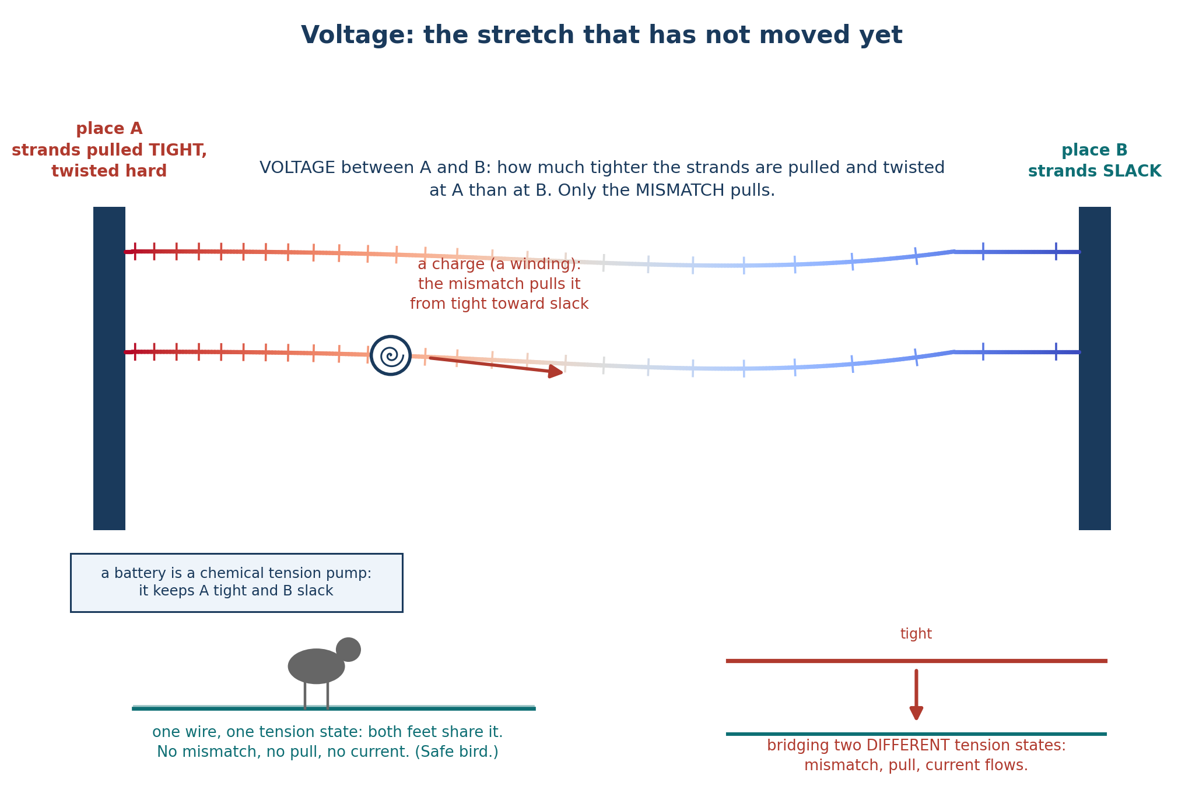
Voltage is a mismatch in stored rope tension between two places, and only the mismatch pulls. A charge (a winding) slides from the tight side toward the slack side; a battery is a chemical tension pump that maintains the difference. A bird sharing one tension state spans no mismatch, which is why it perches unbothered; bridging two different states is what drives a current.
The math: this is exactly the textbook definition reproduced — potential difference as work per unit charge — and the familiar rule that power equals voltage times current appears in rope terms as torque times turning-rate, the same identity the current section verified for the screw.

Magnetism — the Network’s Response to Rotating Ropes
Magnetism needs care, because it is easy to say too much. Here is the honest core. When a current flows down a wire — when the strand-handedness is streaming along it — the SURROUNDING rope network takes on a circulating pattern in response. That circulating pattern is the magnetic field. Electricity’s disturbance runs in a line down the wire; magnetism’s disturbance CURLS around it, like water circling a drain rather than flowing past it.
What mainstream physics says | What the rope picture proposes
The magnetic field is the curl of an abstract “vector potential”; the magnetic force is the velocity-dependent part of the Lorentz force, often explained as a relativistic side-effect of electricity. Intuitive mechanism: essentially none — it is treated as a field-theoretic and relativistic fact. | A current is rotating ropes; that rotation drags the surrounding network into a circulating swirl — a literal vortex — and that swirl is the magnetic field. The force is that swirl acting on other rotating ropes.
One thing worth making explicit: electricity and magnetism here are not two different things that happen to be related — they are one rope seen two ways. Look along the rope and you see the imbalance that is electric charge and current; look around it and you see the circulation that is the magnetic field. That is exactly why the two can never be fully separated, and why a change in one always stirs up the other — they were never separate substances to begin with. > EQUATIONS| the SAME laws, reproduced — the force between currents (F/L ∝ I₁I₂/d, with the correct signs) and the full Lorentz force F = qv×B both come out of the rope mechanism. No new equations; a physical mechanism where physics usually offers none.
WHAT THE MAGNETIC FIELD IS | A current is ropes rotating in place (the electricity chapter). Those rotating ropes swing the surrounding network’s threads around the wire — a circulating swirl whose speed falls off with distance. That swirl IS the magnetic field. The threads really do swing; what they cannot do is swing rigidly, all together, like a merry-go-round — a rigid arm far from the wire would have to move faster than light. So the swing travels outward as a fast wave, each ring of the network taking up the motion a moment after the one inside it. Seen up close it is threads swinging; seen as a whole it is a smooth circulating vortex in the network’s rotation. The two descriptions are the same thing at different scales.
Two things are worth stating carefully. First, why does the response CURL rather than simply spread outward? A featureless, scalar imbalance — one that is the same all the way around the wire — could not pick a direction to circulate; it has no handedness. But the two-strand rope is a HELIX, and a helix has a screw-sense: a left-handed and a right-handed winding are genuinely different. That handedness is exactly what selects the direction of the curl, and it reverses when you reverse the current — matching what magnets actually do.
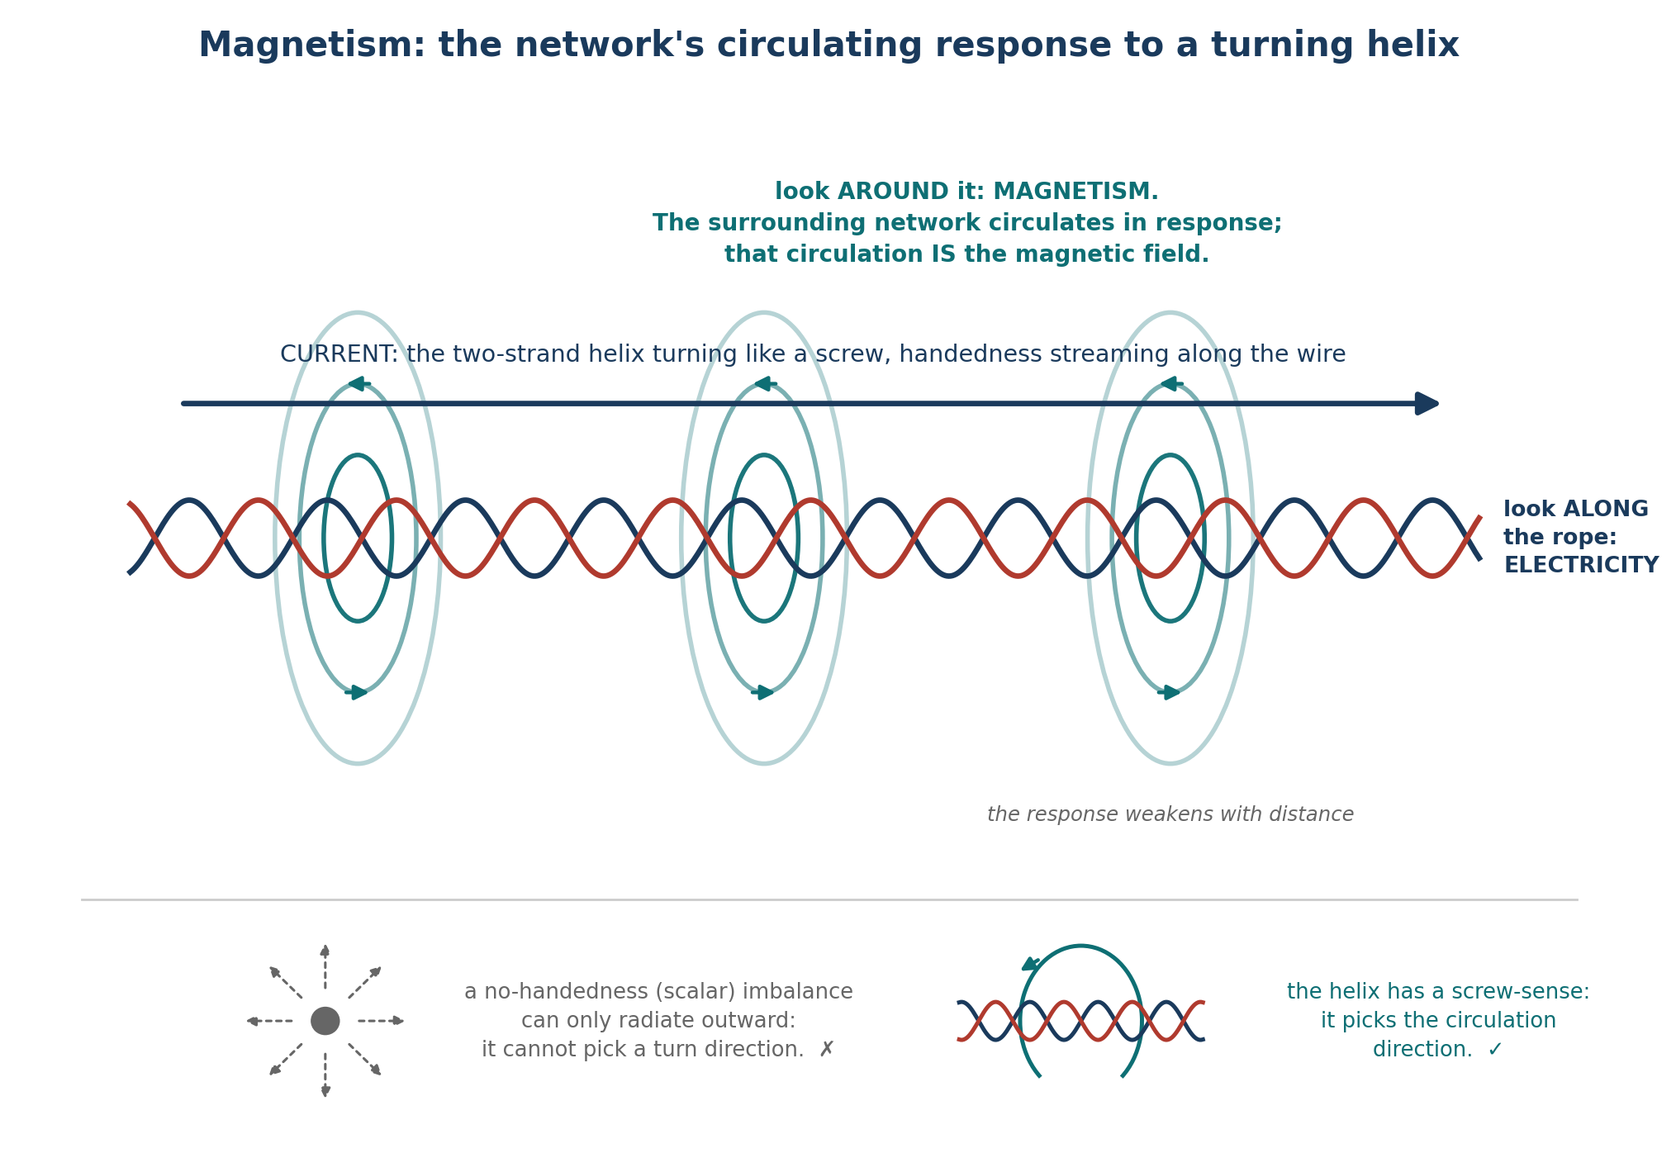
Current is the two-strand helix turning like a screw, with handedness streaming along the wire; the surrounding network answers with a circulating pattern, and that circulation is the magnetic field, weakening with distance. Look along the rope and you see electricity; look around it and you see magnetism. A scalar imbalance has no handedness and could not pick a turn direction; the helix's screw-sense is what sets it.
Second, does the mechanism actually produce a FORCE, with the right size and direction? A field that just sits there is only bookkeeping. The answer is yes, and it comes out of the energy stored in the twisting network.
THE MAGNETIC FORCE, FROM ROTATING ROPES | Two current-carrying wires sit in a shared rope network that stores energy in its twisting. Move the wires and that stored energy changes; the network pulls toward the lower-energy arrangement. Worked out, this gives exactly the observed force: parallel currents in the SAME direction ATTRACT, opposite directions REPEL, with the right strength and the right falloff with distance. Two currents attract or repel because moving them changes the twisting energy in the network they share.
The same picture delivers the force on a single moving charge — the famous rule that a magnetic force pushes SIDEWAYS, at right angles to both the motion and the field, and never speeds the charge up or slows it down (it only deflects). In the rope picture this sideways, does-no-work character is not a strange postulate; it falls straight out of how a moving winding couples to the surrounding circulation.
HONEST LIMIT | This picture reproduces the known magnetic forces mechanically — it does not predict anything the standard laws do not. And it rests on one unproven assumption: that the ropes carry inertia, a resistance to being spun up, the way any real spinning object has mass distributed around its axis. That assumption is natural — a physical rope would have mass — but it has not yet been shown to follow from the strands themselves. Everything else about the magnetic force follows once you grant it.
So far this has all been about currents — but the magnet on your refrigerator carries no current at all. Where is its magnetism coming from? The rope picture gives the same answer standard physics does, translated into mechanism. In an ordinary material each atom’s little swirl points a random way, and the swirls cancel. In iron, something makes whole neighbourhoods of atoms line up so their rope-swirls all turn the same way; add up billions of aligned swirls and you get one big circulation sweeping around the whole bar — the magnet’s field — with no charge flowing anywhere. A permanent magnet and a coil of current-carrying wire are, in this picture, the very same thing: aligned rope-rotation sweeping the network into a circulation. That is exactly why a coil of wire acts like a bar magnet.
This also explains a deep fact: you can cut a magnet in half and never get a lone north or south pole — you just get two smaller complete magnets. In the rope picture a “pole” is simply which way the threads sweep at one end; the threads have to enter one end and leave the other, so a single isolated pole is as impossible as a rope with only one end.
HONEST LIMIT — PERMANENT MAGNETS | Two things in this account are borrowed rather than derived. WHY the atoms in iron spontaneously line up (and stay lined up) is not explained by the rope mechanics here — it is taken as given, exactly as standard physics takes the alignment of atomic magnets as given. (The related question of WHY two currents or two magnets attract or repel — the direction of the force — does come straight out of the mechanics: in the gap between two swirls, opposing motion meshes and pulls together while aligned motion clashes and pushes apart, exactly the jump-rope rule, and it matches the measured force.) What remains only partly explained is the alignment itself — why whole neighbourhoods of atoms lock together. The rope picture does offer a mechanism: neighbouring atomic swirls share the network between them, and when their patterns mesh smoothly the shared region carries less strain, so a lined-up neighbourhood costs less energy — the same kind of “modes fitting together” that makes a chemical bond, and far stronger than the feeble magnetic pull between the atoms themselves (which is thousands of times too weak to survive room-temperature jostling). What the picture does not yet do — and here it is no worse off than standard physics — is calculate, for a given material, whether that meshing favours lining up (a magnet, like iron) or alternating (like chromium), or why only a few metals do it strongly. The mechanism is there; the material-by-material prediction is not.
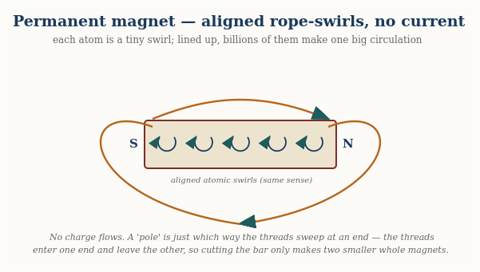
A permanent magnet needs no current: each atom is a small rope-swirl, and in iron whole neighbourhoods line up so their swirls add into one big circulation sweeping from end to end. A “pole” is just which way the threads sweep at that end — which is why you can never cut out a lone north or south.
It is worth showing how the picture handles a tempting idea that turns out to be wrong — because being able to be wrong is what makes it a real physical claim. One might guess that the DENSITY of ropes in space sets how strong electromagnetism is. If so, then since the early universe was denser, electromagnetism should have been measurably different in the distant past — and we can check that, by studying ancient light from distant galaxies. The measurement has been done, and the answer is clear: no such change is seen, by a wide margin. So that guess fails, and the strength of electromagnetism is best treated as a fixed property of space rather than something tuned by local rope density. The rotating-rope mechanism itself is untouched by this; only the extra guess about density is ruled out.
Electricity and magnetism together are governed by a famous set of four equations — Maxwell’s equations — that underpin every motor, radio, and magnet. The next chapter shows how all four fall out of the rope picture.

Maxwell’s Equations — The Four Rules, From Ropes
Electricity and magnetism are governed by four equations — Maxwell’s equations — that underpin every motor, radio, antenna, and magnet ever built. Their content, in plain words, is four statements: electric charges are sources that field lines spring from; there are no isolated magnetic “charges,” so magnetic field lines never begin or end but always close on themselves; a changing magnetic field stirs up a circulating electric field; and a current or a changing electric field stirs up a circulating magnetic field.
Each of these has a mechanical reading in the rope picture. Charges as sources are the strand-handedness the electricity chapter described. The absence of magnetic monopoles — that magnetic lines never start or stop — is the strongest single result: it falls out automatically because the magnetic field is defined as the curl of the network’s orientation, and a curl can never have loose ends (a mathematical identity, not an added assumption). The two “induction” rules — changing one field stirring up the other — are the network’s circulating response to a changing disturbance, the same swirl the magnetism chapter described, now running in both directions.
WHAT THIS DOES AND DOESN’T CLAIM | Under the rope picture all four Maxwell equations are reproduced — the structure of classical electromagnetism comes out of the mechanics of a twisted-strand network. This is a mechanical RETELLING of known physics, not a replacement for it: it makes no prediction that classical electromagnetism does not already make. Its value is that one physical picture — ropes that ripple, wind, and swirl — yields the whole set, rather than four separately postulated laws.

Gravity — A Taut Rope Between Every Two Things
This is the most basic version of the rope picture, and it is worth stating plainly before anything more complicated: every pair of masses in the universe is connected by a physical rope, that rope is under tension, and a rope under tension pulls its two ends together — exactly the way a stretched rubber band pulls your two hands toward each other, or a tightened cable pulls whatever it’s anchored to inward. Nothing more exotic than that. The apple falls toward the Earth because the rope directly connecting them is taut, and a taut rope pulls.
What mainstream physics says | What the rope picture proposes
Gravity is the curvature of spacetime (general relativity): mass-energy bends the four-dimensional geometry of space and time, and objects follow the straightest available paths through that curved geometry. There is no “pull” — only geometry. | Gravity is literal tension: real ropes under tension stretch between masses and pull them together, the way a stretched spring pulls its ends toward each other.
The math: this is the least-developed sector, and it is worth being exact about what the rope picture does and does not do. It CAN reproduce the four classic weak-field tests of general relativity — the bending of starlight (1.751″ at the Sun’s edge), Mercury’s perihelion drift (43″/century), the Shapiro time delay — but only by taking the known weak-field geometry (the “Schwarzschild metric”) as its starting point and computing the consequences. For the WEAK field there is a modest recent step: if one grants that mass sources a conserved “conditioning” of the network (the gravitational cousin of how charge sources its field), then a simple field equation — the same Poisson equation that underlies Newtonian gravity — GENERATES the weak-field geometry rather than having it inserted by hand. But that step is linear, and real gravity is not: the deep feature of Einstein’s theory is that gravity gravitates (the field feeds on itself), and nothing in the rope picture reproduces that nonlinearity. So there is still no rope-derived equivalent of Einstein’s full field equations Gμν = 8πTμν. So it matches GR’s answers in the weak, slow, spherical case, but says nothing yet about strong gravity (black-hole interiors, neutron stars), gravitational waves, or cosmology. The tension picture is a genuine intuition; a full theory of gravity it is not.
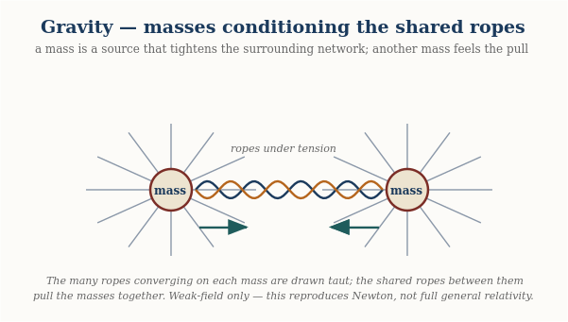
Two masses each sit at the focus of many taut ropes; the ropes they share pull them together. This reproduces Newtonian gravity in the weak field — not the full curved-spacetime account of general relativity.
Two questions follow naturally from that picture, and the honest rope-model answers to both add detail without changing this basic fact.
Why does a heavier mass pull harder?
Because a heavier object is made of more atoms, and every one of those atoms has its own rope running out to the other mass. A boulder connected to you by one thick cable pulls harder than a pebble connected to you by one thin thread — not because the cable is stretched any differently, but because there is simply more rope, more strands, doing the pulling at once. A planet pulls harder than a pebble for the same reason: far more individual ropes running between it and you, each contributing its own share of tension.
Why does the pull weaken with distance?
Because in the rope picture, every mass is connected by rope to EVERY other mass in the universe, not just to the one you’re interested in star in the sky, all at once. The direct rope to a nearby mass is only one strand in an enormous web running off in every direction. A rope to something far away has to share the network’s attention, in a sense, with countless other ropes along the way, and its individual contribution to the pull you feel thins out the farther its other end is to pick out of a stadium crowd even if that person is shouting just as loud. This is the piece of the rope picture that reproduces the familiar 1/r² falloff of gravity with distance.
HONEST NOTE: the technical papers describe this same fact in more abstract field language — as a dip in local rope tension near a mass, which anything nearby then drifts toward, the way a ball rolls downhill. That is not a different mechanism from the direct rope-pull described here; it is the same fact restated as a smooth field once you account for EVERY rope running to EVERY mass in the universe at once, rather than picturing one rope at a time. The direct picture above is the simpler and more basic of the two, and the one worth holding onto first.
Then why doesn’t a whole galaxy outpull the Earth?
A sharp reader will spot what looks like a problem. A distant galaxy contains trillions of stars — vastly more atoms than the Earth, and so vastly more ropes running to you. If a taut rope pulls no matter how long it is, shouldn’t all those ropes drag you off the ground toward the galaxy? Picture a carriage with five horses tied close on one side, against ten thousand horses pulling on long ropes from far away: the ten thousand win easily. Distance doesn’t save the carriage. So why does it save you?
The answer is that the picture of the ten thousand horses all pulling from ONE direction is not how the universe is arranged. Distant galaxies are not massed on one side of you with empty sky opposite — they are scattered in EVERY direction, all around you, roughly evenly across the whole sky. So the honest version of the carriage isn’t five horses against ten thousand on one side. It is five local horses against ten thousand spread in a full circle, all pulling OUTWARD against one another. And a ring of horses pulling evenly in all directions goes nowhere — every pull toward one galaxy is met by an equal pull toward a galaxy on the opposite side. The enormous far-away pull very nearly cancels itself out.
Once the balanced far-away pull cancels, what is left to actually move you? Only the LOCAL, one-sided lumps — the Earth right beneath your feet, with nothing equal on the far side of you to cancel it. The Earth wins not because it out-pulls a galaxy — it plainly cannot — but because the galaxies are busy cancelling each OTHER, while the ground under you pulls unopposed. Local and lopsided beats distant and balanced.
This isn’t a special rope-theory escape hatch, by the way — it is a known fact of ordinary gravity too: matter that surrounds you evenly on all sides exerts no net pull from inside it, because every direction’s tug is matched by its opposite. A roughly even universe of distant galaxies pulls you almost nowhere; only the nearby unbalanced masses — Earth, then the Sun, the Moon, our galaxy’s centre — have no opposite number to cancel them, so those are the ones you feel.
HONEST NOTE: the cancellation isn’t perfectly exact — the universe isn’t perfectly even, and a balanced far-away pull still leaves a tiny leftover difference across your body (that faint residue is, in fact, what raises ocean tides). But that leftover is minuscule next to the unopposed pull of the ground beneath you. The main reason a galaxy doesn’t yank you away is simply that another galaxy on the far side is pulling back just as hard.
This might seem to clash with the electricity picture, where MORE bundled ropes meant a STRONGER pull, not a weaker one — but the two are describing different things, and a single thick cable makes both true at once. As a BUNDLE, more strands together can exert more combined pull on something else nearby, the way a thick cable can hold more total weight than a single thread — that is the electricity story. But any ONE thread within that thick cable, sharing the load with all its neighbors, is under LESS individual strain than a lone thread carrying the whole weight by itself — that is the gravity story. Same cable, two different questions: how hard does the bundle pull on others, versus how taut is any single strand within it.
THE ANALOGY. Picture two people each holding one end of a long stretched rubber band. The band pulls them toward each other for one plain reason: it is under tension, and a rope or band under tension always pulls its two ends inward. That is the whole of gravity in the rope picture — you and another mass, with a rope between you always under tension, always pulling. A heavier mass is like swapping the single rubber band for a whole bundle of them — more strands pulling at once, so a stronger net pull, but each strand doing the exact same simple job: tension pulling its ends together.
This connects directly to light: because a ripple’s speed on the rope depends on the rope’s tension, and convergence near mass lowers each rope’s SHARE of tension the way it always does, light itself slows and bends near heavy objects — which is exactly the bending of starlight around the sun that first confirmed Einstein’s theory in 1919. The rope picture arrives at the same bending, but gives it a mechanical reason: light is simply moving through a patch where the converging, load-sharing ropes are individually under less tension, the way a wave crossing from deep to shallow water changes speed and bends.
Where does the STRENGTH of gravity come from?
Gravity is famously weak — a tiny fridge magnet lifts a paperclip against the pull of the entire Earth. That overall strength is captured by a number called Newton’s constant, G, and a fair question is: in the rope picture, what SETS it? Why is gravity as strong as it is, and not a hundred times stronger or weaker?
The rope picture offers a genuinely striking hint here, though not a finished answer. If the ropes’ tension is ultimately sourced by the whole cosmos — the universe stretched taut on the largest scale — then G should be tied to the total amount of matter in the universe and its size. And when you actually check the numbers, something remarkable falls out: the observable universe sits right at its own “gravitational radius.” Put plainly, if you took all the mass in the visible universe and asked how large a region it would take to make a black hole of that mass, the answer is… about the size of the visible universe itself. The mass, the size, the speed of light, and G all lock together in one clean relation.
That is a real and long-known fact of cosmology, and the rope picture reproduces it naturally — which is a genuine point in its favour: it says gravity has just the strength needed to make the universe “closed” in this balanced way, rather than that strength being an arbitrary accident.
HONEST LIMIT ON THIS: satisfying as that is, it does NOT let us calculate G from scratch, for a subtle but airtight reason. To use the relation you need the total mass of the universe — but there is no way to weigh the universe WITHOUT already using gravity to do the weighing. Every method (counting stars and multiplying by a star’s mass, reading the expansion rate, measuring the cosmic microwave background) sooner or later measures mass through its gravitational pull, which means through G itself. So the relation is beautifully self-consistent but circular: it explains why G fits the universe it lives in, without predicting G’s raw value from nothing. Pinning that raw value down remains one of the framework’s genuine open problems.
HONEST LIMIT: this picture reproduces the CLASSIC tests of gravity — the bending of starlight, the slow drift in Mercury’s orbit — to the same precision as standard general relativity, and the tension-drop itself is CHOSEN to reproduce the correct, measured slowing of clocks near Earth (the same effect GPS satellites must correct for). The interpenetrable-sharing story above is a reasonable, consistent way to picture WHY convergence lowers tension, building on postulates the technical papers do state — but the papers themselves assert the tension-drop and verify its CONSEQUENCES, rather than spelling out this particular mechanical reasoning step by step. (Where gravity’s overall STRENGTH comes from is taken up just above.)

Chemistry — Standing Waves Around a Nucleus
An atom’s nucleus, in this picture, is an especially dense knot of rope. The electrons around it aren’t tiny balls circling like planets way a guitar string doesn’t move at random but settles into specific standing-wave patterns depending on where you press your finger.
What mainstream physics says | What the rope picture proposes
Bonds and orbitals are solutions of the quantum Schrödinger equation — “standing waves” of an electron probability-wave whose square gives the odds of finding the electron somewhere. Concrete mechanism: contested; the wavefunction is famously hard to picture as a physical thing. | The same standing-wave pattern, but of a REAL rope humming between nucleus and surroundings — an actual vibration with actual nodes, the way a plucked guitar string settles into a standing note.
The math: the SAME standing-wave mathematics, reproduced. Where “orbital” is a probability cloud in the textbooks, here it is a literal standing vibration; the allowed patterns (and so the allowed energies) come out the same.
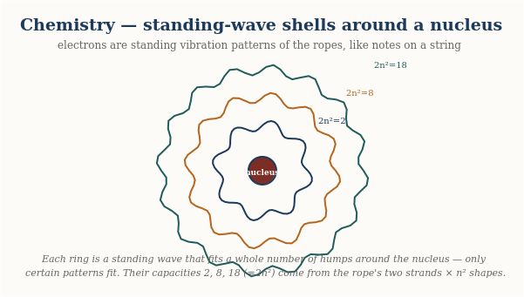
Electrons are standing vibration patterns of the ropes around the nucleus — only certain patterns fit, like notes on a plucked string. Their capacities 2, 8, 18 (= 2n²) come from the rope’s two strands times the n² shapes that fit on a sphere.
THE ANALOGY. Picture a guitar string. Left alone, it can only vibrate in certain fixed patterns — the open string, the octave, the fifth — never anything in between; you cannot get “half a note.” An electron’s allowed orbits are the same idea in three dimensions: only certain standing-wave patterns fit cleanly around the nucleus without canceling themselves out, and those patterns are the electron shells chemistry is built from. A chemical bond, in this picture, is two atoms sharing a single standing-wave pattern that wraps around BOTH nuclei at once — the molecular equivalent of two guitar strings clamped to the same fixed points, forced to vibrate together.
There is a second everyday image that makes WHY only certain patterns are allowed feel obvious: resonance. Strike one wine glass in a rack, and nearby glasses of just the right size begin to hum on their own — while glasses of the wrong size stay silent. Only matching frequencies respond. An atom is the same: only certain standing-wave patterns “fit” around a given nucleus and come alive; all the in-between patterns cancel themselves and simply cannot exist. That is why an electron’s energy levels are a fixed ladder with no rungs between — the atom, like the wine glasses, only rings at its own special frequencies. Chemistry is which patterns fit, and which atoms can share them.
This is the one part of the rope picture we should be most upfront about: by the technical paper’s OWN admission, the mathematics here is identical to standard quantum chemistry — the same equations, just told with a rope picture standing behind them instead of an abstract wavefunction. The value of the rope version isn’t a different periodic table; it’s a physical picture for why the periodic table has the shape it does.
HONEST LIMIT: one deep chemistry rule — the Pauli exclusion principle, the fact that no two electrons can occupy the exact same state — is only PARTIALLY explained in this picture (roughly: a standing-wave “slot” can hold at most two oppositely-twisted kinks). The framework’s own papers call this the single most important unsolved problem in rope chemistry, not a finished result.
One more thing chemistry demands: molecules have SHAPES. Water is not a straight line — its two hydrogens sit at an angle — and that bend is why ice floats, why water dissolves salt, and ultimately why it supports life. The rope picture now derives the bend. The standing-wave patterns around a nucleus include dumbbell-shaped modes with two lobes — and the two lobes of one dumbbell are always moving OPPOSITELY, like the two ends of a seesaw. A hydrogen attaching to one lobe grips a wave moving with it; a second hydrogen trying to attach to the other lobe finds the wave moving against it — one grips, one slips. So a single dumbbell can never hold two bonds, which rules out water being straight. The second hydrogen instead grabs a sideways dumbbell — and the dumbbells point at perfect right angles to each other — so water starts bent at ninety degrees, then opens a little wider as the two crowded hydrogens push apart. The honest scorecard: the BEND is derived; the exact opening is not yet (water measures 104.5°). And nature offers a lovely confirmation: in hydrogen sulfide — water's heavier cousin, where the wave patterns mix less — the measured angle is 92°, almost exactly the raw right-angle the picture predicts. Meanwhile carbon dioxide, whose bonds are double, IS straight — its double bonds impose crossed constraints that force the two arms into line.

The Nucleus — The Strong Force as Physical Contact
Deep inside every atom, a handful of protons and neutrons are packed into a nucleus a hundred-thousand times smaller than the atom around it. Something has to hold them there — the protons all carry positive charge and should fly apart violently. The thing that holds them is the strongest force in nature, and in this picture it is not a new or exotic force at all. It is the same thing that stops your hand from passing through a table.
What mainstream physics says | What the rope picture proposes
The strong force is carried by gluons exchanged between quarks, described by quantum chromodynamics (QCD). The mathematics is precise and enormously successful, but the mechanism is famously hard to picture: gluons themselves carry the charge they transmit, the force does not fall off with distance the way gravity or electricity does, and the quarks can never be pulled apart to look at. What “exchanging a gluon” physically IS remains a mathematical description rather than a mechanical one. | The strong force is physical contact — the same contact that makes solid things solid. Where many ropes bunch together into a dense bundle, that bundle takes up space and pushes back when another bundle presses into it. At the scale of atoms this bundle-contact is what makes molecules bump rather than blend. At the scale of the nucleus, a hundred-thousand times smaller, the very same bundles are packed a hundred-thousand times tighter, and the same contact becomes the overwhelmingly strong grip that binds the nucleus.
The math: the characteristic shape of the nuclear force — a hard repulsive core at very short range, a strong attractive well a little farther out, and nothing at all beyond about three femtometres — comes out of bundles that push hard when they jam together, pull when they just touch, and feel nothing when they are too far apart to touch at all.
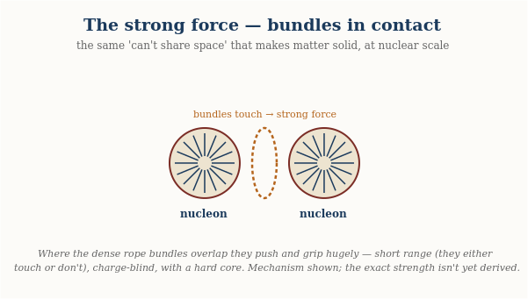
Each nucleon is a dense bundle of ropes. Where two bundles overlap they push and grip enormously — the strong force as physical contact: short range (they either touch or they don’t), the same whatever the charge, with a hard core that stops the nucleus collapsing.
The single most important idea here is that nuclear physics is not a separate world with its own rules. It is ordinary contact physics, scaled down.
THE ANALOGY. Press two of your fingertips together. They touch; they don’t merge, and if you push harder they push back harder — that resistance is the crowded material in each fingertip refusing to share the same space. Now imagine shrinking that same touching-and-resisting down to the size of a nucleus. The crowded material is a bundle of ropes; the touch is the strong force. Nothing new has been added — the same “you can’t be in my space” that you feel between your fingers is, a hundred-thousand times smaller and denser, the force that holds a nucleus together.
This picture explains three things about the strong force that otherwise look like separate, unrelated facts.
First, it has a short range and then simply stops. A field like gravity or electricity reaches out forever, fading with distance. Contact does not fade — it is either happening or it is not. Two nucleons whose bundles overlap feel an enormous force; pull them a little farther apart, past about three femtometres, and their bundles no longer touch at all, so the force vanishes completely rather than trailing off. That sharp cutoff is the signature of touch, not of a field.
Second, it doesn’t care about charge. The electric force between two protons depends entirely on their charge. But the strong grip between two nucleons is nearly the same whether they are two protons, two neutrons, or one of each — because it is bundle bumping into bundle, and bundles take up space regardless of the twist that gives a nucleon its charge.
Third, it resists being squeezed AND resists being pulled apart. Push two nucleons too close and the bundles jam — fiercely repulsive, which is why nuclei don’t collapse to a point. Let them sit at just the right separation and the bundles rest in contact — attractive, which is what binds them. This “hard core plus attractive well” is exactly the nuclear potential physicists measure, and here it is just what contact between two crowded bundles feels like.
There is one more piece the picture offers, and it is worth stating plainly because it is where the rope idea is boldest. In this model the proton and neutron are not featureless balls: each is a small cluster of partial knots — the objects standard physics calls quarks. A partial knot is not a whole twist on its own, and crucially it cannot exist alone; it only settles into something stable when it joins its partners to complete a whole twist. That is offered as a physical reason for one of the deepest puzzles in physics — why quarks are never found in isolation. They are pieces of a knot, and a piece of a knot is not a thing that can stand by itself.
A closing note on honesty, in keeping with the rest of this guide. The contact picture reproduces the shape of the nuclear force — and more than the shape: the exact mathematical FORM of the force (the Yukawa law physicists write down) now falls out of the rope mode-overlap mechanism rather than being assumed, and the two leading terms of the nuclear binding formula (the bulk energy and the surface correction) emerge from the geometry of bundles packing together. With a single calibrated constant — the depth of one nucleon bond — the model then predicts the masses of atoms from carbon to uranium to about a tenth of a percent. What it does NOT yet do is derive that one constant — the absolute STRENGTH of the bond — from the rope properties alone; that single number is still read from experiment. So the honest summary has shifted since the early drafts: the mechanism, the force law, and the structure of the binding are now derived; what remains calibrated is one overall scale. The engine is largely built; it runs on one number still read from the dial.

Heat — The Rope Jiggling at Random
Every trick so far has been the rope doing something orderly: a clean ripple, a fixed handedness, a smooth winding, a standing hum. Heat is what you get when you take all that order away. Heat is simply the rope network jiggling at random — a restless, disorganised trembling of the ropes on top of whatever orderly thing they are also doing.
What mainstream physics says | What the rope picture proposes
Temperature is a parameter of a statistical distribution; phase transitions are “non-analyticities of the free energy” — sharp mathematical kinks that emerge from averaging over enormous numbers of particles. Rigorous, but abstract. | Temperature is simply how hard the ropes are jiggling; a phase transition is the whole linked network flipping from order to disorder at one sharp tipping point, because the ropes are tied together and must decide as one.
The math: the SAME results, reproduced — including the sharp transition and the universal numbers that describe real melting and real magnets. The rope network, left to jiggle, lands exactly where standard statistical mechanics says it must; the picture is a mechanism for the same math.
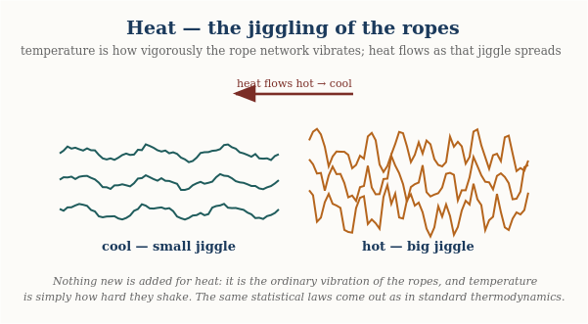
Temperature is simply how hard the ropes are jiggling; heat flows as vigorous jiggling spreads into calmer regions. Nothing new is added for heat — it is the ordinary vibration of the network, and the standard thermodynamic laws come out unchanged.
WHAT HEAT IS. Picture the whole rope network shivering — every strand twitching a little, in no particular direction, with no particular rhythm. A cold object is one whose ropes are nearly still; a hot object is one whose ropes are jiggling hard. Temperature is just how vigorously they jiggle. That is the whole of heat: not a substance that flows in, but the amount of random motion already in the ropes.
Heat is the same rope simply jiggling at random. Cold ropes are nearly still; hot ropes jiggle hard. Temperature is just how vigorously they shake.
This immediately says what temperature is. A thermometer does not measure some invisible fluid called ‘heat’ pouring into it; it measures how hard the ropes around its bulb are trembling. Warm the ropes and they jiggle harder, the reading climbs. Two objects touching share their jiggling — the vigorous ropes of the hot one shake the calmer ropes of the cold one until both tremble equally, which is exactly why a hot cup and a cool hand always drift to the same warmth and never the reverse. Heat flows from hot to cold because random shaking spreads out; it never spontaneously gathers itself back up, the same reason a struck bell rings down to silence rather than a silent bell suddenly ringing.
Notice this reuses an idea from the light chapter rather than adding anything. There, an orderly ripple raced down the rope and we called it a photon. Here the very same ropes carry a messy, directionless version of that motion — countless tiny ripples going every which way at once. Orderly rope motion is light; disorderly rope motion is heat. That is why a hot object glows: shake the ropes hard enough and some of that random jiggling spills out as genuine ripples — real light — which is why an electric stove burner goes from black to red to orange as it heats. The glow of hot things and the chill of cold ones are the same ropes, jiggling more or less.
Why heat always spreads, and never un-spreads
One feature of heat feels almost like a law of fate: it only ever goes one way. Cream stirred into coffee never un-stirs; a warm room never spontaneously sorts itself into a hot corner and a cold corner. The rope picture makes this feel obvious rather than mysterious. There are enormously many ways for the ropes to jiggle randomly and share their motion evenly, and only vanishingly few ways for all that random motion to line back up into something orderly. Left to chance, the ropes almost always end up in one of the overwhelmingly common messy arrangements — so disorder grows, simply because there is so much more of it to land in. This one-way drift toward the most common kind of mess is what physicists call the growth of entropy, and here it is nothing more than the ropes finding the arrangements there are the most of.
Melting, freezing, and the sudden switch
The most striking thing heat does is not the smooth warming — it is the sudden change. Water does not thicken gradually into ice as you chill it; it stays liquid, stays liquid, and then at one exact temperature snaps into a solid. Heat a magnet and it holds its magnetism, holds it, and then at one precise point loses it all at once. These abrupt switches — physicists call them phase transitions — are among the sharpest, most testable things in all of physics, and this is where the recent rope work has the most to say.
THE TUG-OF-WAR. Every phase transition is a tug-of-war between two things the ropes want. Order wants the ropes lined up neatly, because that costs the least tension energy. Heat wants them jiggling freely, because there are so many more ways to be messy. At low temperature order wins and the ropes lock into a tidy pattern — a solid, a magnet. Turn up the heat and at one sharp tipping point the jiggling suddenly overwhelms the ordering pull, the tidy pattern breaks, and the material flips to its disordered state — liquid, or unmagnetised — all at once.
A phase transition: below the tipping point the linked ropes hold an ordered pattern; at one sharp temperature the jiggling wins and the whole network flips to disorder at once.
Why all at once, rather than gradually? Because the ropes are all tied to one another, so they must decide together. No single strand can quietly go its own way while its neighbours hold formation — they are linked, so the whole network tips as one, the way a room full of people all facing forward will, once enough of them turn around, flip the whole crowd’s direction in a rush rather than one straggler at a time. The tipping point is sharp because the decision is collective.
This is not just a story. The tipping-point temperature for the rope network can be computed directly, and it lands exactly where the mathematics of ordinary phase transitions says it must — the same universal numbers that describe real melting, real magnets losing their magnetism, and thin films of superfluid helium. The rope network, left to warm up, reorganises itself with precisely the sharpness and the universal signatures that laboratories measure. It is one of the cleaner recent results: the same ropes that carry light and charge, when you simply let them jiggle, reproduce the textbook physics of heat and phase change without anything new added.
HONEST LIMIT. The rope account here matches the EQUILIBRIUM physics of heat — a system that has settled down and shares its jiggling evenly — including the sharp phase transitions, to the standard textbook results. What it does not yet treat is heat in FULL FLIGHT: the details of exactly how fast heat flows, how a material conducts or relaxes moment to moment while still settling. That living, in-between behaviour is not yet captured; the settled picture, and the sharp switch between phases, is what the rope network reproduces.

What Ties This Together — and What Doesn’t Yet
The appeal of the rope picture is that six seemingly unrelated topics all become the same kind of question asked about the same kind of object:
Before the summary, notice the thing this guide was quietly built around. From the first page to this one, nothing was ever added. There was no new particle for light, no separate substance for electricity, no special material for magnetism, no extra force-carrier for gravity. It was the same rope the whole way through — the explanation simply never changed:
Still the same rope… now it carries a ripple (light). Still the same rope… now its two strands take on a handedness (electricity). Still the same rope… now it sets the network around it circulating (magnetism). Still the same rope… now it is pulled taut between masses (gravity). Still the same rope… now it settles into a standing hum (chemistry). Still the same rope… now its tension is exhausted (a black hole). And still the same rope… now simply jiggling at random (heat). One object, all of it.
- Light is a RIPPLE traveling along the rope.
- Electricity is HANDEDNESS — charge is the mirror-orientation of the two strands (electron vs positron, like a left vs right glove), and current is that helix being TURNED like a screw, driving the load at the far end of the circuit.
- Magnetism is the network’s CIRCULATING RESPONSE — the rotating ropes of a current drag the surrounding network into a swirl (the field), which in turn exerts the magnetic force on other currents and moving charges.
- Gravity is TENSION — a taut rope between two masses pulls them together.
- Chemistry is a STANDING WAVE pattern the rope settles into around a nucleus.
- A black hole is where so much mass is packed together that the ropes nearby run out of tension almost entirely.
- Heat is the same rope simply JIGGLING at random — temperature is how hard it jiggles, and a phase transition (freezing, melting, a magnet switching off) is the whole linked network reorganising at one sharp tipping point.
One rope, many tricks — the same object on every page, doing a different thing each time. Nothing is ever added.
That’s a genuinely appealing kind of unity — six phenomena, one object, six different things the SAME rope can do. It is worth being honest about what kind of claim that is. This is a young, speculative, self-published research programme, not an established theory, and every picture in this document simplifies something the technical papers treat far more carefully — with explicit derivations where they exist, and explicit open problems where they don’t. The single hardest unsolved question is the ABSOLUTE SCALE of mass: the rope picture cannot yet say, from first principles, why an electron weighs what it weighs, and that one missing number is why the framework predicts nuclear masses across the periodic table only AFTER one constant is read from experiment, rather than deriving everything from nothing. (Given that one calibration, the RELATIVE masses of atoms from carbon to uranium do come out, to about a tenth of a percent.) The programme states this limitation as plainly as it states its successes, because a picture that only reports its wins isn’t trustworthy about its wins either. There is also a deeper open question the programme is careful to flag: whether the strands LITERALLY are what charge and the fields are made of, or whether the rope picture is our best physical description of something whose ultimate nature is still unsettled. The papers leave that question open rather than pretending it is closed. A related honesty: picturing the ropes as running “between atoms” is a helpful image at everyday scales, but it is not the fundamental one. For the picture to agree with precision tests of relativity, the rope mesh must be far finer than atoms — smaller even than an atomic nucleus — so that atoms are better thought of as coarse knots in a much finer weave, not as the things the ropes directly tie together. The everyday image is a useful simplification, not the bottom layer.
THE POINT OF ALL THIS. Not to convince you the rope is real. To offer a physical OBJECT in place of abstractions like “fields” and “wave packets” — something you could, in principle, picture — and to be exactly as honest about where that picture breaks down as about where it holds up. The technical papers and the open, tested software behind them (rope_solver) are where every claim in this document is checked, qualified, and where possible, falsified.
The Season of the Stretchy Strand
This period of work began with one question -- why don't atoms collapse? -- and ended with the theory's first real confrontation with experimental data. The key discovery was that the strands must be stretchy: if they carried tension but could not resist stretching, matter would be unstable and nothing solid could exist. That single property, once admitted, turned out to set the repulsive core that holds atoms apart, the spacing of nucleons, the strength of chemical bonds, and the range of the nuclear force -- four seemingly unrelated things governed by one number.
Stretchiness had a strange consequence: the network must carry tension waves that travel faster than light. Careful analysis showed this breaks nothing -- the fast waves cannot carry a message, because they decouple exactly from light and matter -- but it is a real, honest prediction, not an embarrassment to hide. Along the way, a proposed mechanism for suppressing these waves was tested, found wrong, and publicly retracted; the retraction is part of the record.
The confrontation came through optics. The stretchiness implies that intense light should very slightly interact with itself in empty space, with a distinctive fingerprint: an effect three times stronger for light polarized along a magnet than across it, and with light speeding up rather than slowing down -- the opposite of standard quantum electrodynamics in both respects. When the numbers met the PVLAS experiment's limits, our first guess for the strength lost, by a factor of about six hundred. The theory's dial was corrected by real data, and the sharpened prediction now sits directly in the path of experiments that are improving today.
Gravity opened as a working sector: a uniform network -- however much tension it carries -- is gravitationally invisible, which is why the enormous tension of empty space does not crush the universe; and the inverse-square law was derived from simple mechanical balance rather than assumed. Newton's constant itself was proven underivable from current premises -- and shown to be secretly the same question as why particles weigh what they do.
Atomic masses became calculable: with a single calibrated constant, the model now predicts the masses of nuclei from carbon to uranium to about a tenth of a percent, with its errors traced to the declared quantum omissions. And the quantum boundary itself was honestly re-mapped: the old failures were forced by a mathematical theorem, not by lack of effort; the one open door (a nonlocal, pilot-wave-style account) matches the rope picture's shape in four structural respects -- while a fifth, statistical requirement, and the famous cosine-squared correlation law, remain entirely underived. The season's lesson is the programme's lesson: derive the structure, measure the scales, publish the losses.
Chapter added 10 July 2026: The stretchy strand, the fabric of space, and the day the data pushed back
For a long time we treated the rope strands as ideal: pure tension, nothing else. It turns out that picture cannot hold matter together -- squeeze it hard and it collapses. Real strands must also resist STRETCHING, and once that one property (call it k) is added, a repulsive core appears that stops atoms and nuclei from collapsing into each other. The same property sets how far apart nucleons sit, how long chemical bonds are, and how strong magnets can be. One new knob, four old mysteries.
The stretchiness had a startling side effect: waves that run ALONG a strand (stretch pulses) must travel faster than light. At first this looked fatal. Working it through, it is not: those fast waves are invisible to matter and light at ordinary intensities (we proved the decoupling exactly), they cannot carry a message, and in a universe with a fundamental rest frame they create no time-travel paradoxes. The fast channel is real, dark, and -- in a twist nobody planned -- has exactly the shape that quantum entanglement demands of any mechanical picture of the world.
Stretchiness also means intense light should very slightly interact with itself in empty space. To test that, we derived the exchange rate between laboratory units and rope units; it contains one number, the tension the vacuum's network carries per unit volume. Our first guess -- that collider light-by-light events already show the rope effect -- made a prediction for the PVLAS experiment in Italy, which was WRONG by a factor of about 570. PVLAS's silence forced the vacuum to be at least six hundred times stiffer than we assumed. The theory took a real loss against real data, tightened its one constant, and now waits with a sharp signature (light speeding up instead of slowing, in a 3:1 pattern instead of QED's 7:4) exactly where the next generation of measurements is headed.
Gravity opened as a sector: a perfectly uniform network -- however stiff -- is gravitationally invisible (only lumps and gradients gravitate), which is why the enormously tense vacuum does not crush the universe. The 1/r law of gravity now follows from simple force balance of the elastic network. And Newton's constant G turned out not to be derivable yet, for a provable reason: deriving G is the SAME problem as deriving particle masses, which the programme has honestly shown to sit at its current frontier.
Finally, atomic masses: with a single calibrated constant -- the depth of one nucleon bond -- the model now predicts the masses of atoms from carbon to uranium to about one part in a thousand, with the leftover errors quantitatively traced to the quantum effects the classical picture openly lacks. Hydrogen and helium, the two smallest atoms, are honestly its worst cases: they are the most quantum-dominated, and the quantum boundary remains the programme's deepest open wall -- now precisely mapped: four of the five ingredients a mechanical account of quantum correlations needs are present; the fifth, and both sufficient ones, are not.

