Condensed-Matter Analogues of the Rope Medium
Near-Term, Tabletop Tests of the Rope Programme’s Mathematical Structure
Mark Palmer · with computational collaboration by Claude (Anthropic)
Global Networking Practice, NTT DATA, Charlotte, NC · palmer100@gmail.com
Programme credit: the core Rope Hypothesis is due to Bill Gaede; this work develops and formalises it.

Abstract
The Rope Programme’s predictions have, until now, been almost entirely astrophysical or cosmological — correlated drift of the fundamental constants, cosmic birefringence, photon-mass bounds — which are hard to reach and slow to test. This paper identifies a class of NEAR-TERM, TABLETOP tests. The rope medium, when coarse-grained, is mathematically a director/XY system with topological defects and a compact-U(1) phase structure — precisely the mathematics of well-studied condensed-matter systems: superfluids, liquid crystals, superconducting arrays, and Bose–Einstein condensates. Because these laboratory systems share the rope medium’s effective description, they realise the same defect statistics, phase transitions, and stiffness–coefficient relations that the programme derives. We map specific rope results onto specific measurable quantities in specific systems, and state what a positive or negative laboratory result would mean. We are emphatic about one boundary, because it is the paper’s intellectual crux: these experiments test the rope programme’s MATHEMATICS — its derivation chain — and can genuinely falsify it, but they do NOT and cannot confirm the rope ONTOLOGY (that spacetime is made of ropes), because the same mathematics is shared by systems that are manifestly not spacetime. Understood at that boundary, analogue systems give the corpus its first realistic near-term experimental exposure.

The crux: what an analogue can and cannot show
CAN: test the rope programme’s coarse-grained MATHEMATICS — the stiffness–coefficient relation c = κ a/(2T²), the phase criterion, the defect statistics, the Hopf/linking structure. If the laboratory system violates a relation the rope derivation requires, the DERIVATION is wrong. That is a real falsification route.
CANNOT: confirm that spacetime is a rope network. A superfluid obeying the same equations is not evidence that the vacuum is a superfluid. Shared mathematics is shared mathematics — it constrains the programme’s formal correctness, not the truth of its ontology. Any claim otherwise would be an overreach, and we make none.

1. The Testability Gap, and an Unexpected Bridge
A recurring, fair criticism of the Rope Programme is that its predictions are hard to test. The correlated variation of α and G requires cosmological-timescale measurements; cosmic birefringence requires next-generation CMB polarimetry; the photon-mass bound is already so tight that it constrains rather than tests. None of these is a tabletop experiment, and a framework with no near-term empirical exposure is difficult to take beyond the theoretical.
There is an unexpected bridge. The rope medium’s coarse-grained description — developed across the electromagnetism and thermodynamics papers — is a continuous orientation (director) field with a stiffness, topological defects, and a compact-U(1) phase structure. This is not an exotic mathematics invented for the programme; it is the SHARED language of some of the most precisely studied systems in physics: superfluid helium, nematic and cholesteric liquid crystals, Josephson-junction and superconducting arrays, and cold-atom condensates. Wherever the rope programme makes a claim about this coarse-grained structure, a laboratory system governed by the same structure can be used to test it — today, on a bench, at a fraction of the cost of an astronomical campaign.

2. The Shared Mathematical Structure
The bridge exists because several distinct physical systems flow, under coarse-graining, to the same effective field theory. The rope medium is one of them. The shared ingredients are:
- An orientation / director field with an elastic STIFFNESS (Frank elasticity for liquid crystals; superfluid phase stiffness; the rope orientation stiffness K = 2T²/(κ a)).
- TOPOLOGICAL DEFECTS in that field (disclinations and hedgehogs in liquid crystals; quantised vortices in superfluids; the rope network’s vortex/monopole defects).
- A PHASE TRANSITION governed by defect proliferation (the Kosterlitz–Thouless and 3D XY / compact-U(1) transitions; the rope Coulomb-vs-confined transition at T² = κ/2).
- A HOPF / linking structure in the order-parameter space (Hopfions in chiral magnets and certain BECs; the two-strand rope state space as the Hopf bundle).
A necessary caveat on what “shared universality class” guarantees
Belonging to the same universality class guarantees agreement of the LEADING-ORDER UNIVERSAL quantities — critical exponents, universal amplitude ratios, the FORM of defect interaction laws — but NOT of everything. Two systems in one class can differ in non-universal coefficients, in irrelevant-operator corrections, in finite-size effects, and in crossover behaviour away from the critical point. Accordingly, every analogue test below is a test of a LEADING-ORDER UNIVERSAL PREDICTION, not of a system-specific number. Where we write that a laboratory system “must” reproduce a rope relation, we mean its universal content; a mismatch in a non-universal coefficient would not by itself falsify the programme, whereas a mismatch in a universal exponent or interaction FORM would.
Why this licenses tests (and only these tests). Two systems sharing an effective field theory make the SAME predictions about quantities that depend only on that effective theory — critical exponents, defect interaction laws, stiffness relations. A rope prediction that is really a prediction of the shared effective theory can therefore be checked in the laboratory analogue. A rope prediction that depends on the SPECIFIC rope substrate (if any such sharp prediction exists) could not. Sorting the programme’s claims into these two bins is itself a useful exercise, undertaken in §8.
This is, at root, a renormalization statement. Coarse-graining integrates out the microscopic rope details, and the renormalization group guarantees that only its INVARIANT (universal) output survives to the effective theory — non-universal microscopic specifics are washed out along the flow. Consequently only renormalization-group-invariant predictions are expected to survive comparison with analogue systems, which is precisely why the tests below are framed as universal rather than coefficient-level. It also marks the natural boundary of this paper: WHY the rope medium flows to this particular effective theory — director field, compact U(1), Hopf structure, Frank elasticity — is the subject of a dedicated successor, “Renormalization and Effective Field Theory of the Rope Medium,” on whose coarse-graining step nearly every recent paper depends. Here we take that flow as given and test its universal consequences.

3. The Mapping at a Glance
The following table pairs each testable rope result with the laboratory system that realises the same effective physics and the quantity one would measure. Detailed protocols follow in §§4–7.
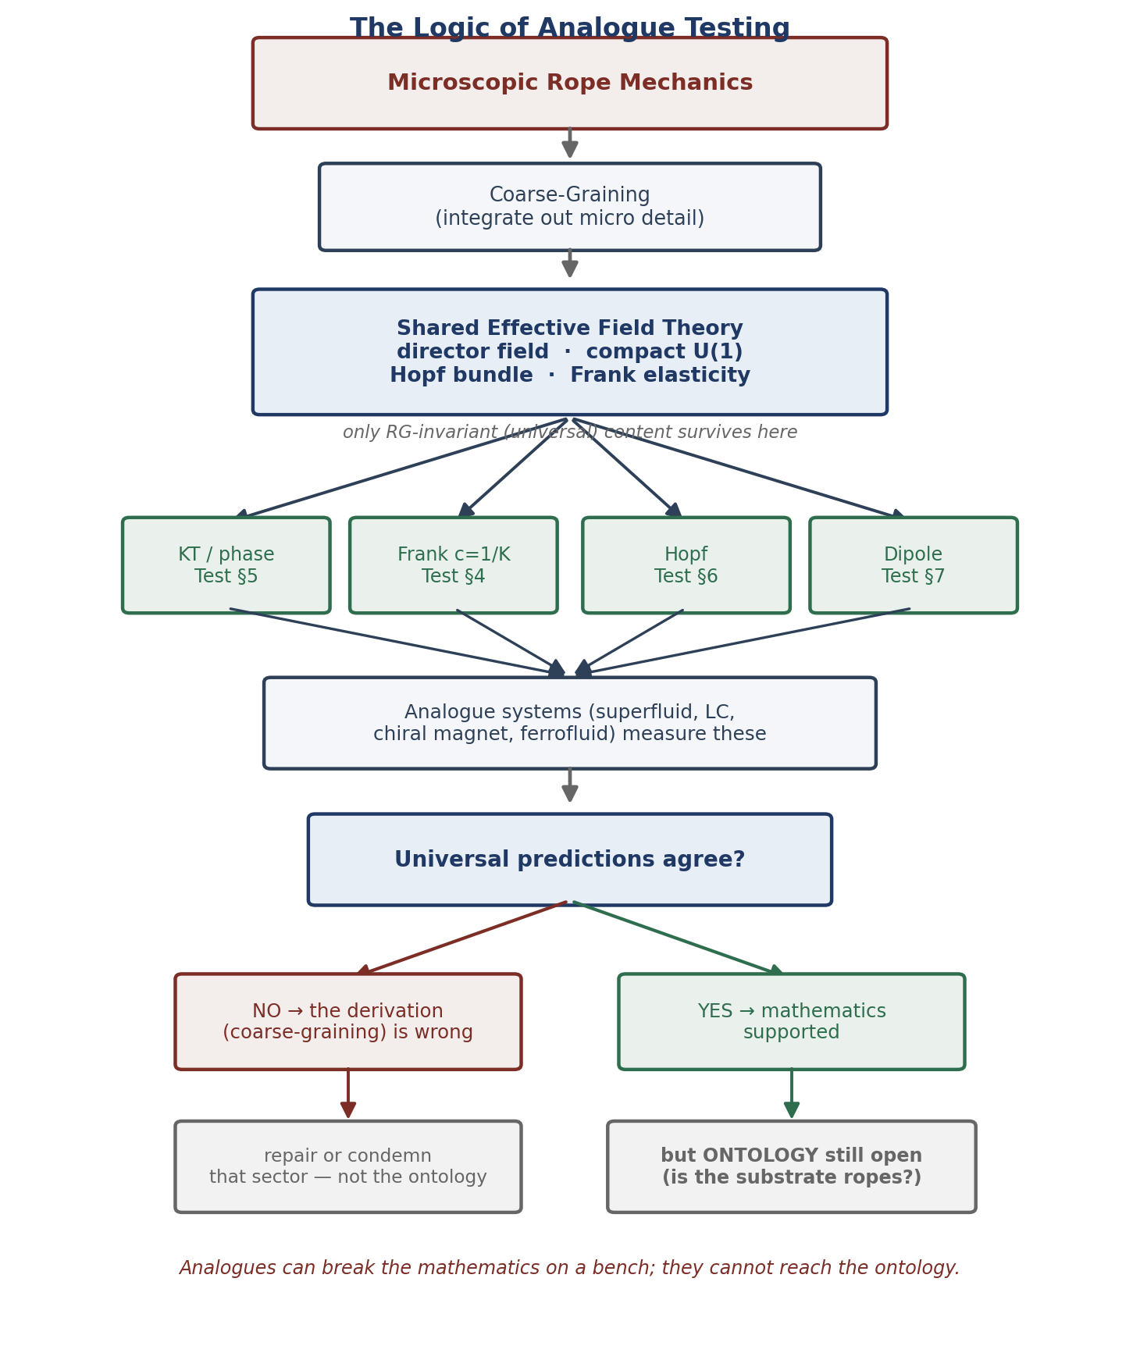
Figure 1. The logic of analogue testing at a glance. Microscopic rope mechanics coarse-grain to a shared effective field theory whose universal content — and only that content — is realised by several condensed-matter systems. The four tests probe it; agreement supports the mathematics, disagreement falsifies a specific derivation, and either way the ontology (is the substrate ropes?) remains beyond the reach of the bench.
Rope result | Analogue system | Measured quantity
Stiffness–coefficient relation c = κ a/(2T²) | nematic liquid crystal; superfluid film | Frank constant / phase stiffness vs. coupling
Exact locking J = T²/κ from endpoint mechanics | colloidal / jammed director networks | defect-pair energy vs. elastic modulus
Coulomb-vs-confined transition at T² = κ/2 | superfluid film (KT); Josephson array | superfluid-density jump; resistance onset
Defect free energy E_core − Θ S_defect | liquid crystal; BEC | defect proliferation temperature; vortex density
Hopf / linking structure of the state space | chiral magnet; spinor BEC | Hopfion stability; linking number of textures
Dipole 1/r³ law from field-energy cross term | ferrofluid; magnetic colloids | force vs. separation and orientation

4. Test 1 — The Stiffness–Coefficient Relation
The programme’s central microscopic result is that the electromagnetic coefficient is fixed by the medium stiffness, c = 1/K with K = 2T²/(κ a), the stiffness in turn built from an exactly-derived locking energy J = T²/κ. In condensed-matter language this is the statement that the effective coupling of the coarse-grained gauge theory is the INVERSE of the director stiffness. This is directly checkable.

Established condensed-matter result
In a nematic liquid crystal the Frank elastic constant K is a standard, well-measured quantity: it is routinely tuned (by temperature, composition, or confinement) and measured independently by light scattering and by Fréedericksz-threshold experiments, the latter already achieving ample precision to resolve the relation of interest. That a director stiffness controls defect energetics is textbook liquid-crystal physics, not a rope claim.

Rope-specific consequence to test
What the rope programme ADDS is a specific INVERSE relationship between the coarse-grained gauge coupling and that stiffness, coefficient ∝ 1/K, as the leading-order universal content of c = κ a/(2T²). One measures the Frank stiffness and the defect (dual) coupling independently across a tuning range and checks the inverse law. Existing Fréedericksz-threshold and light-scattering setups already reach the precision this requires.
Laboratory outcome | Meaning for the rope programme
Coupling ∝ 1/stiffness confirmed across the range | The stiffness–coefficient derivation (a core EM-sector result) is supported in a real system governed by the same math
Relationship deviates from inverse | The rope coarse-graining that yields c = 1/K is wrong or incomplete — a genuine falsification of the derivation
Note precisely what this does: it tests the DERIVATION c = 1/K, which the programme presents as “derived to rope-medium primitives.” A laboratory director system obeying the same coarse-graining either respects that relation or does not. It says nothing about whether spacetime is a rope network; it says a great deal about whether the programme’s central microscopic step is mathematically sound.
If Test 1 fails: what breaks is the COARSE-GRAINING that yields c = 1/K — the step from orientation stiffness to gauge coefficient — not “ropes are wrong.” The failure would localise to that specific derivation, which could be repaired or would condemn the EM-coefficient sector, while leaving the ontology untouched (and unconfirmed).

5. Test 2 — The Phase Transition and Defect Statistics
The programme’s phase result is that long-range electromagnetism (the Coulomb phase) exists only when the medium is stiff enough to suppress defect proliferation — the criterion T² > κ/2 — and that this is the transition of the 3D XY / compact-U(1) universality class. This is perhaps the most direct analogue test available, because the corresponding laboratory transitions are among the best-measured in physics.

Established condensed-matter result
Superfluid helium films undergo the Kosterlitz–Thouless transition by defect (vortex) proliferation, with a universal jump in superfluid density that is one of the celebrated precision measurements of condensed-matter physics. Josephson-junction and superconducting arrays realise the same transition with electrical readout (resistance onset as vortices unbind). The critical behaviour and defect-unbinding temperature are established, high-precision results — not rope claims.

Rope-specific consequence to test
The rope programme CLAIMS its Coulomb-vs-confined transition lies in this same 3D XY / compact-U(1) universality class (it is where the massless-photon phase lives, and why d = 3 is essential), with the defect free energy E_core − Θ S_defect governing proliferation. The leading-order universal predictions — the critical exponents and the defect-unbinding character — must therefore match the measured KT / 3D-XY behaviour. This is a high-stakes consistency check precisely because the programme asserts membership in that class.
Laboratory outcome | Meaning for the rope programme
Measured transition matches 3D-XY / KT with the predicted defect statistics | The phase-selection argument (Coulomb vs confined; T² > κ/2) rests on the correct universality class
Rope defect statistics disagree with the measured transition | The programme has mis-identified its universality class — the phase argument, and the photon-masslessness reasoning built on it, fail

If Test 2 fails: a measured transition NOT in the 3D-XY / KT class (wrong universal exponents, wrong defect-unbinding character) would mean the programme has mis-identified its universality class. The phase-selection argument — and the photon-masslessness reasoning built on T² > κ/2 — would fail, independently of the rope ontology. A mismatch in a non-universal coefficient alone would NOT falsify it; the test is of the universal content.

6. Test 3 — Hopf and Linking Structure
The two-strand rope state space is the Hopf bundle, and linking number plays a central role: charge is strand self-linking, and the non-local quantum connection is a linked topological configuration. Hopf textures (hopfions) and linked/knotted field configurations are no longer only theoretical — they have been created and imaged in chiral magnets, nematic colloids, and spinor Bose–Einstein condensates.

Established condensed-matter result
Hopfions and linked/knotted field textures are no longer theoretical: they have been created and imaged in chiral magnets, nematic colloids, and spinor Bose–Einstein condensates, with their linking numbers and stability characterised. Their existence and basic topology are established experimental facts, independent of any rope claim.

Rope-specific consequence to test
The rope programme ADDS structural claims about such textures: that energy minimisation selects minimal linking, and that the topological energetics obey a positive energy floor of Vakulenko–Kapitanskii type (extra bulk knotting costs energy). These are leading-order topological predictions that must hold for laboratory hopfions governed by the same order-parameter topology; their stability and energetics as a function of linking number are directly measurable by the imaging techniques already used to create them.
Laboratory outcome | Meaning for the rope programme
Hopfion stability and linking energetics match the rope topological predictions | The programme’s use of Hopf/linking structure (charge, minimal-texture selection) is on firm topological ground
Hopfion behaviour departs from the predicted energetics | The topological arguments underlying charge and texture selection need revision

If Test 3 fails: laboratory hopfions departing from the predicted minimal-linking selection or energy floor would mean the topological arguments underlying charge (as strand linking) and minimal-texture selection need revision. This bears on the topological reasoning, not on the ontology directly.

7. Test 4 — Defect Interactions and the Dipole Law
The programme derives the magnetic dipole 1/r³ interaction (with its angular factor) as the field-energy cross term, given the continuum energy functional. Analogue systems with the same field energy exhibit the same interaction laws between their defects and textures.

Established condensed-matter result
Ferrofluids and magnetic colloids interact by the dipole law, and topological defects in liquid crystals interact by force laws fixed by their elastic field energy — both standard, measured physics. Modern optical-tweezer and video-microscopy setups routinely resolve these forces versus separation and orientation at the precision required.

Rope-specific consequence to test
The rope programme reproduces the dipole 1/r³ law (with its angular factor) as the field-energy cross term, GIVEN a continuum energy functional whose form the magnetism paper honestly labels EFT-constrained rather than derived. Measuring defect and colloid interaction laws tests the leading-order consequence of that assumed functional in systems where the energy functional is independently known — a check on the one openly-assumed ingredient of the EM sector.
Laboratory outcome | Meaning for the rope programme
Defect / texture interactions match the field-energy predictions | The continuum energy functional the EM sector relies on has the right form and consequences
Interactions deviate | The assumed energy functional (and the dipole-law derivation) is wrong for a system it should describe
If Test 4 fails: defect / colloid interactions departing from the predicted FORM would mean the continuum energy functional the EM sector assumes is the wrong form — pinpointing the magnetism paper’s acknowledged EFT-constrained assumption as the broken link, not the ontology.

8. The Boundary: Sorting Claims Into Testable and Not
The paper’s discipline depends on sorting the programme’s claims into those an analogue CAN test (properties of the shared effective theory) and those it CANNOT (properties of the specific rope substrate). We do so explicitly.
Rope claim | Analogue-testable? | Why
c = κ a/(2T²); phase criterion; defect statistics; dipole law; Hopf energetics | YES | depend only on the shared coarse-grained effective theory
That the coarse-graining of a director medium yields these | YES | this is a mathematical step any director system shares
That SPACETIME is a rope network | NO | ontological; the same math holds in systems that are not spacetime
α–G correlated variation (as a COSMIC drift) | NO | depends on the cosmic evolution of the actual vacuum, not a lab sample
Non-local quantum correlations FROM ropes specifically | PARTIAL | the Hopf/linking math is testable; the claim that ropes are the substrate is not
The honest upshot. Analogue experiments can confirm or destroy the programme’s MATHEMATICAL SPINE — the coarse-graining, the coefficient relations, the phase structure, the defect and topological energetics. That is a large and genuine exposure: a whole sector of the programme could be falsified on a bench. What they cannot do is elevate a confirmed mathematical spine into a confirmed ontology. A programme whose math survives every analogue test would be a mathematically sound effective theory of SOMETHING; whether that something is spacetime remains a separate question the astrophysical predictions (α–G, birefringence) must carry.

9. What a Definitive Analogue Result Would Mean
It is worth stating both outcomes plainly, because both are valuable:
- If the analogues CONFIRM the rope relations (inverse stiffness law, correct universality class, Hopf energetics, defect interactions): the programme’s coarse-grained mathematics is vindicated in real, independently-characterised systems. This does not prove the ontology, but it removes “the math might be wrong” as an objection and focuses all remaining scrutiny on the ontological claims and the astrophysical predictions.
- If an analogue CONTRADICTS a rope relation it should obey: that is a genuine, inexpensive, near-term falsification of part of the programme — far faster than waiting for cosmological data. The programme would have to locate and repair the broken derivation, or abandon the affected sector.
Either way, the corpus gains what it most lacks: near-term empirical contact. The asymmetry is favourable — cheap potential falsification, with confirmation that meaningfully strengthens the formal case even though it cannot settle the ontology.

9A. Why Analogue Success Would Matter
A fair reader may ask: so what if a liquid crystal behaves the same way? The question deserves a direct answer, because it is the philosophical justification for the entire paper.
Analogue success would NOT establish the rope ontology — nothing about a superfluid can show that spacetime is a rope network. What it WOULD establish is that the derivation chain from microscopic orientation locking, through coarse-graining, to the continuum field theory is mathematically correct in its leading-order universal content. That is not a small thing. A large class of objections to any emergent-spacetime programme is precisely that the effective mathematics is internally inconsistent — that the claimed coarse-graining does not actually produce the field theory asserted. Analogue confirmation would remove that entire class of objection, in real and independently-characterised systems.
The result would be to SHARPEN what remains at issue. With the mathematical spine independently supported, the programme’s open questions would reduce to two: the ontological claim itself (is the substrate ropes?), which only the astrophysical predictions can probe, and the specific derivations that analogues cannot reach (the cosmic α–G drift; the non-local quantum dynamics). In other words, analogue success would convert “the whole framework might be mathematically unsound” into “the mathematics holds; the ontology is the open question” — a far more focused, and far more respectable, position for a speculative programme to occupy.

10. Experimental Priorities
Ordered by a combination of decisiveness and feasibility with existing laboratory technique:
Priority | Experiment | Why first
1 | Superfluid-film / Josephson-array KT transition vs. rope defect statistics | Best-measured analogue; directly tests the phase-selection universality class the programme claims
2 | Nematic stiffness vs. defect coupling (inverse law) | Directly tests the central c = 1/K derivation with mature, tunable systems
3 | Liquid-crystal / ferrofluid defect interaction laws | Tests the continuum energy functional’s form — the EM sector’s principal open assumption
4 | Hopfion stability and linking energetics in chiral magnets / spinor BECs | Tests the topological energetics behind charge and texture selection
None of these requires new apparatus classes; all use established techniques on systems chosen specifically because they realise the rope medium’s effective theory. This is the sense in which the paper delivers near-term testability: the experiments are, in principle, doable now.

11. Connections to the Rest of the Programme
- Thermodynamics: supplies the defect free energy E_core − Θ S_defect whose proliferation the KT/3D-XY analogue directly measures.
- Electromagnetism: supplies c = κ a/(2T²) and the dipole law, tested in §4 and §7.
- Topology: supplies the Hopf/linking structure tested in §6.
- Falsifiable predictions paper: the analogue tests complement the astrophysical predictions — the analogues test the MATH near-term; the astrophysical tests probe the ONTOLOGY long-term. Together they give the programme exposure on both timescales.

Appendix A. Dependency Graph
What an analogue experiment reaches, and where the reach stops.

Rope ontology (spacetime = rope network) [NOT reached by analogues]
|
v
Coarse-grained effective theory [the shared layer]
(director stiffness + defects + compact-U(1) + Hopf)
|
+----------------+----------------+----------------+
v v v v
c = 1/K phase T²>κ/2 Hopf energetics dipole 1/r³
| | | |
v v v v
nematic superfluid/ chiral magnet / ferrofluid /
stiffness Josephson KT spinor BEC LC defects [ALL tabletop]
| | | |
+----------------+-------+--------+----------------+
v
MATHEMATICS falsifiable on a bench [the real exposure]
|
v
ONTOLOGY still only reachable astrophysically [the honest limit]

The graph makes the boundary literal: analogue experiments reach up to the shared effective theory and can break it, but they cannot climb the last step to the ontology. That step is left to the cosmological and astrophysical predictions of the other papers.

Conclusion
The Rope Programme’s coarse-grained description coincides with the effective field theory of several precisely-studied condensed-matter systems — superfluids, liquid crystals, superconducting arrays, and cold-atom condensates. This coincidence supplies what the corpus has most lacked: near-term, tabletop tests. We have mapped specific rope results — the stiffness–coefficient relation c = κ a/(2T²), the Coulomb-vs-confined phase criterion, the Hopf/linking energetics, and the dipole law — onto specific measurements in specific systems, and stated what each outcome would mean. The exposure is real and asymmetric: these experiments can cheaply and quickly FALSIFY the programme’s mathematical spine, and their confirmation would meaningfully strengthen the formal case. We have been equally clear about the boundary they cannot cross: shared mathematics tests the derivation, not the ontology, and no superfluid or liquid crystal, however faithfully it obeys the rope equations, is evidence that spacetime is a rope network. Within that honest boundary, condensed-matter analogues give the Rope Programme its first realistic near-term experimental foothold.

Programme credit: the core Rope Hypothesis is due to Bill Gaede. Computational collaboration and drafting by Claude (Anthropic). Correspondence to palmer100@gmail.com.
Registered Claims in This Paper
Each statement below is traceable to the machine-readable registry (claims.yaml), the corpus's single source of truth. Status labels: Derived (follows from stated mechanics), Modeled (reproduces data with declared inputs), EFT-constrained (bounded by effective-theory limits), Conjecture (proposed, not derived), Open (registered unsolved problem), Failed (falsified, kept as a finding). Where a claim is code-backed, the named benchmark reruns it.
• CM-001 [Modeled]: Condensed-matter analogues

