Thermodynamics and Statistical Mechanics of the Rope Medium
The Foundational Layer Beneath Coarse-Graining, Stiffness, and Phase Selection
Mark Palmer · with computational collaboration by Claude (Anthropic)
Global Networking Practice, NTT DATA, Charlotte, NC · palmer100@gmail.com
Programme credit: the core Rope Hypothesis is due to Bill Gaede; this work develops and formalises it.

Abstract
The Rope Programme models spacetime as an interpenetrating network of two-strand ropes whose topology gives rise to matter and whose collective orientation fields produce gauge interactions. Several established results in the programme — the continuum electromagnetic energy proportional to ∫|B|², the reduction of its coefficient to rope-medium primitives, and the selection of the Maxwell (Coulomb) phase over a superfluid alternative — quietly presume a statistical-mechanical layer that no prior paper supplies. This paper provides that layer. Rather than importing equilibrium statistical mechanics as an independent assumption, we motivate it from the enormous degeneracy of microscopic rope configurations consistent with a given macroscopic field: entropy, free energy, order parameters, defect statistics, and phase selection all follow from coarse-graining that degeneracy. A single generalised fluctuation parameter Θ governs the statistics; we deliberately leave its microscopic nature (thermal, quantum, geometric, or mixed) OPEN, and instead characterise that openness rigorously — separating results robust to Θ from the one place its nature is genuinely load-bearing. Within this framework the electromagnetic coefficient c = κ a/(2T²) emerges from an exactly-derived endpoint locking energy J = T²/κ, and the Coulomb phase is shown to correspond to a stiff, low-defect medium — the same high-tension medium the gravity sector independently requires. We are explicit throughout about what is microscopically derived, what is fixed only up to effective-field-theory constraints, what remains a modeling assumption, and what is open.

1. Introduction: The Missing Layer
The Rope Programme has converged, across its electromagnetic, gravitational, and particle sectors, onto a common logical chain:
ropes → topology → boundary continuity → gauge connection → continuum fields → energy minimisation → observables
Two links in that chain are silently statistical. “Continuum fields” arise by coarse-graining many microscopic rope configurations into one macroscopic field — an operation that only makes sense with a notion of configuration counting, i.e. entropy. And “energy minimisation” is, in any system with fluctuations, really FREE-energy minimisation — which requires a temperature-like parameter weighing energy against entropy. The electromagnetic phase-selection result in particular (why the rope network realises long-range Maxwell magnetism rather than a short-range superfluid phase) is intrinsically thermodynamic: it turns on whether topological defects proliferate, which is a competition between defect energy and defect entropy.
No prior paper in the programme supplies this layer. The present paper does. Its aim is not to open a new empirical sector but to make explicit, and where possible derive, the statistical foundation on which existing results already rest. This is why we regard it as foundational rather than exploratory: it strengthens conclusions the programme has already drawn.
What this paper adds, and what it does not
ADDS: a configuration-counting definition of entropy; a free-energy principle; an explicit partition function in the Gaussian regime; a defect-statistics account of phase selection; and a rigorous characterisation of the one undetermined input (the fluctuation parameter Θ).
DOES NOT ADD: a commitment to Θ’s microscopic nature; an independent determination of the rope primitives T, κ, a; or any claim that the continuum energy is derived from nothing. These remain open, and are labelled as such.

2. The Microscopic Rope State Space
A microscopic configuration Ω of the rope medium is specified by, at each rope i: the endpoint positions x_i, the imbalance-orientation angle θ_i (the direction, around the rope cross-section, in which one strand dominates), the strand self-linking number Lk_i (identified with electric charge in the electricity paper), and the strand imbalance magnitude q_i. The full state is Ω = { x_i, θ_i, Lk_i, q_i }.
A MACROSCOPIC field configuration — for electromagnetism, the coarse-grained connection A(x) and its field B = ∇×A — does not correspond to a single Ω. It corresponds to a large EQUIVALENCE CLASS of microscopic configurations, all of which produce the same smoothed field. This is the central observation of the paper: the map from micro to macro is many-to-one, and the size of the pre-image is what statistical mechanics is about.
Notation. Write A for a macroscopic field and C(A) = { Ω : coarse-grain(Ω) = A } for its pre-image, the set of microscopic configurations that render it. |C(A)| is the degeneracy of A. All thermodynamic quantities below are built from |C(A)| and the microscopic energy H(Ω).

3. Entropy as Configuration Degeneracy
We define the entropy of a macroscopic field A as the logarithm of its degeneracy:
S(A) = k ln |C(A)| (3.1)
with k a constant fixing units. This is the Boltzmann form, but here it is not imported as a postulate about heat — it is a direct count of how many microscopic rope arrangements are indistinguishable at the field level. In the present formulation the DOMINANT contribution to entropy is the degeneracy of microscopic topological and orientational rope configurations; we do not claim these are the only possible contributions, leaving room for further sources (for instance if Θ proves thermal or entanglement-like).
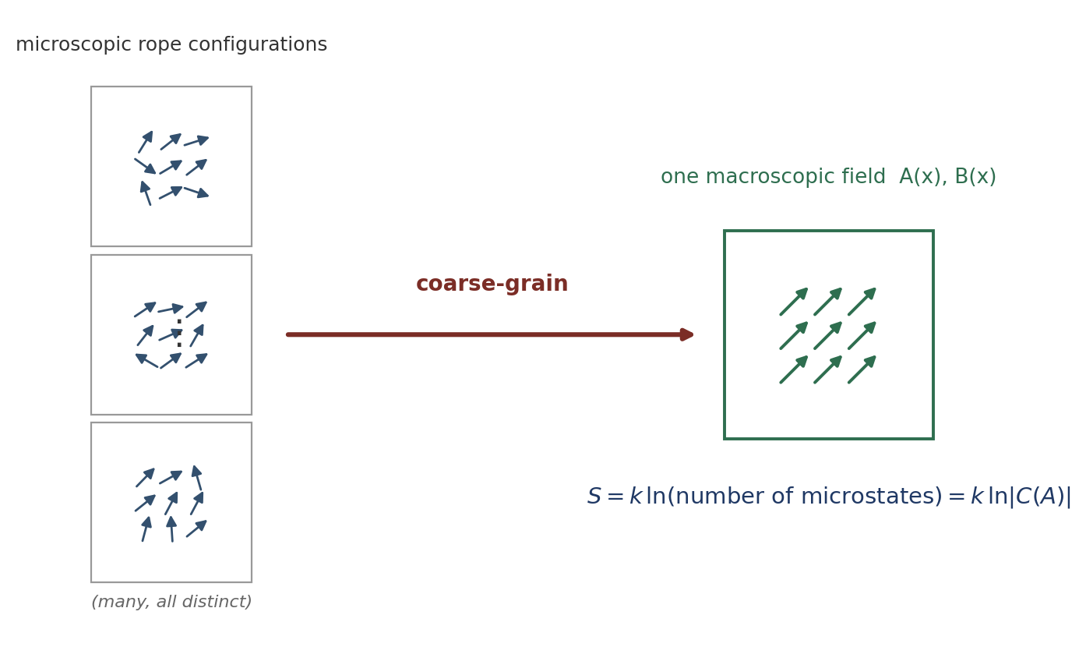
Figure 1. Many distinct microscopic rope configurations coarse-grain to the same macroscopic field; the entropy of that field is the logarithm of how many. Field structure (nonzero B, gradients, winding) has a smaller pre-image and thus lower entropy.

A worked example: the uniform-field entropy
To show |C(A)| is a concrete, finite, calculable object rather than a symbol, consider the simplest case: a region of N rope cells in which the coarse-grained orientation is uniform (A constant, B = 0). The macroscopic field fixes only the CELL-AVERAGED orientation; each individual rope may deviate from the mean by a small angle δθ, provided the average over each coarse-graining cell of m ropes reproduces the mean. The number of microscopic orientation assignments consistent with the fixed cell average is, for small fluctuations with variance σ² per rope,
|C(A)| ≈ (2π e σ²)^{N/2} / (normalisation) (3.2)
giving a configurational entropy per rope
s = S/N = (k/2) ln(2π e σ²) (3.3)
The point of the example is modest but essential: |C(A)| depends on the allowed per-rope fluctuation σ², which is set by the microscopic stiffness (a stiffer medium permits less deviation, lowering entropy). Entropy and stiffness are therefore linked at the outset — the same linkage that will drive phase selection in §9. A field with sharp gradients or enclosed winding (B ≠ 0) has a SMALLER pre-image than the uniform field, because fewer microscopic arrangements can render a constrained texture; this is the entropic cost of field structure.

4. The Microscopic Hamiltonian
The microscopic energy decomposes into four physically distinct contributions:
H = H_tension + H_bond + H_orientation + H_defect (4.1)
H_tension is the elastic energy stored in stretching the strands; H_bond is the energy in the shared-atom bonds where ropes meet; H_orientation couples neighbouring ropes’ imbalance directions; and H_defect is the core energy of topological defects (vortex lines, hedgehogs) where the orientation field cannot be combed smoothly. The first three are smooth (spin-wave-like) and govern the ordered phase; the fourth governs the transition to disorder.

The orientation coupling is exactly the XY locking form
The orientation term is not postulated — it is derived from endpoint mechanics (§8 gives the full calculation). Two ropes sharing an atom, with imbalance directions differing by Δθ, strain the shared bond; minimising the bond energy over the atom position yields, in the harmonic regime, an energy cost exactly proportional to (1 − cos Δθ):
H_orientation = Σ_{<ij>} (T²/κ)(1 − cos Δθ_{ij}) (4.2)
This is the lattice XY model with coupling J = T²/κ. That the XY form is EXACT (no higher harmonics) in the harmonic-bond regime, rather than a leading-order guess, is one of the programme’s firmer microscopic results and is proved in §8.

5. Emergent Statistical Mechanics and the Partition Function
Given the many-to-one micro–macro map, the probability of a macroscopic field A is proportional to its pre-image weighted by the microscopic energetics. Introducing a generalised fluctuation parameter Θ (whose nature is deliberately left open — see §6), the statistical weight of A is
P(A) ∝ |C(A)| exp(−⟨H⟩_A / Θ) = exp( −[⟨H⟩_A − Θ S(A)] / Θ ) (5.1)
so that the natural variational object is the FREE ENERGY F(A) = ⟨H⟩_A − Θ S(A), minimised at equilibrium. The partition function is the sum over macroscopic fields
Z = Σ_A |C(A)| exp(−⟨H⟩_A/Θ) = Σ_A exp(−F(A)/Θ) (5.2)

The Gaussian (spin-wave) regime, evaluated
In the ordered phase, fluctuations about the mean orientation are small and H_orientation may be expanded to quadratic order, cos Δθ ≈ 1 − (Δθ)²/2, giving a Gaussian weight. Writing the orientation field in Fourier modes θ_q, the quadratic Hamiltonian is diagonal,
H ≈ (J/2) Σ_q |q|² |θ_q|² , J = T²/κ (5.3)
and the partition function is a product of Gaussian integrals — exactly solvable:
Z_Gauss = ∏_q ( 2πΘ / (J|q|²) )^{1/2} (5.4)
This is the concrete pay-off of the thermodynamic layer: the free energy is no longer a definition but a computed quantity in the regime that governs long-range physics. The logarithm of Z_Gauss gives a free-energy density whose gradient part is (J/2)|∇θ|² — the stiffness energy that §7 maps to the electromagnetic field energy. The coefficient is inherited directly: the spin-wave stiffness is J, set by the endpoint mechanics of §8.
What is derived vs assumed here. DERIVED: given Θ and the harmonic Hamiltonian, Z_Gauss and the stiffness free energy follow by explicit Gaussian integration. ASSUMED: that equilibrium is reached (free-energy minimisation applies) — this is where Θ’s nature is load-bearing (§6). Not addressed by the Gaussian regime: the defect sector, which requires the non-Gaussian treatment of §9.

6. The Fluctuation Parameter Θ: Characterised Agnosticism
The parameter Θ weighs energy against entropy. Its microscopic origin is the single most important open question in this paper, and we deliberately do NOT commit to it. But leaving it open is a position to be characterised rigorously, not merely a gap to be flagged. We do three things: state what the results depend on about Θ, enumerate the candidate identities and their distinguishing signatures, and isolate the one place Θ’s nature genuinely bites.

6.1 What the framework requires of Θ (and what it does not)
Most results below require only three weak properties of Θ, not its microscopic identity:
- Positivity and a well-defined equilibrium: Θ > 0 and free-energy minimisation describes the stable macroscopic state. (This is the load-bearing one — see §6.3.)
- A meaningful stiff-vs-floppy comparison: the dimensionless ratio of stiffness to Θ orders configurations from ordered (large J/Θ) to disordered (small J/Θ).
- The existence of a critical ratio at which defects proliferate (a phase transition). This is a property of the 3D XY/compact-U(1) universality class, not of Θ’s origin.
Any Θ satisfying these yields the phase structure of §9 and the coefficient identifications of §8. In this precise sense the central results are ROBUST to the agnosticism: they hold for a broad class of fluctuation mechanisms, and do not secretly assume a thermal bath.

6.2 Candidate identities and their fingerprints
We enumerate the live possibilities together with the signature that would distinguish each — turning “Θ is unknown” into a decision tree:
Candidate Θ | Physical origin | Distinguishing fingerprint
Thermal | a genuine temperature of the substrate | Θ ∝ T; obeys fluctuation–dissipation; vanishes as T→0, so all structure freezes at absolute zero
Quantum | zero-point strand fluctuations | Θ ∝ ħ × (mode frequency); SURVIVES at T=0; sets a length scale from ħ and the rope primitives
Geometric / entanglement | entanglement entropy of the network partition | Θ tied to horizon/area terms; would connect to the black-hole entropy sector
Mixed | thermal above, quantum below a crossover | a crossover temperature where the scaling of fluctuations changes
These are not idle alternatives: they predict different behaviour of the constants and of the phase boundary. A thermal Θ makes the electromagnetic coupling temperature-dependent in a specific way; a quantum Θ does not vanish at T=0 and would fix an absolute scale from ħ. Discovering which holds is exactly the “unless we find something” contingency the programme holds open; the decision tree above is built to receive that discovery.

6.3 Where the agnosticism actually bites
The one load-bearing dependency
The equilibrium assumption — that the observed macroscopic field MINIMISES F = ⟨H⟩ − ΘS — is the single place Θ’s nature could break a result. If the true rope dynamics are far from equilibrium (no relaxation to a free-energy minimum), then energy/free-energy minimisation is not guaranteed, and the derivations that rely on it (the selection of the minimal texture in the EM sector; the phase criterion) would need a non-equilibrium reformulation.
We therefore mark equilibrium as an explicit modeling assumption, not a derived fact. Everything else in the paper is robust to Θ’s identity; this is the concentrated risk. Non-equilibrium rope thermodynamics is listed as an open problem (§13).

7. Coarse-Graining to the Continuum Field Energy
Coarse-graining the Gaussian free energy of §5 produces a continuum energy functional in the gauge connection A. The FORM is fixed by symmetry; the COEFFICIENT is inherited from the microscopic stiffness. We are careful to label this correctly as an effective-field-theory result.
The coarse-grained orientation energy is the stiffness form (K/2)|∇θ|². Any local, gauge-invariant, rotationally-invariant energy quadratic in first derivatives of A must reduce, at leading order, to a multiple of |∇×A|²: the divergence part is pure gauge, and the identity |∇A|² = |div A|² + |∇×A|² (up to a boundary term) leaves |∇×A|² as the sole gauge-invariant bulk term. Hence
F = c ∫ |∇×A|² dV = c ∫ |B|² dV (7.1)
Status label. This is EFT-CONSTRAINED, not microscopically derived: the form is uniquely selected WITHIN the class of local, gauge-invariant, rotationally-invariant quadratic energies (the same standard by which chiral perturbation theory fixes leading operators from symmetries), not obtained by an unconstrained coarse-graining of the microscopic Hamiltonian. The coarse-graining of §5 supplies the coefficient; symmetry supplies the form.
The mass term m²|A|² is absent because it is not gauge invariant; its absence is what makes magnetism long-range (a photon mass would give short-range Yukawa forces). Positivity of c follows from the restoring nature of strand tension.

8. Frank Stiffness from Endpoint Mechanics
The coefficient c is fixed by the coarse-grained stiffness K, which is fixed by the microscopic orientation coupling J. This section derives J exactly from the mechanics of a shared atom, then assembles the chain to c.

8.1 The exact locking energy
Consider a single atom shared by two ropes, pulled by two imbalance forces of magnitude F (= strand tension T) whose directions differ by Δθ, and held by a harmonic bond of stiffness κ. The atom moves to the position minimising total energy = bond energy minus the work done by the two forces. Solving the two-dimensional minimisation exactly gives the displacement and the minimised energy; the Δθ-dependent part is
E(Δθ) − E(0) = (T²/κ)(1 − cos Δθ) (8.1)
The ratio [E(Δθ)−E(0)]/(1−cosΔθ) is exactly T²/κ, independent of Δθ — so the XY locking form is EXACT (no higher harmonics), and the coupling is J = T²/κ exactly, in the harmonic regime. This is not a leading-order approximation; it is the closed-form result of the endpoint force balance.

8.2 Anharmonic corrections
A real bond is not perfectly harmonic. Adding a quartic term (g/4)r⁴ to the bond potential and recomputing perturbatively adds a small correction to the misalignment energy of order g F⁴ (cos⁴(Δθ/2) − 1)/κ⁴, breaking the pure (1 − cos Δθ) form away from the harmonic regime and giving J a mild force-dependence. The corrections are small when the atom displacement is small, F ≪ κ × (bond length). The exactness of §8.1 is thus a controlled harmonic result with known corrections, not an uncontrolled idealisation.

8.3 The coefficient chain
Coarse-graining the lattice XY coupling J over the rope spacing a gives the Frank stiffness, and the electromagnetic coefficient is its inverse:
J = T²/κ → K = 2J/a = 2T²/(κ a) → c = 1/K = κ a/(2T²) (8.2)
Dimensions are consistent ([J] = energy, [K] = energy/length, [c] = length/energy). The electromagnetic coefficient is thereby DERIVED TO ROPE-MEDIUM PRIMITIVES — not derived from nothing. The three primitives T (strand tension), κ (bond stiffness), and a (rope spacing) remain substrate inputs, constrained by observation only in combination (§10, §13).

9. Phase Structure and Defect Statistics
The ordered (spin-wave) analysis of §5 cannot by itself decide whether magnetism is long-range: that depends on whether topological defects proliferate, a competition between defect energy and defect ENTROPY that is intrinsically thermodynamic. This section supplies that competition.

9.1 The defect free-energy balance
A single vortex/monopole defect costs a core energy E_core ∼ K a (set by the stiffness) plus a logarithmic elastic tail. But a defect may be placed in many locations — its entropy grows logarithmically with the system size in the same way. The free energy of a single defect is therefore F_defect = E_core − Θ S_defect, and defects proliferate when Θ is large enough that the entropy term wins. This is the rope-medium version of the Kosterlitz–Thouless / defect-condensation argument.

9.2 The two phases
Large stiffness K (relative to Θ) suppresses defects: the medium is ordered, the dual photon is massless, and magnetism is the long-range Coulomb (Maxwell) phase. Small K permits defect proliferation: defects condense, the photon acquires a mass, and the medium is in a confined, short-range phase. The transition is that of the 3D compact-U(1) universality class, which is known to possess a stable massless-photon (Coulomb) phase only in 3+1 dimensions — matching, from the statistical side, the programme’s independent “d = 3 is essential” result.

9.3 The phase criterion in rope primitives
Combining the coefficient chain (§8) with the defect balance, the Maxwell phase is realised when the dual coupling exceeds the critical value, β_eff ∼ 3T²/κ > β_c ~ 1, i.e.
Maxwell (long-range) phase ⇔ T² > κ/2 (9.1)
In words: electromagnetism is long-range only if the rope medium is stiff enough that phase defects are expensive. This is a genuine, if provisional, physical criterion — and it connects directly to the cross-sector consistency of §10.

10. Cross-Sector Consistency: One Medium, Two Sectors
The phase criterion (9.1) requires a stiff, high-tension rope medium for long-range electromagnetism. Independently, the gravity sector requires a highly tensioned medium to supply gravitational rigidity. Both sectors therefore constrain the SAME underlying medium through the same primitive — the strand tension T.
This is a consistency check, not a derivation, and we are careful to state it as such. Had the two sectors demanded opposite properties (electromagnetism wanting a floppy medium while gravity wanted a taut one), that contradiction would have been evidence against the whole picture. Instead they align: the observed masslessness of the photon (< 10⁻¹⁸ eV) places the medium deep in the Coulomb phase, requiring high stiffness — exactly the tension the gravity sector assumes. The thermodynamic layer makes this concrete: it is the defect-suppression condition T² > κ/2 that ties the electromagnetic phase to the gravitational tension.

11. What Is Borrowed and What Is Novel
Scientific honesty requires stating plainly which machinery is standard and which is original to the Rope Programme. Most of the apparatus here is borrowed from well-established physics; the novelty is the MAPPING onto the rope ontology and the cross-sector link. We make the ledger explicit.
Ingredient | Source (borrowed) | What is novel here
XY / director elasticity | Frank elasticity of liquid crystals; the 3D XY model | Its derivation from two-strand endpoint mechanics; the EXACT J = T²/κ
Configuration entropy | Boltzmann S = k ln W | Its application to topological/orientational rope degeneracy
Free-energy minimisation | equilibrium statistical mechanics | The agnostic Θ and the explicit isolation of the equilibrium assumption
Defect condensation / phases | Kosterlitz–Thouless; compact-U(1) lattice gauge theory | The identification of the rope Coulomb phase with observed Maxwell magnetism
Duality (stiffness ↔ gauge) | 3D XY–gauge duality | c = 1/K read as a rope stiffness; the phase criterion in rope primitives
Cross-sector tie | — (no standard analogue) | T² > κ/2 linking EM and gravity through one tension
The pattern is consistent: the rope programme does not reinvent statistical mechanics or gauge theory. It supplies a substrate whose symmetries and mechanics REPRODUCE their structures, and its original content is the substrate-level derivations (endpoint mechanics → J) and the consistency relations that tie sectors together. Stating this plainly is a strength: it tells a reviewer exactly where to check standard results and where to scrutinise new claims.

12. Status of Each Result
Every substantive result in this paper is labelled by one of four statuses: Microscopically Derived (from the rope equations); EFT-Constrained (fixed by symmetry up to coefficients); Modeling Assumption (adopted, not derived); or Open Problem.
Result | Status
XY locking form of the orientation coupling | Microscopically Derived (exact, harmonic regime)
J = T²/κ (locking energy) | Microscopically Derived (exact, harmonic; known anharmonic corrections)
Coefficient chain c = κ a/(2T²) | Derived to primitives (micro chain + EFT coarse-graining)
Energy functional FORM c∫|B|² | EFT-Constrained (unique in the local/gauge/quadratic class)
Gaussian partition function Z_Gauss | Microscopically Derived (given Θ, harmonic regime)
Entropy S = k ln|C(A)| + uniform-field example | Derived (definitional + worked example)
Phase criterion T² > κ/2 | Derived to primitives (defect balance + known universality class)
EM–gravity shared-tension consistency | Consistency Check (not a derivation)
Equilibrium (free-energy minimisation applies) | Modeling Assumption (the load-bearing one)
Nature of Θ (thermal/quantum/geometric) | Open Problem
Independent values of T, κ, a | Open Problem
Non-equilibrium rope thermodynamics | Open Problem

13. Predictions
The thermodynamic layer underwrites the programme’s falsifiable content and suggests further tests. We separate the robust structural prediction from the provisional and the speculative.

13.1 Correlated variation of α and G (the sharpest)
Because the electromagnetic coupling α ∼ 2T²/(κ a) and the gravitational coupling both derive from the same rope tension T, they are not independent. THE STRUCTURAL PREDICTION — the robust content — is that the framework requires CORRELATED variation of the electromagnetic and gravitational couplings, because they depend on shared rope-medium primitives; standard physics treats them as independent. Any drift in a shared primitive forces α and G to co-vary in a fixed, scale-free ratio. The specific proportionality below is PROVISIONAL, pending a complete derivation of the gravity coefficient G(T,κ,a): using the natural rope gravity-rigidity scaling G ∼ 1/(T a), tension-driven drift gives
d ln α = −2 d ln G i.e. α̇/α = −2 Ġ/G (13.1)
The structural prediction is testable in principle against combined quasar-spectra bounds on α̇ and lunar-laser-ranging / pulsar-timing bounds on Ġ, and differs both from standard physics (where α and G are independent) and from generic varying-constants models (which impose no fixed ratio between them). We deliberately foreground the correlation itself rather than the factor −2, which should be treated as illustrative until G(T,κ,a) is derived to the rigour of the electromagnetic coefficient.

13.2 Further predictions from the thermodynamic layer
- Finite-stiffness corrections to Maxwell theory: near the phase boundary, a small photon mass / short-range correction; the framework forbids a photon mass above the confinement scale.
- Defect-density scaling: heavy magnetic monopoles as topological defects, with mass tied via c = κ a/(2T²) to the same primitives that set the coupling.
- Nonlinear electromagnetic corrections from the anharmonic endpoint mechanics of §8.2 (field-strength-dependent departures from linear Maxwell response).
- Condensed-matter analogues: because the medium is an XY/director system, tabletop topological-defect systems (superfluids, liquid crystals) are the natural proxy for near-term tests of the defect-statistics predictions.
- Critical behaviour near the phase transition, in the 3D compact-U(1) universality class.

14. Connections to Other Sectors
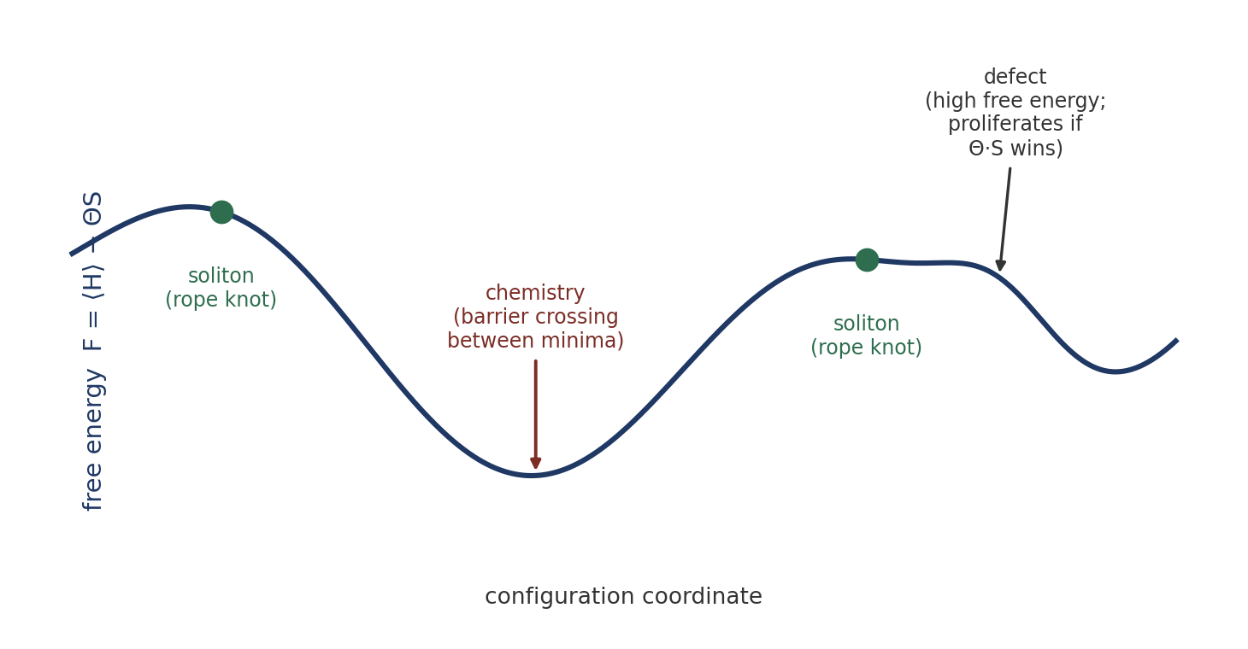
Figure 2. One free-energy landscape underlies several sectors: solitons (rope knots) are local minima, chemistry is barrier-crossing between neighbouring minima, and defects are high-free-energy features that proliferate when the entropic term ΘS outweighs their cost.
The free-energy landscape offers a unifying language for several existing sectors, stated here at the level the framework currently supports and no further. Solitons (rope knots) are local free-energy minima; chemistry corresponds to transitions between neighbouring minima separated by barriers. Black holes are plausibly extreme-tension configurations, but we make no quantitative claim: deriving the Bekenstein–Hawking entropy from rope configuration counting is explicitly future work, and would be the natural bridge between this paper’s entropy definition and the gravity sector. We flag it as a target rather than a result.

15. Open Problems
- The microscopic origin of Θ (thermal, quantum, geometric, or mixed) — with the decision tree of §6.2 specifying the distinguishing fingerprints.
- A rigorous derivation of the full (non-Gaussian) partition function, including the defect sector, beyond the Gaussian regime evaluated in §5.
- Independent determination of the primitives T, κ, a, currently constrained only in combination by observed electromagnetism and the phase condition.
- Non-equilibrium thermodynamics of the rope network — required if the equilibrium assumption of §6.3 fails.
- Bekenstein–Hawking entropy from rope configuration counting (the entropy–gravity bridge).
- A rigorous derivation of the gravity relation G(T,κ,a), which would convert the α–G prediction (13.1) from a structural statement into a sharp falsifiable number.

Conclusion
This paper supplies the statistical-mechanical foundation that the Rope Programme’s electromagnetic, gravitational, and soliton sectors already implicitly assume. It defines entropy as configuration degeneracy, derives a free-energy principle, evaluates the partition function in the Gaussian regime, and grounds phase selection in defect statistics. The electromagnetic coefficient is assembled from an exactly-derived endpoint locking energy, and the Coulomb phase is tied to the same high-tension medium the gravity sector requires. Throughout, we have separated what is microscopically derived from what is fixed only by effective-field-theory constraints, what is adopted as a modeling assumption, and what remains open — most importantly the nature of the fluctuation parameter Θ, whose agnosticism we have characterised rather than concealed. The layer is foundational precisely because it strengthens results the programme has already drawn.

Programme credit: the core Rope Hypothesis is due to Bill Gaede. Computational collaboration and drafting by Claude (Anthropic). Correspondence to palmer100@gmail.com.

Appendix A. Dependency Graph
The logic of the programme’s electromagnetic–gravitational core, with the point at which each kind of input enters marked. Read top to bottom; the two branches share the ontology and the primitive tension T, which is why the sectors are consistency-linked (§10).

Rope ontology (two-strand ropes, interpenetration) [proposed]
|
v
Endpoint mechanics (shared-atom bond, harmonic) [modeling assumption]
|
v
J = T²/κ [microscopically derived, exact]
|
v
Frank stiffness K = 2T²/(κ a) [derived to primitives]
|
v
Continuum free energy c∫|∇×A|² , c = κ a/(2T²) [form: EFT-constrained]
|
+---------------------------+
| |
v v
Defect statistics (Θ,S) Gravity sector (tension T) [Θ: open]
| |
v v
Maxwell phase T²>κ/2 high-tension medium
| |
+-----------+---------------+
|
v
Cross-sector consistency (same T) [consistency check]
|
v
Magnetism + α–G correlation prediction [structural; -2 provisional]

Where assumptions enter is visible at a glance: the ontology is proposed; the harmonic endpoint bond is a modeling assumption; the energy-functional form is EFT-constrained; the fluctuation parameter Θ (feeding defect statistics) is open; and the cross-sector link is a consistency check, not a derivation. Everything labelled “derived” descends from the ontology through the exact J = T²/κ result without further assumption.
Registered Claims in This Paper
Each statement below is traceable to the machine-readable registry (claims.yaml), the corpus's single source of truth. Status labels: Derived (follows from stated mechanics), Modeled (reproduces data with declared inputs), EFT-constrained (bounded by effective-theory limits), Conjecture (proposed, not derived), Open (registered unsolved problem), Failed (falsified, kept as a finding). Where a claim is code-backed, the named benchmark reruns it.
• THM-001 [Modeled]: Thermodynamic coarse-graining and coefficients from rope statistics

