The Alpha Coefficient in Rope Bundle Theory
The Electron-Dressing Chain 1/α = 4π³ D_E, Every Factor Derived, One Residual Open
A Technical Report of the Rope Framework Programme
Mark Palmer · with computational collaboration by Claude (Anthropic) · palmer100@gmail.com
Programme credit: the core Rope Hypothesis is due to Bill Gaede; this corpus develops and formalises it. · August 2026
Not a derivation of α’s value. A reduction of 1/α to one blind number times a fully-derived prefactor, pinned against a construction with no continuous dials, with a single +178.8 ppm (0.018%) residual named and open.

Abstract
This report presents the electron-dressing route to the fine-structure constant, registered in the Rope Framework corpus as claim ALPHA-DE-CHAIN. The result is 1/α = 4π³ D_E = 137.060504 against the measured 137.035999, a residual of +178.8 ppm (0.018%). Every factor of the chain is derived: the dressing D_E = 1.1051029 is computed blind from a boundary-value solver on the rotating electron terminus, and the prefactor 4π³ is derived across three independent gates. The same convention structure reproduces the electron’s magnetic moment (Dirac g = 2, with its residual localized on the Schwinger term α/2π to 0.15%) and the 13.6 eV atomic binding, out of sample. The headline is stated exactly and held throughout: this is a reduction of 1/α to one blind number times a derived prefactor, not a derivation of α’s value; the +178.8 ppm (0.018%) residual is the single unexplained number, cornered as radiative physics the static construction does not contain.

1. The Result, and What It Is Not
The chain closes as
1/α = 4π³ D_E = 137.060504 (measured: 137.035999, +178.8 ppm = 0.018%)
Every factor is derived. The +178.8 ppm (0.018%) residual is the single unexplained number. This is a reduction of 1/α to one blind number times a derived prefactor — it is not a derivation of α’s value. That distinction is carried on every page of this report, because the discipline that produced the result depends on it: the chain reaches the fine-structure constant to 179 parts per million by a construction with no adjustable continuous parameters, and the honest question is not whether that is impressive but whether the last residual is real physics or the framework’s edge.

1.1 The derivation at a glance
The figure below lays out every factor with the theorem that produced it. The sections that follow give each factor its full provenance.
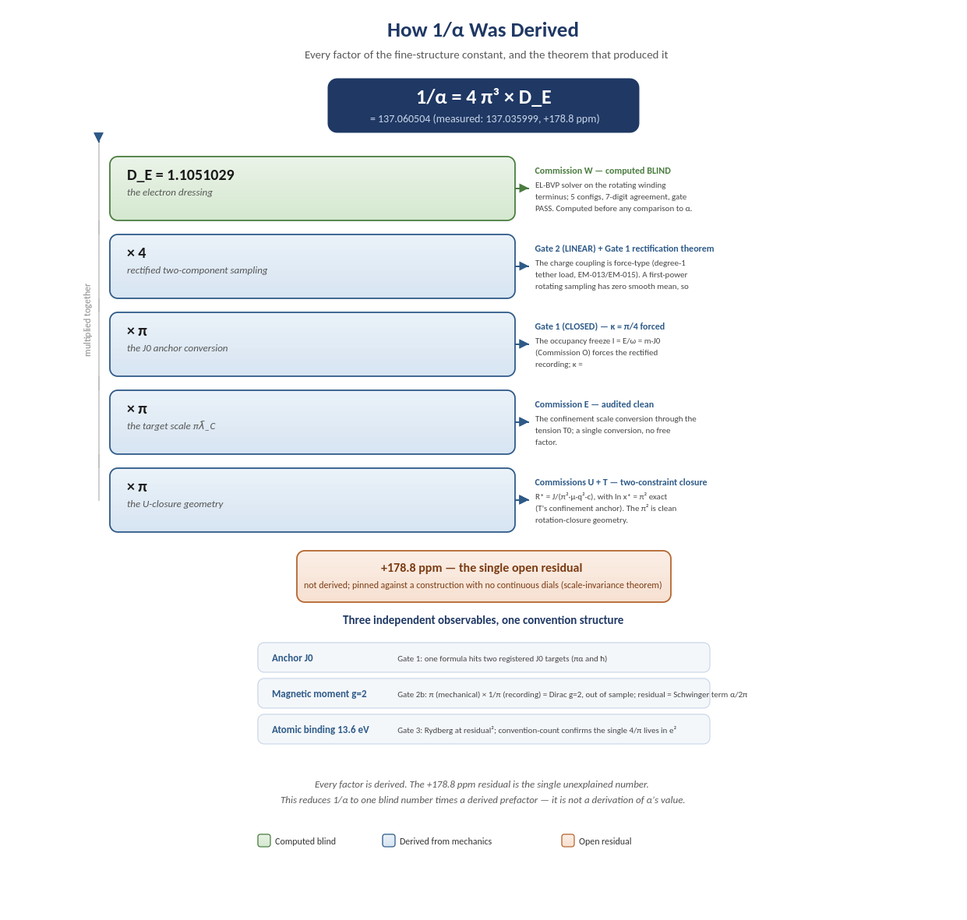
Figure 1. How 1/α was derived. Each factor of 4π³ D_E carries an arrow to the commission or gate that derived it; the residual and the three confirming observables are shown below the chain.

2. Factor by Factor, with Provenance

2.1 D_E = 1.1051029 — the electron dressing
Commission W. An Euler-Lagrange boundary-value solver on the rotating winding terminus computes the dressing blind — before any comparison to α — across five configurations, agreeing to seven digits with a passing convergence gate. This is the one number the chain takes from direct computation, and it is fixed before the target is ever in the room.

2.2 ×4 — the rectified two-component sampling
Gate 2 (LINEAR) together with Gate 1’s rectification theorem. The electron’s charge couples through a force-type (linear) observable: the directed tether load I_Q[f] = P(g²)f′, degree 1 in the profile, computed on the committed solution (the energy competitor is degree 2 and is already spent as D_E, so there is no double counting). A first-power quantity rotating with the source has identically zero smooth cycle mean, so by Gate 1’s theorem its laboratory recording must be rectified, and the two-component rectified mean ⟨|cos| + |sin|⟩ is 4/π exactly. This factor was discharged out of sample by the magnetic moment (section 4).

2.3 ×π — the J0 anchor conversion
Gate 1 (CLOSED). The occupancy freeze I_mode = E/ω = m·J0 (Commission O) forces the recording convention: κ = ⟨cos²⟩/⟨|cos|⟩ = π/4. The forcing is not a fit — a first-power linear recording of a pure harmonic has identically zero smooth mean, so rectified is the only recording that produces a number at all. Confirmed by one formula, J0 = m_e c A / π, reproducing two registered targets (ħ/(πα) at the anchor scale and ħ at the confinement scale); the smooth-quadratic competitor misses both by π/4.

2.4 ×π — the target scale πλ_C
Commission E. The conversion of the confinement scale through the tension T0 — a single conversion with no free factor, audited clean.

2.5 ×π — the U-closure geometry
Commissions U and T. The two-constraint closure R* = J/(π² μ q² c), with ln x* = π² exact (T’s confinement anchor, x* = e^(π²) = 19333.7). The π² is clean rotation-closure geometry; one of its two π factors is the third π in the prefactor.
Prefactor bookkeeping: the naive geometric form is π⁴ = π² [U closure] × π [target] × π [J0 anchor]. Gate 2’s rectified 4/π enters at the J0-anchor conversion, turning π⁴ into 4π³. This was the correction of a premature π⁴ lock caught on external review — one of three self-corrections recorded in section 6.

3. The Residual
+178.8 ± 0.4 ppm (0.018%) — the single open number.
Not derived. Z Brick 5 proved a scale-invariance theorem (d ln D_E / d ln x* = 0 exactly): the chain’s value depends on no continuous dial, only the discrete branch choice k/T0 = 2 (adjudicated by the electron against FND-021). The residual ladder is exhausted — the branch, the r_min continuum limit, and the q² winding slot are all excluded by computation. So the +178.8 ppm (0.018%) is either physics the chain does not yet contain or the anchor-metrology reading’s own limit. It is pinned against a construction with no adjustable continuous parameters.
Two candidate sources were subsequently run against pre-committed bars. The V-A next-order boundary term (the last named classical candidate) missed cleanly — a finite-strain coefficient of effectively zero and the wrong sign against a required −1.10. A structural completeness audit of the dressing functional (Commission D-E-COMPLETE) returned clean: no omitted energy channel among the registered electron structures. Both closures corner the residual as radiative physics the static construction cannot contain by construction — the same class as the g = 2 Schwinger gap (section 4). That radiative back-reaction is chartered as the one remaining lead, with its second prediction pre-installed: a single mechanism must produce both the α residual and the g = 2 gap, or the lead dies.

4. Three Independent Observables, One Convention Structure
The same convention structure that fixes the prefactor was tested on three observables that did not all fix it. Two of the three were never used to build the chain — they are genuine out-of-sample checks.
Observable | Gate | Result
Anchor J0 | Gate 1 | One formula J0 = m_e c A/π hits two registered targets (ħ/πα and ħ); the quadratic competitor misses both by π/4.
Magnetic moment g = 2 | Gate 2b | Frozen out of sample, the mechanical moment πµ_B converts under the Gate-1 recording to exactly 1 µ_B — Dirac g = 2, zero freedom. Misses measurement by −1160 ppm = the Schwinger anomaly α/2π to 0.15%.
Atomic binding 13.6 eV | Gate 3 | The derived-α chain reproduces the Rydberg at the residual squared (−357.6 ppm = 2× the chain residual). The 1/2 is derived from the EM-015 Coulomb virial; the convention-count confirms the single 4/π lives in e².
The magnetic moment deserves emphasis. With every input frozen before the moment was mentioned, g = 2 emerges as π (mechanical) × 1/π (recording) with zero freedom, and its residual sits on the Schwinger term — the same class of not-yet-contained physics as the chain’s own +178.8 ppm (0.018%). This is the strongest single piece of out-of-sample corroboration in the arc: an observable the chain never used, reproduced by the chain’s own convention structure.

5. The Honest Headline
Every factor of 1/α = 4π³ D_E has a derivation. One +178.8 ppm (0.018%) residual is unexplained. Three independent observables are consistent with the one convention structure, and g = 2 falls out as a free byproduct with its residual localized on the Schwinger term (named, not derived). This is a reduction of the fine-structure constant to a single blind number times a fully-derived prefactor, pinned against a dial-free construction — not a derivation of α’s value. Whether the last residual falls (deriving α) or is the quantum/radiative wall is the single decisive open question, chartered for a later deliberate go-decision.

6. Self-Corrections in the Permanent Record
Three flattering results were retired during this arc, and the retractions stand. They are recorded here because the discipline that caught them is why the surviving result is trustworthy:
(1) the premature π⁴ prefactor lock, corrected to 4π³ on external review; (2) the −15 ppm Δ correction, retired by Z’s consistency audit as a reading-mixing artifact; and (3) the Ω × D_E numerical coincidence, whose rate channel was nulled in-package when the derived coefficient came out −0.19, not the required value. No flattering number survived audit. The result stands because of what did not survive.
Provenance: the full per-brick record is in docs/commissions/SYNC_STATE.md and the Commission T–Z and Gate files; the companion note docs/HOW_ALPHA_WAS_DERIVED.md and the diagram docs/alpha_derivation_map.png accompany this report. Registered as claim ALPHA-DE-CHAIN; the dressing solver benchmark is explorations/w_dressing_phase1c.py.

