Satellite Dataset Analysis

Title
Exploratory Data Analysis on Satellite Dataset

Objective
The objective of this project is to perform Exploratory Data Analysis (EDA) on a satellite dataset to understand satellite characteristics, launch trends, orbital classifications, mission purposes, launch vehicles, and technical parameters. The analysis helps identify patterns in satellite launches and space missions.

Introduction
EDA is an important step in Data Analysis that helps understand dataset structure, quality, and patterns. In this project, a satellite dataset was analyzed using Python libraries such as Pandas, NumPy, Matplotlib, and Seaborn. The dataset contains information about satellite purpose, orbit class, launch vehicle, launch date, launch mass, power consumption, perigee, and apogee.

Data Sources
Dataset File: satellite_data_EDa.csv
Loaded using Pandas:
import pandas as pd
df = pd.read_csv("satellite_data_EDa.csv")
Source Type:
• Structured CSV Dataset
• Satellite and Space Mission Data

Data Description
Important Columns Used:
• purpose – Mission purpose of satellite
• class_of_orbit – Orbit classification
• launch_vehicle – Rocket/vehicle used for launch
• date_of_launch – Launch date
• launch_mass_kg – Satellite launch mass
• power_watts – Power consumption
• perigee_km – Closest orbital distance
• apogee_km – Farthest orbital distance

Project Structure / Workflow
1. Import Libraries
2. Load Dataset
3. Understand Dataset Structure
4. Data Cleaning
5. Missing Value Analysis
6. Statistical Analysis
7. Data Visualization
8. Question & Answer Analysis
9. Key Insights
10. Final Findings

Data Preprocessing
The dataset was inspected using shape, columns, info(), missing value checks, and statistical summaries. Date columns were converted into datetime format, and numerical variables were prepared for analysis and visualization.

Data Analysis & Visualization
Several visualizations were created to analyze satellite launches, orbit classes, launch vehicles, and technical parameters.

Questions, Answers & Explanation
Question 1: What are the most common satellite purposes?
Answer:
The graph shows the most frequently occurring mission purposes in the dataset such as communication, Earth observation, navigation, and scientific research.
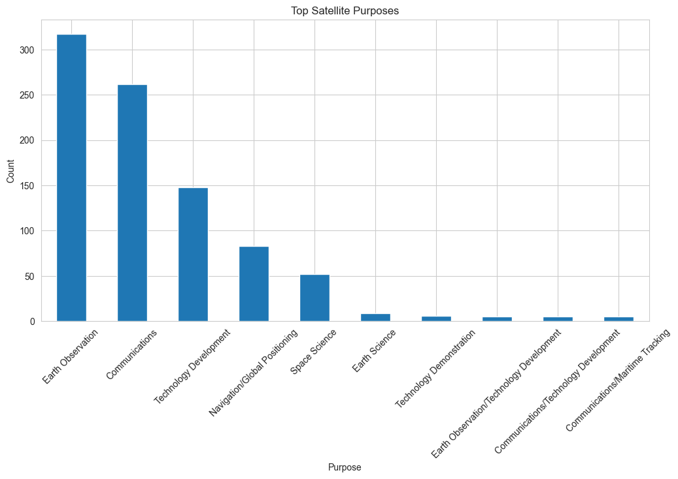
Explanation:
This analysis helps identify the primary objectives for which satellites are launched. Understanding mission purposes provides insights into the growing demand for communication networks, weather monitoring, navigation systems, and scientific exploration. It also helps researchers understand how satellite technology supports different sectors of society and industry.
Question 2: What is the distribution of orbit classes?
Answer:
Satellites are distributed across different orbit categories including LEO, MEO, GEO, and other orbital classes.
Explanation:
Orbit class analysis helps in understanding how satellites are positioned around the Earth based on their mission requirements. Different orbit types provide different advantages such as global coverage, faster communication, or better Earth observation capabilities. The distribution also reflects technological and operational strategies used in space missions.
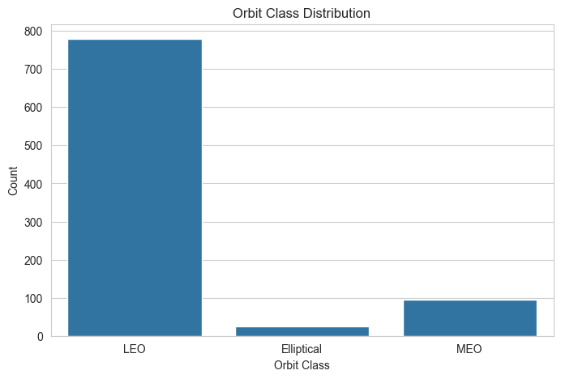
Question 3: Which launch vehicles are most frequently used?
Answer:
The graph highlights the launch vehicles that have been used most often to deploy satellites.
Explanation:
Launch vehicle analysis helps determine which rockets are most reliable and widely adopted by space agencies and private companies. It provides insight into the popularity and performance of different launch systems. Understanding launch vehicle usage also helps evaluate trends in the global space industry.
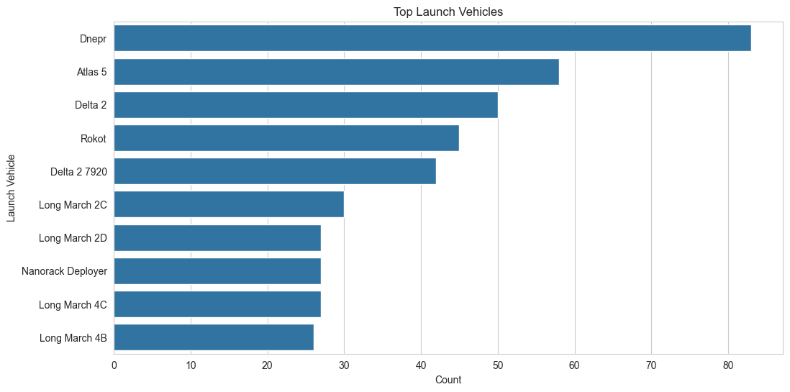
Question 4: How have satellite launches changed over time?
Answer:
The launch trend graph shows variations in the number of satellite launches across different years.
Explanation:
Analyzing launch trends helps identify periods of growth and technological advancement in the space sector. Increasing launch activity often indicates improvements in launch technology, greater commercial investment, and expanding applications of satellite systems. This analysis reveals the evolution of the satellite industry over time.
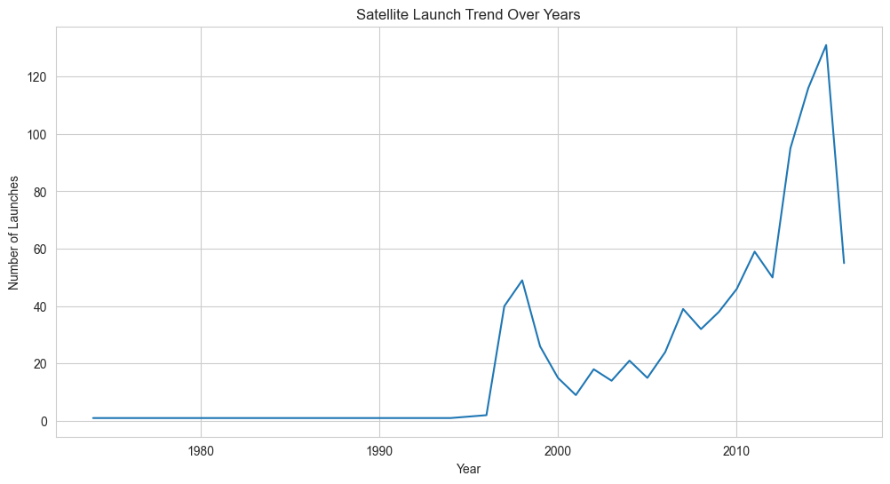
Question 5: What is the distribution of satellite launch mass?
Answer:
The distribution graph shows how satellite masses vary across the dataset.
Explanation:
Launch mass is an important technical characteristic that influences launch costs and mission design. Studying mass distribution helps identify whether most satellites are small, medium, or large-sized. It also provides insights into modern trends such as the increasing popularity of lightweight satellites and CubeSats.
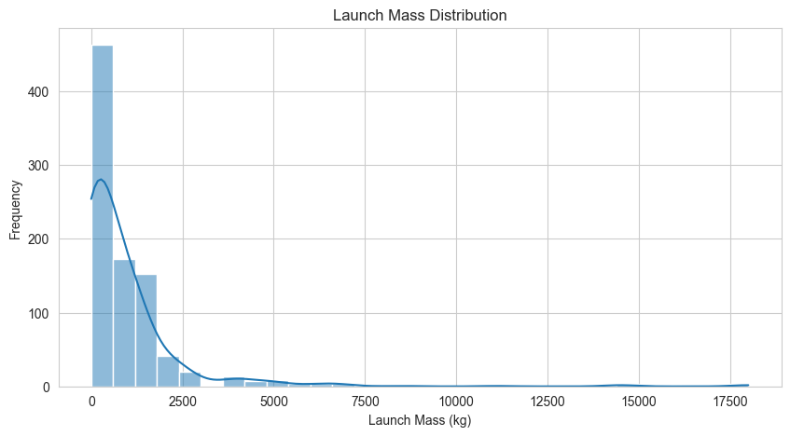
Question 6: What is the distribution of satellite power consumption?
Answer:
The graph presents the variation in power requirements among satellites.
Explanation:
Power consumption reflects the complexity and operational capabilities of a satellite. Satellites with higher power requirements generally support advanced communication systems, imaging equipment, or scientific instruments. Analyzing power distribution helps understand technological differences among various satellite missions.
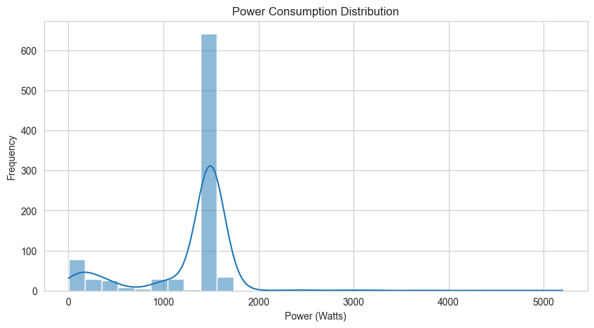
Question 7: What is the relationship between perigee and apogee?
Answer:
The scatter plot illustrates the relationship between the closest and farthest orbital distances of satellites.
Explanation:
Perigee and apogee are important orbital parameters that define the shape and size of a satellite’s orbit. Understanding their relationship helps researchers analyze orbital stability and mission characteristics. This information is useful for studying satellite trajectories and operational efficiency.
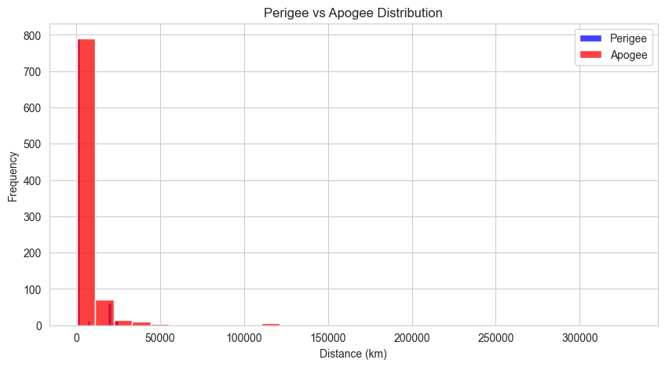
Question 8: Are there outliers in launch mass?
Answer:
Boxplot analysis identifies unusually high or low launch mass values within the dataset.
Explanation:
Outliers often represent special-purpose satellites, experimental missions, or exceptionally large spacecraft. Identifying these values helps improve data understanding and ensures accurate statistical analysis. It also highlights unique missions that differ significantly from the majority of satellites.
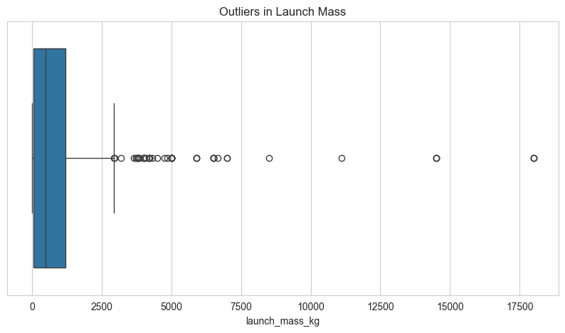
Question 9: What are the key orbital characteristics?
Answer:
The analysis of perigee and apogee values provides insights into orbital configurations.
Explanation:
Orbital characteristics determine satellite coverage area, mission duration, and communication efficiency. By studying these parameters, we can understand how different satellites are designed to meet specific mission objectives. This analysis also helps compare operational patterns among different satellite categories.
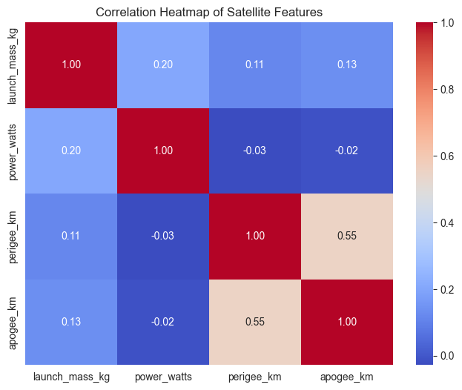
Question 10: What overall trends can be observed in satellite missions?
Answer:
The dataset reveals trends related to mission purposes, launch technology, and orbital deployment.
Explanation:
Overall trend analysis combines multiple aspects of the dataset to provide a complete understanding of satellite activities. It helps identify technological advancements, changing mission priorities, and industry growth patterns. Such insights are valuable for future planning and decision-making in the space sector.
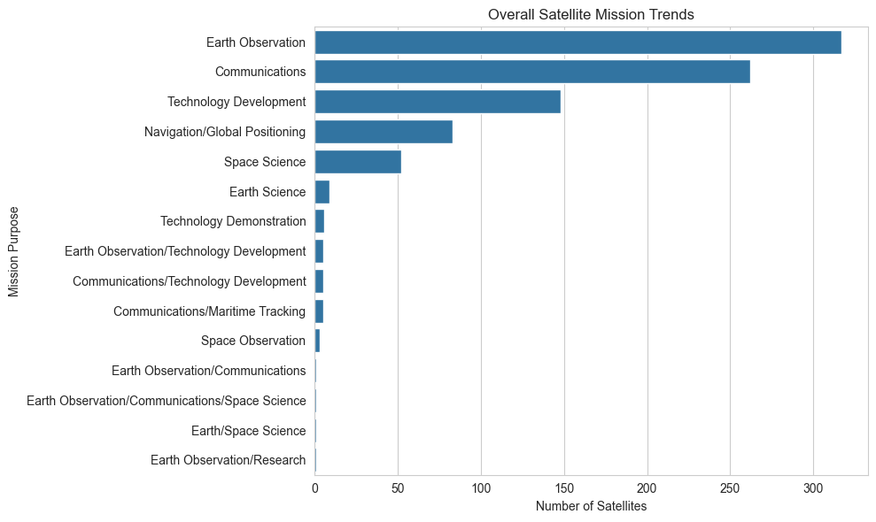

Key Insights
• Certain satellite purposes dominate space missions.
• Some orbit classes are used more frequently than others.
• A limited number of launch vehicles account for most launches.
• Satellite launches have increased over time.
• Launch mass and power consumption vary significantly.
• Orbital parameters reveal diverse mission requirements.

Findings
• Communication and observation missions are common.
• Launch vehicle choice depends on mission requirements.
• Satellite technology has evolved over time.
• Orbital characteristics differ across mission types.

Problems Faced During the Project
• Handling missing values.
• Working with date formats.
• Understanding orbital parameters.
• Selecting suitable visualizations.
• Interpreting satellite mission data.

Recommendations
• Improve dataset completeness.
• Include more recent launch records.
• Analyze mission success rates.
• Perform predictive analytics on future launch trends.
• Compare satellite characteristics across countries.

Conclusion
The EDA project successfully analyzed the satellite dataset and identified important patterns related to mission purposes, launch vehicles, orbital classes, launch trends, and technical characteristics. The analysis demonstrates how EDA can provide meaningful insights into space and satellite data.

Tools and Technologies Used
• Python
• Pandas
• NumPy
• Matplotlib
• Seaborn
• Jupyter Notebook

Final Result
The Satellite EDA project helped in:
• Understanding satellite launch trends.
• Identifying common mission purposes.
• Analyzing orbital classifications.
• Exploring technical satellite parameters.
• Generating actionable insights from space mission data.

