Exploratory Data Analysis (EDA) Report

Adidas Sales Dataset Analysis

Title
Exploratory Data Analysis on Adidas Sales Dataset

Objective
The main objective of this project is to perform Exploratory Data Analysis (EDA) on the Adidas Sales Dataset to understand sales performance, revenue generation, profit trends, product performance, regional sales distribution, and business growth patterns.
This project helps in:
- Understanding overall sales performance.
- Identifying top-performing products.
- Analyzing revenue and profit trends.
- Finding regional and country-wise sales patterns.
- Generating insights useful for business decision-making.

Introduction
Exploratory Data Analysis (EDA) is an important step in Data Analysis and Data Science. It helps in understanding the structure, quality, and patterns of data before applying advanced analytics.
In this project, an Adidas sales dataset is analyzed using Python libraries such as Pandas, NumPy, Matplotlib, and Seaborn.
The dataset contains information related to:
- Product Name
- Category
- Region
- Country
- City
- Units Sold
- Revenue
- Profit
- Discount Percentage
- Sales Date
The analysis provides statistical and visual insights into Adidas sales performance.

Data Sources
The dataset used in this project is:
adidas_sales_dataset_rows.csv
The dataset was loaded using Pandas:
import pandas as pd
df = pd.read_csv("adidas_sales_dataset_rows.csv")

Source Type
- Structured CSV Dataset
- Adidas Sales Dataset
- Retail and Business Sales Data

Data Description
The dataset contains information related to Adidas product sales across multiple regions and countries.

Important Columns Used
Column Name | Description
Product_Name | Product Name
Category | Product Category
Region | Sales Region
Country | Country Name
City | City Name
Units_Sold | Number of Units Sold
Price_per_Unit | Product Price
Total_Revenue | Revenue Generated
Profit | Profit Earned
Discount_% | Discount Offered
Month | Sales Month
Year | Sales Year

Project Structure / Workflow
The complete workflow of this EDA project is:
- Import Required Libraries
- Load Dataset
- Understand Dataset Structure
- Data Cleaning
- Check Missing Values
- Remove Duplicate Records
- Perform Statistical Analysis
- Data Visualization
- Business Question Analysis
- Generate Insights and Recommendations

Data Preprocessing
Data preprocessing was performed to improve data quality and prepare the dataset for analysis.
The following steps were completed:
- Dataset structure examined.
- Data types verified.
- Missing values checked.
- Duplicate records identified and removed.
- Numerical and categorical columns separated.
- Statistical summaries generated.
The preprocessing process ensured that the dataset was clean and ready for analysis.

Data Analysis & Visualization
Several visualizations were created to understand sales performance, revenue generation, profit distribution, product popularity, and business growth trends.

Questions, Answers & Explanation

Question 1: What is the distribution of Total Revenue?

Answer
The histogram shows how revenue values are distributed across sales transactions.

Explanation

This visualization helps in understanding how revenue is distributed across all sales transactions. It identifies the most common revenue ranges and highlights the presence of extremely high or low revenue values. Analyzing revenue distribution allows businesses to evaluate overall sales performance and identify potential opportunities for increasing revenue generation.

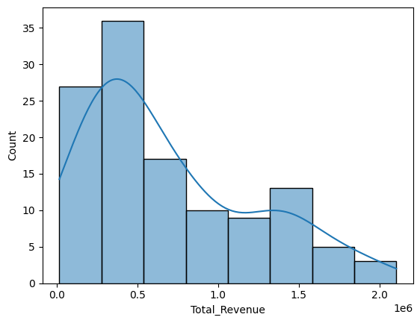

Question 2: What is the distribution of Profit?

Answer
The graph displays the spread of profit values generated from sales.

Explanation
Profit distribution analysis provides insights into the profitability of sales transactions. It helps determine whether most transactions generate low, moderate, or high profit margins. Understanding profit patterns is essential for evaluating business performance and making strategic decisions related to pricing and product management.
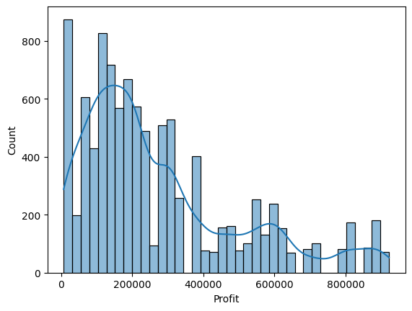

Question 3: Which region generates the highest sales?

Answer
The graph compares sales activities across different regions.

Explanation
Regional sales analysis helps identify which geographical areas contribute the most to the company's overall sales performance. By understanding regional demand patterns, businesses can allocate resources more effectively, improve marketing strategies, and focus on expanding operations in high-performing regions.
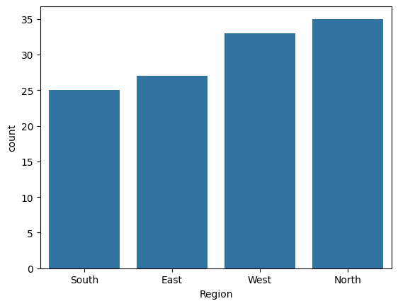

Question 4: Which products are sold the most?

Answer
The graph displays the most frequently sold Adidas products.

Explanation
This analysis highlights the most popular Adidas products among customers. Understanding product demand helps businesses manage inventory efficiently, improve product availability, and develop targeted promotional campaigns. Best-selling products often play a significant role in overall revenue generation.
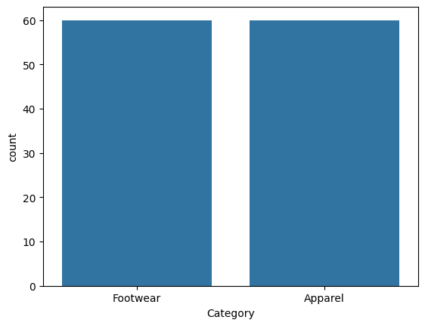

Question 5: Which category generates the highest revenue?

Answer
Different product categories contribute differently to overall revenue.

Explanation

Revenue generated by different product categories provides valuable information about customer preferences and market demand. Categories contributing higher revenue indicate stronger market acceptance and can help businesses focus on profitable product segments for future growth.
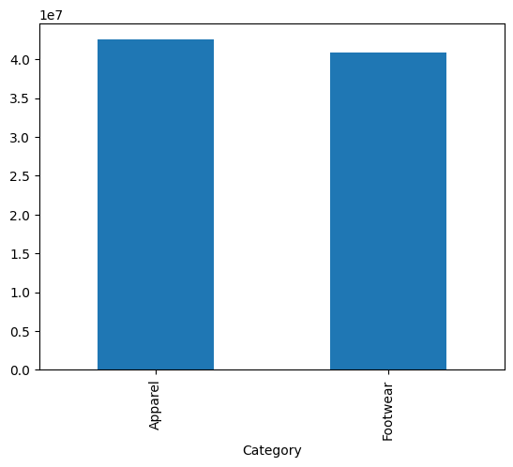

Question 6: Which category generates the highest profit?

Answer
The graph compares profit contribution from different categories.

Explanation
Profitability analysis across product categories helps determine which categories contribute the most to the company's financial success. A category with high profit may not necessarily have the highest sales volume, making this analysis important for business planning and resource allocation
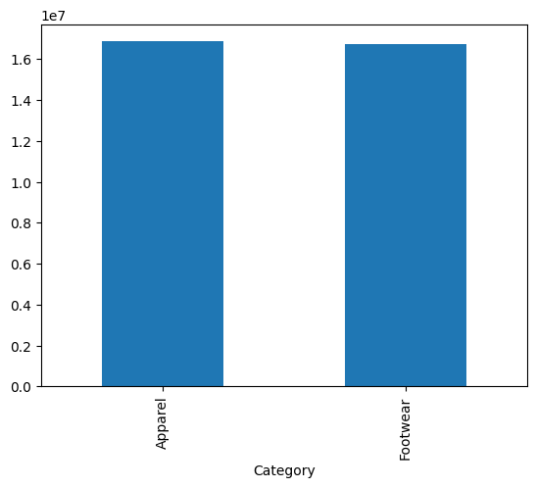

Question 7: Which region contributes the highest revenue?

Answer
Revenue generated by each region is compared.

Explanation
Regional revenue analysis provides insights into the economic value generated by different markets. It helps identify regions where customers spend more on Adidas products and supports strategic decisions related to expansion, distribution, and regional marketing efforts
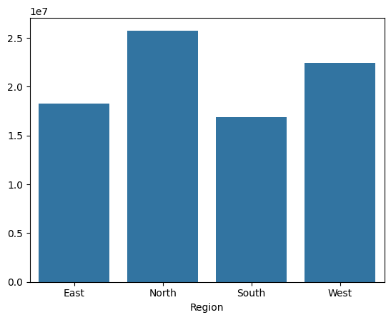

Question 8: Which cities generate the highest revenue?

Answer
The graph shows the top cities based on revenue generation.

Explanation
City-level revenue analysis helps identify key urban markets that contribute significantly to business growth. Understanding high-performing cities allows businesses to strengthen their presence, improve customer engagement, and optimize supply chain operations in important locations.
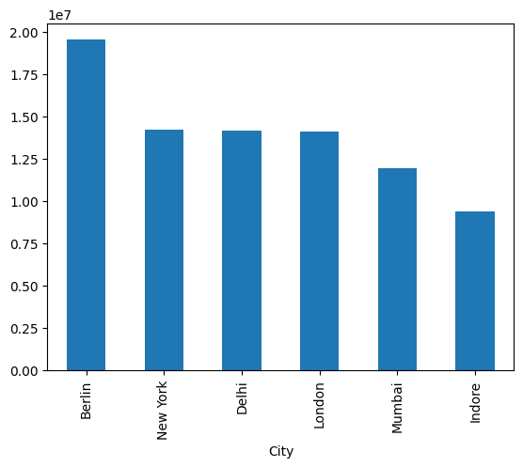

Question 9: Which countries contribute the highest revenue?

Answer
Countries are ranked according to total revenue generated.

Explanation
Country-wise revenue comparison helps evaluate international market performance. It identifies major revenue-generating countries and provides insights into global sales trends. This information is useful for planning international business strategies and market expansion initiatives.

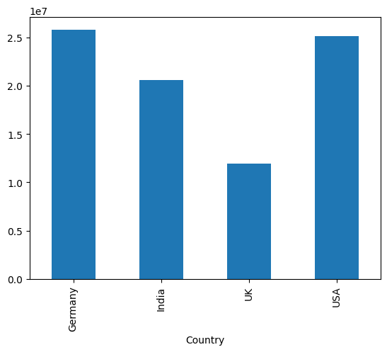

Question 10: What is the monthly sales trend?

Answer
Monthly sales revenue varies throughout the year.

Explanation
Monthly sales trend analysis helps identify seasonal patterns and fluctuations in customer demand throughout the year. Businesses can use this information for forecasting, inventory planning, promotional activities, and improving operational efficiency during peak and low sales periods.

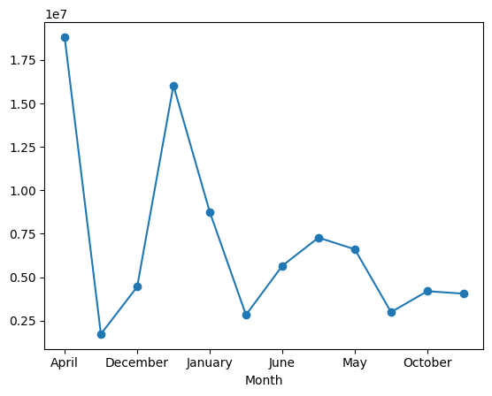

Question 11: How has revenue grown over the years?

Answer
The graph displays year-wise revenue performance.

Explanation
Year-wise revenue growth analysis helps evaluate long-term business performance and market expansion. It provides a clear understanding of whether the company is achieving consistent growth and helps management assess the effectiveness of business strategies over time.
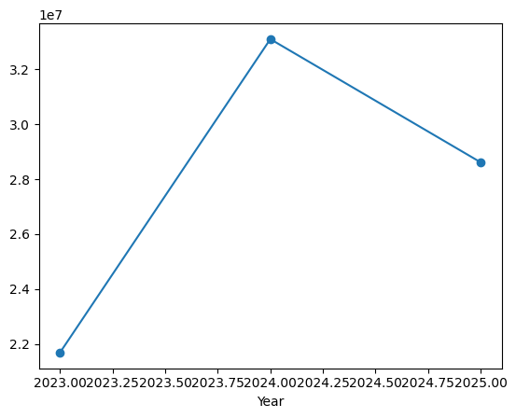

Question 12: What is the correlation between numerical features?

Answer
The correlation heatmap displays relationships among numerical variables.

Explanation
Correlation analysis measures the strength and direction of relationships between numerical variables such as revenue, profit, units sold, and pricing. Understanding these relationships helps identify important business drivers and supports data-driven decision-making for improving performance.
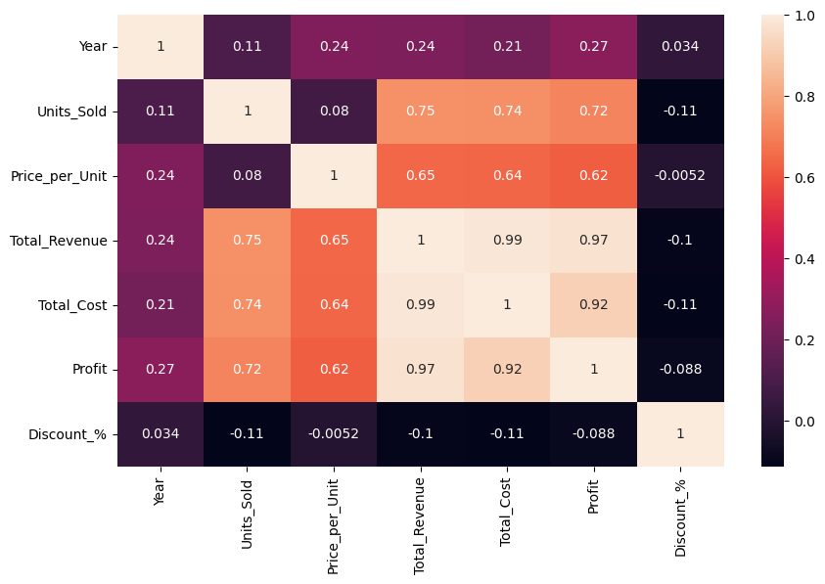

Key Insights
- Adidas generated strong revenue across multiple regions.
- Certain product categories contribute significantly more revenue.
- Profitability varies across product categories.
- Some regions consistently outperform others.
- Monthly sales show seasonal patterns.
- Revenue has grown steadily over time.
- Product demand differs by market location.

Findings
- High-selling products contribute major revenue.
- Regional markets significantly influence business growth.
- Profit and revenue are strongly connected.
- Country-wise sales performance varies considerably.
- Business growth opportunities exist in emerging markets.

Problems Faced During the Project
- Handling large sales data.
- Managing duplicate records.
- Understanding relationships among multiple variables.
- Choosing effective visualizations.
- Interpreting business trends accurately.

Recommendations
- Focus marketing efforts on top-performing regions.
- Increase inventory for high-demand products.
- Optimize pricing strategies based on profit trends.
- Expand sales in growing markets.
- Monitor seasonal demand patterns for better planning.

Conclusion
This EDA project successfully analyzed the Adidas Sales Dataset and identified important business patterns related to sales performance, revenue generation, product demand, profitability, and regional performance.
Using Python libraries and visualization techniques, valuable business insights were generated that can support strategic decision-making and future growth planning.

Tools and Technologies Used
Tool/Technology | Purpose
Python | Programming Language
Pandas | Data Analysis
NumPy | Numerical Operations
Matplotlib | Data Visualization
Seaborn | Statistical Visualization
Jupyter Notebook | Development Environment

Final Result
The Adidas Sales EDA Project helped in:
- Understanding sales performance.
- Identifying top-selling products.
- Analyzing revenue and profit trends.
- Visualizing business growth.
- Generating actionable business insights.

