Netflix Dataset Exploratory Data Analysis (EDA) Report

Title
Netflix Dataset Exploratory Data Analysis

Objective
The main objective of this project is to perform Exploratory Data Analysis (EDA) on the Netflix dataset to understand trends, patterns, and useful insights related to movies and TV shows available on Netflix. The project helps in understanding content distribution, genre popularity, ratings, duration, countries, directors, and actors. The analysis also helps in improving data understanding through graphical visualization.

Introduction
Netflix is one of the world’s largest online streaming platforms that provides movies, TV shows, documentaries, and web series. The Netflix dataset contains important information such as title, type, director, cast, country, release year, duration, rating, and genres. In this project, Exploratory Data Analysis was performed using Python libraries such as Pandas, NumPy, and Matplotlib to discover meaningful insights and visualize the dataset effectively.

Data Sources
The dataset used in this project is the Netflix Titles Dataset collected in CSV format. The dataset contains detailed information about Netflix movies and TV shows. The file used in this project is 'netflix_titles.csv'. The dataset includes metadata such as movie titles, release years, ratings, duration, genres, and country information.

Data Description
The dataset contains columns such as show_id, type, title, director, cast, country, date_added, release_year, rating, duration, listed_in, and description. These columns provide detailed information about Netflix content and help in performing various types of analysis and comparisons.

Project Structure / Workflow
1. Dataset Collection
2. Importing Libraries
3. Loading Dataset
4. Data Cleaning
5. Data Preprocessing
6. Exploratory Data Analysis
7. Data Visualization
8. Finding Insights and Conclusions

Data Preprocessing
Different preprocessing techniques were applied before analysis. Missing values were handled using fillna(). The date_added column was converted into datetime format. Duration values were converted into numeric format for proper analysis. Genres and actor names were separated using split and explode methods to perform detailed analysis.

Data Analysis & Visualization

Question 1: Movies vs TV Shows
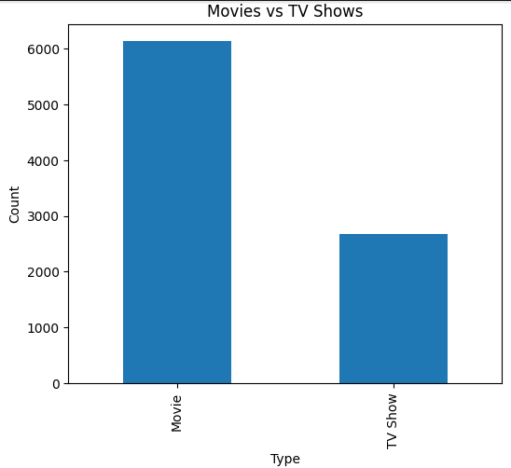
Explanation-:This analysis compares the total number of Movies and TV Shows available on Netflix. Bar chart and pie chart were used to visualize the comparison clearly. The analysis shows that Movies are significantly higher than TV Shows on Netflix. This indicates that Netflix mainly focuses on movie-based content because movies attract a larger audience and require less long-term commitment compared to TV Shows.

Question 2: Release Year Trend
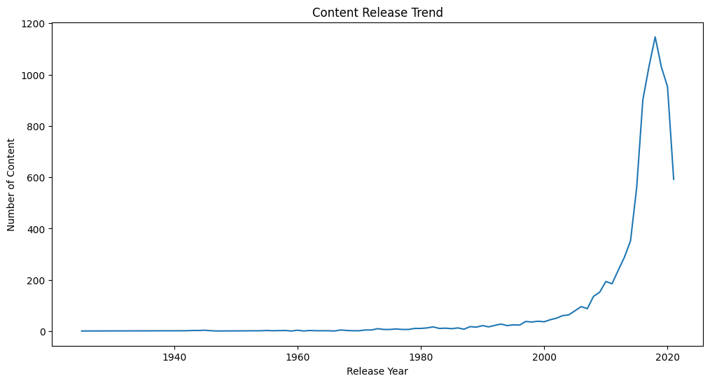
A line chart was used to analyze the release year trend of Netflix content. This graph shows how content production changed over different years. It was observed that the amount of content increased rapidly after 2015. This indicates the rapid expansion and popularity growth of Netflix in recent years as more movies and shows were added globally.

Question 3: Top 10 Countries
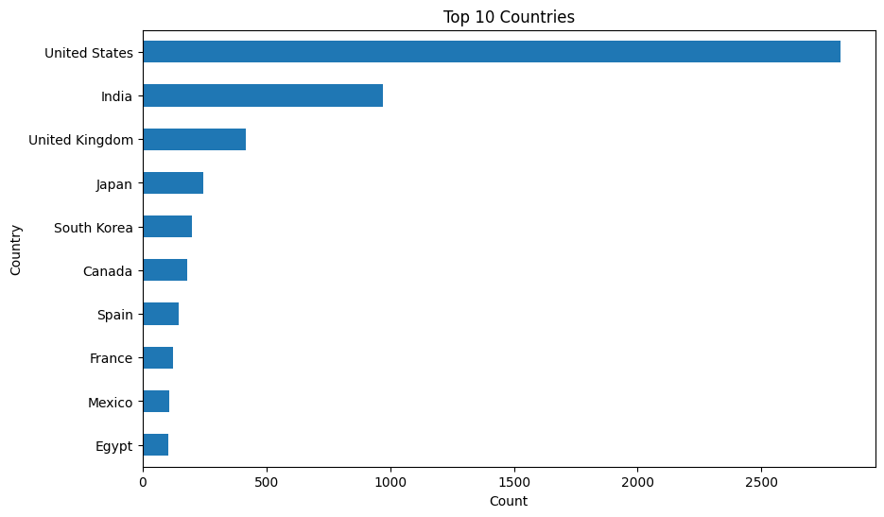
A horizontal bar chart was created to identify the top countries producing Netflix content. The analysis showed that the United States contributes the highest amount of content on Netflix. Countries such as India, United Kingdom, and Canada also contribute significantly. This analysis helps in understanding which countries dominate the streaming industry.

Question 4: Top Directors
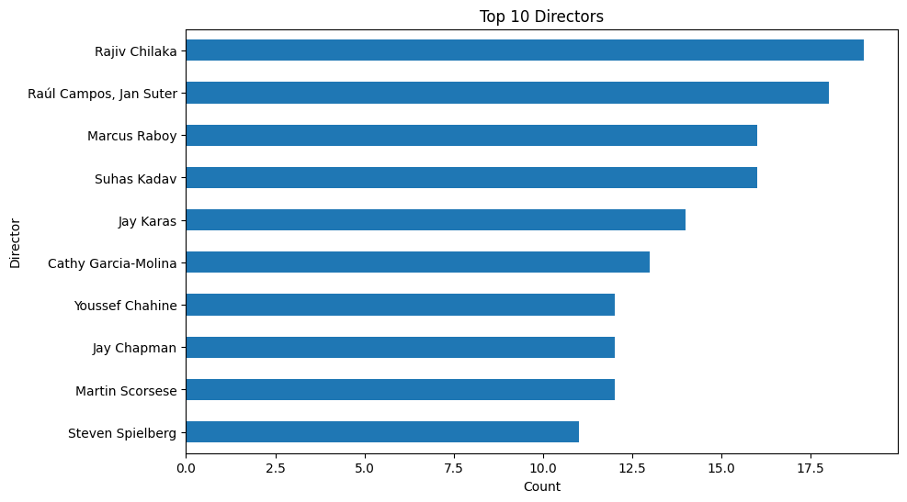
This analysis identifies directors with the highest number of movies and TV shows on Netflix. A horizontal bar chart was used for better comparison. The graph shows that some directors repeatedly contribute content to Netflix. This analysis helps in identifying popular and highly active directors on the platform.

Question 5: Rating Distribution
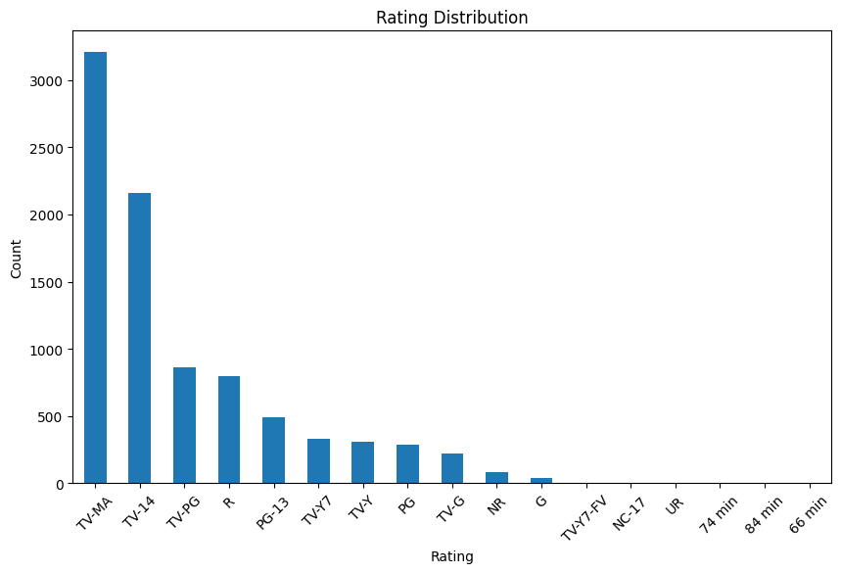
The rating distribution analysis was performed using a bar chart. Ratings such as TV-MA, TV-14, PG, and R were analyzed to understand audience targeting. The graph shows that TV-MA and TV-14 are the most common ratings, indicating that Netflix contains a large amount of mature and teenage audience content.

Question 6: Top Genres
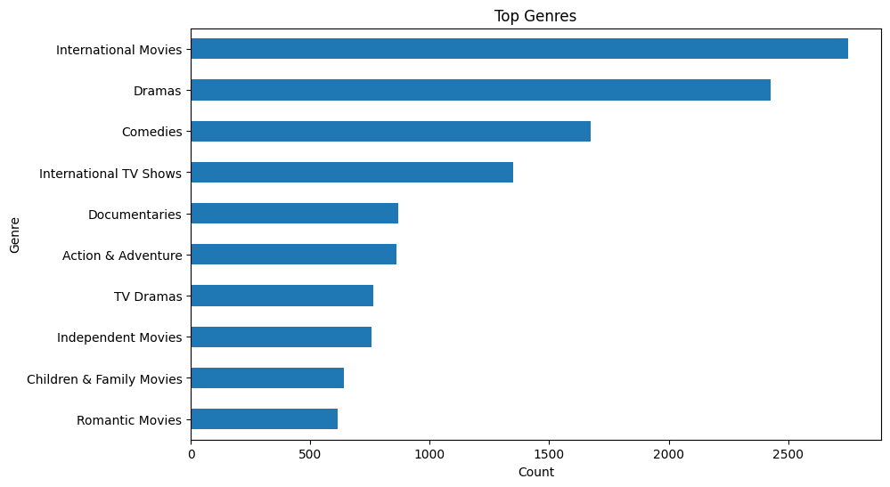
Genre analysis was performed using the listed_in column after splitting multiple genres. A horizontal bar chart was used to identify the most popular genres. The analysis revealed that Drama, International Movies, and Comedy are among the most popular genres on Netflix. This indicates viewer preference for emotional and entertainment-based content.

Question 7: Movie Duration Analysis
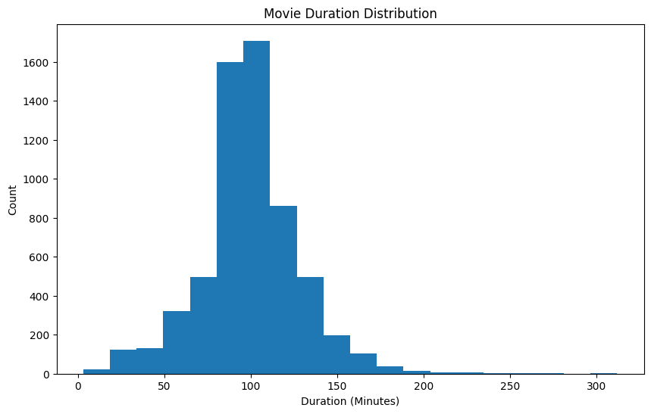
Histogram visualization was used to analyze movie duration distribution. The graph shows that most Netflix movies have a duration between 80 and 120 minutes. Very long-duration movies are comparatively less common. This suggests that viewers generally prefer medium-length movies for better engagement and convenience.

Question 8: TV Show Seasons Analysis
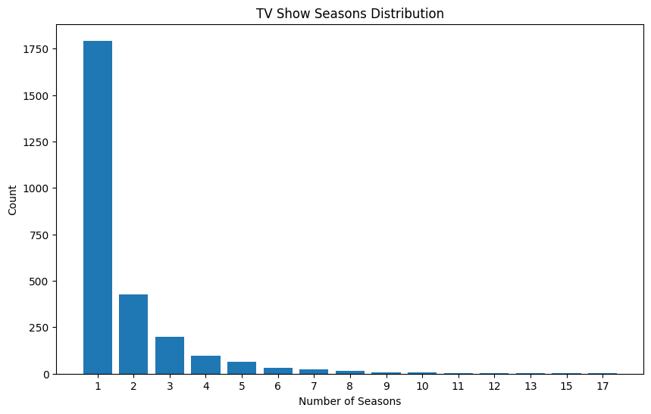
A bar chart was used to analyze the number of seasons in TV Shows. The analysis revealed that most TV Shows on Netflix contain only 1 or 2 seasons. Shows with many seasons are relatively fewer. This indicates that shorter TV Shows are more common and easier for audiences to complete.

Question 9: Type vs Rating
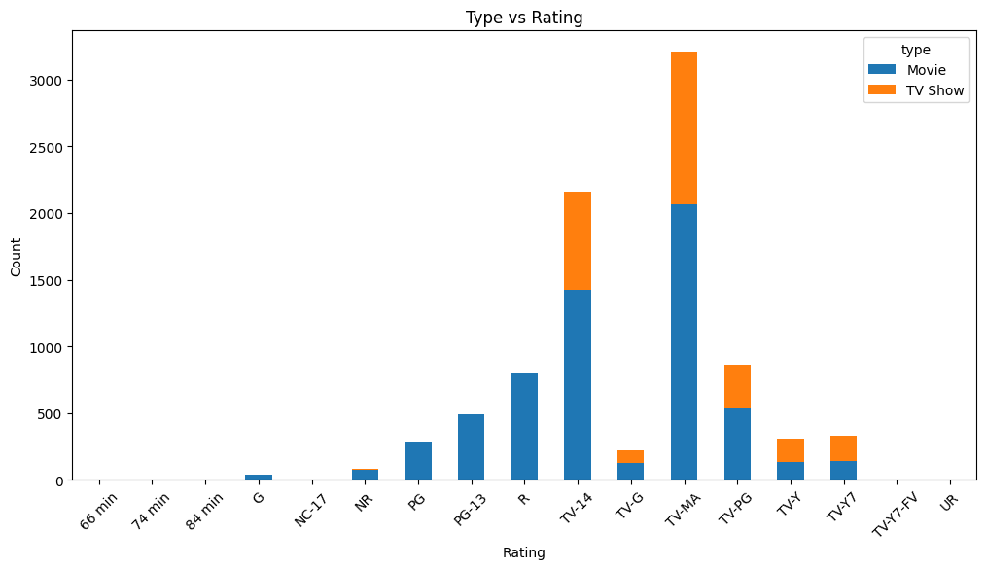
Stacked bar chart analysis was used to compare content ratings between Movies and TV Shows. The graph indicates that Movies contain more mature-rated content compared to TV Shows. TV Shows are relatively more balanced across audience categories. This helps in understanding the content strategy used by Netflix.

Question 10: Country vs Type
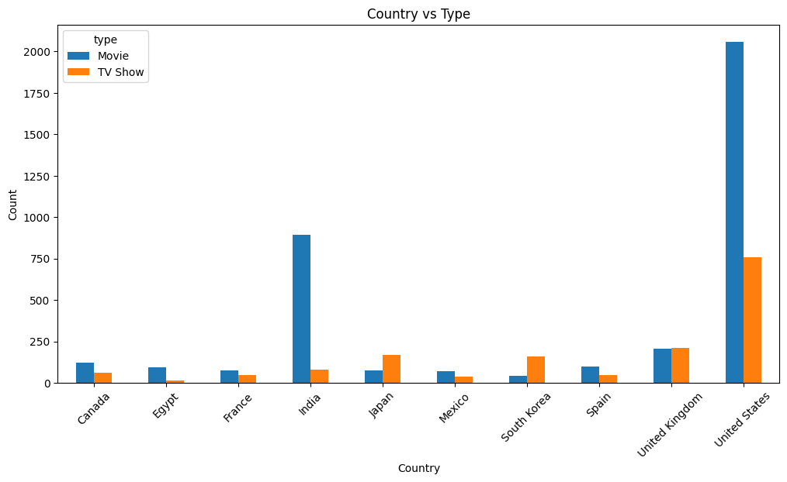
This analysis compares Movies and TV Shows produced by different countries. Grouped bar charts were used for visualization. The analysis shows that some countries focus mainly on Movies, while others produce more TV Shows. This reflects differences in entertainment industries and audience demand across countries.

Question 11: Genre vs Type
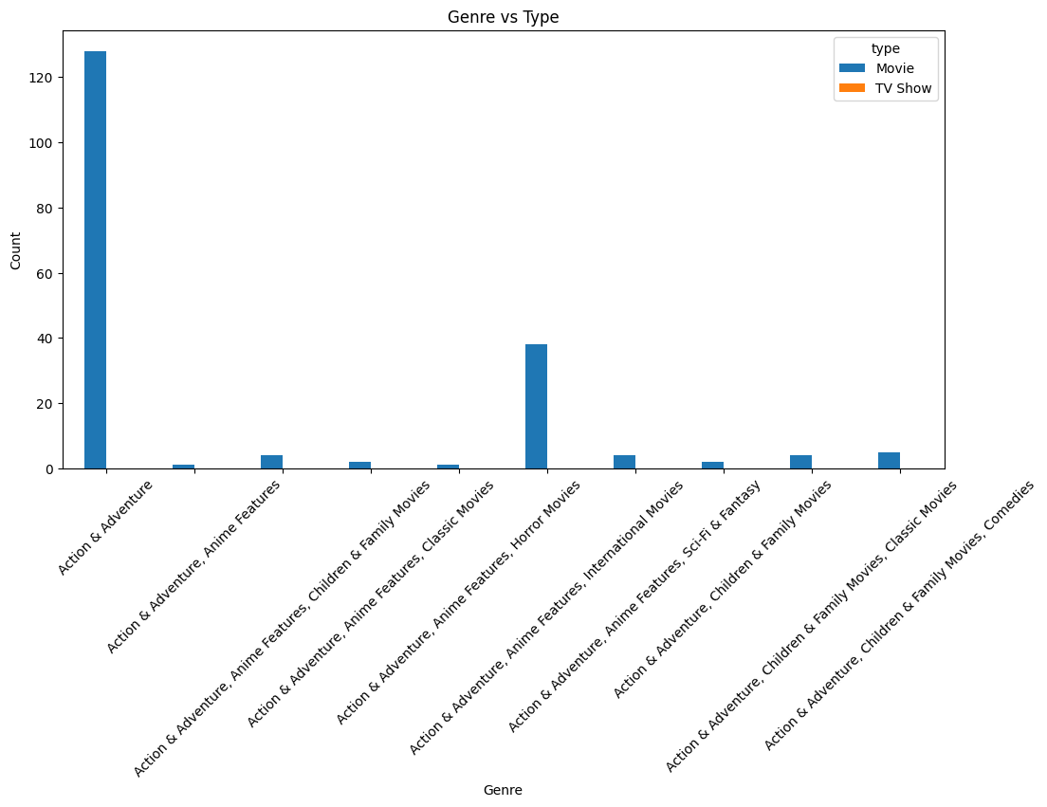
Genre vs Type analysis compares genres between Movies and TV Shows. Different genres dominate different content types. Drama and International Movies are more common in Movies, while TV Shows often focus on Crime, Kids, and International TV content. This analysis helps in understanding genre distribution on Netflix.

Question 12: Content Added Per Year
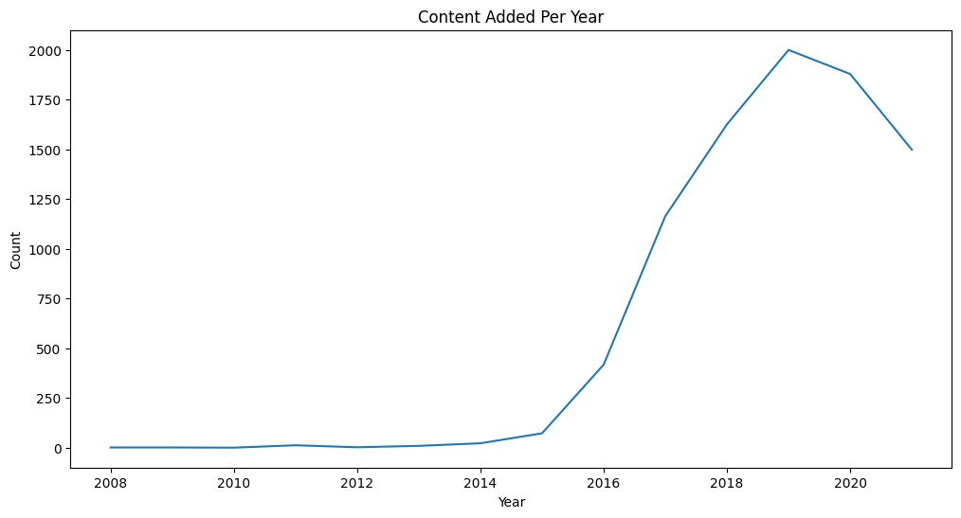
A line chart was used to analyze how much content was added to Netflix every year. The graph clearly shows a major increase in content addition after 2016. This reflects Netflix’s rapid global expansion and increasing investment in entertainment content production.

Question 13: Top Actors
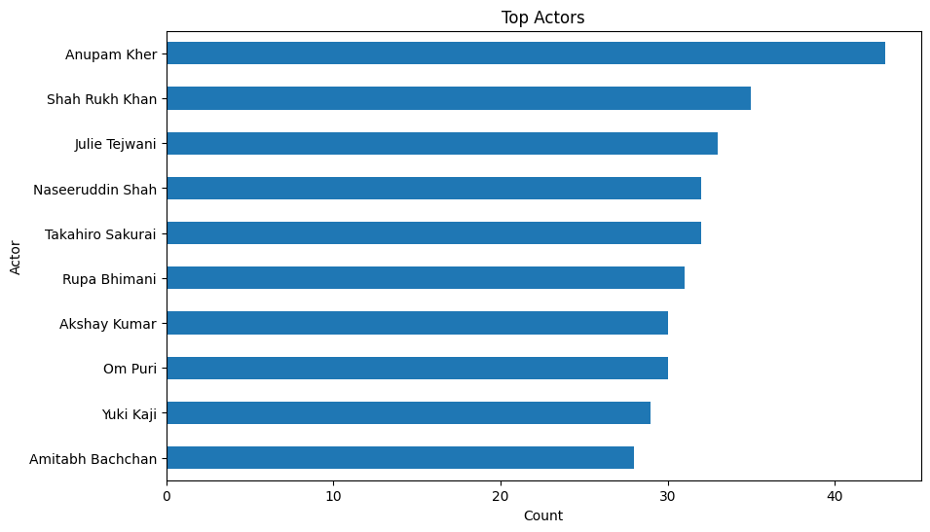
Actor analysis was performed by separating actor names from the cast column. A horizontal bar chart was used to identify actors appearing most frequently on Netflix. The analysis shows that some actors repeatedly appear in Netflix content, indicating their popularity and strong collaboration with production companies.

Key Insights
1. Netflix contains more Movies than TV Shows.
2. Content production increased rapidly after 2015.
3. United States is the largest content producer.
4. Drama and International Movies are highly popular genres.
5. Most movies have a duration between 80–120 minutes.
6. TV-MA is one of the most common ratings on Netflix.

Findings
The project findings indicate that Netflix focuses heavily on movie content and international expansion. Mature audience content is highly common, and genres such as Drama and Comedy dominate the platform. Most TV Shows contain fewer seasons, showing a preference for shorter content series.

Recommendations
Netflix should continue investing in international content and regional entertainment because audience diversity is increasing rapidly. More family-friendly and educational content can also be added. Popular genres such as Drama, Comedy, and International content should receive more focus due to higher viewer engagement.

Conclusion
This project successfully performed Exploratory Data Analysis on the Netflix dataset using Python. Different visualizations and analytical techniques were used to understand trends related to movies, TV shows, ratings, genres, actors, directors, and countries. The project demonstrates how EDA helps in discovering hidden insights from real-world datasets and supports better decision-making using data visualization techniques.

