Title
Supply Chain Data Analysis Report
By : Rahul Patidar

Objective:
The main objective of this project is to perform Exploratory Data Analysis (EDA) on a Supply Chain dataset to understand product performance, supplier efficiency, logistics operations, transportation patterns, shipping costs, inventory management, and overall business performance.
This project helps in:
- Understanding supply chain operations.
- Identifying product performance trends.
- Analyzing supplier contribution and efficiency.
- Studying transportation and shipping patterns.
- Understanding inventory and stock management.
- Generating insights useful for business decision-making.

Introduction:
Exploratory Data Analysis (EDA) is an important process in Data Analysis and Data Science. It helps in understanding the structure, quality, patterns, and relationships within a dataset before applying advanced analytical methods or machine learning techniques.
In this project, a Supply Chain dataset is analyzed using Python libraries such as Pandas, NumPy, Matplotlib, and Seaborn. The dataset contains information related to products, suppliers, transportation modes, shipping costs, manufacturing costs, stock levels, revenues, and logistics operations.
The analysis provides statistical and visual insights that help understand supply chain performance and business operations more effectively.

Data Sources:
The dataset used in this project is a CSV file related to Supply Chain Management.
The dataset was loaded using Pandas:
import pandas as pd

df = pd.read_csv("supply_chain_data.csv")

Source Type
- Structured CSV Dataset
- Supply Chain and Logistics related business data

Data Description:
The dataset contains information related to supply chain management and logistics operations.

Important Columns Used
Column Name | Description
Product Type | Type/category of product
Revenue Generated | Revenue earned from products
Supplier Name | Supplier providing the product
Transportation Mode | Method used for transportation
Shipping Costs | Cost of product shipping
Manufacturing Costs | Cost of manufacturing products
Stock Levels | Available inventory stock
Products Sold | Number of products sold
Lead Time | Product delivery preparation time
Shipping Time | Total shipping duration
Defect Rates | Product defect percentage
Price | Product selling price

Project Structure / Workflow
The complete workflow of this EDA project is:
- Import Required Libraries
- Load Dataset
- Understand Dataset Structure
- Data Cleaning and Preprocessing
- Handle Missing Values
- Perform Statistical Analysis
- Data Visualization
- Question and Answer Analysis
- Generate Key Insights
- Final Findings and Recommendations

Data Preprocessing
Data preprocessing was performed to prepare the dataset for analysis. In this step, the dataset was checked properly to identify missing values, incorrect data types, duplicate records, and overall data quality.
The dataset structure was analyzed to understand the number of rows and columns available in the data. Numerical and categorical columns were identified separately for better analysis.
Missing values and duplicate records were checked to ensure data consistency. Statistical summaries were generated to understand the distribution of numerical variables such as revenue, shipping costs, stock levels, and product prices.
Outliers were detected using boxplots and statistical methods to identify unusual values in important columns.
The preprocessing step improved data quality and made the dataset ready for visualization and analysis.

Data Analysis & Visualization
Several visualizations were created to analyze supply chain performance and business operations.

Questions, Answers & Explanation

Question 1: Which product type generates the highest revenue?

Answer
The graph shows that some product categories generate significantly higher revenue compared to others.
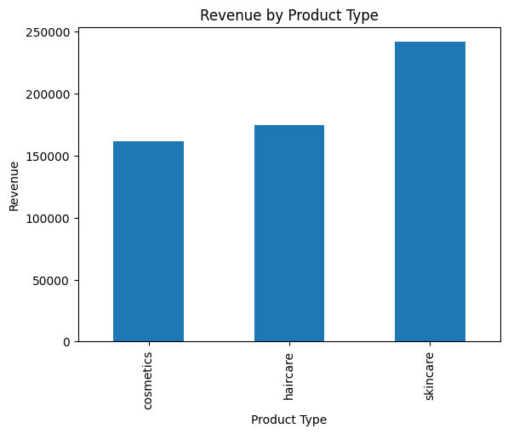

Explanation
This bar chart compares the total revenue generated by different product categories. The graph helps identify which products contribute the most to the company’s overall revenue and profit.
This analysis is useful for understanding customer demand, product popularity, and business performance.

Question 2: What is the distribution of product types in the dataset?

Answer
The dataset contains multiple product categories distributed across different proportions.
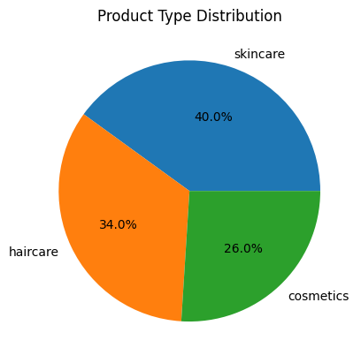

Explanation
The pie chart represents the percentage share of each product category available in the dataset. It helps in understanding how products are distributed across the business.
This visualization provides a quick overview of product composition and category contribution.

Question 3: Which supplier contributes the highest revenue?

Answer
Some suppliers contribute significantly more revenue than others.
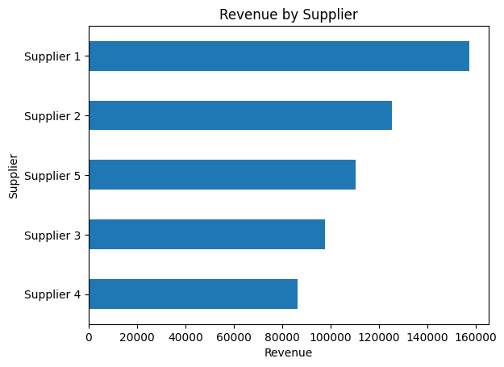

Explanation
This graph compares suppliers based on the revenue generated from their products. It helps identify the best-performing suppliers in the supply chain process.
The analysis is useful for evaluating supplier efficiency, supplier contribution, and business dependency on suppliers.

Question 4: Which transportation mode is used the most?

Answer
The graph shows that certain transportation modes are used more frequently in logistics operations.
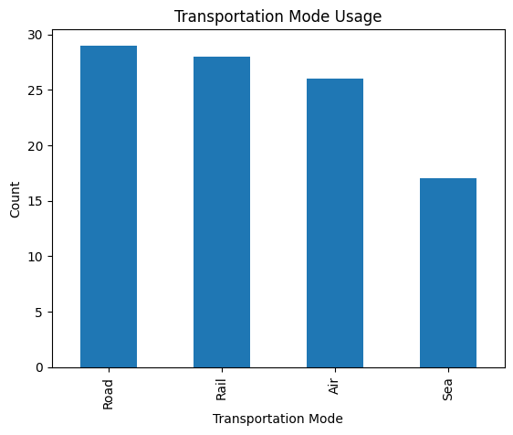

Explanation
This graph displays the usage frequency of transportation modes such as road, air, rail, and sea.
It helps determine the most commonly used transportation method in the supply chain. The graph also reflects logistics preferences and operational strategies.

Question 5: Which transportation mode has the highest shipping cost?

Answer
Some transportation modes have higher average shipping costs compared to others.
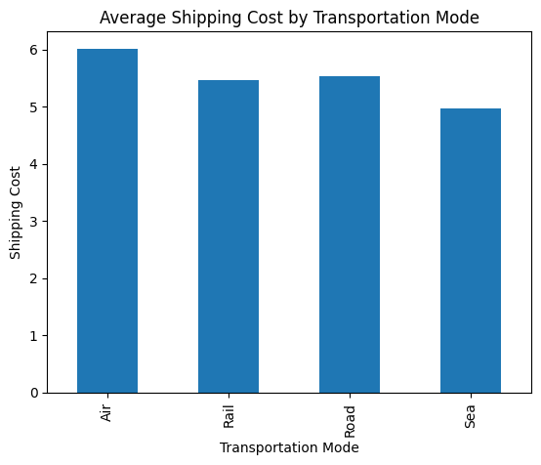

Explanation
This visualization compares the average shipping costs of different transportation methods.
It helps analyze which transportation mode is more expensive and supports cost optimization and logistics planning.

Question 6: Which product type has the highest defect rate?

Answer
Certain product categories show higher defect rates than others.
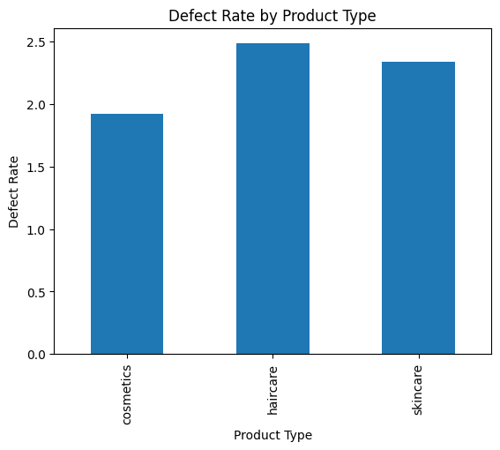

Explanation
This graph compares defect rates among different product categories. It helps identify products with quality-related issues or manufacturing problems.
The analysis is useful for improving product quality and reducing manufacturing defects.

Question 7: How is revenue distributed in the dataset?

Answer
Revenue values are distributed across different ranges in the dataset.
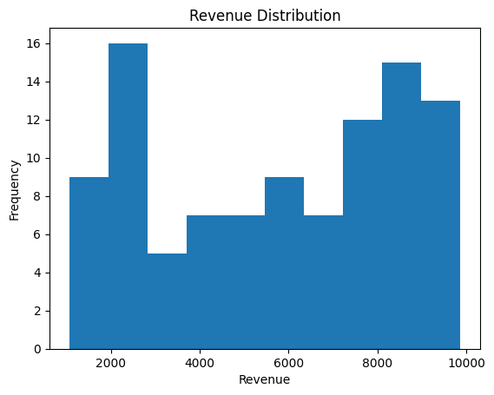

Explanation
The histogram shows the frequency distribution of revenue values.
It helps understand whether revenue values are evenly distributed or concentrated within a specific range. This graph provides insights into business earnings patterns.

Question 8: Is there a relationship between price and revenue generated?

Answer
The graph shows a relationship between product price and revenue generated.
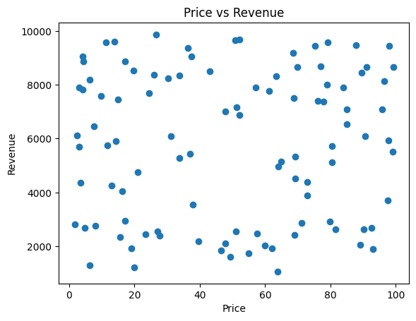

Explanation
This scatter plot compares product price with revenue generated.
It helps determine whether higher-priced products generate higher revenue. The graph is useful for understanding pricing strategies and customer purchasing behavior.

Question 9: Is there a relationship between manufacturing cost and revenue?

Answer
Manufacturing cost and revenue show varying relationships across products.
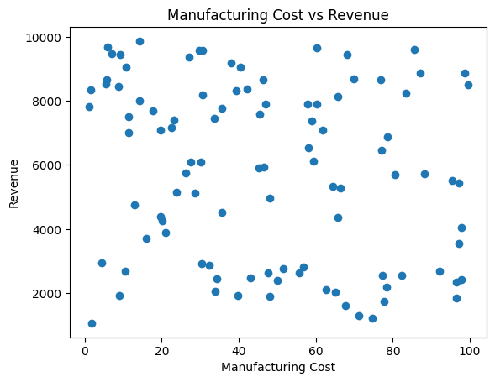

Explanation
This graph compares manufacturing costs with revenue generated.
It helps analyze whether products with higher production costs generate higher profit or revenue. The visualization supports cost and profitability analysis.

Question 10: Is there a relationship between stock levels and products sold?

Answer
The graph shows how stock availability relates to product sales.
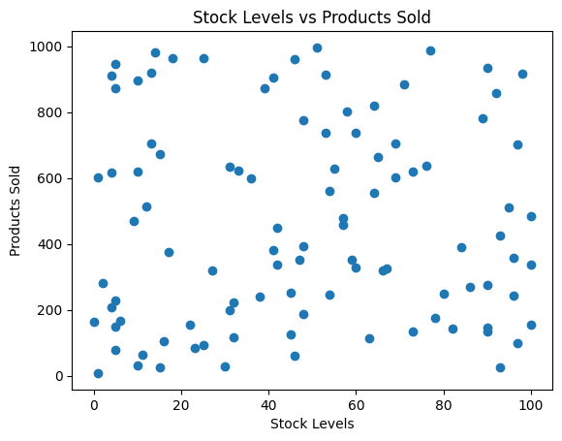

Explanation
This scatter plot compares stock levels with the number of products sold.
It helps determine whether higher stock availability leads to increased sales. This analysis supports inventory management and stock planning decisions.

Question 11: What is the relationship between lead time and shipping time?

Answer
Lead time and shipping time show operational relationships within the logistics process.
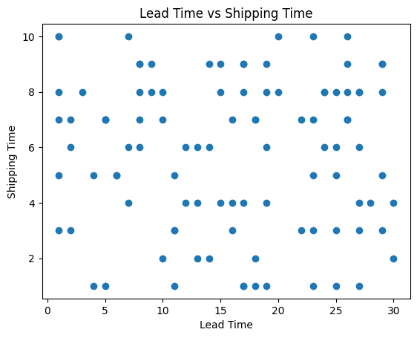

Explanation
This visualization compares lead time with shipping time for products.
It helps analyze how delivery delays affect shipping performance. The graph is useful for improving logistics efficiency and delivery operations.

Question 12: Which numerical columns are highly correlated?

Answer
The correlation heatmap shows relationships between numerical variables in the dataset.
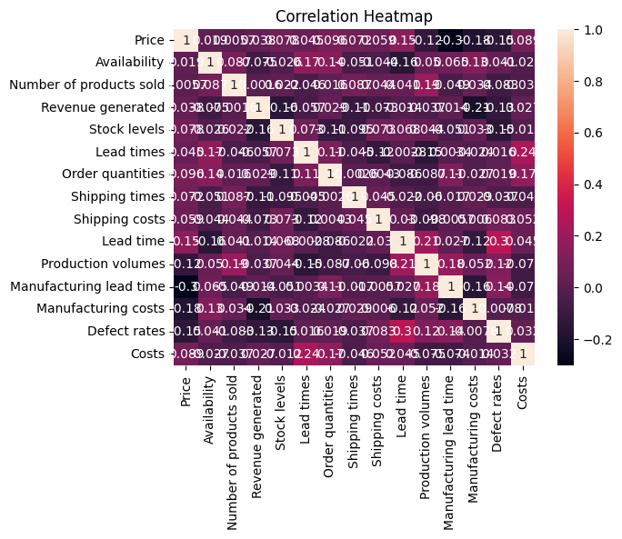

Explanation
The heatmap displays positive and negative correlation values among numerical columns such as revenue, price, stock levels, manufacturing costs, and shipping costs.
This graph provides a complete overview of numerical relationships and business patterns.

Question 13: Are there any outliers in product prices?

Answer
The boxplot identifies the presence of outliers and unusual price values.
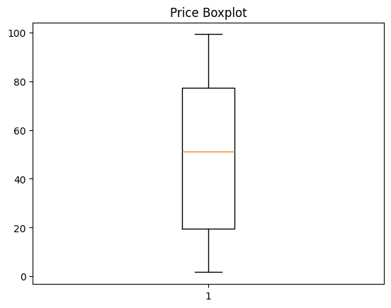

Explanation
The boxplot is used to detect outliers and extreme values in product prices.
It helps identify unusual price values that differ significantly from the rest of the dataset. This analysis is important for maintaining data quality and improving analysis accuracy.

Key Insights
- Some product categories generated significantly higher revenue.
- Supplier performance varied across the dataset.
- Transportation mode affected shipping cost and delivery efficiency.
- Defect rates differed between product categories.
- Certain numerical variables showed positive correlation.
- Outliers were present in price and revenue columns.
- Logistics performance affected overall business operations.
- Shipping and manufacturing costs influenced profitability.

Findings
- Products with higher demand generated greater revenue.
- Supplier contribution varied significantly in the supply chain.
- Transportation methods affected both delivery time and shipping costs.
- Product quality issues were visible through defect rate analysis.
- Inventory management played an important role in product sales.
- Correlation analysis helped identify relationships among business variables.
- Some product prices contained extreme values or outliers.

Problems Faced During the Project
- Understanding the dataset structure containing multiple numerical and categorical columns.
- Identifying meaningful relationships between variables.
- Selecting suitable visualization techniques for analysis.
- Detecting and interpreting outliers in important columns.
- Understanding business impact through correlation analysis.
- Managing multiple supply chain factors together.
- Generating clear business insights from large datasets.
- Creating understandable and meaningful visualizations.

Recommendations
- Businesses should focus on high-performing product categories.
- Supplier performance should be monitored regularly.
- Transportation methods should be optimized to reduce shipping costs.
- Product quality improvement strategies should be implemented.
- Inventory management systems should be strengthened.
- Businesses should improve logistics planning for faster delivery.
- Data collection can be improved for more accurate analysis.

Conclusion
This EDA project successfully analyzed the Supply Chain dataset and identified important business patterns related to product performance, supplier contribution, transportation operations, logistics efficiency, stock management, and revenue generation.
Using Python libraries and visualization techniques, the project provided valuable insights into supply chain management and business operations.
The analysis demonstrated the importance of Exploratory Data Analysis in understanding supply chain datasets and generating meaningful business insights.

Tools and Technologies Used
Tool/Technology | Purpose
Python | Programming Language
Pandas | Data Analysis
NumPy | Numerical Operations
Matplotlib | Data Visualization
Seaborn | Statistical Visualization
Jupyter Notebook | Development Environment

Final Result
The Supply Chain EDA project helped in:
- Understanding supply chain operations.
- Identifying product and supplier performance.
- Visualizing logistics and transportation patterns.
- Detecting correlations and outliers.
- Generating business insights from the dataset.
- Improving decision-making through data analysis.

