Madan Mohan Reddy Patil

Ansible

# *Intro:*

Ansible is simple open source IT engine which automates application deployment, intra service orchestration, cloud provisioning and many other IT tools.

Ansible is easy to deploy because it does not use any agents or custom security infrastructure.

# *Basic Concepts*

## [*Control node*](https://docs.ansible.com/ansible/latest/network/getting_started/basic_concepts.html#id1)*:*

*Any machine with Ansible installed. You can run Ansible commands and playbooks by invoking the ansible or ansible-playbook command from any control node. You can use any computer that has a Python installation as a control node - laptops, shared desktops, and servers can all run Ansible. However, you cannot use a Windows machine as a control node. You can have multiple control nodes.*

## [*Managed nodes*](https://docs.ansible.com/ansible/latest/network/getting_started/basic_concepts.html#id2)*:*

The network devices (and/or servers) you manage with Ansible. Managed nodes are also sometimes called “hosts”. Ansible is not installed on managed nodes.

## [*Inventory*](https://docs.ansible.com/ansible/latest/network/getting_started/basic_concepts.html#id3)*:*

*A list of managed nodes. An inventory file is also sometimes called a “hostfile”. Your inventory can specify information like IP address for each managed node. An inventory can also organize managed nodes, creating and nesting groups for easier scaling.*

## [*Collections*](https://docs.ansible.com/ansible/latest/network/getting_started/basic_concepts.html#id4)

Collections are a distribution format for Ansible content that can include playbooks, roles, modules,and plugins. You can install and use collections through [Ansible Galaxy](https://galaxy.ansible.com/).

## [*Modules*](https://docs.ansible.com/ansible/latest/network/getting_started/basic_concepts.html#id5)

The units of code Ansible executes. Each module has a particular use, from administering users on a specific type of database to managing VLAN interfaces on a specific type of network device. You can invoke a single module with a task, or invoke several different modules in a playbook. Starting in Ansible 2.10, modules are grouped in collections.

## [*Tasks*](https://docs.ansible.com/ansible/latest/network/getting_started/basic_concepts.html#id6)

The units of action in Ansible. You can execute a single task once with an ad hoc command.

## [*Playbooks*](https://docs.ansible.com/ansible/latest/network/getting_started/basic_concepts.html#id7)

Ordered lists of tasks, saved so you can run those tasks in that order repeatedly. Playbooks can include variables as well as tasks. Playbooks are written in YAML and are easy to read, write, share and understand.

## [*Installing Ansible on Ubuntu*](https://docs.ansible.com/ansible/latest/installation_guide/intro_installation.html#id22)*:*

$ ***sudo apt update***

$ ***sudo apt install software-properties-common***

$ sudo add-apt-repository --yes --update ppa:ansible/ansible

$ sudo apt install ansible

Ansible Default Host file Location: # cat /etc/ansible/hosts

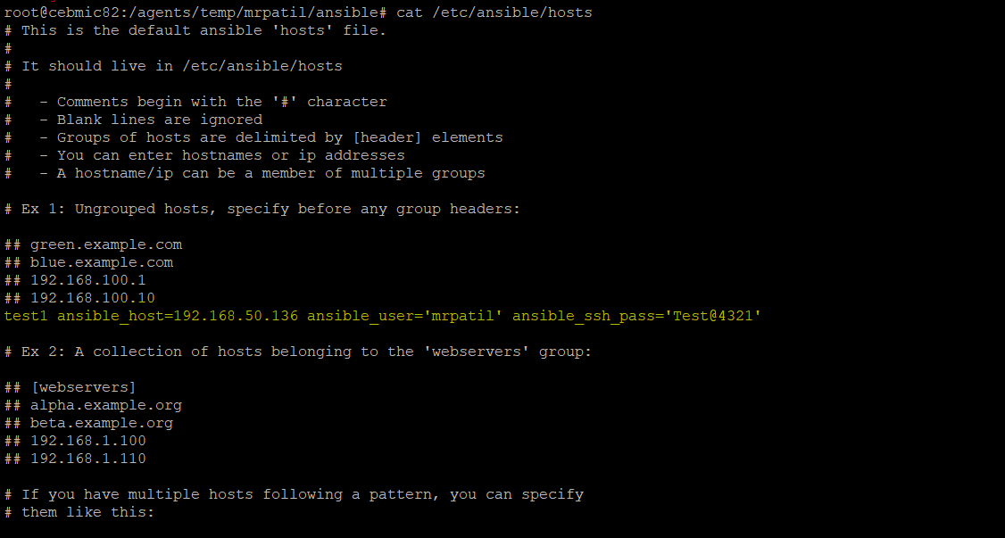

Ad hoc commands:

**syntax:** ansible [pattern] -m [module] -a "[module options]"

### Examples:

# ansible test1 -m shell -a 'free -m'

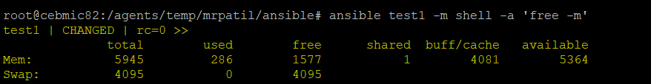

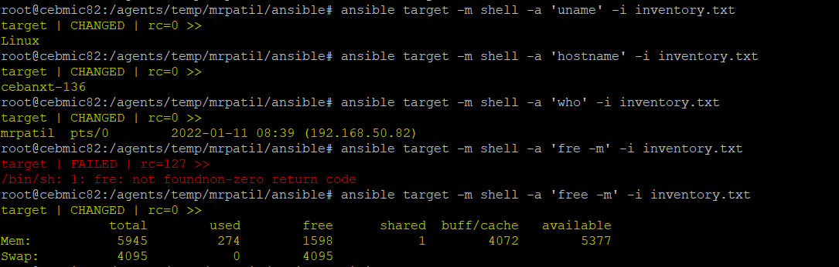

When a host is not authenticate we will get the follow errors.,

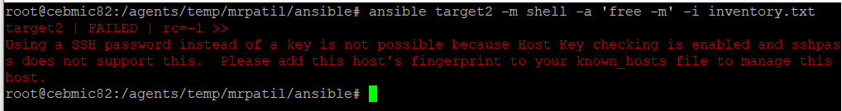

To avoid the above error, modify the ansible config file

# vi /etc/ansible/ansible.cfg

Add the following file in above file.

[defaults]

host_key_checking = False

Note: Not recommended for prod

# Ansible Playbook:

* *Playbooks written in yaml*
* *Sample playbook:*

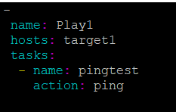

Syntax to run ansible:

# ansible-playbook <playbook.yaml> -i <inventory_file>

### *Output:*

