## Wiris Server Component Deployment

### Step1: Install PHP and required extensions on IIS.

Ref: <https://learn.microsoft.com/en-us/iis/application-frameworks/scenario-build-a-php-website-on-iis/configuring-step-1-install-iis-and-php>

<https://stackify.com/how-to-host-php-on-windows-with-iis/>

### Step2: Deploy the Wiris Server component.

* Create a new folder with name ‘WirisEditor’, under ‘MOE’ folder.
* Extract the content of the zip package “Wiris_Editor.zip”, to folder ‘WirisEditor’.

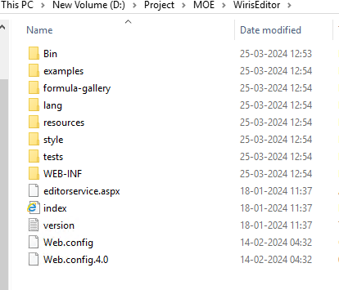

* Create a VD in IIS under Default Web Site with name “WirisEditor”.

### Step3: Deploy Wiris Integration service.

* Create a new folder with name “WirisIntegration”, under “MOE” folder.
* Extract the content of the zip package “WirisIntegration.zip”, to folder ‘WirisIntegration’.

* Open the file ‘Configuration.ini’ and change the value of key “wirisimageservicehost” to the domain name of the respective environment.

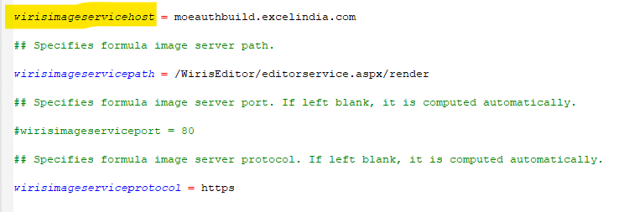

* Create a VD in IIS under Default Web Site with name “WirisIntegration”, pointing to integration folder.

### Step4: Change the appsettings key value in Common config.

* Change the value of the below key in ‘TestAndAssessment.environment.config’, as given below.

<add key="wirisOffline" value="true"/>

### Step5: Restart IIS.