**OBFUSCATION**

1. Go to search and select Dotfuscator in 192.168.5.164

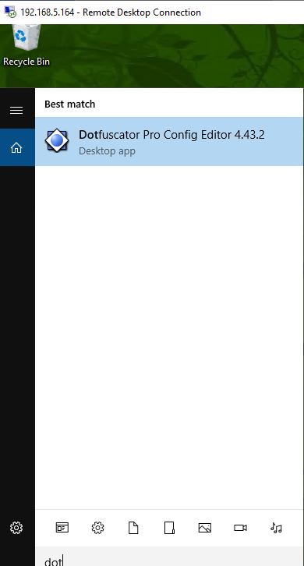

1. Below window will be seen as shown in screen capture.

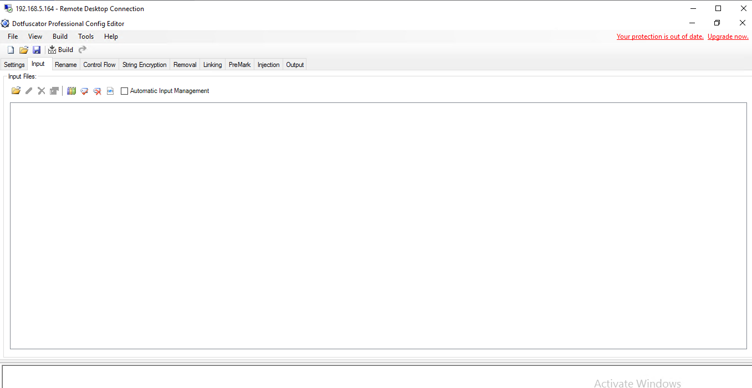

1. select input file as shown in below screen capture.

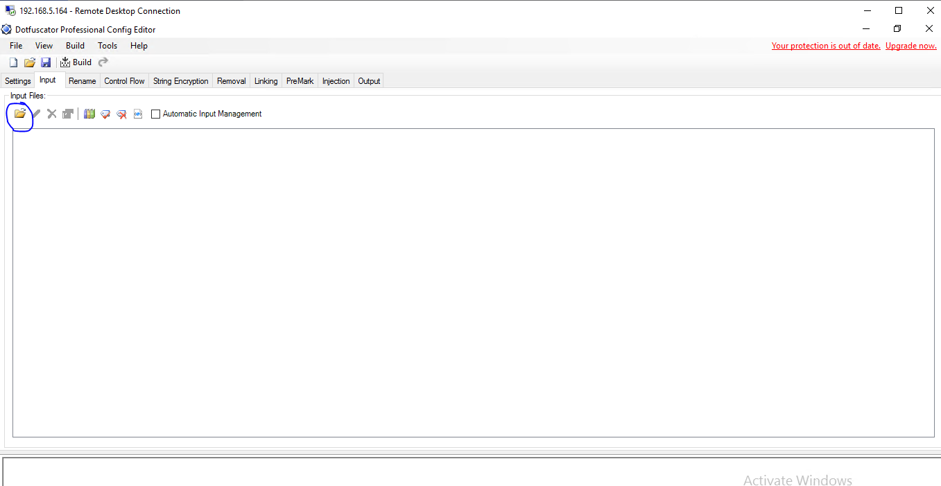

1. select browse and open the file which has to be obfuscated

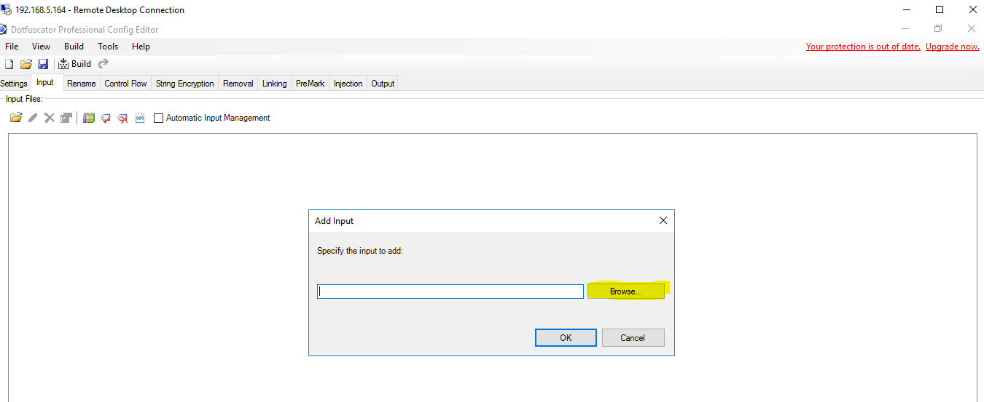

1. After selecting the input path, click OK.

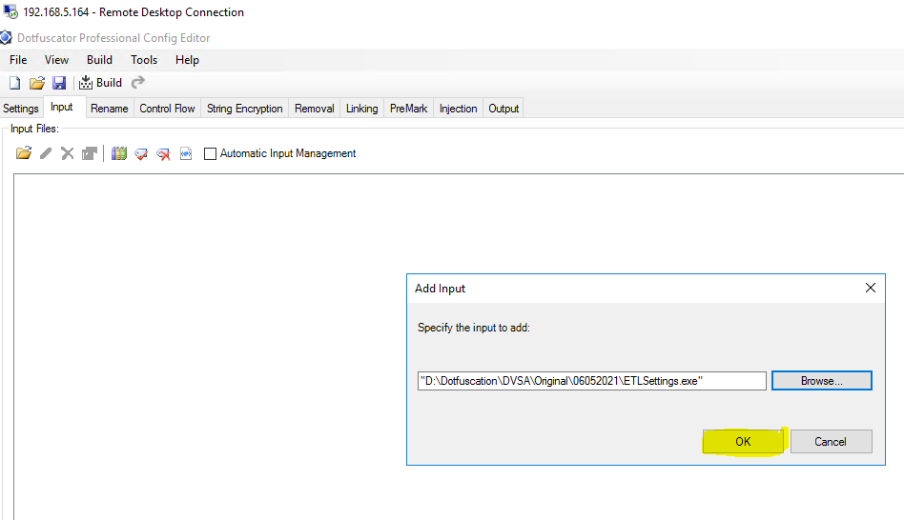

1. Now the input part has done, to get output we need to give the output path , for that go to setting.

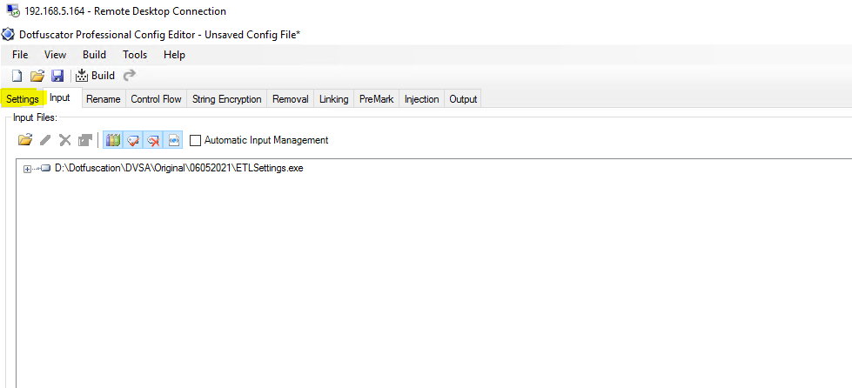

1. Now go to build setting and provide the output path I.e, providing output folder.

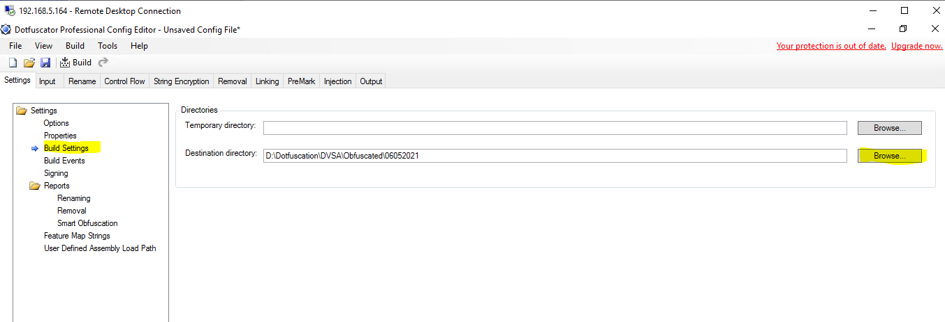

1. To Add digital signature ,Go to signing

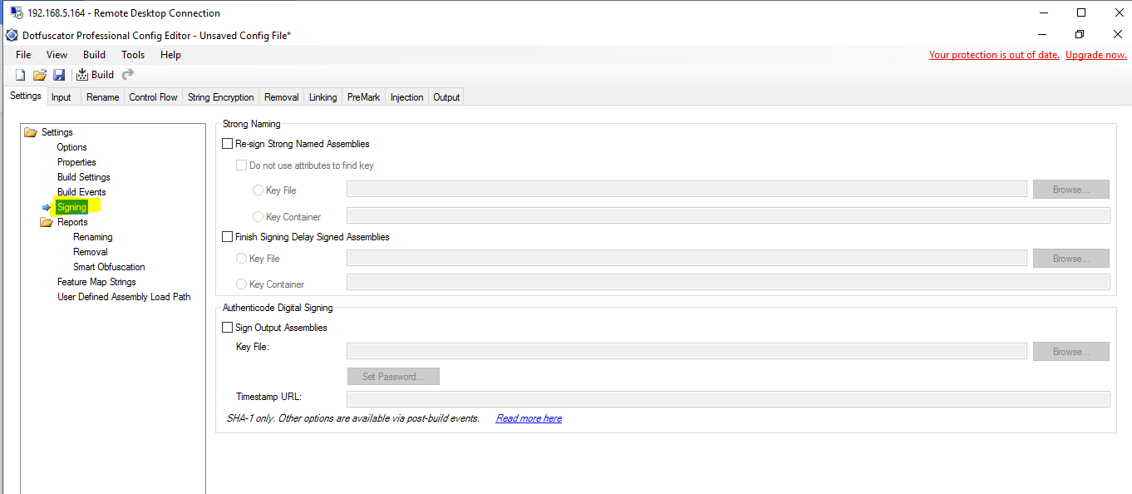

1. Tick the check box of sign output assemblies and browse the certificate path

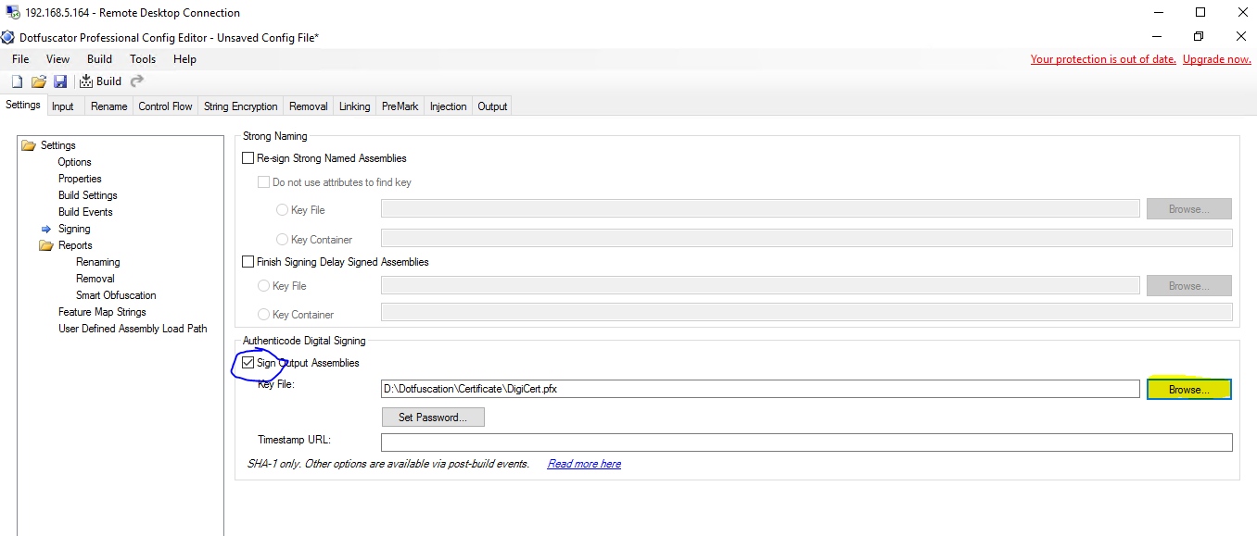

1. Set the password as : ExcelMysore and Timestamp URL is <http://timestamp.sectigo.com>

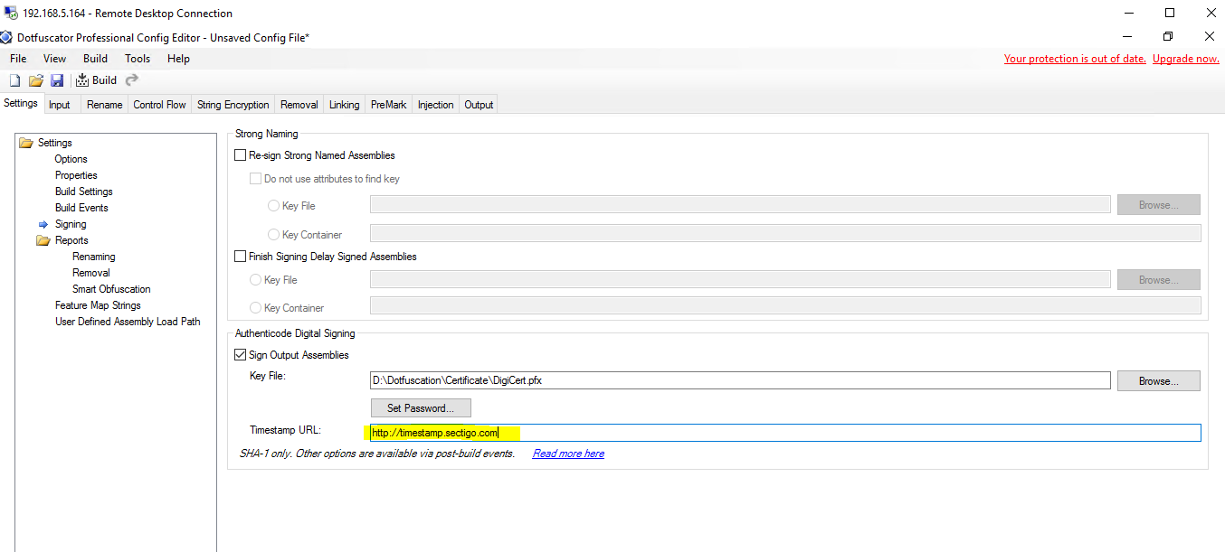

1. Now initiate the build as shown in below screen capture.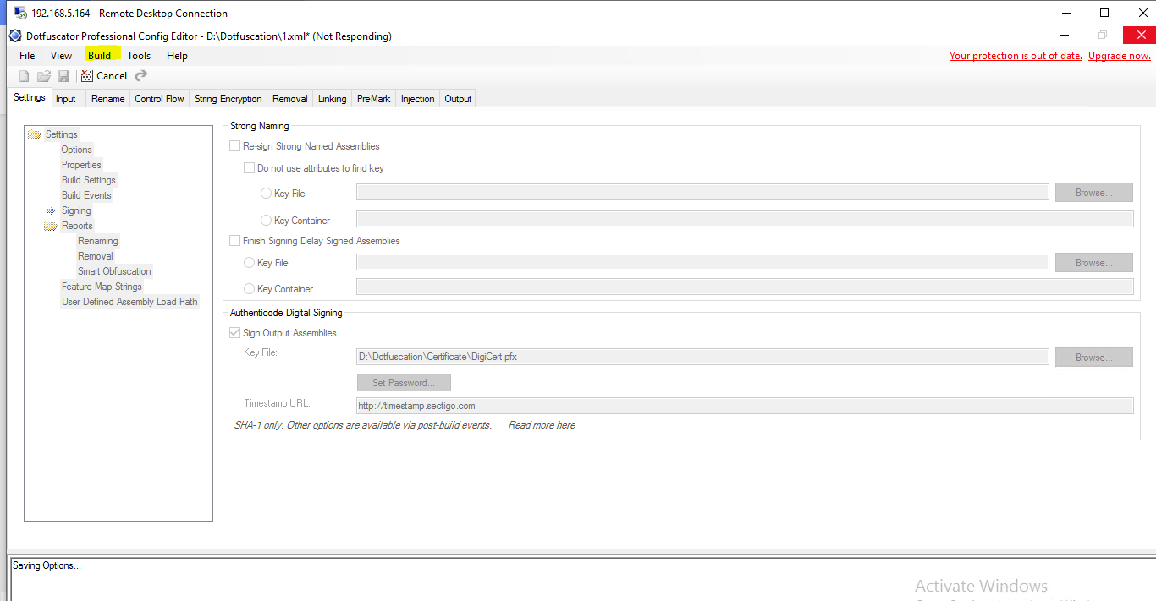
2. The status of the obfuscation will be seen in output tab , and also we can see the digital signature added to the EXE file

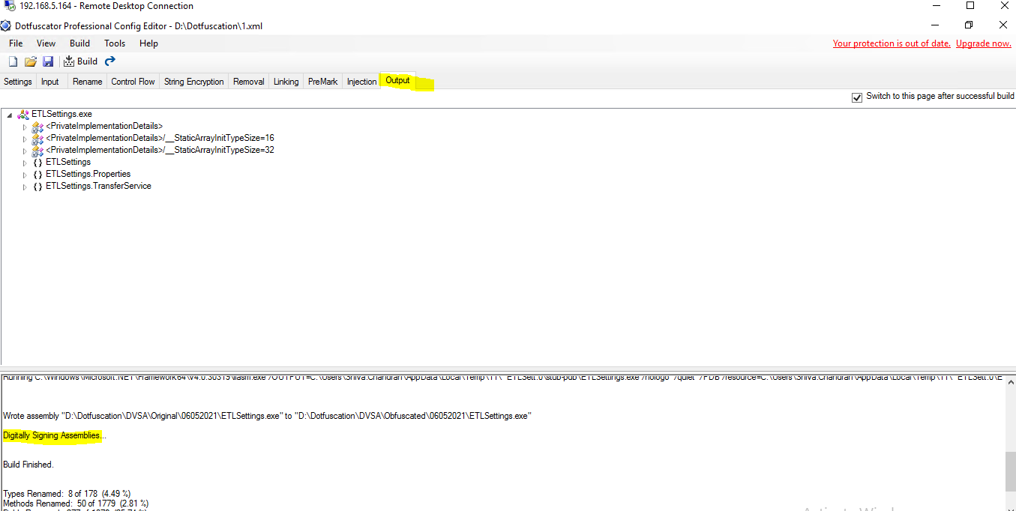

13.We can see the digital signature added to the EXE files by clicking their properties of the obfuscated files

