* Dev Check-in to TFS

* Change-set will be shared to us

* Using the URL <https://estfs.excelindia.com/tfs/SARAS/TestandAssessment/_versionControl/changesets>

One can verify the contents of the change-set with this URL

*Using the below sheet one can identify the module for incremental update

<https://docs.google.com/spreadsheets/d/10INxVgAUjtspm49_vkJPSDtLMsfULrGY_pdVJQ3E6Fk/edit#gid=816507878>

* Once the module is known, login for build Jenkins <http://192.168.3.171:8080/login?from=%2F>

Sarasbuilder\Bu!d!@#$

* In Jenkins navigate to MOE_Inc_Build_Jobs

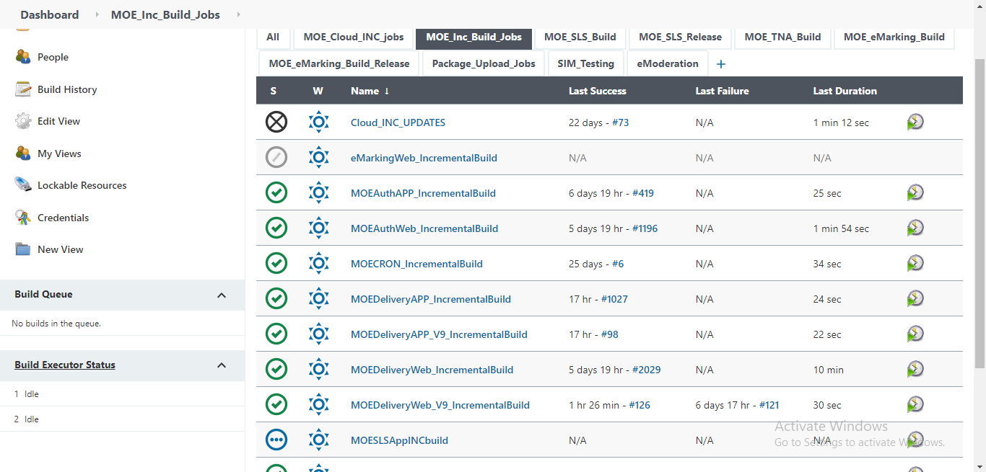

* In Build we have Delivery and Authoring with both web and app

* Some modules are explicitly in one of the environment or present in both which can be known from google sheet

* Once the module is known navigate to Delivery/Auth Web/App and select build with parameters and select the module to build

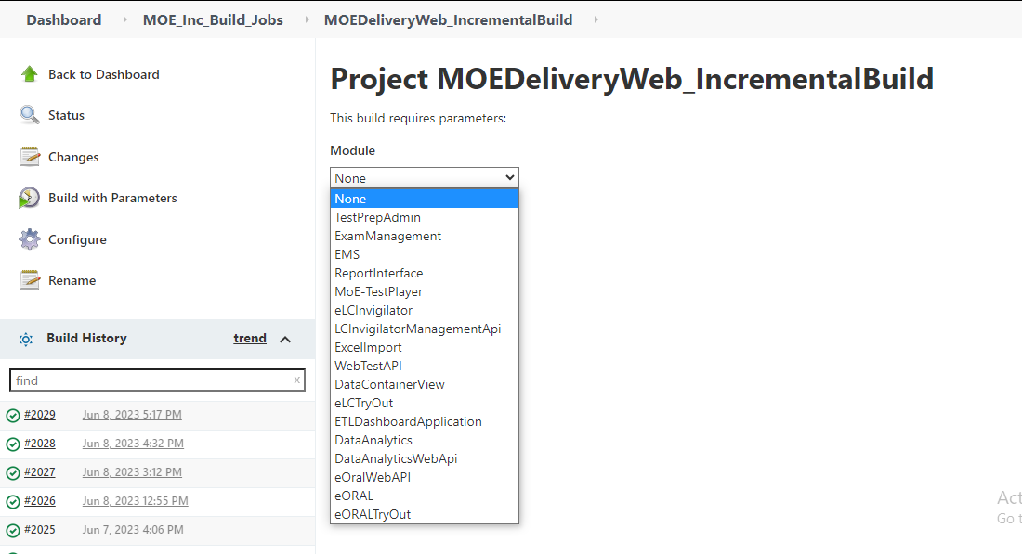

* Once the build completes cross verify the updated files with the help of change-set

**CLOUD UPDATE**

* Similar to Build Update we carry out Cloud Update

* Using the Cloud Jenkins

<http://54.255.27.60:8080/login?from=%2Fview%2FTandA%2520Modules%2520Deployment%2F>

* For Cloud Updates we’ll run the jobs in build Jenkins by navigating to Cloud_inc_Jobs

* Once the job completes successfully the artifact is pushed to S3

* Post this login to cloud Jenkins and navigate to Download S3 job to download the artifact to cloud Jenkins

* once the download job completes

navigate to TNA_INC_Jobs

* Select the environment and build parameters just like build and run the job and verify once the job completes

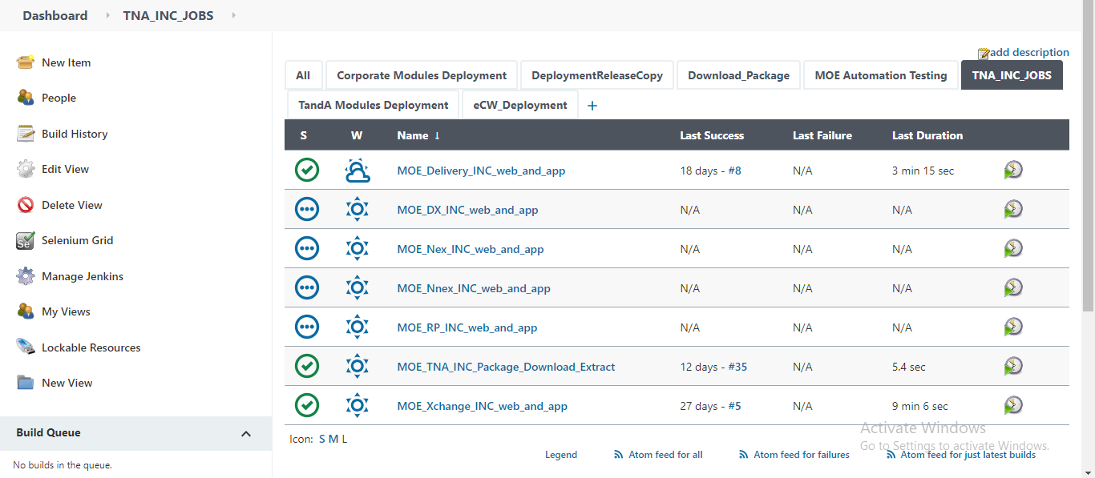

* We have multiple environments in Cloud like Delivery, Nexauth, Non-Nex auth, Report(RP),

DX