C:\Users\traecit2\Desktop\excelsoft_logo.png

**Base AMI - Preparation and Best Practices**

**Description of the Document -**

This document provides a brief description to create a Base AMI for Ec2 Image builder.

**Note:** This document is the sole property of EXCELSOFT, the contents of this document shall not be reproduced either partly or wholly without appropriate approvals from EXCELSOFT.

|  |  |
| --- | --- |
| **Document Details** | |
| **Type Of Information** | **Document Data** |
| **Document Title** | Base AMI Creation for Ec2 Image Builder |
| **Document Reference Number** | ES/RE/2 |
| **Document Owner** | ES/RE Team |
| **Security Classification** | Internal Use |
| **Review Frequency** | Daily |

|  |  |  |  |
| --- | --- | --- | --- |
| **Document Approval** | | | |
| **Name** | **Role** | **Signature** | **Date** |
| Pavan Prasad R | Lead Engineer | Pavan Prasad | 20 MAY 2025 |

|  |  |  |  |
| --- | --- | --- | --- |
| **Version Control Details** | | | |
| **Version**  **Number** | **Revision Date** | **Prepared by** | **Nature of Change** |
| **1.0** | 21 MAY 2025 | Nikhil MG | Initial release |

Table of Contents

1. **OBJECTIVE ……………………………………………………………………**
2. **PREREQUISITE ………………..……………………………………………**
3. **Step-by-step guide ……………………………………..………………….…**

# OBJECTIVE

The purpose of this document is to provide a comprehensive and practical guide on creating a base AMI for Ec2 Image Builder to implement CICD pipeline. This includes,

* Capturing every step in base AMI creation and its best practices.
* Documenting softwares , IIS roles and features installed.

# Prerequisites

* 1. **EC2 Instance :** An Ec2 instance with the preferred windows base. Required softwares and IIS roles and features.
  2. **Code Deploy Agent :** Pre-installed in base AMI or installed via a script during the build process (in EC2 Image Builder).
  3. **CloudWatch Agent :** Pre-installed in base AMI with a sample config.json to keep the service running.

# Step-by-step guide

To create a Base AMI first need to launch an EC2 instance with the preferred windows base.

In this instance we’ll carry out some of the best practices software installation, required IIS roles and features are downloaded, server level best practices as below,

IIS roles and features : 41 of 43 needs to be installed. Below is the list

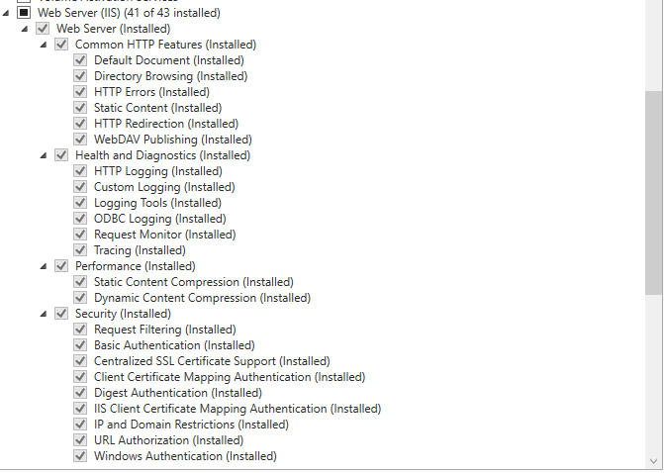

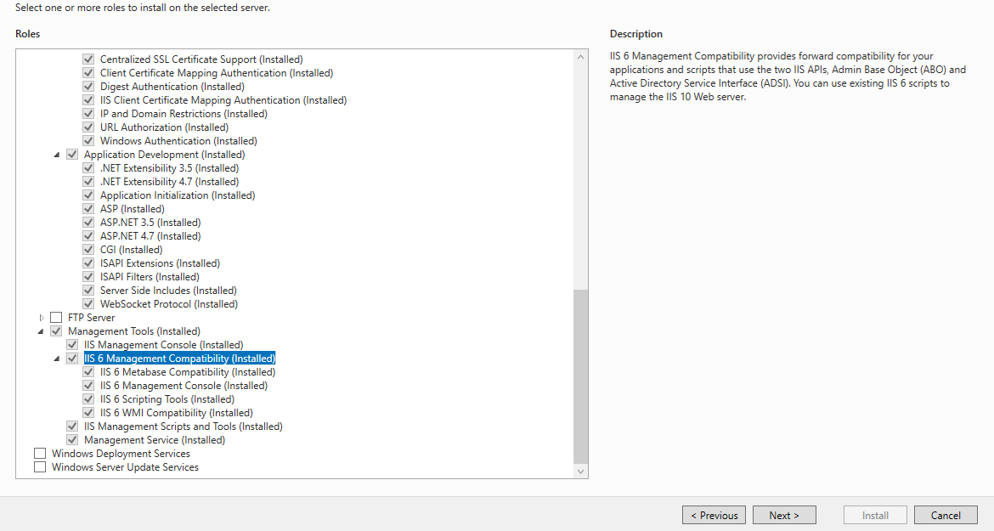

Click on Next and select the roles and features as shown below,

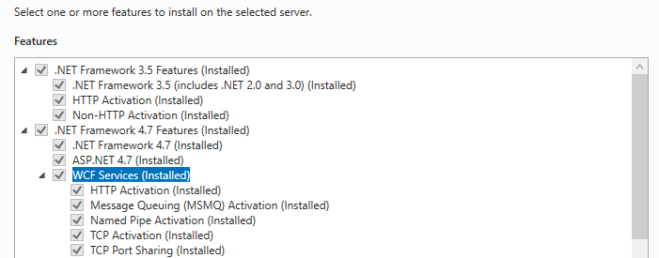

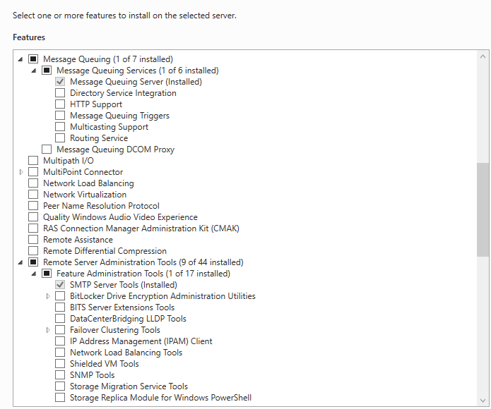

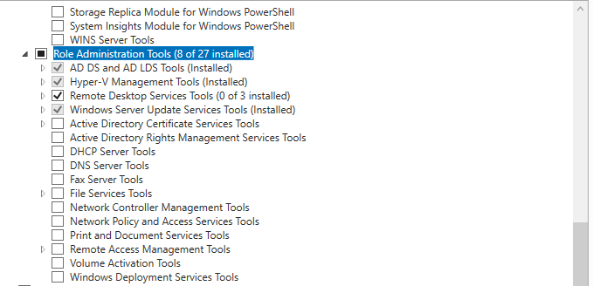

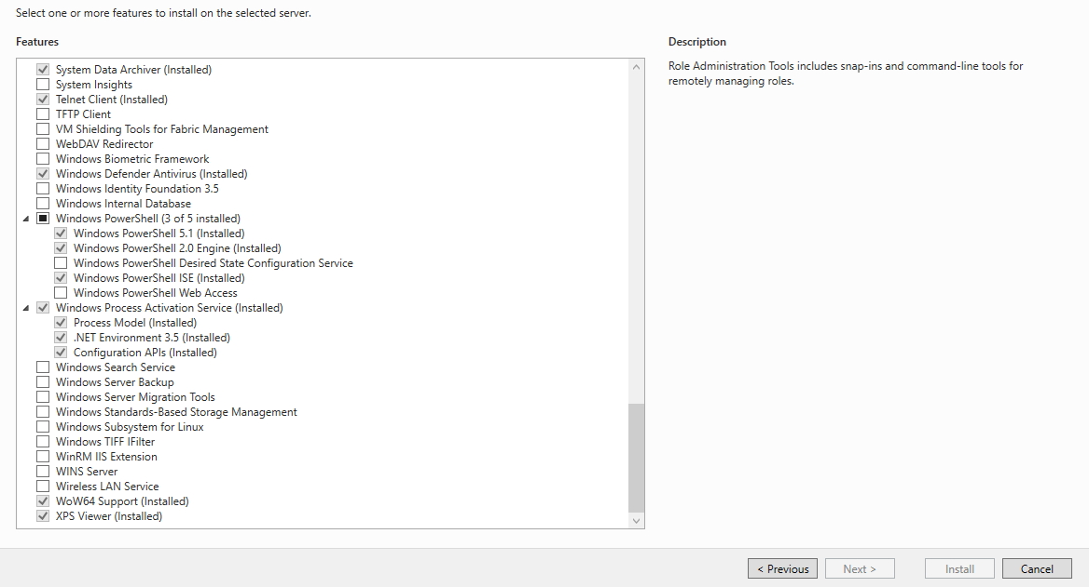

Once all the roles and features are selected Click on Install

Note :- Make sure the windows services BITS, Windows Installer , Windows Update and Windows Modules Installer are runnng while installing IIS roles and features.  
  
Do the IIS best practices like,   
  
Logging, Limits, ISAPI and CGI restrictions, Setting App-pool defaults.

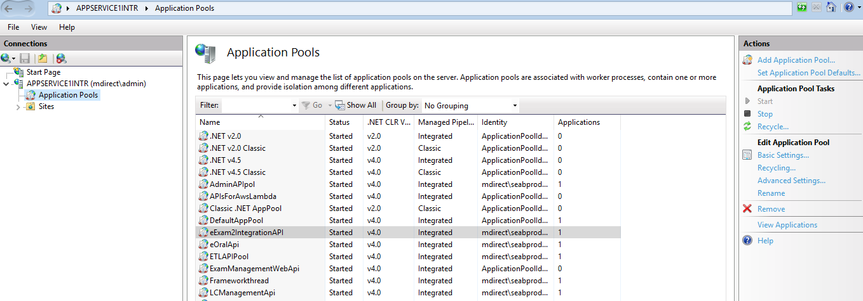

In IIS go to Application Pools , on the right -top corner select Set Application Pool Defaults. In the defaults do the pool best practices as per the requirement and add a service account in the pool identity as below.

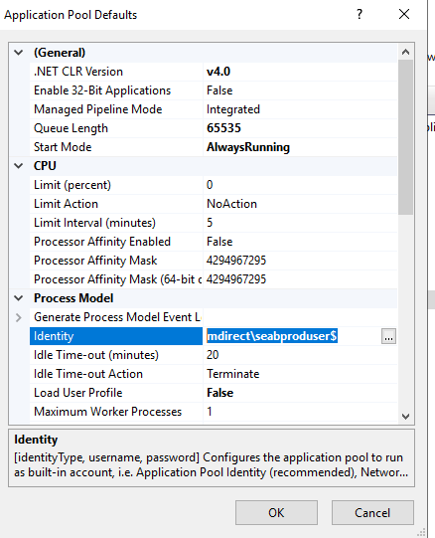

Once IIS installation is done , need to installed the softwares below ,

Microsoft Access database engine 2016 (English)

Microsoft .NET Runtime - 6.0.27 (x64)

Microsoft.NET.Sdk.iOS.Manifest-6.0.300

Microsoft .NET Framework 4.8 Targeting Pack

Microsoft ASP.NET Core Module V2

Microsoft Windows Desktop Runtime - 6.0.20 (x64)

Microsoft .NET AppHost Pack - 6.0.20 (x64\_x86)

Microsoft Windows Desktop Targeting Pack - 6.0.20 (x64)

Microsoft Visual C++ 2019 X64 Additional Runtime - 14.28.29913

Microsoft ASP.NET Core 6.0.27 Hosting Bundle Options

Microsoft.NET.Sdk.macOS.Manifest-6.0.300

Microsoft ASP.NET Core 6.0.20 Targeting Pack (x64)

Microsoft .NET 6.0 Templates 6.0.315 (x64)

Microsoft .NET Targeting Pack - 6.0.20 (x64)

Microsoft .NET Framework 4.8 SDK

Microsoft ASP.NET Core 6.0.27 Shared Framework (x86)

Microsoft ASP.NET MVC 4 Runtime

Microsoft .NET Framework 4.8 Targeting Pack (ENU)

Microsoft ASP.NET Web Pages 2 Runtime

Microsoft ReportViewer 2010 Redistributable

Microsoft Visual C++ 2019 X64 Minimum Runtime - 14.28.29913

Microsoft .NET Runtime - 6.0.27 (x86)

Microsoft .NET Host - 6.0.27 (x86)

Microsoft .NET Toolset 6.0.315 (x64)

Microsoft .NET AppHost Pack - 6.0.20 (x64)

Microsoft.NET.Sdk.tvOS.Manifest-6.0.300

Microsoft .NET AppHost Pack - 6.0.20 (x64\_arm64)

Microsoft ASP.NET Core 6.0.27 Shared Framework (x64)

Microsoft .NET Standard Targeting Pack - 2.1.0 (x64)

Microsoft ASP.NET Core 6.0.20 Shared Framework (x64)

Microsoft .NET AppHost Pack - 6.0.20 (x64\_arm)

Microsoft .NET Runtime - 6.0.20 (x64)

Microsoft.NET.Sdk.Android.Manifest-6.0.300

Microsoft .NET Host - 6.0.27 (x64)

Wkhtmltox 0.12.6-1

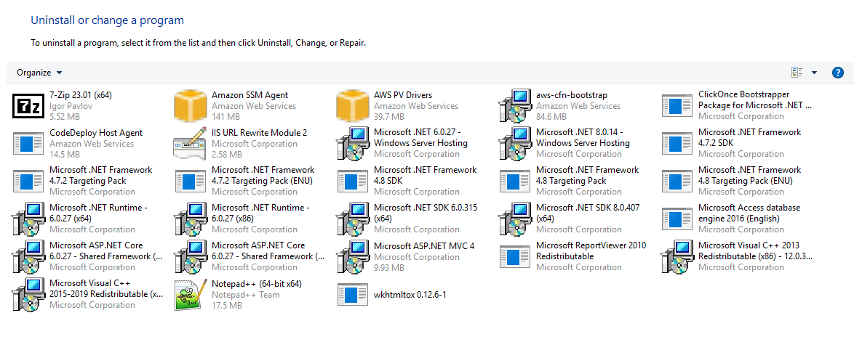

Once all these are done we can proceed with creating Base AMI  
  
The image backup of the server is taken after the IIS and Server level best practices are performed by RE team.  
  
The AMI of Image backup is used as an input in System Preparaton (Sys-prep).

Post Sys-prep again Image backup is taken and the output AMI from this is our Base AMI for EC2 Image Builder.