C:\Users\traecit2\Desktop\excelsoft_logo.png

**S3- for EC2 Image Build Components**

**Description of the Document -**

This document provides a brief description of S3 bucket creation and usage for EC2 Image Build components.

**Note:** This document is the sole property of EXCELSOFT, the contents of this document shall not be reproduced either partly or wholly without appropriate approvals from EXCELSOFT.

|  |  |
| --- | --- |
| **Document Details** | |
| **Type Of Information** | **Document Data** |
| **Document Title** | S3- for EC2 Image Build Components |
| **Document Reference Number** | ES/RE/3 |
| **Document Owner** | ES-RE team |
| **Security Classification** | Internal Use |
| **Review Frequency** | Annual |

|  |  |  |  |
| --- | --- | --- | --- |
| **Document Approval** | | | |
| **Name** | **Role** | **Signature** | **Date** |
| Pavan Prasad R | Lead Engineer | Pavan Prasad | 21 MAY 2025 |

|  |  |  |  |
| --- | --- | --- | --- |
| **Version Control Details** | | | |
| **Version**  **Number** | **Revision Date** | **Prepared by** | **Nature of Change** |
| **1.0** | 21 MAY 2025 | Nikhil MG | Initial release |

Table of Contents

1. **OBJECTIVE ……………………………………………………………………**
2. **PREREQUISITES ………………..…………………………………………..**
3. **S3 bucket creation ………………………………………………. …………..**

# OBJECTIVE

This document gives a brief about S3 bucket creation and storing the scripts and artifacts for EC2 Image Builder pipeline creation with Build Components.

# PREREQUISITES

AWS account to create S3 buckets in the preferred region.

# Step-by-step guide

Firstly we’ll create S3 buckets as below

* Bucket to store the scripts which will be executed as per the YAML definition in build component.
* Buckets to store the artifact to be deployed over EC2 seperately for Web and App tier.

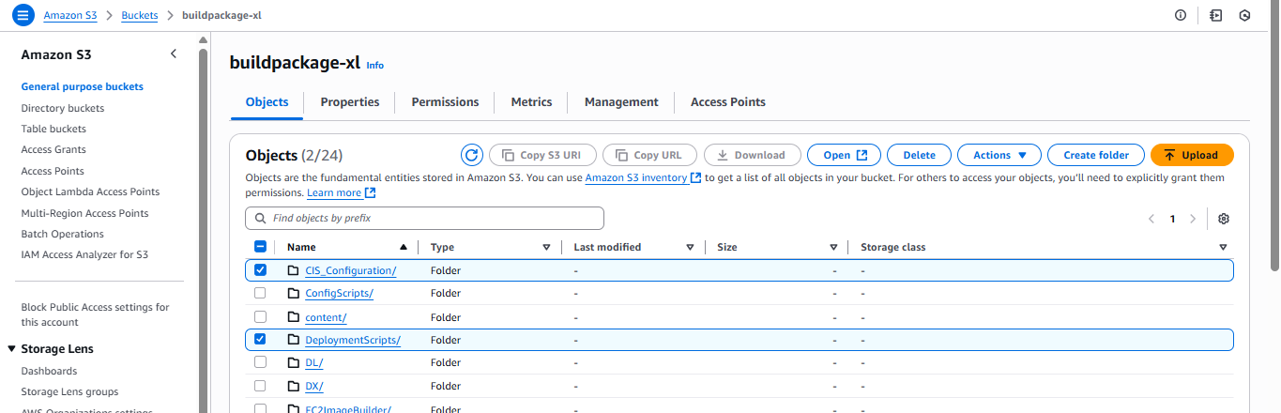

As in the above image , this bucket we’re using to store scripts in the separate directory under the bucket.  
This has CIS\_Configuration and Deployment scripts.  
CIS\_Configuration script will be executed in the EC2 to achieve CIS\_benchmark.

In the Deployment scripts we have the PS and XML to perform the actions defined in YAML. This is where we have the App-pool and VD creation, Taskscheduler Job creation.

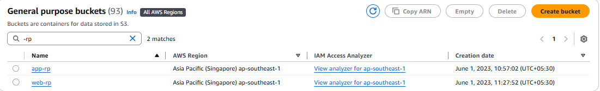

This is how buckets are created for Web and App. Again there’s a folder structure to access the artifact. s3://web-rp/Source/Web.zip, s3://app-rp/Source/App.zip

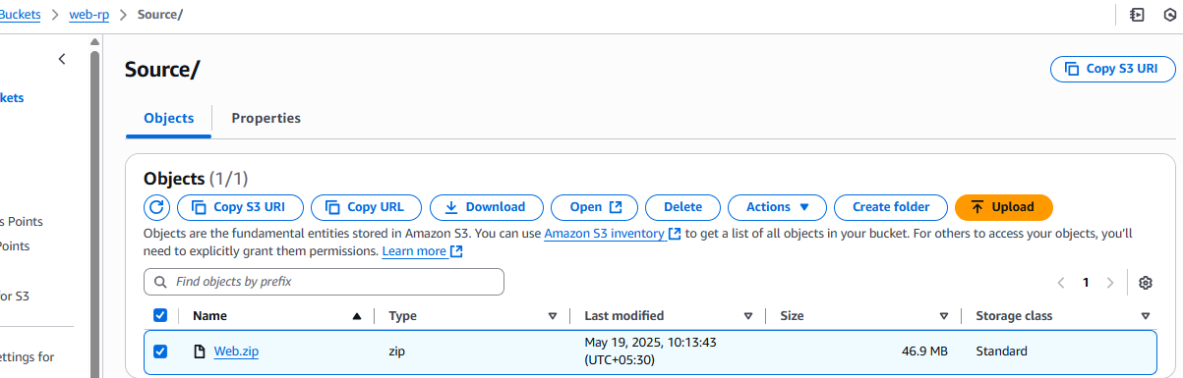

***Note :-*** S3 and the object are case sensitive, make sure the s3 url is proper in YAML file.