# Heading 1

## R Markdown

This is an R Markdown document. Markdown is a simple formatting syntax for authoring HTML, PDF, and MS Word documents. For more details on using R Markdown see <http://rmarkdown.rstudio.com>.

When you click the **Knit** button a document will be generated that includes both content as well as the output of any embedded R code chunks within the document. You can embed an R code chunk like this:

summary(cars)

## speed dist   
## Min. : 4.0 Min. : 2.00   
## 1st Qu.:12.0 1st Qu.: 26.00   
## Median :15.0 Median : 36.00   
## Mean :15.4 Mean : 42.98   
## 3rd Qu.:19.0 3rd Qu.: 56.00   
## Max. :25.0 Max. :120.00

## Including Plots

You can also embed plots, for example:

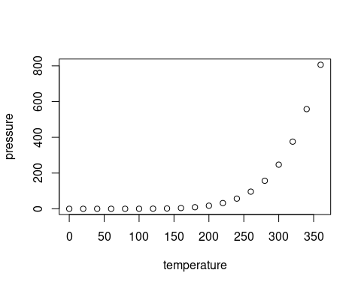

Note that the echo = FALSE parameter was added to the code chunk to prevent printing of the R code that generated the plot.

| level | description | count |
| --- | --- | --- |
| Full | The entire sample | 11876 |
| FQC | Subjects who passed operator QC (T1, 1 rsFMRI, field map) in fastqc01. | 10088 |
| ABCC | Subjects included in the ABCC. | 9600 |
| .5mm | >375 frames with motion below threshold | 9320 |
| .4mm | ” | 9262 |
| .3mm | ” | 9098 |
| .2mm | ” | 8507 |
| .1mm | ” | 5250 |

Feczko, E., Conan, G., Marek, S., Tervo-Clemmens, B., Cordova, M., Doyle, O., Earl, E., Perrone, A., Sturgeon, D., Klein, R., Harman, G., Kilamovich, D., Hermosillo, R., Miranda-Dominguez, O., Adebimpe, A., Bertolero, M., Cieslak, M., Covitz, S., Hendrickson, T., … Fair, D. A. (2021). *Adolescent Brain Cognitive Development (ABCD) Community MRI Collection and Utilities* [Preprint]. Neuroscience. <https://doi.org/10.1101/2021.07.09.451638>

Power, J. D., Mitra, A., Laumann, T. O., Snyder, A. Z., Schlaggar, B. L., & Petersen, S. E. (2014). Methods to detect, characterize, and remove motion artifact in resting state fMRI. *NeuroImage*, *84*, 320–341. <https://doi.org/10.1016/j.neuroimage.2013.08.048>