Gravity-experi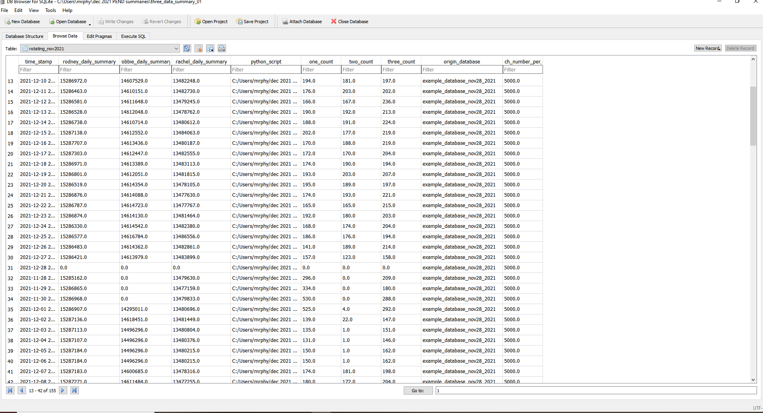ment-data-interpretation