# 1. INTRODUCTION

## 1.1 Project Overview

The Educational Organisation Management System is a digital solution built on the ServiceNow platform to manage student admissions in a structured and automated way. This project includes custom tables, forms, flows, and scripts that help administrators streamline data entry and approval processes.

## 1.2 Purpose

The purpose of this project is to simplify and automate the student admission process using a low-code platform like ServiceNow. It minimizes human error, speeds up data handling, and enhances visibility into admission records.

# 2. IDEATION PHASE

## 2.1 Problem Statement

Manual admission processes are time-consuming, error-prone, and lack real-time tracking or digital data storage.

## 2.2 Empathy Map Canvas

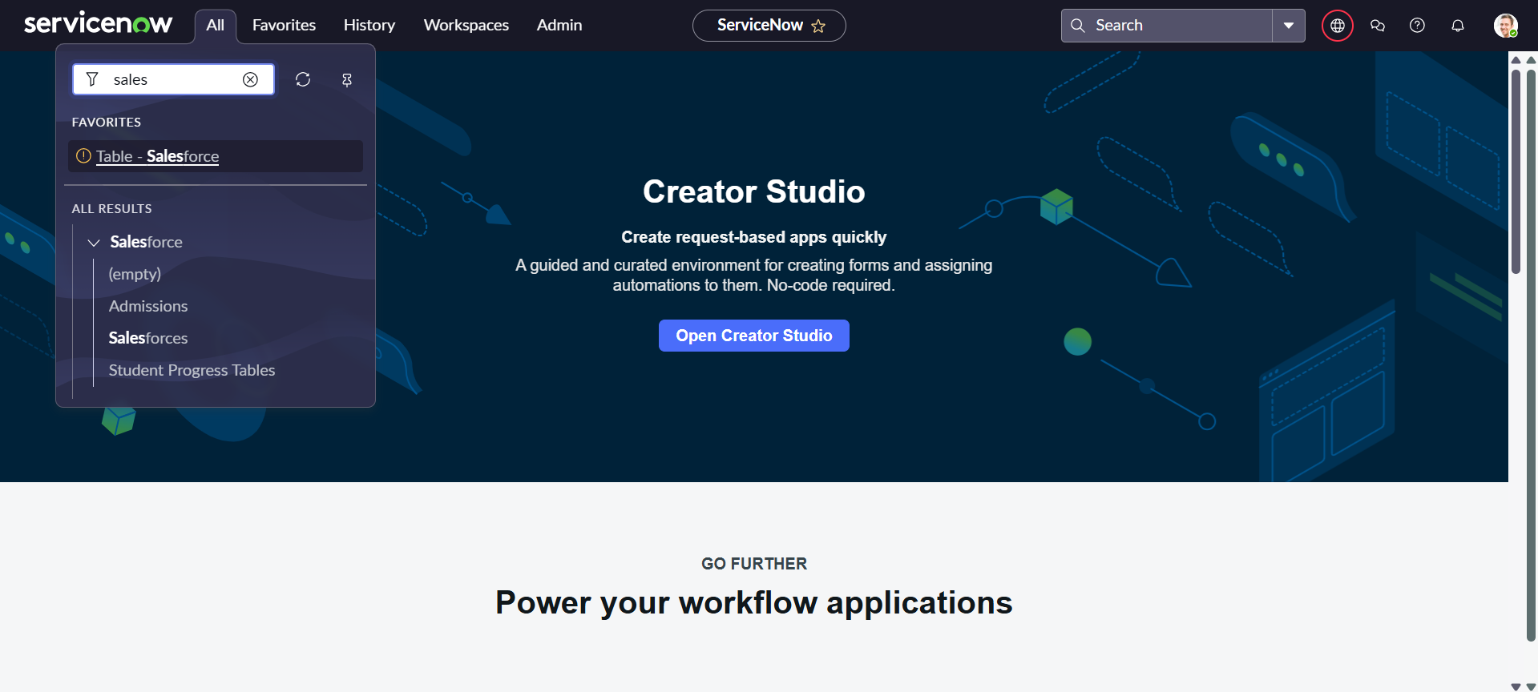

Empathy map canvas is used to understand the users' needs. (Placeholder for canvas image)

## 2.3 Brainstorming

Multiple ideas were explored such as using Google Forms, Excel Sheets, and external tools, but ServiceNow was selected due to its native workflow, form, and scripting capabilities.

# 3. REQUIREMENT ANALYSIS

## 3.1 Customer Journey Map

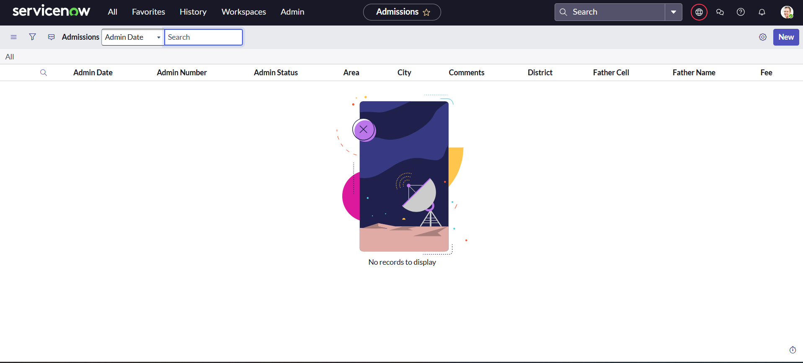

Mapped student journey from application to approval. (Add visual if available)

## 3.2 Solution Requirement

The system should collect admission details, validate inputs, assign auto-generated admission numbers, and allow form approval.

## 3.3 Data Flow Diagram

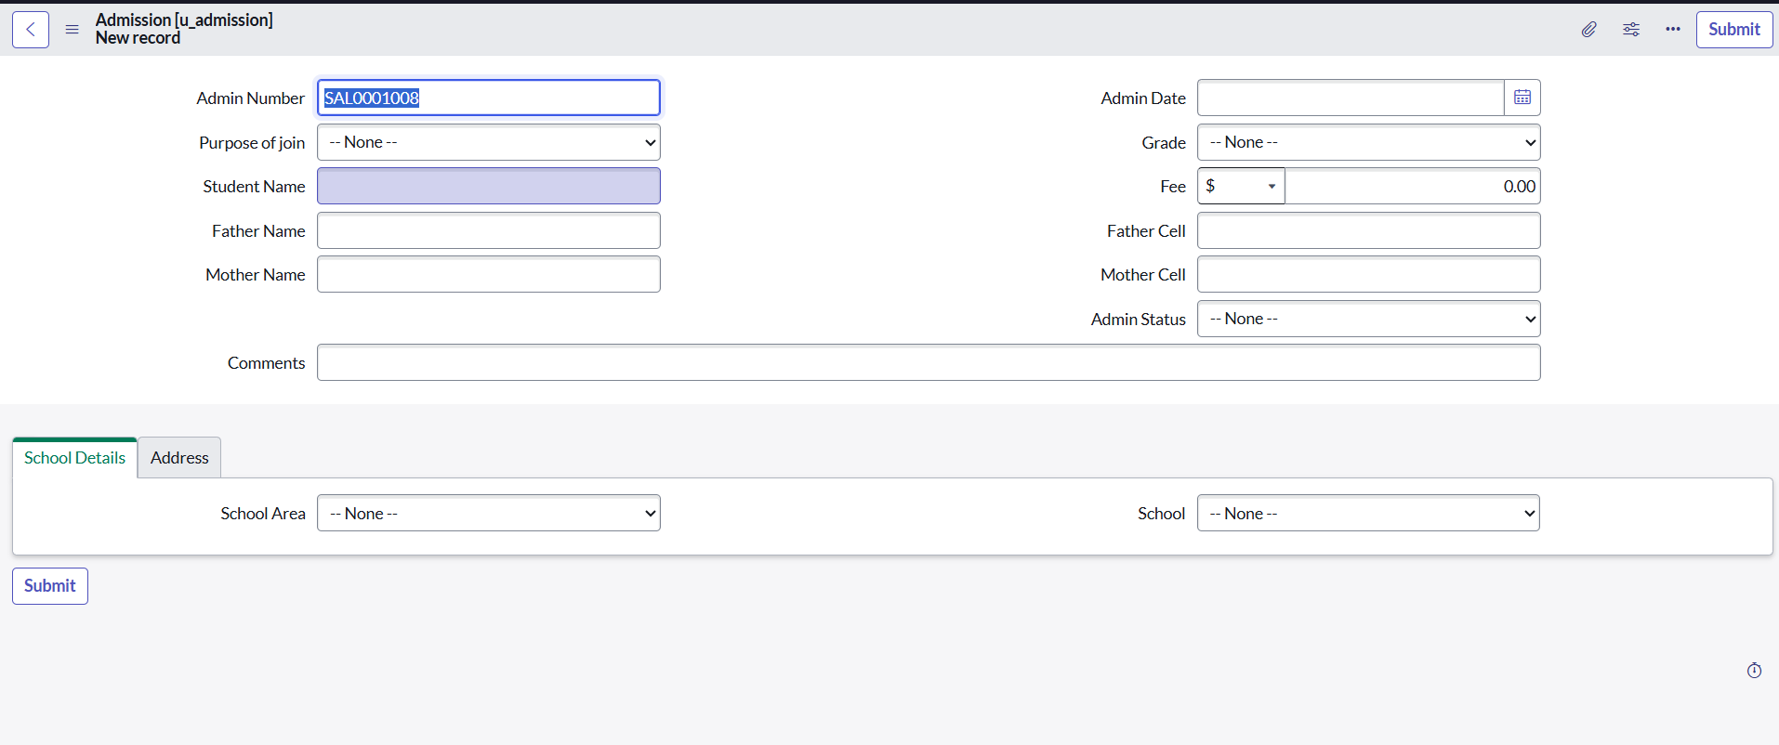

Shows flow of data between student form, database, and approval stage. (Add diagram manually)

## 3.4 Technology Stack

- Platform: ServiceNow  
- Scripting: JavaScript (Client Scripts)  
- Tools: Flow Designer, Form Designer, Update Sets

# 4. PROJECT DESIGN

## 4.1 Problem Solution Fit

The solution fits well for institutions looking to digitize the admission process using a proven ITSM platform.

## 4.2 Proposed Solution

Design and deploy a custom admission management module in ServiceNow, with auto-numbering, client-side logic, and approval flows.

## 4.3 Solution Architecture

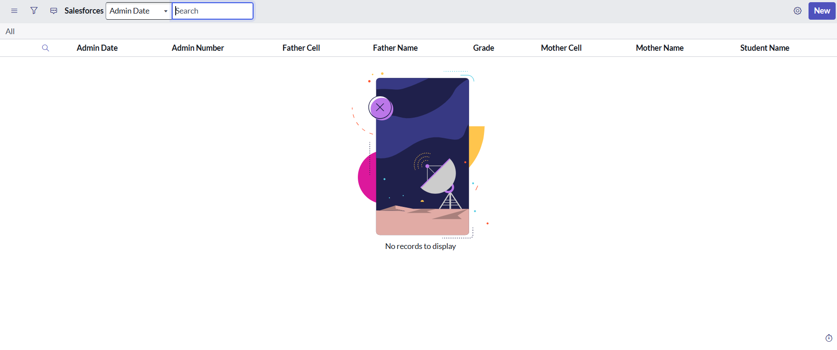

Architecture includes custom tables, UI forms, client scripts, and flow designer for approvals. (Add diagram if needed)

# 5. PROJECT PLANNING & SCHEDULING

## 5.1 Project Planning

Project was planned across the following phases:  
- Requirement Gathering  
- Instance Setup  
- Table/Form Design  
- Flow Design  
- Testing & Submission

# 6. FUNCTIONAL AND PERFORMANCE TESTING

## 6.1 Performance Testing

Basic form load and submission times were tested. All operations performed smoothly under normal usage. No performance issues encountered.

# 7. RESULTS

## 7.1 Output Screenshots

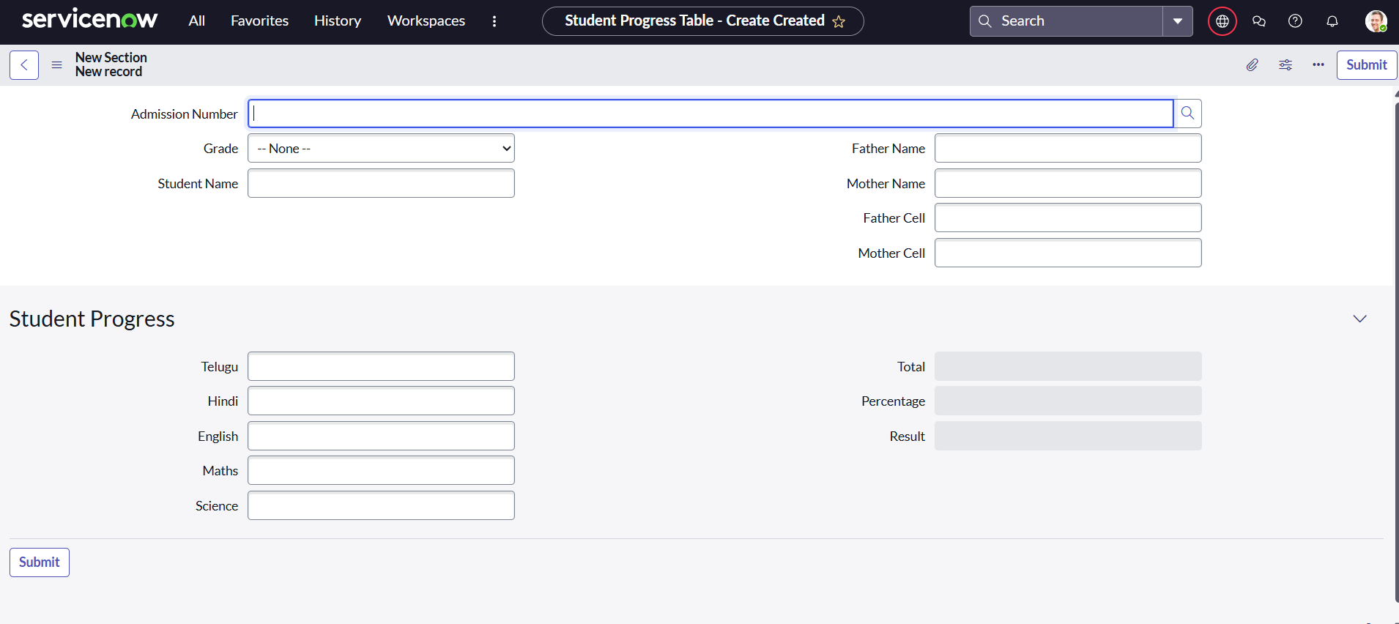

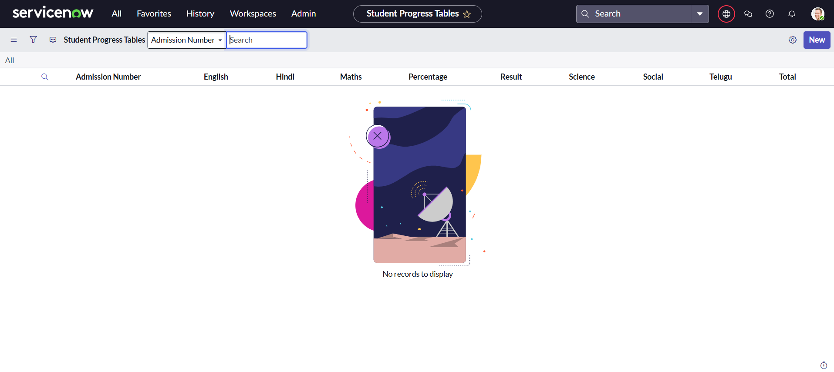

Output screenshots are added manually to showcase the final working system.

# 8. ADVANTAGES & DISADVANTAGES

Advantages:  
- Low-code implementation  
- Faster development  
- Built-in workflows  
  
Disadvantages:  
- Limited offline capabilities  
- Platform-specific customizations required

# 9. CONCLUSION

This project effectively automates the student admission workflow using ServiceNow. It demonstrates how low-code platforms can replace manual processes with streamlined, digital operations.

# 10. FUTURE SCOPE

The system can be extended to include SMS/Email notifications, parent dashboards, fee tracking integration, and data analytics dashboards.

# 11. APPENDIX

Source Code: Not applicable  
Dataset Link: Not applicable  
GitHub & Project Demo Link: Not applicable