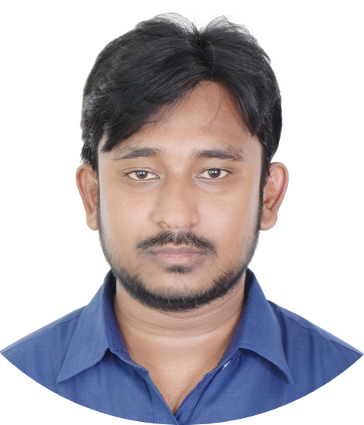

| Mazedur Rahman Pranto  **Full Stack Software Engineer having 5+ years of experience** |  |
| --- | --- |
| EXPERIENCEReformed Tech , Shyamoli — *Senior Full Stack Software Engineer*Mar 2023 - PRESENT  * Develop and maintain scalable applications using **Vue.js, Laravel and MERN Stack with Microservice architecture.** * Ensure clean, efficient, and secure code following **SOLID & DRY principles** * Troubleshoot, test, and optimize databases (**MySQL Master-Slave Replication**) * Implement **RESTful APIs, Zoom API, and Stripe Subscription Gateway** * Utilize **Docker, GitHub, Jira, Bitbucket, Slack** for modern DevOps workflows * **Key Projects:** Dokane API (POS), Quran Academy API (LMS), Logify User Management (Full Stack)  IT Clan BD, Uttara, Dhaka — *Laravel Web Apps Developer*Sep 2021 - PRESENT  * Developed SaaS applications using **Laravel, Vue.js, and Nuxt.js** * Take Ownership & full responsibility for the projects * Follow Standard coding practices i.e : SOLID and DRY approach * Ensure the code is extendable, manageable and secured. * Use version control, set debug tools and other monitoring process * Consume and write RESTful API * **Worked projects :**- Inventory (SaaS), Telemedicine REST Api (SaaS), Job Portal, Fulfillment (SaaS), Currency Conversion * **Technology Used :**- PHP - Laravel, Vue js, Nuxt js, Dexiejs, Mysql, CouchDB (Nosql), Docker, AWS Cognito, Gitlab, Trello, jira, Bitbucket, Slack  Gain Solution, Mirpur DOHS — *Laravel & Vuejs Developer*Mar 2020 - Aug 2021  * Write well-designed, testable, efficient code by using the best software development practices * Work with development teams and product managers to ideate software solutions * Design client-side and server-side architecture * Develop and manage well-functioning databases and applications * Write effective REST APIs * Work with data scientists and analysts to improve software * Build features and applications with a mobile responsive design * Create and maintain software documentation * **Worked project :**- POS System, Booking System, Core POS and Booking System, HR Management System * Note: This all projects are for codecanyon * **Technology Used :**- PHP - Laravel, Vuejs, Mysql, Github, Zenhub, Sluck, Paypal Payment Gateway, Stripe  Smart Software, Panthapath, Dhaka— *Software Developer*Jul 2018 - Feb 2020  * Write clear and well-documented code * Ability to work under pressure and tight deadlines. * Take ownership of back end development and front end on multiple projects. * Project Requirement analysis and discuss with clients * Project Deadline set * Worked Project :- Inventory, POS, HRM System, Merchandising System, Commercial System * Technology Used :- PHP - Laravel, Javascript, Jquery, Mysql, Github, Trello, Google Drive Api, Google Location Api, Paypal, Sslcommerz Payment Gateway  Smart Corporation, Hatirpul, Dhaka— *Junior web Developer*Apr 2017 - Dec 2017  * Website Content Management * Website theme modifying * Content Image design and video editing * Technology Used :- Adobe Photoshop, Camtasia, Wordpress Dynamic theme | CONTACT Mirpur-12, Dhaka  **01710750665**  [**prantoabir1@gmail.com**](mailto:prantoabir1@gmail.com) SKILLS  * **Language:** * PHP (5+ years), * Javascript (4+ years), * Node js (0.3 year) * **Framework:** * Laravel (5+ years), * Vue js (4+ years), * Nuxt js (1.5+ Years), * React js (1.2+ years), * Express Js (0.3 year), * Next js (1+ years), * Jquery (2+ years), * Dexies js (0.4 year) * **Database:** * Mysql, Sqlite, Postgresql,MongoDB, * CouchDB (Nosql), IndexedDB * **Cloud:** * Cpanel, FTP, AWS Cognito, Firebase * **Other Technologies:** * Git, Gitlab, Github, Bitbucket, Jira, Trello, Sluck, Adobe Photoshop, Video Editing * **3rd Party Api:** * Paypal, Stripe, Twilio (sms), Sslcommerz, Mailtrap, Bkash, * etc.  PROFILES [Github](https://github.com/mrpranto), [Linkedin](https://www.linkedin.com/in/m-r-pranto/), [Facebook](https://www.facebook.com/pranto420840) LANGUAGES Bangla (Good),  English (Medium),  Hindi (Medium) EDUCATIONS Bangladesh University of Business and Technology   * BSC in CSE   Jhenaidah Polytechnic Institute   * Diploma in CSE   Khalishpur M.L High School   * SSC in Science |