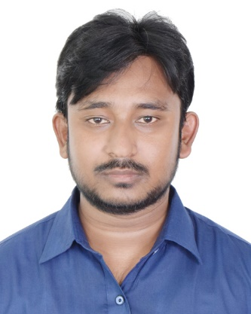

Mazedur Rahman Pranto

16/1c, Komishonar Goli, Kollyanpur, Mirpur-1, Dhaka

[prantoabir1@gmail.com](mailto:prantoabir1@gmail.com)

[prantobd.com](http://prantobd.com)

01710750665, 01928550545

|  |  |  |  |
| --- | --- | --- | --- |
| Career Objective | | | |
| I am very passionate about computer and programming since 2016. I dream to be an expert software engineer so that I can build professional and useful software that has business value. I am looking for a software engineer position in a reputed software company that can help me to achieve my goal. To obtain as a part of a team and creating integrated strategies by problem-solving skills, develop and expand existing knowledge and skills with commitment, novelty, implementation of the innovative idea and efficient technical solution. | | | |
| Skills | | | |
| * Extensive knowledge on OOP, PHP, JavaScript and MySQL. * Also Expert on HTML, CSS, Jquery, Ajax and Vue Js. * Working experience with MVC Framework Laravel. * knowledge on Github. * Working experience with REST API. * Familiar with using Linux. * An understanding of HTTP, Apache, FTP. * Have Knowledge about cPanel. * Experience and skills in integrating 3rd Party API. * Experience and skills in Database Design. | | | |
| Educational Information | | | |
| 2017 – Present |  | Bachelor of Science  *Bangladesh University of Business and Technology* |
| 2012-2016 |  | Diploma in Engineering  *Jhenaidah Polytechnic Institute* |
| 2012 |  | SSC – in Science  *Khalishpur M.L High School* |
| Job Experience  |  |  |  | | --- | --- | --- | | 2018 (April) – 2018 (December) |  | Smart Corporation  *Web Development, Photo Editing, Video Editing.* |  Language Proficiency  * Bengali and English.  Training & Internship  * Make Practical Web Applications by learning PHP Framework Laravel   (**Talha Traning**, Flat #4A (3rd Floor), House #51/A/3, West Rajabazar, Panthapath, Dhaka 1215)   * Web development using PHP   (**Genuity Systems Ltd**, sruti Tower, Plot-8, Block-Ka Mirpur Rd, Dhaka 1216) Personal Information  |  |  |  | | --- | --- | --- | | Father's Name | : | Md. Khalid Hossain | | Mother's Name | : | Mst. Kalpona Khatun | | Date of Birth | : | September 25, 1997 | | Gender | : | Male | | Marital Status | : | Unmarried | | Nationality | : | Bangladeshi | | National Id No. | : | 645 500 8786 | | Religion | : | Islam | | Permanent Address | : | Kakiladery, Khalishpur, Maheshpur, Jhenaidah 7340 | | Current Location | : | Dhaka |  Profile Link  1. <https://github.com/mrpranto> 2. <https://www.linkedin.com/in/m-r-pranto-3abb15142/> 3. <http://prantobd.com>   I hereby declare that the information given in this CV is complete and accurate.  WP_20170305_002 (2).jpg  Signature | | | |