A Mid Term report on

**‘NCITArena *Your Opinion Matter*’**

Submitted in Partial Fulfillment of the Requirements for the Degree of **Bachelor of Engineering in Information Technology**

under Pokhara University

Submitted by:

**Rohan khanal,211434**

**Sushant Sharma,211445**

**Pravin Bhatta,211428**

Date: 23-Jan-2024

**Department of IT engineering** 

NEPAL COLLEGE OF

INFORMATION TECHNOLOGY Balkumari, Lalitpur, Nepal

NCITArena

**Abstract**

"Knowledge is power." In the fast-paced world of **academia**, students often find themselves overwhelmed with the demands of coursework and the need for a centralized platform to connect, share, and engage. "NCITArena" is a dynamic, web-based college community website **tailored** for students at the Nepal College of Information Technology (NCIT). Recognizing the importance of a vibrant academic community, NCITArena aims to foster collaboration, knowledge sharing, and a sense of unity among students.

In this virtual **realm**, students not only share educational resources but also participate in discussions that foster a sense of belonging. The platform's interactive features, such as polls, provide a unique opportunity for students to express their opinions on campus-related matters, contributing to a more inclusive and connected NCIT community. NCITArena is the digital **nexus** that bridges the gap between students, creating a **cohesive** online environment that complements their academic pursuits and strengthens the sense of community within the NCIT student body.

Keywords*: academia, tailored, realm, nexus, cohesive*

i

NCITArena

**Table of contents**

Abstract.......................................................................................................................................i Table of contents........................................................................................................................ii List of figures............................................................................................................................iii List of tables..............................................................................................................................iv 1. Introduction........................................................................................................................1

1.1 Problem Statement ......................................................................................................1 1.2 Project Objectives .......................................................................................................2 1.3 Significance of study...................................................................................................2

2. Scope and Limitations........................................................................................................3 2.1 Scope ...........................................................................................................................3 2.2 Limitations ..................................................................................................................3

3. Literature review................................................................................................................4 3.1 Features not provided..................................................................................................5 3.2 Features offered...........................................................................................................5 3.3 Feasibility study ..........................................................................................................5

4. Proposed Methodology ......................................................................................................6 5. Task Done so far................................................................................................................8 5.1 Team and divide roles .................................................................................................8 5.2 Use Case Diagram.......................................................................................................9 6. Technologies and tools used ................................................................................................10 7. Proposed Result/Output ...................................................................................................11 8. Task Remaining ...................................................................................................................12 9. Project task and time schedule.........................................................................................13 9.1 Project Schedule ............................................................................................................13 10.References........................................................................................................................... 14

ii

NCITArena

**List of figures**

Figure 1: Incremental Methodology ..........................................................................................6 Figure 2:Use Case Diagram........................................................................................................9

iii

NCITArena

**List of tables**

Table 1: Team members and divided roles................................................................................8 Table 2: Tools Used.................................................................................................................10 Table 3: Project Schedule ........................................................................................................13

iv

NCITArena

**1. Introduction**

In development of this project "**NCITArena**," we are crafting a dynamic space for the Nepal College of Information Technology (NCIT) community. Featuring a secure login system and a user-friendly sign-up facility, the platform ensures effortless access for all students, fostering a connected academic environment. NCITArena serves as a central hub where students can seamlessly share notes, stay informed about campus events, and actively engage in polls to express their opinions. Beyond conventional social media functions, this project is driven by the goal of enhancing the overall academic and social experience at NCIT, promoting community engagement and collaboration among students. Envisioned as a comprehensive ecosystem, NCITArena empowers NCIT students to actively shape their academic journey, contributing to a more cohesive and interactive campus environment.

**1.1 Problem Statement**

The prevailing issue at the Nepal College of Information Technology (NCIT) is the dependency of the entire student body on external platforms, specifically the Facebook group **"NCIT Society,"** for important notices and event updates. This reliance on a non dedicated platform poses challenges as there is currently no specialized space for students to effectively share and find academic notes. The absence of an official platform catering to the unique needs of NCIT students hinders the seamless exchange of academic resources, leading to inefficiencies and fragmented communication. To alleviate these challenges and foster a more cohesive and secure academic environment, the development of NCITArena, a dedicated NCIT-dependent social college community platform, is imperative. NCITArena aims to provide a centralized space for students to share, access, and collaborate on academic content, thus mitigating the dependence on external platforms and enhancing the overall student experience at NCIT.

The development of NCITArena is not only aimed at addressing the immediate need for a dedicated space for sharing notes but also strives to establish a secure, centralized, and student-centric platform that prioritizes privacy and enhances the overall communication and collaboration experience within the NCIT community. With NCITArena, students can have a digital space designed specifically for their academic and social needs.

1

NCITArena

**1.2 Project Objectives**

There are following objectives of our project ‘**NCITArena** ’: ➢ Unified Communication**.**

➢ ➢ ➢ ➢

Efficient Note SharingStudent-Centric Design Community Engagement Centralized Sharing

**1.3 Significance ofstudy**

The significance of the "NCITArena" project lies in its pivotal role in addressing critical communication challenges within the Nepal College of Information Technology (NCIT) community .Currently, students heavily rely on external platforms ,leading to fragmented communication and the absence of a centralized hub for sharing academic resources and event details. The project aims to rectify this issue by providing a dedicated space that caters specifically to the academic and social needs of NCIT students.

In the absence of such a platform, students may miss out on crucial information and opportunities. "NCITArena" seeks to create a unified space that fosters a sense of community, where students can actively participate, collaborate, and stay informed about important announcements. By developing this project, we aim to enhance the overall student experience, making information easily accessible and contributing to a more connected and engaged NCIT community. The project is not just a remedy for current communication challenges but also an investment in the long-term improvement of the student experience at NCIT.

2

NCITArena

**2. Scope and Limitations**

**2.1 Scope**

This system comprises of following scopes :

➢ Develop a comprehensive communication platform for the NCIT community. ➢ Implement an efficient event management system for seamless organization and participation in campus events.

➢ Integrate features promoting skill development in software and encouraging collaborative teamwork.

➢ Design the platform for daily utility, offering convenience in accessing information, participating in polls, and staying updated on events and resources.

➢ Explore possibilities for integration with existing NCIT systems and platforms for seamless connectivity.

➢ Incorporate a notification system to keep users informed about important announcements, deadlines, and updates.

**2.2 Limitations**

However, our system does come with certain limitations, including:

➢ Challenges in maintaining a balance between freedom of expression and

preventing misuse.

➢ Possible resistance from traditional communication channels might hinder

widespread adoption.

➢ Potential difficulties in aligning platform updates with rapidly changing user

expectations .

3

NCITArena

**3. Literature review**

As part of the literature review, an exploration was undertaken to investigate existing applications in the Nepal College of Information Technology (NCIT) community, focusing on student collaboration and communication platforms. The objective was to comprehend their functionalities, discern areas for improvement, and identify points of differentiation. In the process, we encountered noteworthy platforms, each characterized by distinct features and valuable contributions. Some of noteworthy Platforms we discovered were:

• **NCITHUB**:- NCITHUB was an exclusive website for NCIT students, offering access to a variety of reading materials such as PDF notes, syllabus, question banks, examination routines, results, and the latest college news feed.

• **Note-Vault:** This app was intended to help student in daily life as by solving the problem of hassling here and there to find the specific subject notes they are looking for.

• **‘College diaries'** :It was an android based application all about the collection of study materials and college notices brought together for the users. This android platform efficiently assists students to collect the notes and compare the study materials to get more verified answers to their queries.

4

NCITArena

**3.1 Features not provided**

• No direct platform for student to communicate with college administration. • Lack of Polls to express personal opinions.

• Does not provide one-stop solutions to student problems due to lack of an integrated platform.

.

**3.2 Features offered**

• Easy platform for expressing personal opinion .

• Providing regular updates on upcoming events.

• Providing genuine information through trusted sources.

**3.3 Feasibility study**

Feasibility study plays a vital role before undergoing any project construction. The study determines if the new proposed system is useful or not. The main aspects of studying the feasibility of this application is to determine whether the application can be built correctly and precisely in time with available resources.

This application is technically feasible since it will be based on websites rather than desktop application. Similarly, it is operationally feasible since this application will have a proper graphic user interface and hence user interactive.

5

NCITArena

**4. Methodology**

In alignment with the project's nature and requirements, the incremental model has been adopted as the chosen development methodology for NCITArena. This popular model emphasizes a systematic and iterative approach to software development. Unlike traditional waterfall models, the incremental model divides the development process into smaller, manageable parts or increments. Each increment represents a portion of the complete system's functionality, and new features are added in subsequent iterations

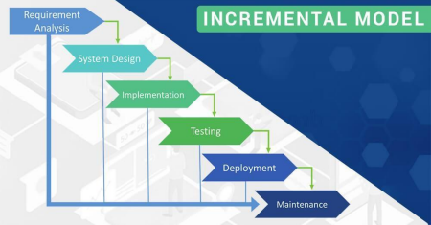*Figure 1: INCREMENTAL MODEL*

**4.1.1** Analysis Phase In this phase, analysis was performed in order to find out the requirements of the system. An SRS minimizes the time and effort required by developers to achieve desired goals and also minimizes the development cost. A good SRS defines how an application will interact with system hardware, other programs and human users in a wide variety of real-world situations.

Parameters such as operating speed, response time, availability, portability, maintainability, footprint, security and speed of recovery from adverse events were evaluated.

6

NCITArena

**4.1.2 Design Phase** In this phase the SRS was translated into the system’s design. ER – Diagram, Use Case Diagram, Class Diagram was developed. E-R Diagram: ER diagram also known as Entity Relationship Diagram. This diagram is used to describe the relationship between the objects and the system in the database. It shows the logical structure of the database. The following diagram describes the relationship between our components

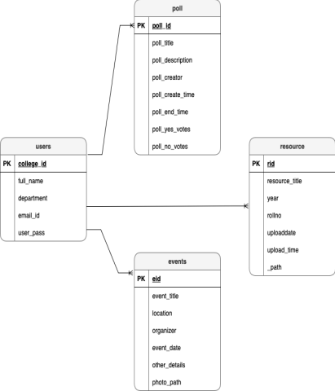Fig.Schema diagram

7

NCITArena

**5. Task Done so far**

Our progress on the project is running in parallel ways for data collection, documentation, research on data as well as development. System design is mentioned below:

**5.1 Team and divide roles**

| **Team member** | **Roles** | **Responsibilities** |
| --- | --- | --- |
| Pravin Bhatta | Developer, Visualizer | • Front end developer • Back-end Developer • Presentation  coordinator |
| Rohan khanal | Developer**,** Researcher | • Front end developer • Back-end developer • Content writer |
| Sushant Sharma | Developer, **,**  Documentation  specialist | • Front end developer. • Documentation |

*Table 1: Team members and divided roles*

8

NCITArena

**5.2 Use Case Diagram**

**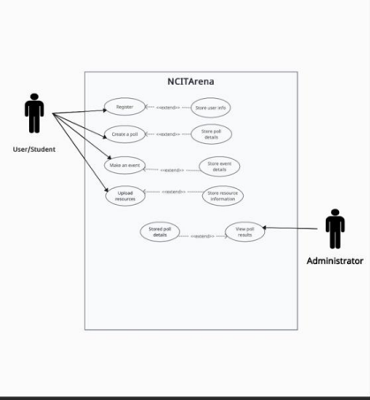***Figure 2:Use Case Diagram*

9

NCITArena

**6. Technologies and tools used**

The tools used for documentation, designing, and developing GUI testing are listed below in table:

| **TOOLS** | **PURPOSE** |
| --- | --- |
| HTML | Designing the Web Pages front endwith predefined tags. |
| CSS | The style and user-interactive layout |
| PHP | For Server- side scripting |
| MY SQL | Work related to database |
| XAMPP | Local Host |
| MS word, | Documentation |

*Table 2: Tools Used*

In this system, the various raw data and information is collected through NCIT lMS system.

10

NCITArena

**7. Proposed Result/Output**

Our system is being developed with the purpose of providing easier way to access resources by providing details in single platform , so main proposed output are.

➢ Voting and commenting functionalities for expressing opinions.

➢ Dedicated section for sharing academic resources

➢ Event calendars and notifications for upcoming activities.

➢ Content management features for administrators.

➢ ALL IN ONE platform for notes, events and resource sharing.

11

NCITArena

**8. Task Remaining**

As stated above, the designing, data collection and database integration is almost completed. On the other hand, some validation is still remaining , and database design is almost done. User and admin panel hasbeencompleted. Almost85percent of theworkhasbeencompleted.The remaining15 percent ofthe task isstillongoing.

12

NCITArena

**9. Project task and time schedule**

The project schedule has been designed as per the requirements and constraints involved. This project is scheduled to be completed in 3 months. Requirements and analysis have been given more emphasis. Debugging and Testing is to be done prior to the completion of the project and after achieving output of each sprint.

**9.1 Project Schedule**

| ***TASK*** | ***APPROX DURATION (in days)*** |
| --- | --- |
| Requirement Analysis and Specification | 10 |
| Analysis of the System | 10 |
| Design System | 20 |
| Procedure Requirement and Coding | 25 |
| Testing and debugging | 10 |
| Test System Output of each sprint | 5 |
| Overall System Test | 10 |
| Develop Documentation | **90** |

*Table 3: Project Schedule*

13

NCITArena

**10.References**

[1]. *COLLEGE DIARY (2017) “web app for NCIT ”.* [2]. *NOTE-VAULT(2018) “Note sharing platform”.*

14