**UNDERSTANDING UNCERTAINTIES**

**(or how to cheat a bank!)**

1. **WEIGHING A SINGLE PENNY**

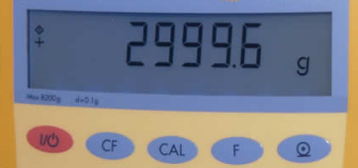 [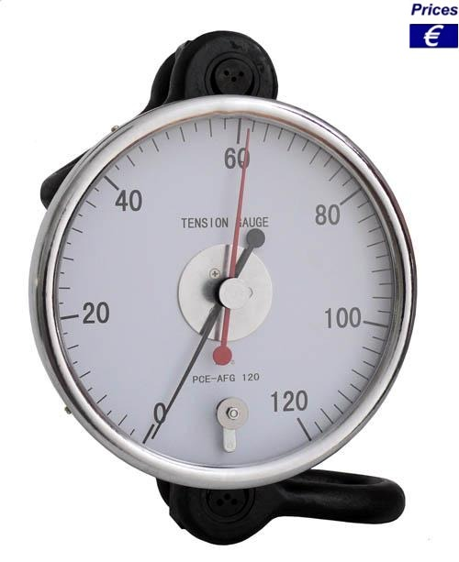](http://www.google.co.uk/url?sa=i&rct=j&q=analogue%20kitchen%20scales%20balance&source=images&cd=&cad=rja&docid=Tto8lhxyXKMznM&tbnid=t0vOAmKt1P7OGM:&ved=0CAUQjRw&url=http%3A%2F%2Fwww.industrial-needs.com%2Ftechnical-data-balances%2Fcrane-balance-pce-afg.htm&ei=8UofUpPpKIK40QW-54GYBQ&psig=AFQjCNE9rwROtYg0yZX_BQScXqWiU-WIEQ&ust=1377868902539985)

A penny was weighed using a ____________________ with a resolution of _________________.

Mass of THIS penny = ±

The uncertainty in the measurement was governed by _____________________.

Given this information alone, state, including an uncertainty, your best estimate of the mass of

1. TWO pennies
2. 100 pennies
3. **REPEAT!**

Ten pennies were weighed: Average:

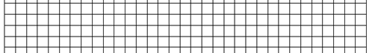

OUTLIERS?

RANGE?

SPREAD?

BEST ESTIMATE of mass of ANY penny = ±

The mass of ANY other penny that you measure should lie within this range.

Outlier check?

1. **CHEATING THE BANKS**

When you take bags of coins to the bank, they weigh the bags rather than counting all of the coins. Use your measurements to explain whether or not you could cheat the bank (or if they could cheat you) by a penny in a pound.

***HINT****: start by considering the range of masses that 99 coins could be, then 100, then 101.*

**KEY IDEAS IN PENNY PRACTICAL:**

* Single reading:
  + digital vs analogue device
  + resolution, including whether to subdivide analogue scale or not
  + parallax, zero error
  + what sig. figs tell us
  + flickering readings?
  + units
* Repeats
* Dot plot
  + Outliers, spread, range, best estimate
* combining uncertainties when adding quantities