ONLINE WEBSITE CHAT USING PHP, MYSQL

In this we can communicate using website. The chat application we will be building today will be quite simple. It not required login, AJAX-style features, and will also offer support for multiple users.

Languages Used:

php

mysql

javascript

ajax

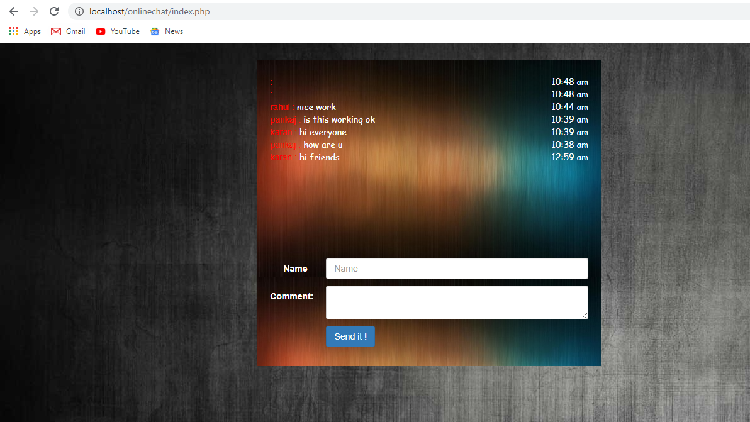

Submitted By : Pankaj Rawat 4431 & Gaurav Jaswal