Omni-Foundation Deployed Document

**Revision History**

|  |  |  |  |
| --- | --- | --- | --- |
| **Version** | **Revision Date** | **Revised By** | **Description** |
| V1.0 | 08/25/2016 | Keven Wang | Created |
|  |  |  |  |
|  |  |  |  |

Table of Contents

Chapter 1 Setup environment 4

• Software version 4

• Internal software. 4

Chapter 2 Database Setup 5

• Database created. 5

• Initialize data 5

• Database upgrade. 6

Chapter 3 Identity server deployment and configuration 7

• Port & Https certification 7

• Configure ADFS 7

• Configure foundation database. 8

• Configure timeout/expiry 8

• Configure client secret and scope 8

Chapter 4 Foundation server deployment and configuration 9

• Build on Jenkins 9

• Package Preparation 10

• Database configuration & Identity Server configuration & AD configuration 11

• Setup database(if devops setup database using migration) 12

• Port & Http certification 14

• Configure application pool 14

Chapter 5 ESB Setup 15

• Proxy 15

• Setup rabbit queue 16

• Set handler address and salesforce connect. 17

• ESB Port 18

Chapter 6 Windows Job Setup 19

• Install & Run windows job 19

• Configure database. 21

• Settings 21

• Restart service 22

Chapter 7 Client deployment 23

• Preparation 23

• Foundation address & Identity Server address 23

• Configure cloud address 23

• Run build 24

# Chapter 1 Setup environment

## Software version

* We need SQL Server 2014

|  |  |
| --- | --- |
| **Component Name** | **Versions** |
| Microsoft SQL Server Manager Studio | 12.0.2000.8 |
| Microsoft Analysis Services Client Tools | 12.0.2000.8 |
| Microsoft Data Access Components(MDAC) | 6.1.7601.17514 |
| Microsoft MSXML | 3.0 6.0 |
| Microsoft Internet Explorer | 9.0.8112.16421 |
| Microsoft .NET Framework | 4.0.3.0319.42000 |
| Operating System | 6.1.7601 |
|  |  |

* We need IIS Server 6.1.
* Java environment.

## Internal software.

|  |  |
| --- | --- |
| **Software Name** | **Version** |
| Identity Server |  |
| Omni Foundation Server |  |
| ESB |  |
| Omni Foundation Client |  |

# Chapter 2 Database Setup

## Database created.

* + Open SQL Server Management studio, remote SQL Server on cloud server.
  + Create a new database(OmniFoundation)

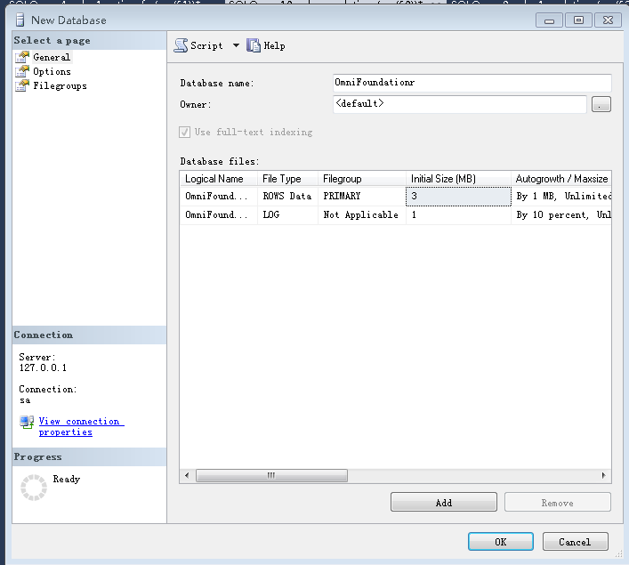

* Run script to database schema.

## Initialize data

* Run initialization script on the created database. The script path: <https://stash.englishtown.com/projects/ITIS/repos/omni-foundation-bk/browse/database/initData>.

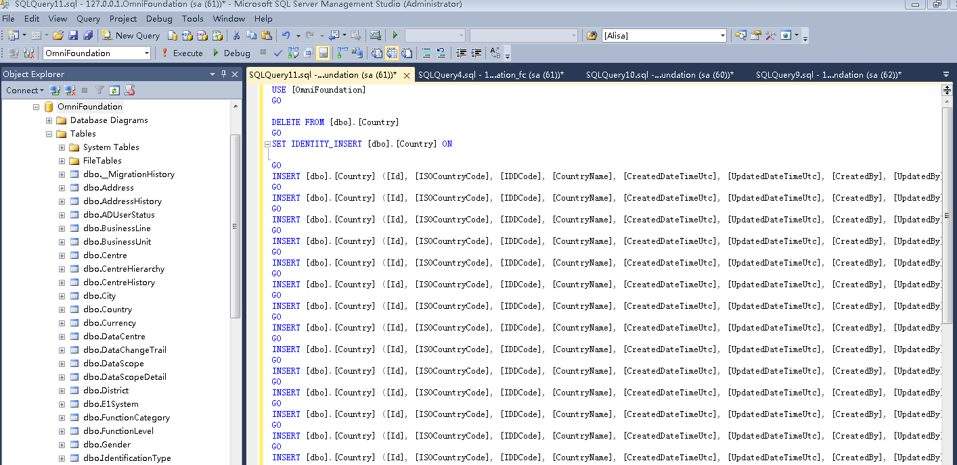

## Database upgrade.

* If devops upgrade database, please run upgraded script.

# Chapter 3 Identity server deployment and configuration

## Port & Https certification

* Get the release package of identity server, copy the package to identity server’s cloud server.
* Open IIS, create website, set port and configure Certification.

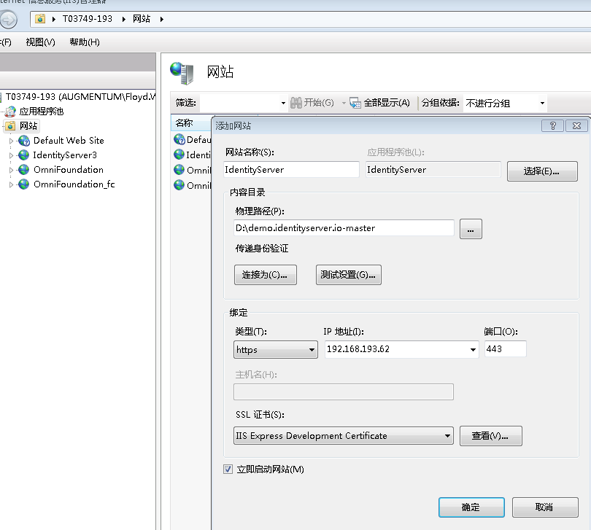

## Configure ADFS

* Configure ADFS Url.
* Configure relying part.

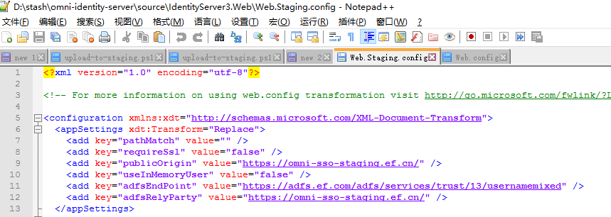

## Configure foundation database.

* Configure foundation database connect string.

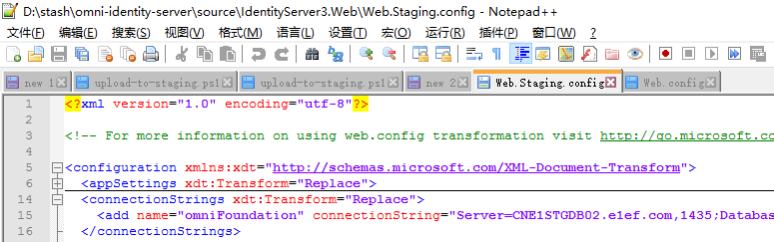

## Configure timeout/expiry

* Configure timeout/expiry.

## Configure client secret and scope

* Configure client secret and scope.

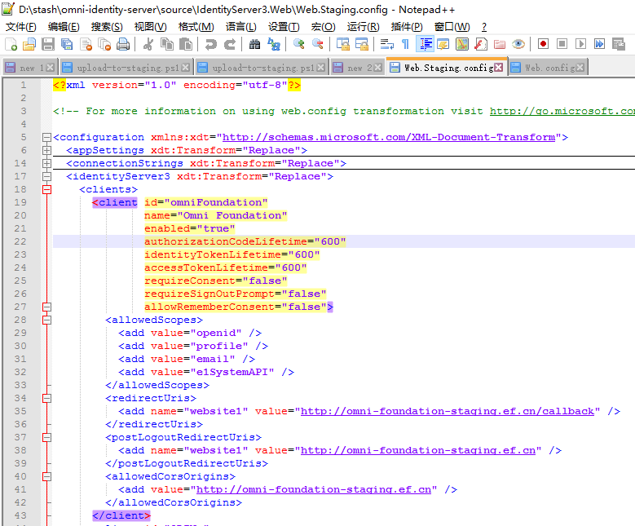

# Chapter 4 Foundation server deployment and configuration

## Build on Jenkins

* Go to Jenkins, select foundation server job, click “Immediately build”.

<http://ct1-e1scmd01.ef.com:8080/jenkins/view/Omni/>

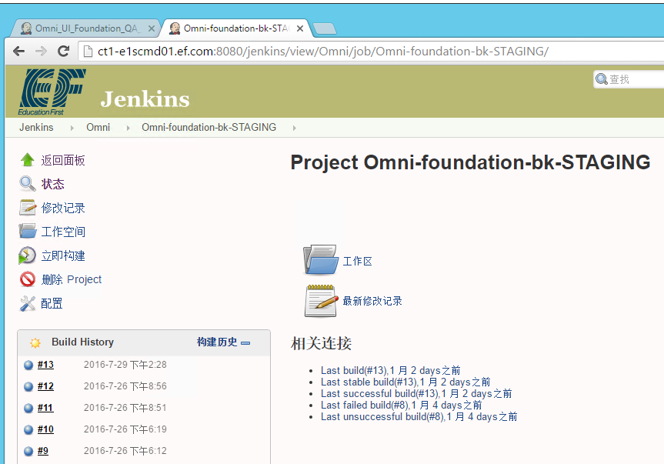

For live environment, we don’t use Jenkins.

## Package Preparation

* Check out server code from the website:<https://stash.englishtown.com/projects/ITIS/repos/odinplus/browse>.
* Open folder of code, and double click build.cmd, the project start building.
* After build completed, double click publish.cmd, it will be generated artifacts folder under current folder.

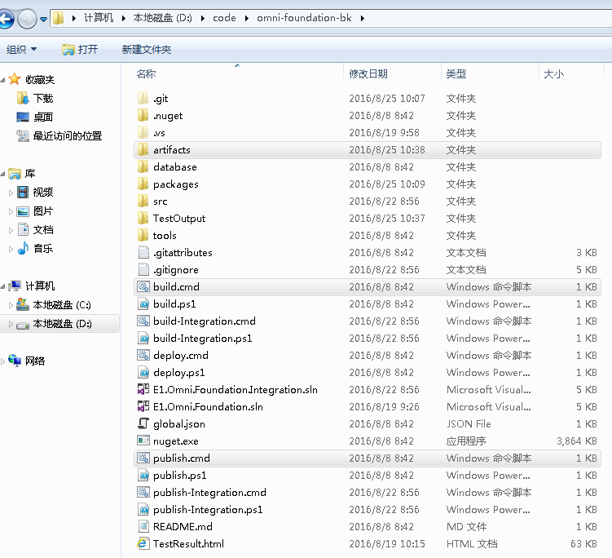

## Database configuration & Identity Server configuration & AD configuration

* Go to artifacts folder, open appsettings.staging.json file.
* Configure connect sting of database (SQL Server address, account, password and database name.) , identity server information and AD information.

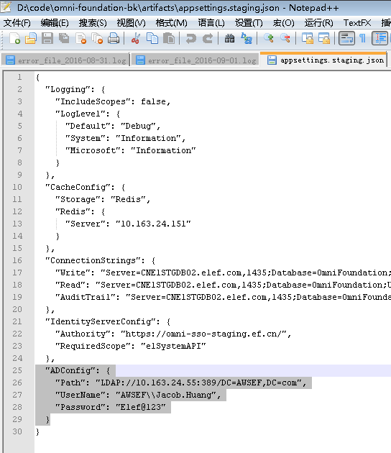

## Setup database(if devops setup database using migration)

* Go to folder package > EntityFramework.6.1.3 > tools, copy migrate.exe to artifacts folder.

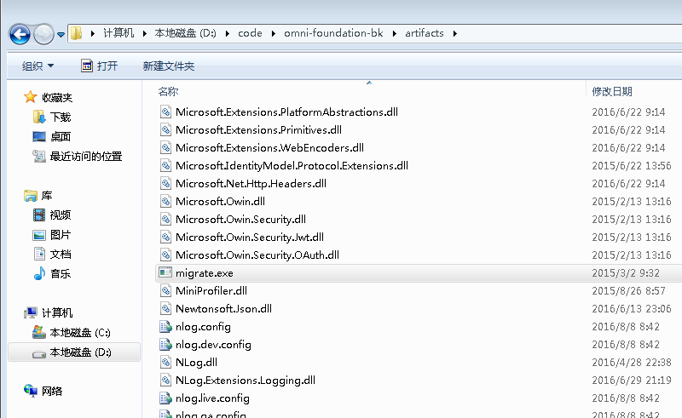

* Open terminal, go to artifacts folder run script

'Update db: Migrate.exe E1.Omni.Foundation.DataAccess.dll /startupConfigurationFile="App.config" /connectionString="Server=127.0.0.1;Database=OmniFoundation;User=sa;Password=sa;" /connectionProviderName="System.Data.SqlClient"'(**Please fill database information**).

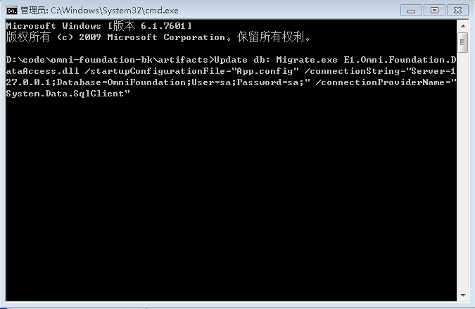

## Port & Http certification

* Remote to fundation server's server, copy artifacts folder to server.
* Open IIS, create website, set port and configure Certification.

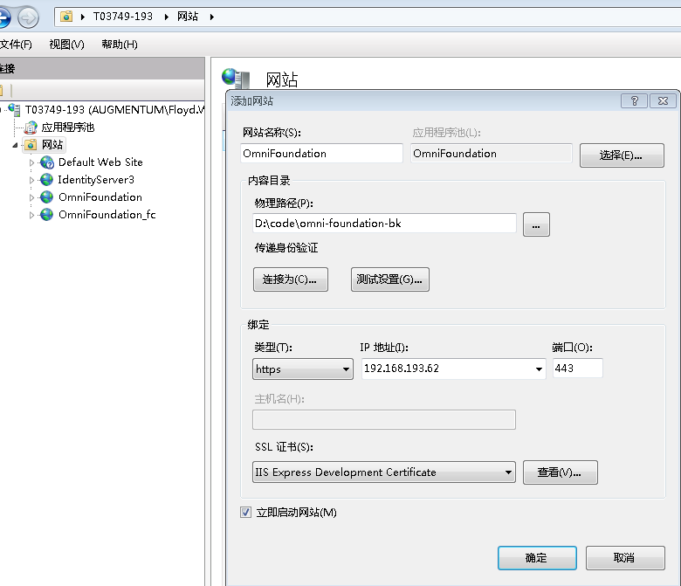

## Configure application pool

* Changed .net framework version to no managed code for Omni Foundation server's application pool.

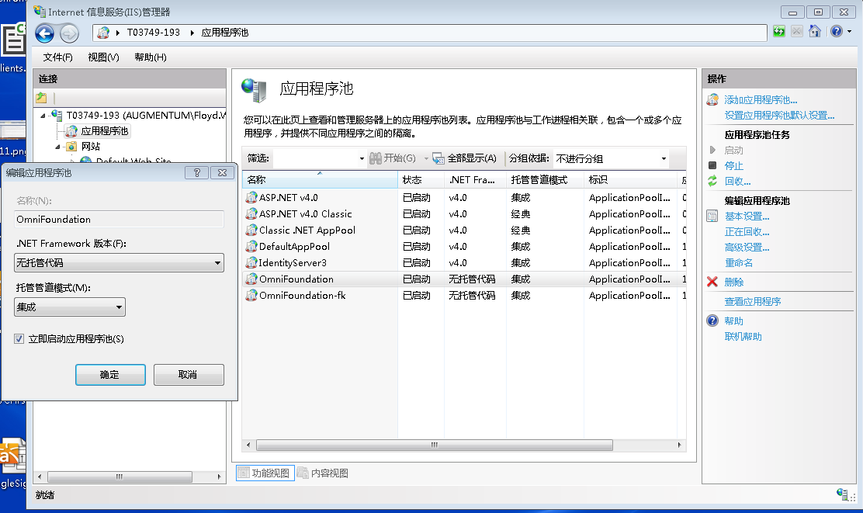

# Chapter 5 ESB Setup

If devops deploy an new ESB, you should copy all package to ESB server, if devops update ESB, use new package to replace old package.

## Proxy

* Configure Foundation API URL.(wso2esb\repository\deployment\server\synapse-configs\default\proxy-services\EFProxy.xml).

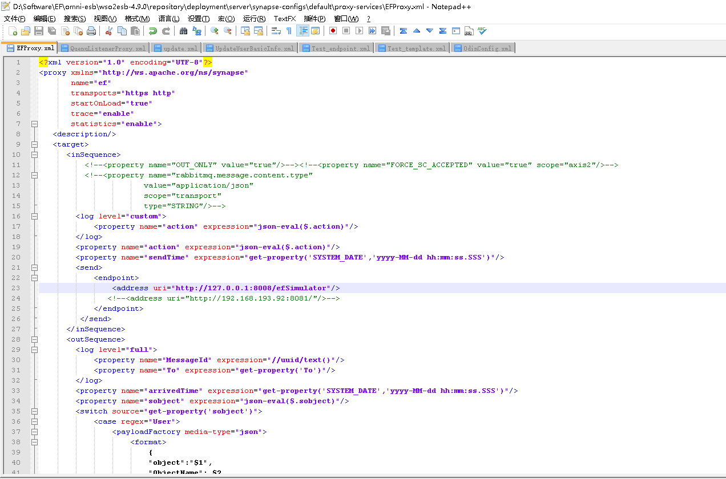

## Setup rabbit queue

* Install
* Install c:\camp\rabbitmq\otp_win64_R16B01.exe
* Install c:\camp\rabbitmq\rabbitmq-server-3.2.1.exe
* Start Plugin
* Run follow commands in command terminal:

|  |
| --- |
| *cd "C:\Program Files (x86)\RabbitMQ Server\rabbitmq_server-3.2.1\sbin"*  rabbitmq*-plugins enable* rabbitmq*_management*  *net stop RabbitMQ*  *net start RabbitMQ* |

* Change Port
* Default port of RabbitMQ is 5672. Follow this step if need to change port.

|  |
| --- |
| *setx RABBITMQ_NODE_PORT [port]*  *exit* |

* Run follow commands in a NEW command terminal:

|  |
| --- |
| *cd "C:\Program Files (x86)\RabbitMQ Server\rabbitmq_server-3.2.1\sbin"*  *rabbitmq-service stop*  *rabbitmq-service install*  *rabbitmq-service start* |

* Verify

Open http://localhost:15672/ in Browser. Login by “guest/guest” or other user/password. Check “Ports and contexts”.

* Configure Windows Firewall
* Shut down Windows Firewall or add ports “5672” and “15672” of RabbitMQ in Windows Firewall.
* Add ports in Windows Firewall, Run follow commands in command terminal:

|  |
| --- |
| *netsh advfirewall firewall add rule name="rabbitmq" protocol=TCP dir=in localport=5672 action=allow*  *netsh advfirewall firewall add rule name="rabbitmq-mgt" protocol=TCP dir=in localport=15672 action=allow* |

## Set handler address and salesforce connect.

* Copy handler package and salesforce package to the libs.

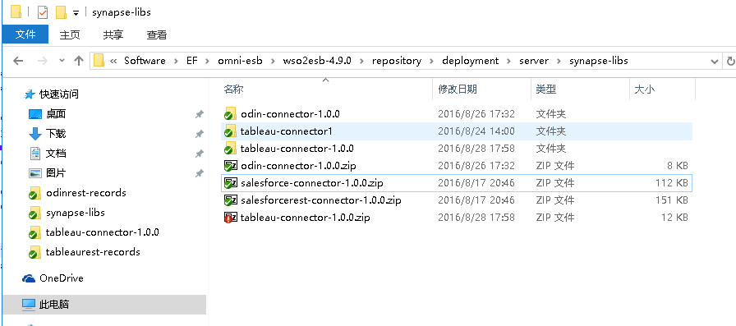

* Configure connector api information.

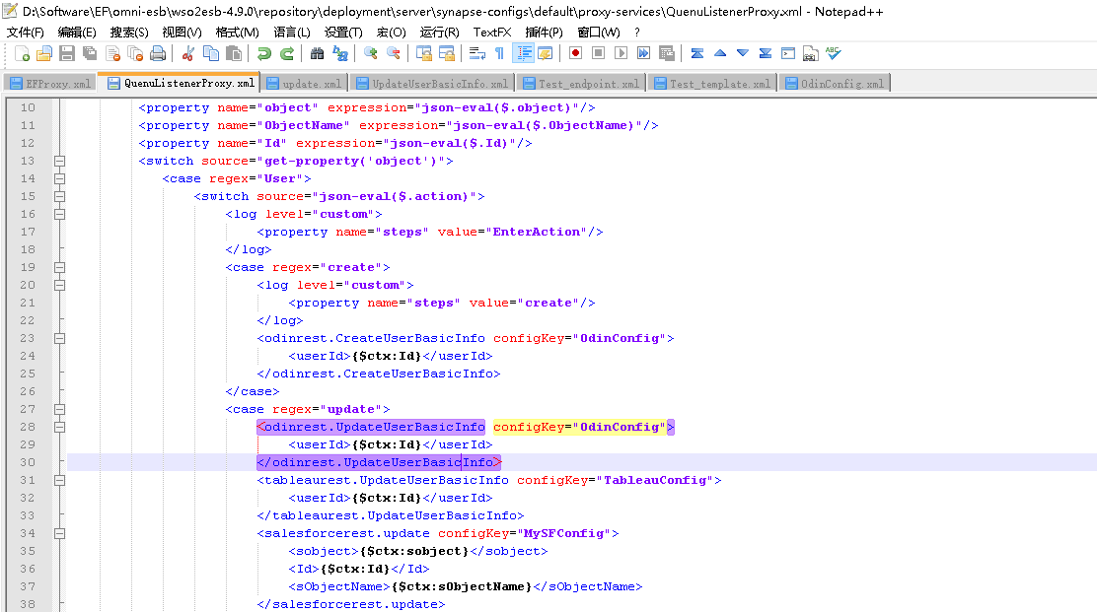

* Configure connector api proxy.

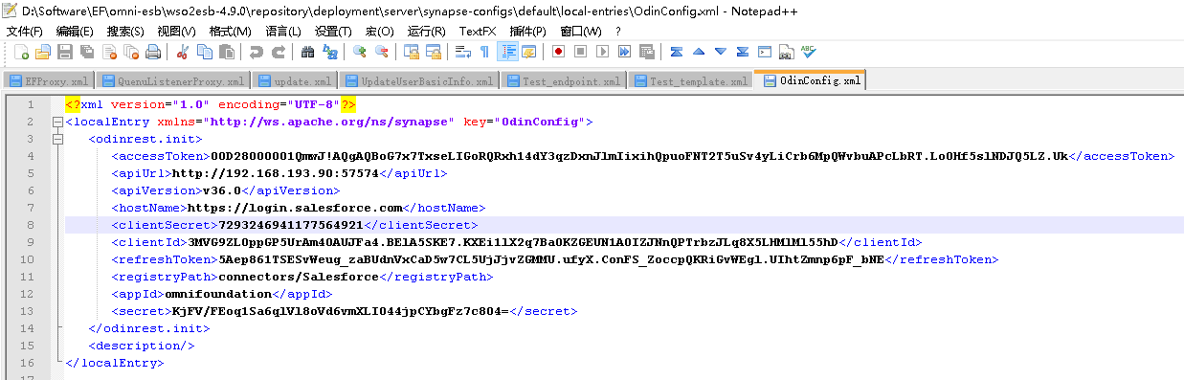

## ESB Port

* Set ESB port and run ESB server.

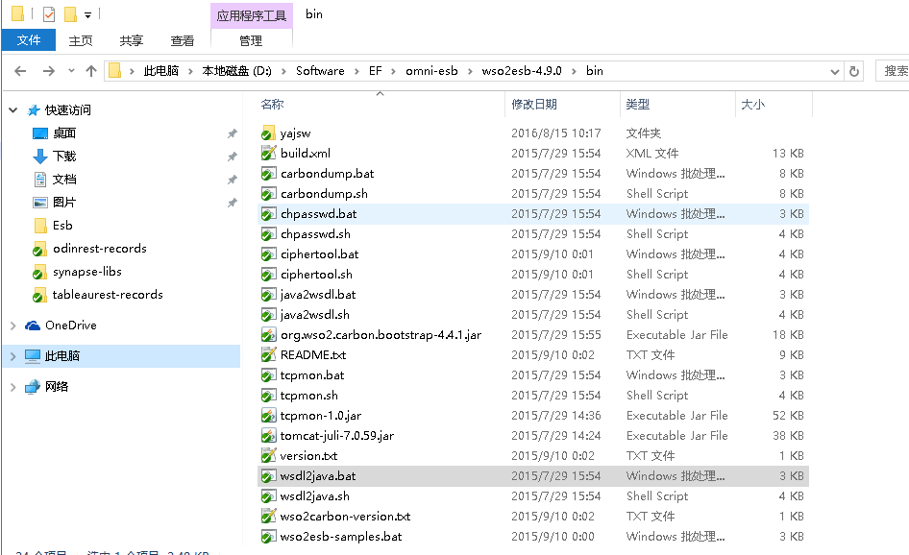

# Chapter 6 Windows Job Setup

## Install & Run windows job

* Check out server code from the website:<https://stash.englishtown.com/projects/ITIS/repos/odinplus/browse>.
* Double click deploy_service_dev, it will be generated OminBackgroundService folder under C:\Windows Services\.

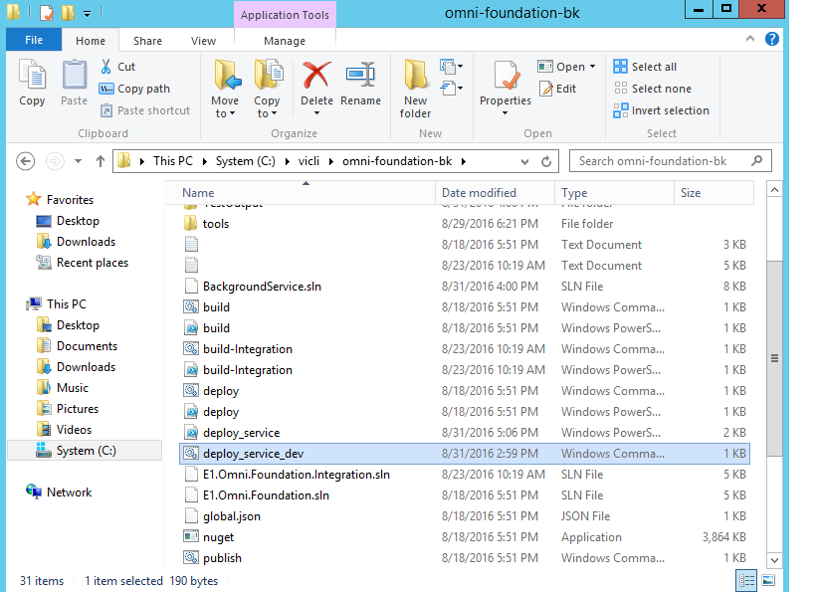

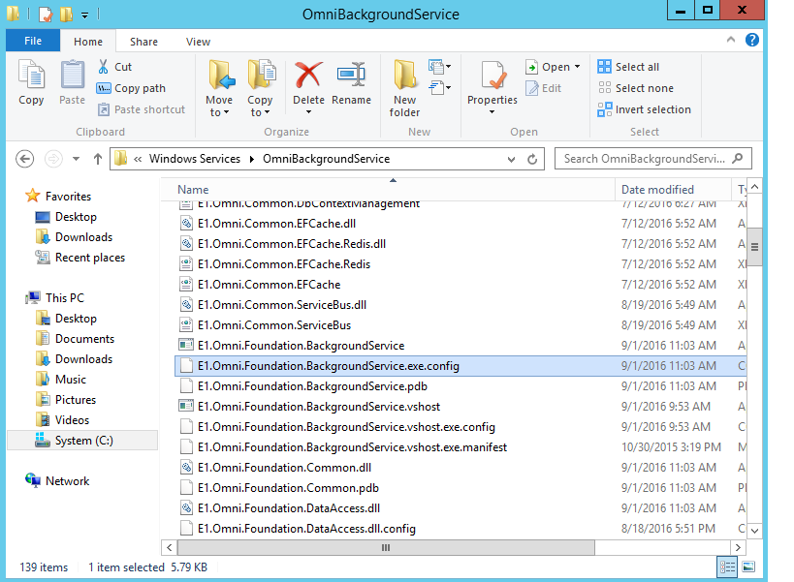

## Configure database.

* Open OminBackgroundService folder, open E1.OmniFoundation.BackgroundService.exe.config to configure database.

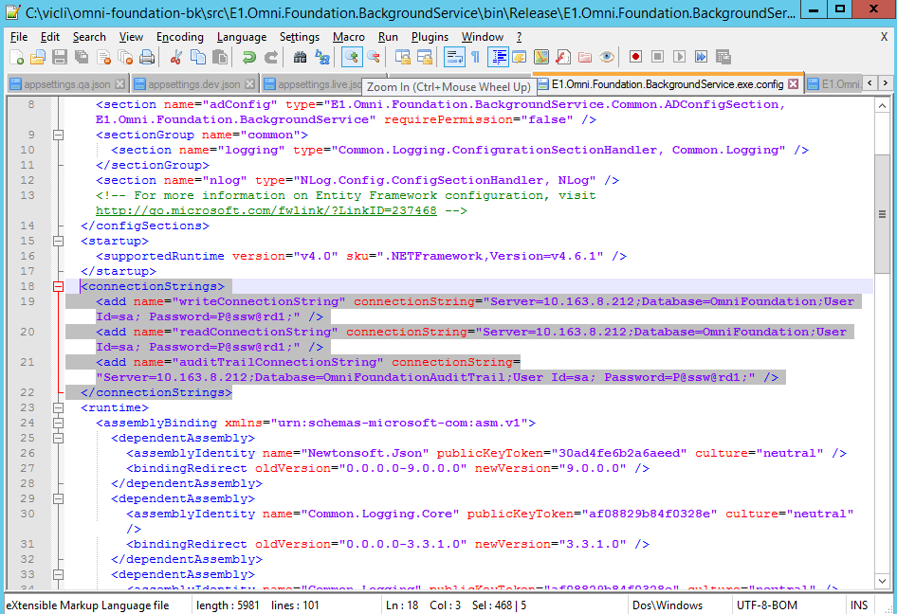

## Settings

* Open OminBackgroundService folder, open E1.OmniFoundation.BackgroundService.exe.config to configure LDAP.

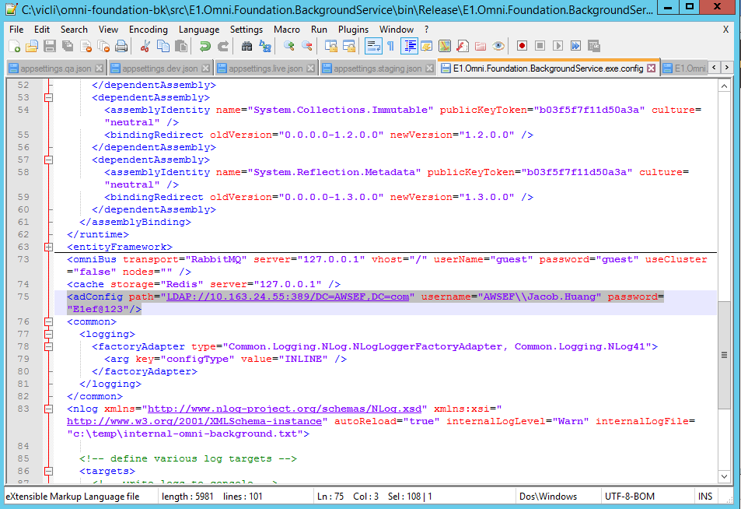

## Restart service

* Open service manager and restart Omni foundation service.

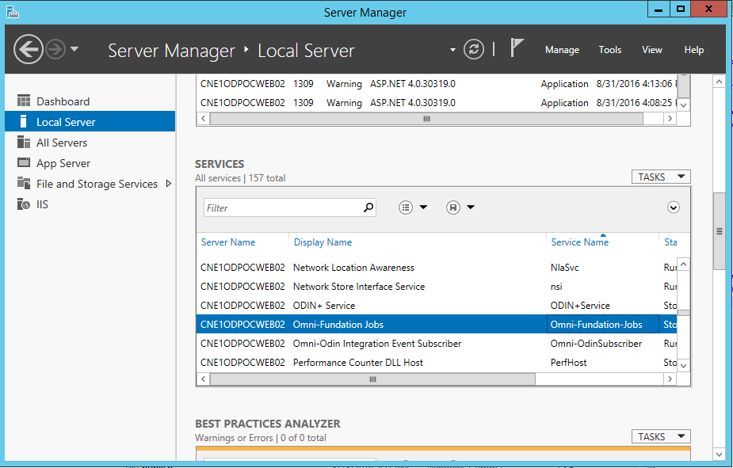

# Chapter 7 Client deployment

## Preparation

* Check out client code from website:

[https://stash.englishtown.com/projects/ITIS/repos/omni-foundation-ui/browse?at=refs%2Fheads%2Frelease](https://stash.englishtown.com/projects/ITIS/repos/omni-foundation-ui/browse?at=refs/heads/release).

## Foundation address & Identity Server address

* Configure foundation server's url, identity server's url and portal links.

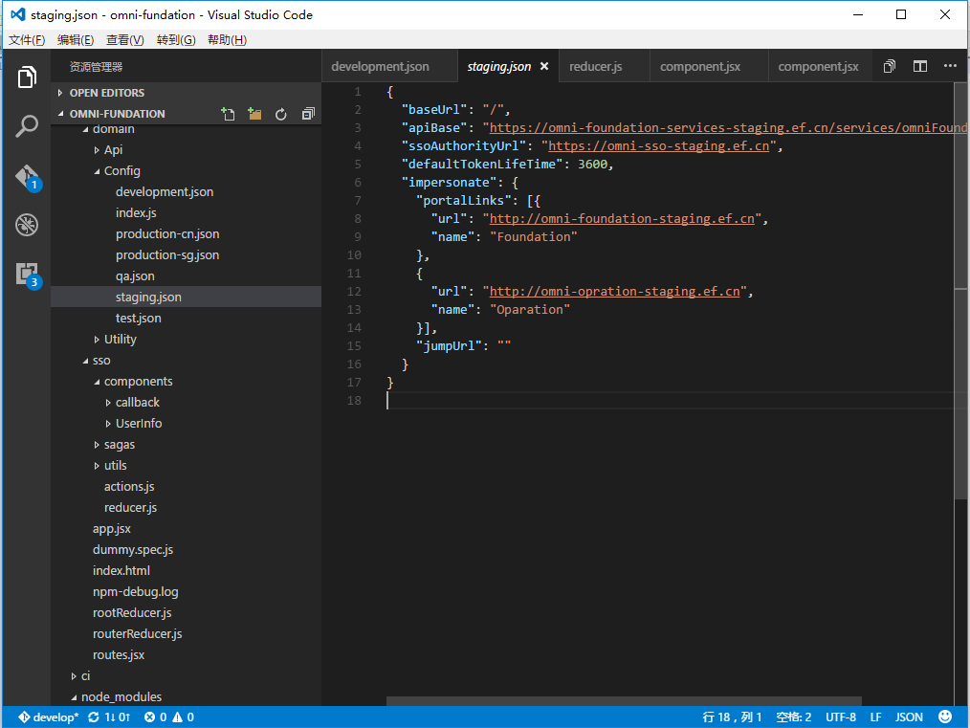

## Configure cloud address

* Configure cloud address, access key and secret key.

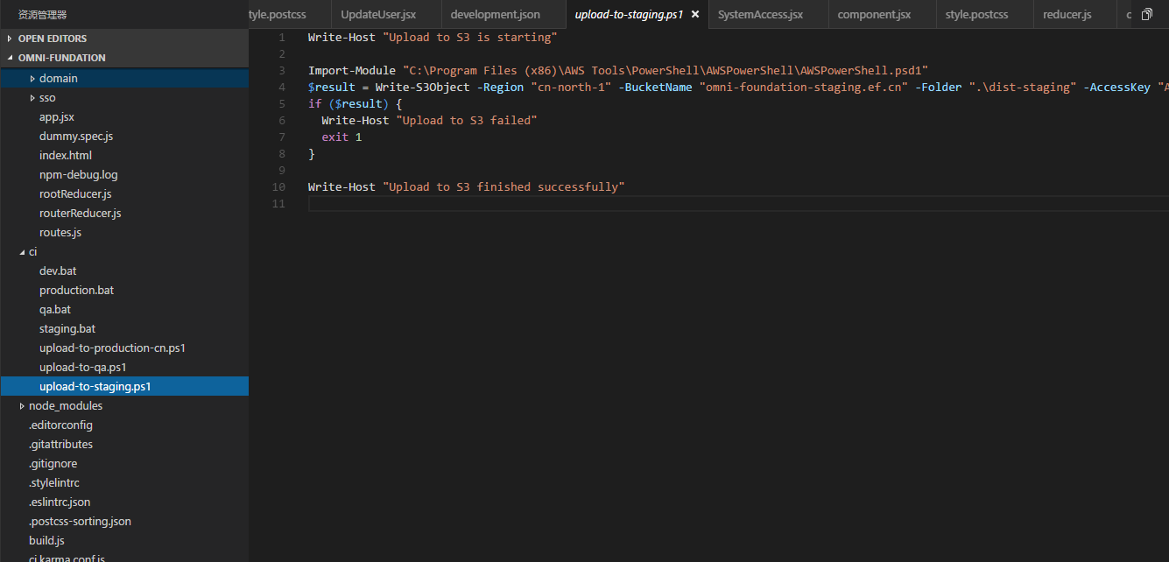

## Run build

* Open website: <http://ct1-e1scmd01.ef.com:8080/jenkins/view/Omni/>, select the environment which you will deployed.

