Why QUIC Cannot Be Blocked by Domain Detection with WinDivert

Overview
Blocking QUIC (HTTP/3) traffic based on domain names using tools like WinDivert is extremely challenging due to the protocol's advanced encryption and design philosophy. This document explores the technical challenges, including TLS 1.3 integration, ECH, and limitations of traditional DPI (Deep Packet Inspection), and provides a visual representation for clarity.

1. Understanding TLS 1.3, QUIC, and ECH

1.1 TLS 1.3 Overview
TLS 1.3 significantly reduces metadata leakage compared to TLS 1.2:
- The Server Name Indication (SNI) remains unencrypted by default.
- However, with Encrypted Client Hello (ECH), even the SNI is encrypted.
- Only minimal handshake data (like supported cipher suites) is visible.

1.2 What is QUIC?
QUIC is a transport-layer network protocol developed by Google, now standardized as RFC 9000. Key characteristics:
- Runs over UDP, not TCP.
- Built-in TLS 1.3 for encryption.
- Multiplexed connections without Head-of-Line blocking.
- Designed for speed, mobility, and security.

1.3 QUIC Variants
- QUIC without ECH: The initial TLS Client Hello may still expose the domain (SNI) in plaintext.
- QUIC with ECH: Encrypts the entire Client Hello, including SNI. DPI cannot extract domain info.

2. Encryption Architecture of QUIC

2.1 Full Payload Encryption
QUIC encrypts not just application data, but also:
- Most header fields.
- TLS handshake messages (including SNI, once ECH is enabled).

2.2 Impact of ECH
When ECH is in use:
- The client uses the server’s public key to encrypt the SNI.
- Even with QUIC decryption, the SNI cannot be extracted without access to the server’s private key.

3. Challenges with WinDivert and Proxy-Level Inspection

3.1 UDP and Stateless Transport
WinDivert is designed primarily for TCP. Challenges include:
- No connection state (no SYN/ACK).
- No sequence tracking.
- QUIC Connection IDs can change mid-session (mobility support).

3.2 Inability to Parse QUIC Headers
WinDivert cannot:
- Parse QUIC long vs short headers.
- Extract CRYPTO frames containing TLS handshake.
- Compute initial secrets needed for QUIC decryption.
Example decryption code (manual approach):
byte[] initialSecret = Hkdf.Extract(HashAlgorithmName.SHA256, dcid, QuicV1InitialSalt);
byte[] clientKey = HkdfExpandLabel(initialSecret, "client in", 16);

3.3 Traditional DPI Is Ineffective
Deep Packet Inspection tools:
- Look for plaintext SNI in Client Hello messages.
- Fail completely when ECH is enabled or protocol is fully encrypted.

4. Domain Detection Workflows: Why They Fail
Traditional TCP+TLS Workflow (with SNI exposed):
Client -> Proxy: TCP SYN (SNI in clear)
Proxy -> Proxy: Parse SNI → Allow/Block
Proxy -> Server: TCP Forward
QUIC + ECH Workflow (SNI encrypted):
Client -> Proxy: QUIC Initial (SNI encrypted)
Proxy -> Proxy: Cannot decrypt → No domain info
Proxy -> Server: Forwards blind

5. Workarounds and Their Limitations

5.1 Blocking All QUIC Traffic
Using WinDivert filters:
string filter = "udp.DstPort == 443";
✔ Blocks QUIC/HTTP3.
✘ Forces fallback to TCP/HTTPS (which may still use ECH).
✘ User experience degradation.

5.2 DNS-Based Domain Logging
- Capture DNS queries → map IPs to domains.
- Block IPs based on known domain associations.
Limitations:
- Fails with DoH/DoT (encrypted DNS).
- Not effective with CDNs or shared IPs (e.g., Cloudflare, Google).

6. Comparative Effectiveness Chart
Method | QUIC (No ECH) | QUIC (With ECH)
------------------------|----------------|-----------------
SNI-Based Filtering | ✅ Possible | ❌ Impossible
DNS Correlation | ⚠️ Limited | ⚠️ Limited
Block QUIC (UDP 443) | ✅ Effective | ✅ Effective

7. Visual Summary Diagram
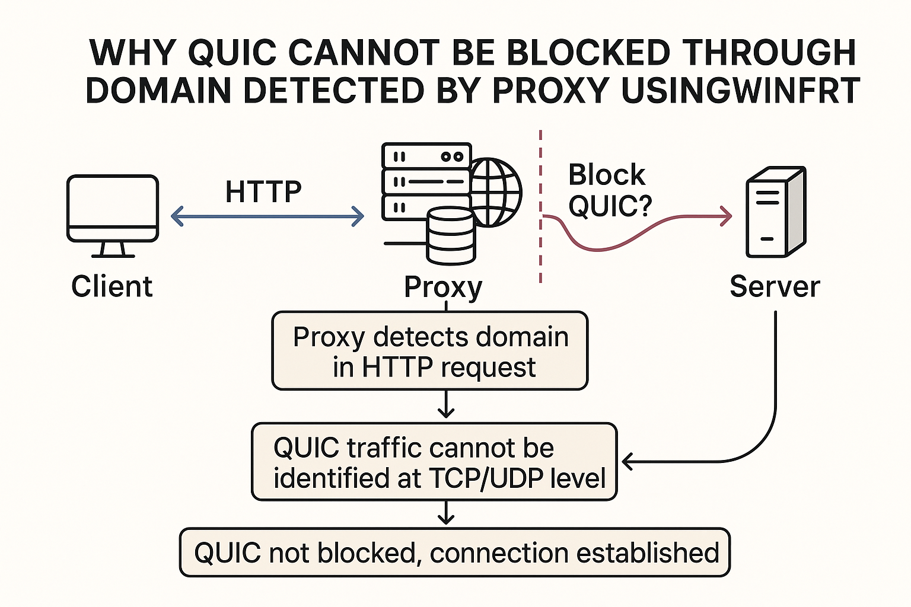

8. Conclusion
Due to the encrypted-by-design nature of QUIC, especially with ECH, it is not feasible to block QUIC traffic using domain name detection at the proxy level with tools like WinDivert. This leaves network defenders with limited, coarse-grained options like blocking QUIC entirely or relying on external DNS logs.
Future Directions:
- AI/ML-based traffic fingerprinting.
- Collaboration with DNS/CDN providers.
- Use of TLS Client Fingerprints.

References
- RFC 9000: QUIC Protocol
- Cloudflare: Encrypted Client Hello
- Wireshark QUIC Dissector

